Neurons

1. The diagram below is of a nerve cell or neurone.
i. Add the following labels to the diagram.
Axon; Myelin sheath; Cell body; Dendrites; Muscle fibres;
ii. If you like, colour in the diagram as suggested below.
Axon - purple;
Myelin sheath - yellow;
Cell body - blue;
Dendrites - green;
Muscle fibres – red;
iii. Now indicate the direction that the nerve impulse travels.
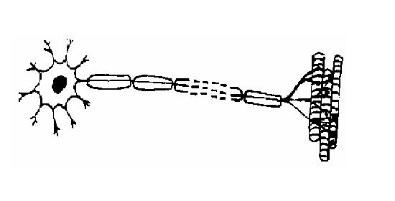
2. There are three different kinds of neuron or nerve cell. Match each kind with its function.
A. Motor neuron; B. Sensory neuron; C. Relay neuron;
Kind of neuron | Function
................................... | The nerve cell that carries impulses from a sense receptor  to the brain or spinal cord.
.................................... | The nerve cell that connects sensory and motor neurons
..................................... | The nerve cell that transmits impulses from the brain  or spinal cord to a muscle or gland

3. Match the descriptions in the table below with the terms in the list.
A. Synapse; B. Axon; C. Myelin sheath; D. Nerve impulse; E. Sense receptor; F. Response;
G.Reflex; H. Cell body; I. Dendrite; J. Nerve; K. Neurotransmitter; L. Axon terminal
Term | Function
.............................. | 1. The long fibre that carries the nerve impulses.
.............................. | 2. A bundle of axons.
.............................. | 3. The connection between adjacent neurons.
............................... | 4. The chemical secreted into the gap  between neurons at a synapse.
............................... | 5. A rapid automatic response to a stimulus.
............................... | 6. The covering of fatty material that  speeds up the passage of nerve impulses.
................................... | 7. The structure at the end of an axon that produces neurotransmitters  to transmit the nerve impulse across the synapse.
................................ | 8. The high speed signals that pass along the axons of nerve cells.
................................ | 9. The branching filaments that conduct nerve impulses  towards the cell.
..................................... | 10. The sense organ or cells that receive stimuli from within  and outside the body.
..................................... | 11. The reaction to a stimulus by a muscle or gland.
..................................... | 12.The part of the nerve cell containing the nucleus.

4. The diagram below shows a cross-section of the spinal cord. Add the following labels to the diagram.
Central canal; White matter; Dorsal root; Grey matter; Ventral root; Skin;
Muscle; Sensory neuron; Relay neuron; Motor neuron; Pain receptors in skin
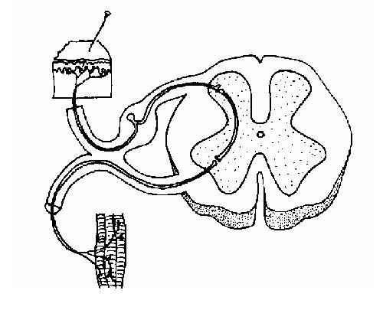
5.
a) List in order the 3 different neurons involved in a reflex arc from the stimulus to the response.
Stimulus | ........................... | ........................... | ........................... | Response

