Wet cells, Dry cells and Batteries
The electrochemical cell.
A simple device that converts stored chemical energy into electrical energy. A battery is one or more electrochemical cells together. Alessandro Volta invented the first battery (or "voltaic pile") in 1800.
Wet Cell
A wet cell has a couple of parts
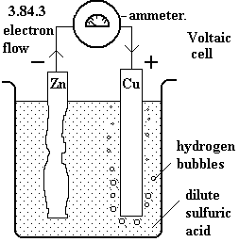

The electrodes. These are plates of _________ or ________. One plate breaks down and gives away electrons. The other plate collects these __________.
The plate that gives away electrons us called the Anode.
The plate that collects electrons is called the Cathode
An Electrolyte. This is a __________that __________electricity. This movement of electrons gives a current.
A wet cell is not very portable as the electrolyte can _________. Also as the anode gives away its electrons it breaks down. Once the anode has completely broken down the wet cell will stop working.
An example of a wet cell used today is :________________________________
_____________________________________________________________
Label the electrodes and electrolyte in the diagram below.
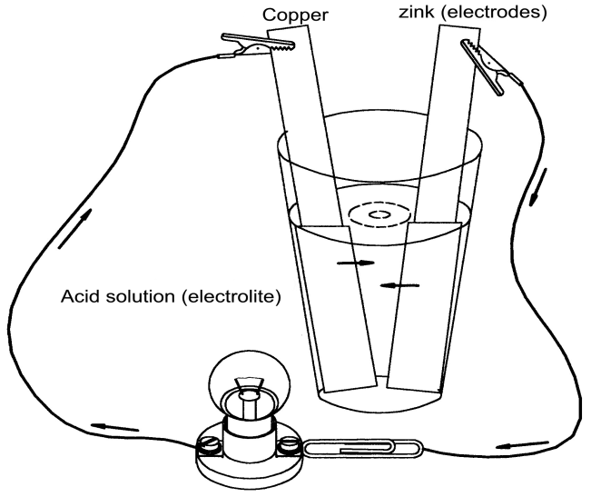
What were the problems with a wet cell?

Dry Cell
A dry cell has the same basic parts as a wet cell, but has characteristics that make it more useful. The electrolyte is a _________, not a liquid. As a result it does not splash around and spill if the cell is moved. The zinc electrode has been made into part of the outer casing of the battery. The other electrode is often made of graphite.
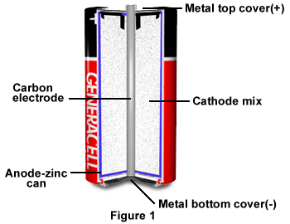

Why is the dry cell so useful?

Photovoltaic Cells
Another word for photovoltaic cell is ________ cell. These convert solar energy directly into _________ energy. The solar energy knocks ______________ off of the silicon crystals inside. As the electrons move away they form an electric current.
The current can be used straight away or it can be used to charge a battery for later use.

Primary and Secondary Batteries
Primary batteries (disposable batteries). These are designed to be used only once and then thrown away. This is a problem as the batteries must be replaced regularly. Also the wastes in these batteries are toxic, so safe disposal is not always easy.

Secondary batteries (rechargeable batteries or storage cells). These are designed to be recharged and used many times.

Questions:

- A mobile phone uses a _____ cell _______ battery, because it has a paste electrolyte and can be recharged.

- Bob has a torch that he uses when he goes camping. After a few nights use the globe gets quite dim. Bob replaces the torch batteries with new ones and safely disposes of the old ones. The batteries in Bob’s torch where ______ cells and ________ batteries.

- A car battery has a liquid electrolyte so it is a type of _____ cell. It can be recharged, so it is a _______ battery.

- What type of cell/battery would be best to use in an MP3 player? Give a reason for your answer.

- Why must you be careful when carrying a car battery?

- Why must batteries be disposed of carefully?

- Energy conversion= Where energy changes from one ______ of energy to another.

- Draw the energy conversion flow diagram for the following.

Battery in Mp3 player current music produced

- Complete this table
Word | Meaning
Battery

Wet Cell

Dry Cell

Electrode
Anode
Cathode
Electrolyte

