IONS
Atoms contain 3 types of particles: Protons, neutrons and electrons.
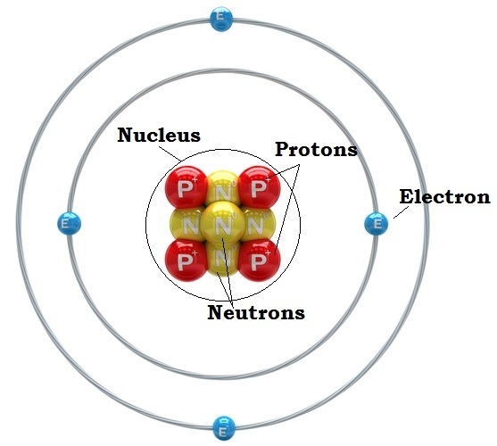

Sometimes electrons can be lost or gained by an atom.
When atoms loose or gain electrons they become charged.
There are two possible charges: positive or negative.
Positive = +
Negative = -
When atoms become charged we call them IONS.
Ions are charged particles.

When atoms lose electrons they become positive ions.
Metal atoms tend to lose electrons and become positive ions.
Element | Symbol for element | Symbol for ion | Number of Electrons lost by each atom
Potassium | K | K | 1
Lithium | Li | Li | 1
Silver | Ag | Ag | 1
Calcium | Ca | Ca | 2
Magnesium | Mg | Mg | 2
Aluminium | Al | Al | 3
Copper | Cu | Cu
Sodium | Na | Na
Iron (III) | Fe |  | 3
Zinc |  |  | 2

When atoms gain electrons they become negative ions.
Non-metal atoms tend to gain electrons and become negative ions.
Also when non-metals become ions the end of their name is changed to ide.
Element name | Ion name
Bromine | Bromide
Nitrogen | nitride

Element  Name | Ion name | Symbol for element | Symbol for ion | Number of Electrons gained by each atom
Sulphur | Sulphide | S | S | 2
Chlorine | Chloride | Cl | Cl | 1
Iodine |  |  |  | 1
Oxygen |  | O | O | 2

