Circuit diagrams

1
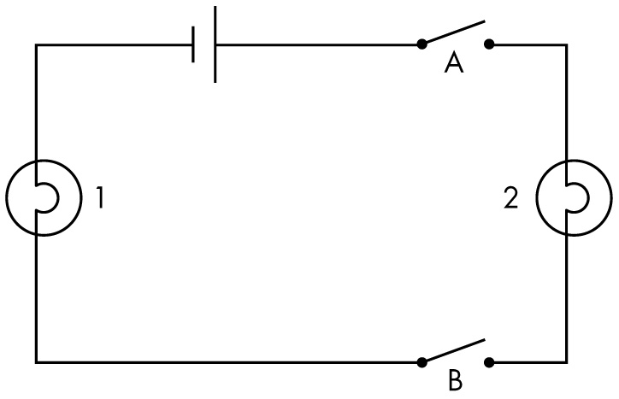
Explain what will happen to globes 1 and 2 when
a both switches are open

b both switches are closed

c switch A is open and switch B is closed

d switch B is open and switch A is closed

2
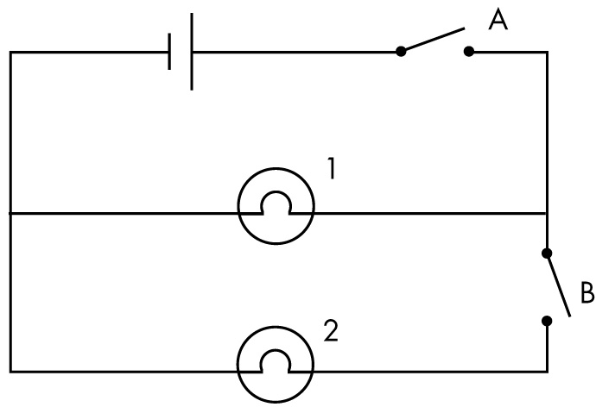
Explain what will happen to globes 1 and 2 when
a both switches are open

b both switches are closed

c switch A is open and switch B is closed

d switch B is open and switch A is closed



3
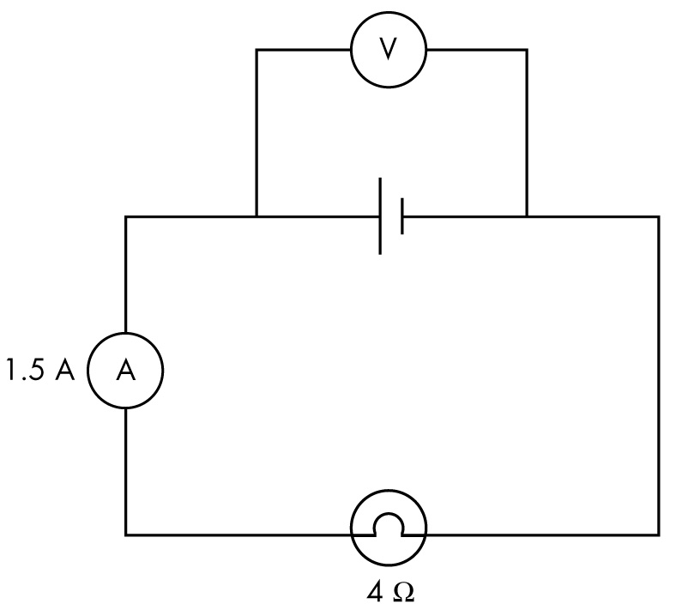
Calculate the voltage across the battery.

4
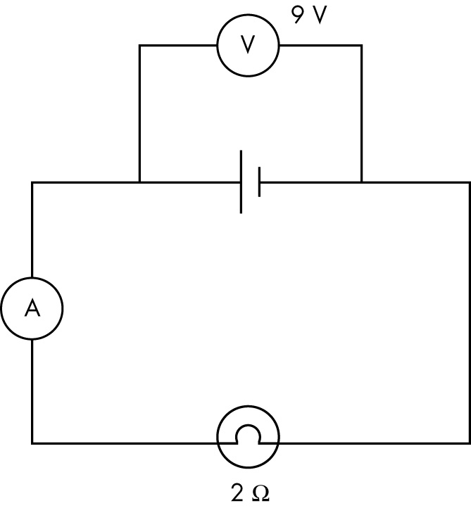
Calculate the current flowing through the ammeter.

5
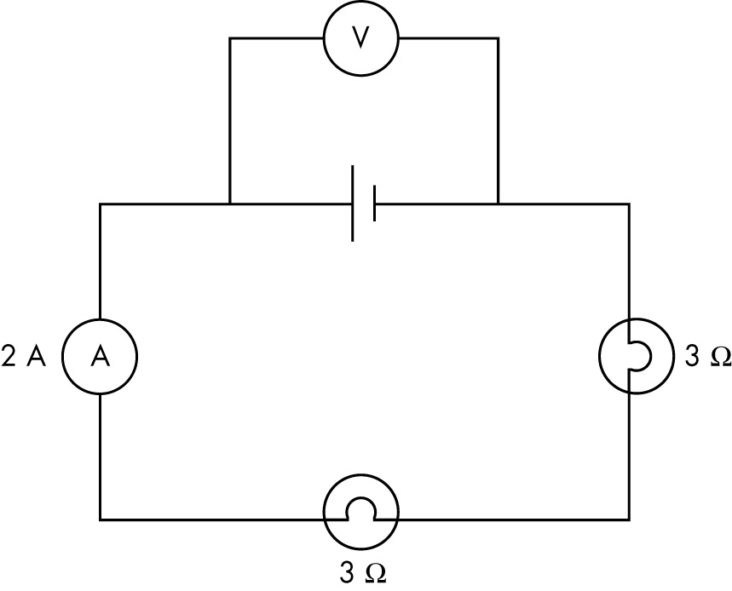
Calculate the voltage across the battery.

6
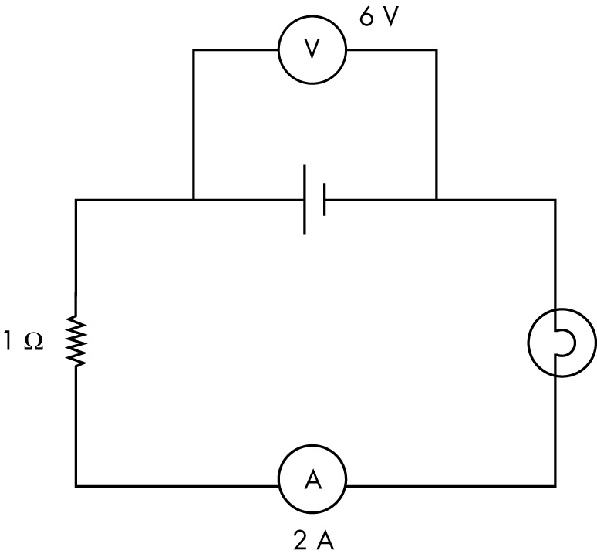
Calculate the resistance of the globe.

