Completing the circuit
Questions
1 Why don’t the bulbs light up in the circuits below?
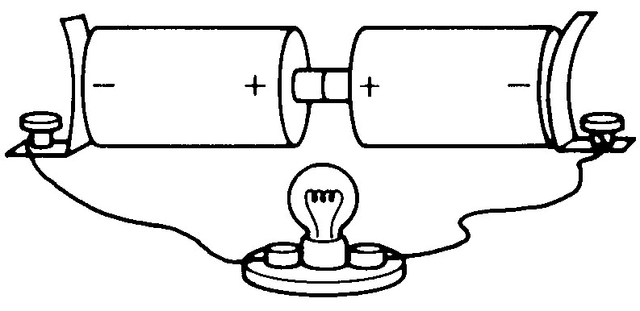 | _________________________________________  _________________________________________

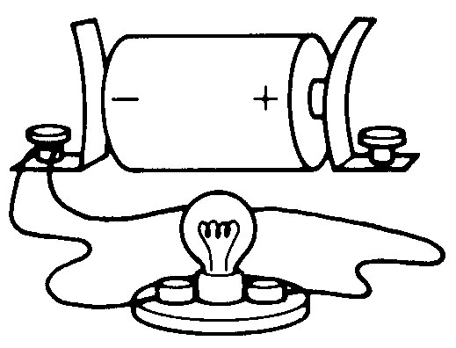 | _________________________________________  _________________________________________
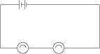 | _________________________________________  _________________________________________

2 Label each diagram with the words in the box. Consult your textbook if necessary.
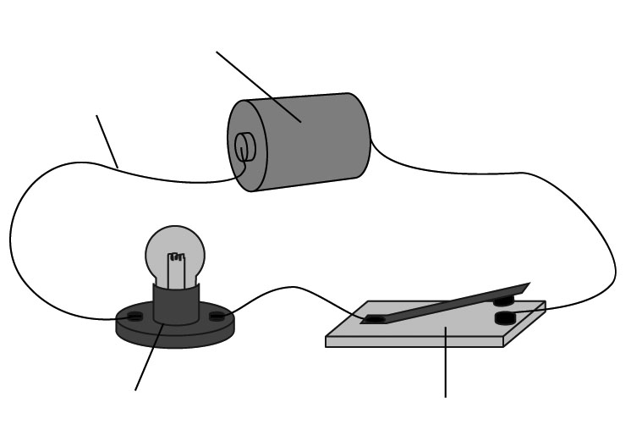 | switch  globe  wire  battery

3 Which types of circuits are shown below—a series circuit, a parallel circuit or a combination of both? Write the name beside each circuit diagram.
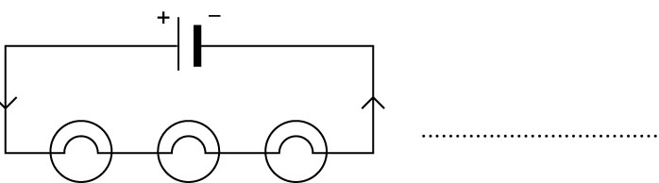 | 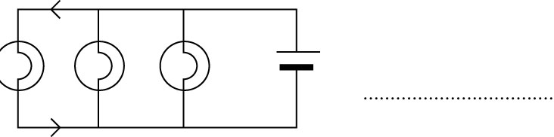
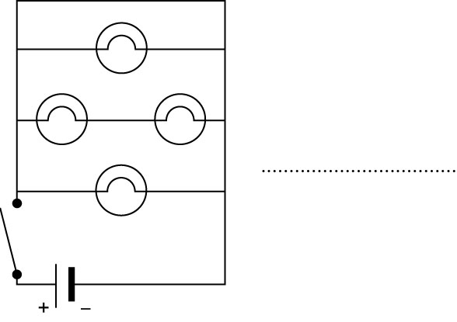 | 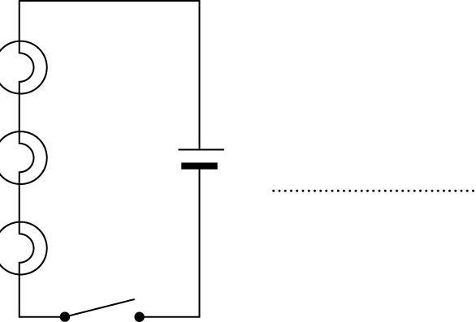
- Look at the diagram below, in which the wires are rather tangled. Trace the path of each circuit, and say what will happen when each switch is closed.

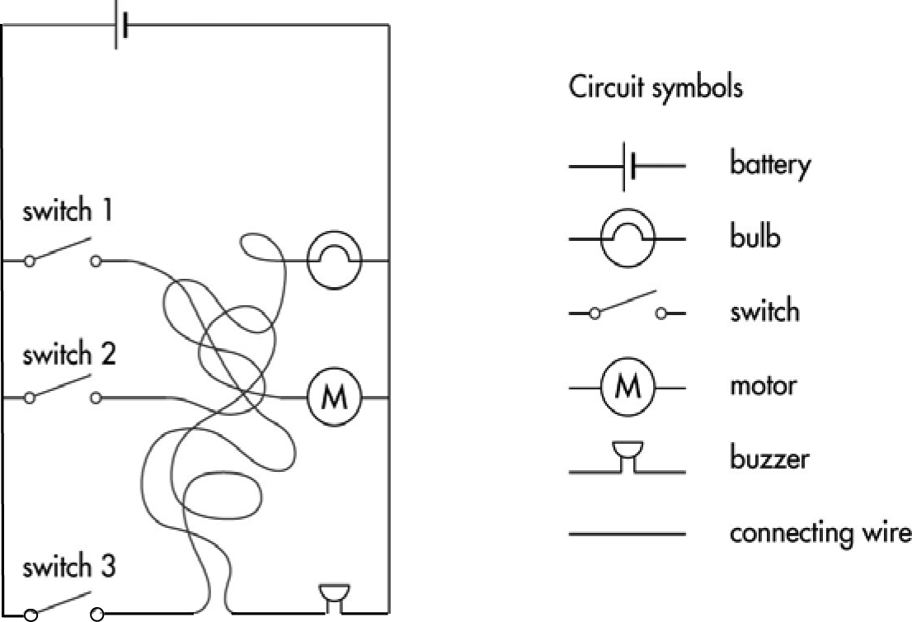
a switch 1 ____________________________
b switch 2 ____________________________
c switch 3 ____________________________

