More circuits
Questions
1 Some students were carrying out an experiment to check whether certain materials were conductors or insulators. Being careful students, they ensured that all components tested were the same size and shape (a fair test). Their results are shown in the following table.
Material | Brightness of bulb | Conductor (C) or insulator (I)?
Copper wire | Very bright
Steel wire | Not so bright
Wooden stick | No light
Lead from a pencil | Very dull
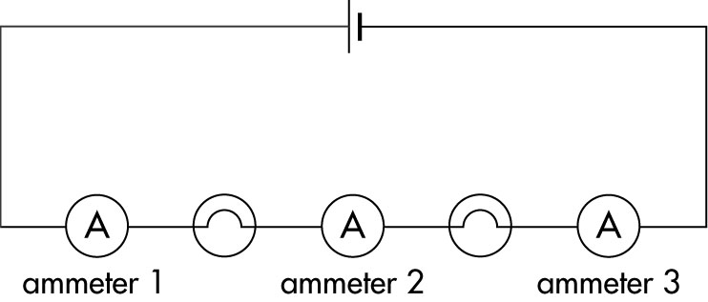
Complete the last column of the table for the students. What can be said about the structure of the materials tested?
2 In the following circuit, ammeter 1 reads 0.5 A. What will
be the reading on:
a ammeter 2? _________
b ammeter 3? _________
3 For each of the circuits below, say what happens when the switch is closed and try to explain why it happens.
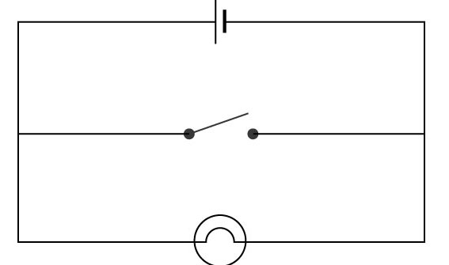 | ______________________________________________  ______________________________________________  ______________________________________________
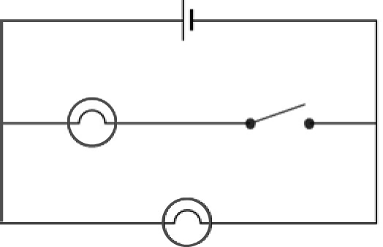 | ______________________________________________  ______________________________________________  ______________________________________________

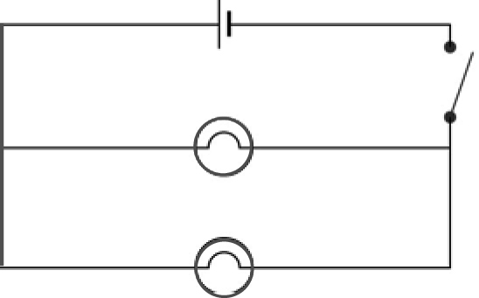 | ______________________________________________  ______________________________________________  ______________________________________________  ______________________________________________

4 Yvette ran a series of tests on the voltage obtained when torch batteries were connected in various ways.
Her results are shown below.
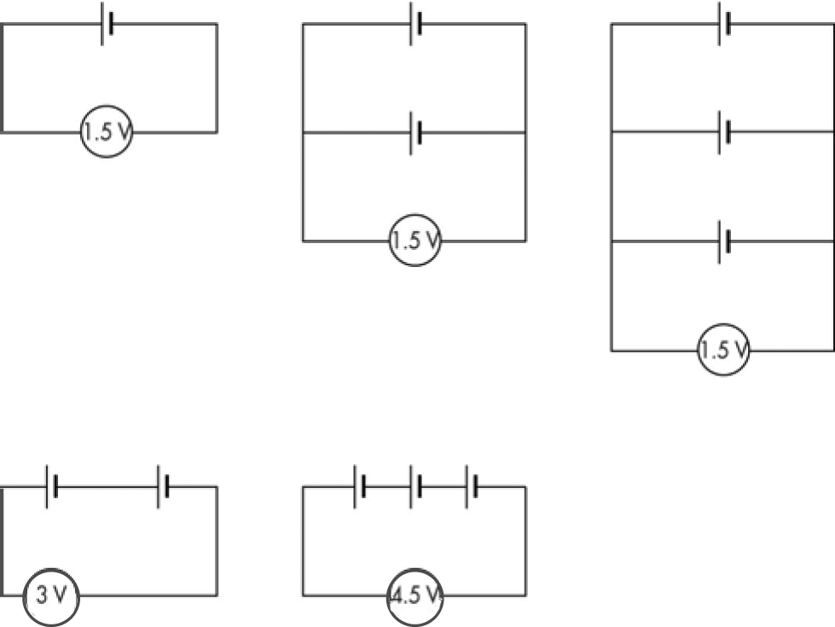
a Yvette has four batteries and wishes to obtain a 6-V output. How should she connect the batteries?
_______________________________________________________________________________
_______________________________________________________________________________
b (A harder one!) If Yvette had to use five batteries and still obtain an output of 6 V, suggest a way of connecting the batteries.
_______________________________________________________________________________
_______________________________________________________________________________
5 Look at the following circuit diagram.
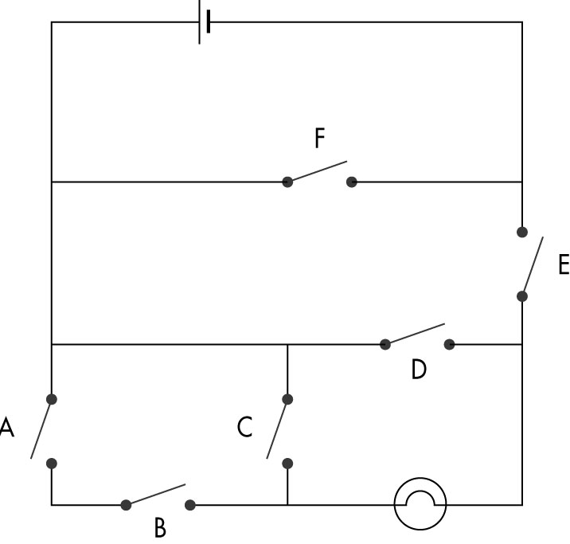
a Will the globe be alight with the circuit as shown? _______________________________________
b What is the fewest number of switches that has to be closed to make the light come on? Which switches are they? ________________________________________________________________________
c If switches A, B and E are closed, the light comes on. What happens if you then switch D on?
_______________________________________________________________________________
_______________________________________________________________________________
d Try to explain your result from part c.
_______________________________________________________________________________
_______________________________________________________________________________
_______________________________________________________________________________

6 Use words from the diagram below to complete the sentences.
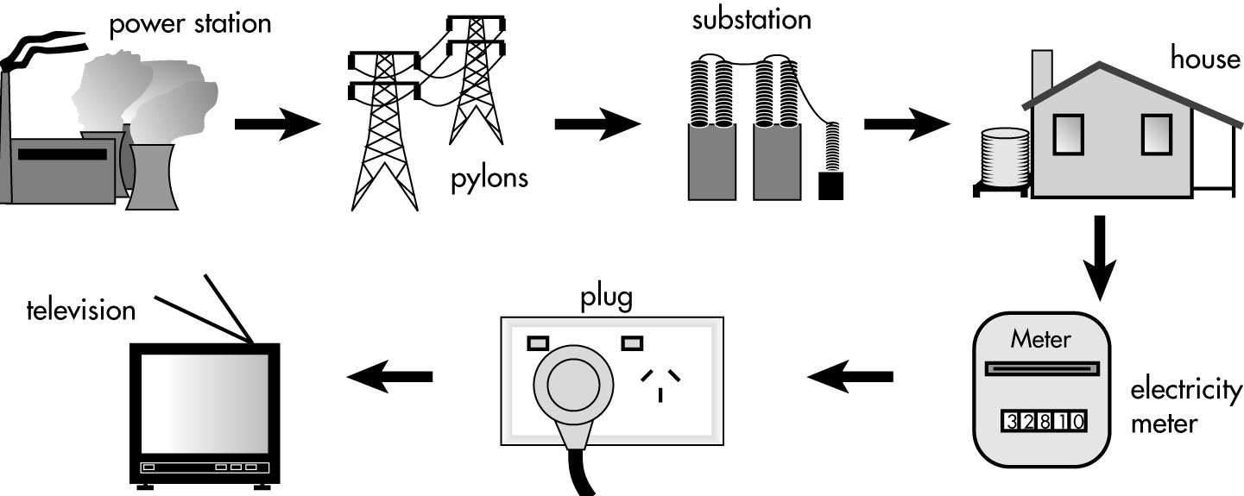
a Electricity is generated in a ___________ ___________.
b It is carried in big wires or cables. ___________ hold the cables above the ground.
c Sometimes the cables are buried in the ground. The electricity always goes to a ___________ before it reaches our homes. An ___________ ___________ outside the house measures how much electricity we use.

