Specialized Cells Worksheet Name____________________
CB
13

Many organisms are multi-cellular - they are made up of lots of cells, not just one! Many of these cells are specialized, working together to carry out the life processes (they work together as a team, supporting the organism). Specialized cells occur in both animals and plants…
Animal Cells
Animal Cell | Cell Diagram | Function | Specialization | Explain how each cell’s specialization helps it carry out its function
Red blood cells |  | To carry oxygen | - Large surface area for oxygen  - Hemoglobin which binds the oxygen
Nerve cell |  | To carry nerve impulses to different parts of the body | - Long  - Connections at each end  - Can carry electrical signals
Male reproductive cell |  | To reach the female cell in order to join with it | - Long tail for swimming  - Head which is able to penetrate the female cell

Plant Cells
Explain some of the specialized plant cells.
Plant Cell | Cell Diagram | Function | Specialization | Explain how each cell’s specialization helps it carry out its function
Root hair cells | 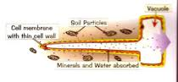 | To absorb water and minerals | - Large surface area
Leaf cell | 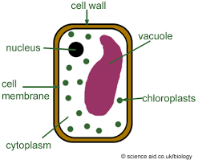 | To absorb sunlight (needed for photosynthesis) | - Large surface area  - Many chloroplasts (containing chlorophyll, for photosynthesis)

Cells “R”Us
These drawings show how WE are made of CELLS!
Directions:
Match the correct word from the WORD LIST below to the drawing 1-5.
Color each drawing the CORRECT color noted under the word.
Use your colored drawings and the same words to fill in the blanks for the questions.
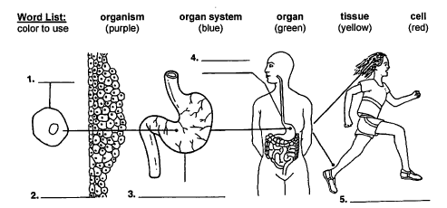

- A ______________________ is the smallest unit of structure and function of a living thing.

- An example of a cell is a ______________________ cell.

- A tissue is made of a group of similar _________________________working together.

- An example of a tissue is _______________________ tissue.

- An organ is made of different ____________________ working together to do a special job.

- An example of an organ is the ________________________.

- An organ system is made of many _________________ working together to do a special job.

- An example of an organ system is the ______________________ system.

- An ___________________is a living thing that carries out its own life activities.

- An example of an organism is ________________________.

Challenges:

The largest organ in the human body is the _______________________

Human skin is an example of a _______________ because_________________________

