People have long asked,  "What is the world made of?"  and  "What holds it together?" | 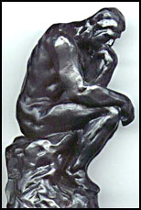

What is the World Made of?
Why do so many things in this world share the same characteristics?
People have come to realize that the matter of the world is made from a few fundamental building blocks of nature.
The word "fundamental" is key here. By fundamental building blocks we mean objects that are simple and structureless -- not made of anything smaller.
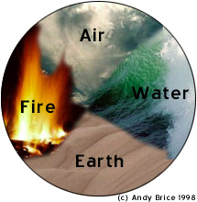
Even in ancient times, people sought to organize the world around them into fundamental elements, such as earth, air, fire, and water.

Today we know that there is something more fundamental than earth, water, air, and fire...

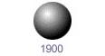
By convention there is color,
By convention sweetness,
By convention bitterness,
But in reality there are atoms and space.
-Democritus (c. 400 BCE)
Around 1900, people thought of atoms as permeable balls with bits of electric charge bouncing around inside.

But is the atom fundamental?

Is the Atom Fundamental?

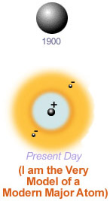
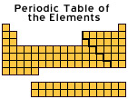
People soon realized that they could could categorize atoms into groups that shared similiar chemical properties (as in the Periodic Table of the Elements). This indicated that atoms were made up of simpler building blocks, and that it was these simpler building blocks in different combinations that determined which atoms had which chemical properties.
Moreover, experiments which "looked" into an atom using particle probes indicated that atoms had structure and were not just squishy balls. These experiments helped scientists determine that atoms have a tiny but dense, positive nucleus and a cloud of negative electrons (e⁻).
Trivia: The term "atom" is a misnomer. Why? [Answer]

Is the Nucleus Fundamental?

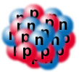
Because it appeared small, solid, and dense, scientists originally thought that the nucleus was fundamental. Later, they discovered that it was made of protons (p⁺), which are positively charged, and neutrons (n), which have no charge.

So, then, are protons and neutrons fundamental?

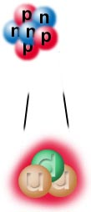
Physicists have discovered that protons and neutrons are composed of even smaller particles called quarks.
As far as we know, quarks are like points in geometry. They're not made up of anything else.

After extensively testing this theory, scientists now suspect that quarks and the electron (and a few other things we'll see in a minute) are fundamental.

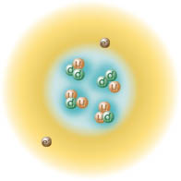
This is the modern atom model.
Electrons are in constant motion around the nucleus, protons and neutrons jiggle within the nucleus, and quarks jiggle within the protons and neutrons.
This picture is quite distorted. If we drew the atom to scale and made protons and neutrons a centimeter in diameter, then the electrons and quarks would be less than the diameter of a hair and the entire atom's diameter would be greater than the length of thirty football fields! 99.999999999999% of an atom's volume is just empty space!

Scale of the atom.
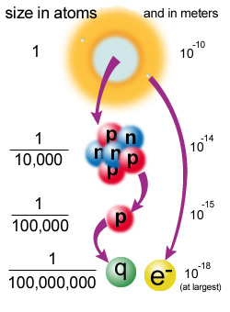
While an atom is tiny, the nucleus is ten thousand times smaller than the atom and the quarks and electrons are at least ten thousand times smaller than that. We don't know exactly how small quarks and electrons are; they are definitely smaller than 10⁻¹⁸ meters, and they might literally be points, but we do not know.
It is also possible that quarks and electrons are not fundamental after all, and will turn out to be made up of other, more fundamental particles. (Oh, will this madness ever end?)

