Minerals
Mineral occur in the Earth’s crust and have 5 characteristics that make them minerals(criteria)
S____________
N_____________ o___________
I____________
Fixed chemical f____________
Specific atomic arrangement
Ore=a rock containing a m____________. Minerals often contain specific elements. When elements need to be mined, geologists will look for the ore with the mineral they want.
Mineral | Element that it contains
Haematite
Bauxite
Cassiterite
Pentlandite

HARDNESS
The Mohs scale measures hardness of minerals. It has the idea that harder minerals can scratch softer minerals.
Diamond is the hardest mineral so it has a value of 10. It can scratch all other minerals.
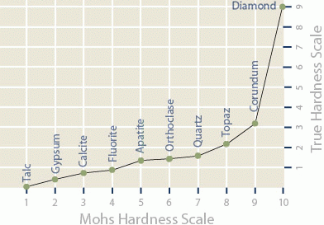
Complete this table.
Hardness | Mineral
1
2
3
4
5
6
7
8
9
10

Read the two worked examples on page 317. Then try these.
- Unknown mineral X will scratch fluorite, but not feldspar. How hard is it?

- Unknown mineral Z will scratch feldspar but not topaz. How hard is it?

- Why is diamond given a Mohs hardness measure of 10?

- Which minerals can talc scratch?

- Which minerals can scratch talc?

- Why is hard plastic not counted as a mineral?

- Why is hard wood not counted as a mineral?

Minerals

A | Z | W | M | H | I | Y | T | K | H | P | B | J | G | E
L | E | N | D | G | A | J | L | O | L | Z | R | K | Z | I
U | X | O | P | N | V | R | R | L | P | O | V | S | P | J
M | R | E | V | I | O | Z | D | T | A | A | G | C | N | S
R | E | R | O | R | W | M | S | N | Z | R | Z | R | L | C
O | N | M | Q | R | U | U | A | N | E | J | U | A | L | I
F | R | Y | Q | U | R | Y | G | I | J | S | R | T | N | J
E | R | U | T | C | U | R | T | S | D | E | S | C | A | E
B | R | H | E | C | P | N | S | J | N | V | S | H | L | N
U | I | P | L | O | Q | Z | I | I | J | T | M | E | D | S
L | A | T | S | Y | R | C | M | G | M | O | M | B | T | R
R | O | J | Z | Q | X | O | T | T | H | E | L | P | D | E
Z | X | P | V | Y | K | D | A | S | N | F | H | G | H | B
B | J | W | O | X | W | Q | L | T | D | S | O | L | I | D
I | N | O | R | A | N | I | C | C | A | G | E | N | E | Q

CRUST | CRYSTAL | DIAMOND
ELEMENT | FORMULA | HARDNESS
INORANIC | MINERALS | MOHS
NATURALLY | OCCURRING | ORE
SCRATCH | SOLID | STRUCTURE
TALC | TOPAZ

