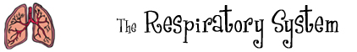

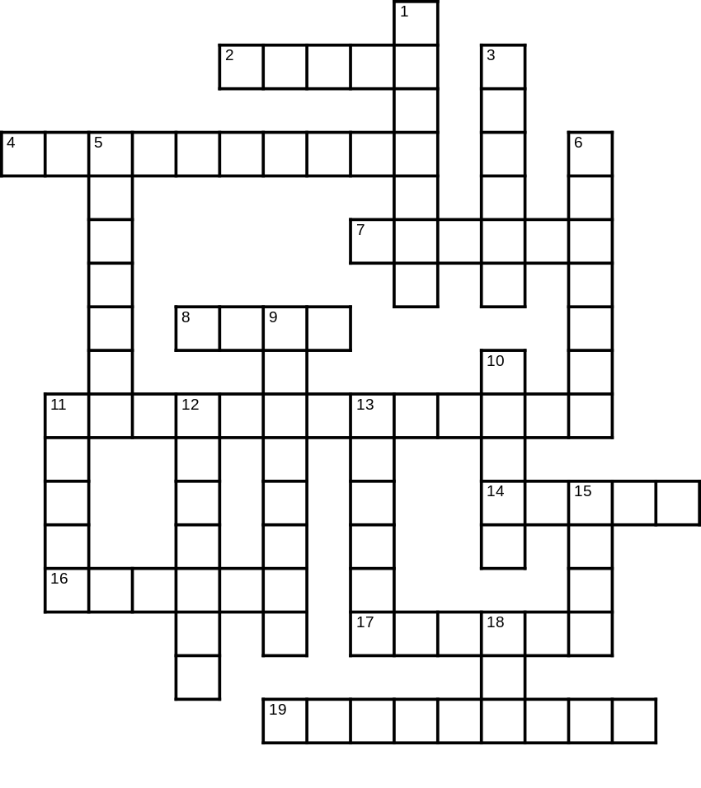 |  | Find the circulatory system words below in the grid to the left.  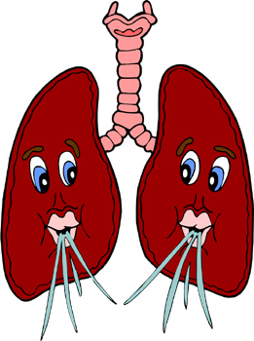
Across  2. One of two places where air enters your body.  4. When we exhale we breathe this plus carbon dioxide.  7. You do this when something irritates your nose.  8. You do this when you don't get enough oxygen to your blood.  11. A gas that you breathe out. It is a waste gas.  14. The place where oxygen enters the blood.  16. You do this when something irritates your diaphragm.  17. Breathe out.  19. Large muscle that controls the lungs. | Down  1. This prevents food from going down your lungs.  3. All animals need this gas to make energy from food.  5. Scientific name for the windpipe.  6. Inhale and exhale.  9. Common name for the trachea.  10. Fish have these instead of lungs.  11. You do this when something irritates your trachea or bronchi.  12. Two tubes that connect the trachea to the lungs.  13. Breathe in.  15. One of two places where air enters your body.  18. What we breathe.
© 2006 www.bogglesworldesl.com

