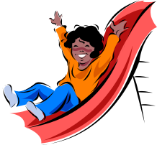
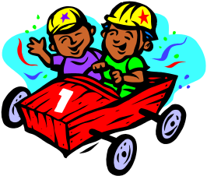
Friction

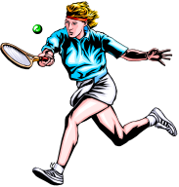
Friction ___ the name given to a force _______ opposes the movement of two objects which are in contact with ____ another. Friction forces ____ present whenever two objects are moving ___ attempt to move.

What Can Friction Do?
Friction forces ___ be both helpful and a nuisance to us.

When ___ play tennis we rely on friction ___ stop us from slipping as we run across ____ court. However, after doing this ____ some time you will notice that the tread on ______ shoes will have started to wear away.

one, is, can, your, are, the, we, or, for, which, to,

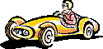
Grand prix racing cars are fitted _____ special tyres. These tyres prevent the cars _____ slipping off the road when _____ are turning the corners ___ high speed. The friction force between the tyres and _____ road not only prevents slipping but _____ causes the tyres to be worn down. As the tyres wear, they are less able to prevent the car from sliding sideways on the __________.
also, the, corners, with, from, at, they

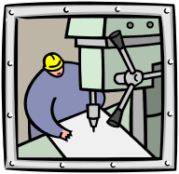
When ___ rub our hands together, ____ become hot. This heat ___ produced because friction exists between the two surfaces of ____ hands. The energy used ___ push against friction changes _____ heat. This _____ explains why bicycle tyres feel warm after we have been ____ a ride. Friction is also ____ reason why the bit in ___ electric drill feels hot after drilling a hole into __ piece of wood.
into, we, an, our, they, also, the, to, a, for, is,

Spacecraft enter ____ Earth’s atmosphere ___ fast that the friction between ____ and the air causes them to glow red-hot.
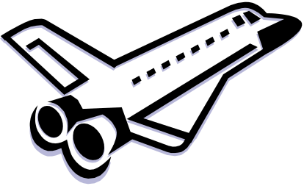
As well ___ preventing one object _____ sliding easily over another object, friction _____ cause wear ____ heat.
the, from, can, them, as, and, so,

