How to use a Microscope

As you already know, Micro-Organisms are very small, too small to be seen with the naked eye. In order to be able to see and study Micro-Organisms, Micro-Biologists use a tool called a Microscope that allows us to see very small things.

Before you attempt to use the Microscopes, look at the diagram below and make sure you can locate all the parts on your own Microscope.
Eyepiece
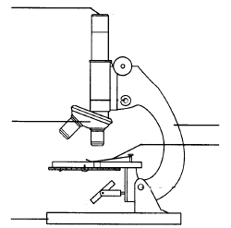
Objective lens
Mirror
Base
Stage clip
Body
Focussing Knob

Now follow the instructions below Carefully.

- Make sure you have selected the low power objective lens (it’s the smallest) .
- Look down the eyepiece and adjust the mirror until it is as light as you can get it.
- Move the focussing knob until the objective lens is as far down as it will go.
- Put your slide on the stage and secure it with the stage clips.
- Using the focussing knob, move the objective lens slowly up. Until you can see something. (You will need to keep looking down the eyepiece as you do this).
- When you think you can see something, check with the teacher before drawing what you see.
- When you have finished, remember to remove the slide from the microscope before packing it away.

