MEASURING
Scientists try to use units of measure that they can all agree on and understand all over the world. These units are called SI units. SI stands for System International. Using SI units makes it easier for scientists to exchange and understand data.
Some SI units are listed in the table below.
Quantity | SI  Unit | Definition | Equipment used to measure the quantity
Mass | Kg and g | How much matter an object contains. | Scales and balances
Volume | L and mL | How much space something takes up. | Measuring cylinder
Temperature | ⁰C | How hot something is | Thermometer
Length | cm and m | How long something is | Ruler or measuring tape.

Mass
Mass is measured in ______ and _____ using ___________ and ___________.

We often use electronic balances because they are easy and usualy accurate.
We can also TARE(or Zero) with an electronic set of scales.
Tare allows us to remove the mass of the container. We can then see just the mass of the container’s contents.
Gross is the mass of container loaded with contents.
If we subtract the Tare from the Gross to get the Net, Net being the mass of just the contents.

To do this place the container on the scales and press TARE. This will remove mass of the container and send the scales back to zero. If you now put the something in the container and put it on the scales, the scales will only show the mass of the contents.
Volume
Volume is measure in ___________ and ___________ using a ___________ _______________.
If you look at the top of a column of water you will notice that it curves down in the centre. This downwards curve at the top of a column of liquid is called a meniscus.
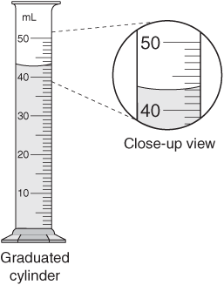
To measure the volume of water. Measure from the bottom of the meniscus.
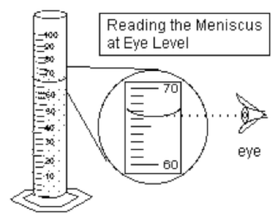
It is important to crouch down and read the measrument at eye level. If not you may get different measurements. These errors caused by reading a measurement at an incorrect angle are called Parallax error.
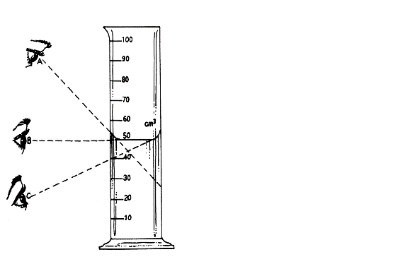

Write the volume in mL for the cylinders in these diagrams.
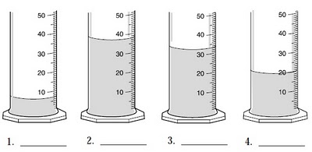

Length
Is how long something is. We can measure it using a ruler or a measuring tape.
We can also get Parallax error when using a ruler.
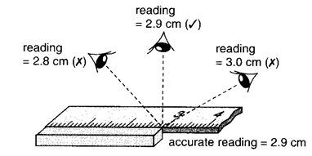
It is important to get the eye in line with the point being measured.
How long is this screw?
- 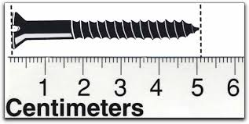
Practical
What is the Mass of 10ml of water?
Aim: to find the mass of 10ml of water.
Equipment: 10 ml measuring cylinder, electronic pan balance and water.
Procedure:
Place a 10ml measuring cylinder on the electronic pan balance.
Tare (zero) the balance with the cylinder on the pan balance.
Remove the measuring cylinder and add 10mls of water as accuratiely as you can.
Place the cylinder back on the pan balance.
Results.
10ml of water has a mass of ___________ g.

Word | Meaning
Parallax error

Mass

Volume

Length

