Lab Safety 1

You will usually find a set of ‘Lab Rules’ in a science lab. They are there for your safety!

The drawing below shows a lab where there are no safety rules.

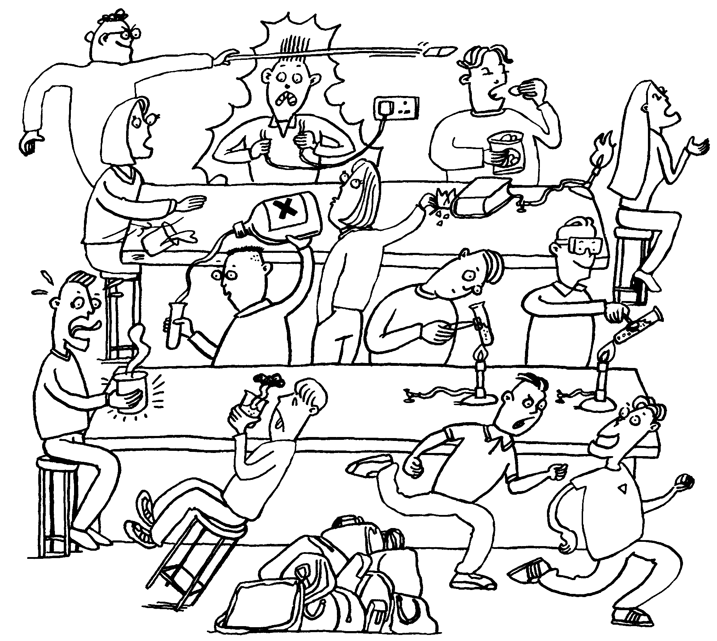

1 Write down a list of all the things going wrong in this lab.
2 For each of your answers, write a safety rule.
3 Design a poster for your lab, showing one safety rule and the reason for having it.

[ Developing skills in: planning ]

