Habitats
A habitat is the place where an organism ______________.
This habitat must have certain resources for the organism to survive.
These include:
-
-
-
-
-
-
These things can divided into two types:
Types of factors
Biotic | Abiotic
These are the living things | These are the non-living things
Examples | Examples

Look at the frog in this picture. List the biotic and abiotic factors into the table below the picture

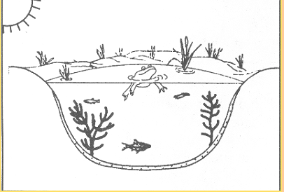

Types of factors
Biotic | Abiotic

