
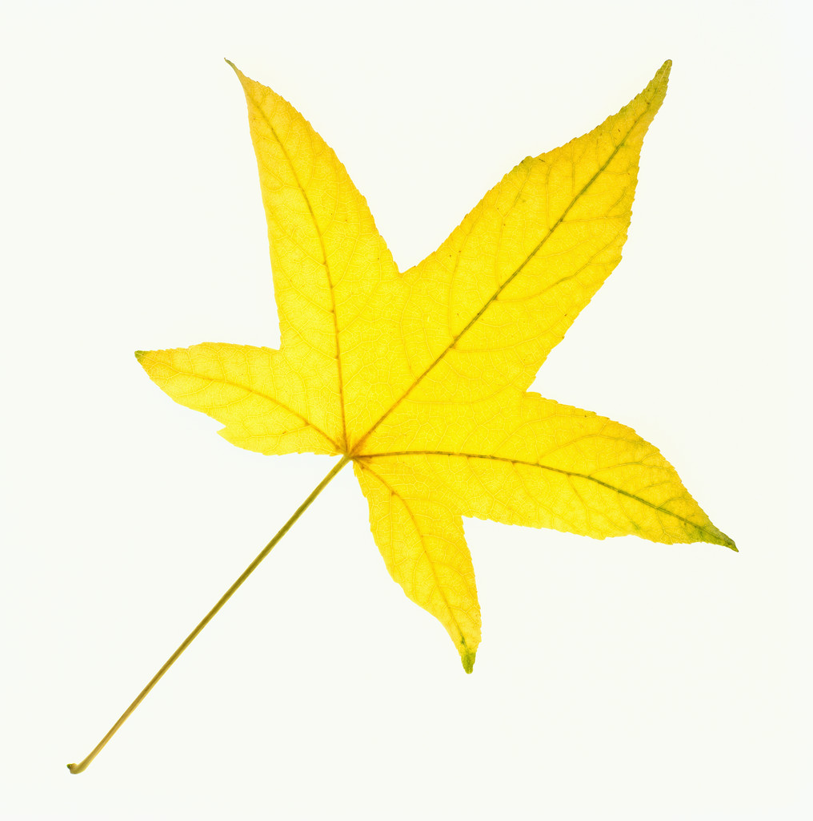

Photosynthesis

Words to choose from: oxygen, carbon dioxide, photosynthesis, water, food, chlorophyll, glucose

Leaves help to make ___________ for a plant.
Leaves contain a green substance called ___________.
The leaves take in a gas called ________ _________.
The roots take in _______ and other substances from the ground.
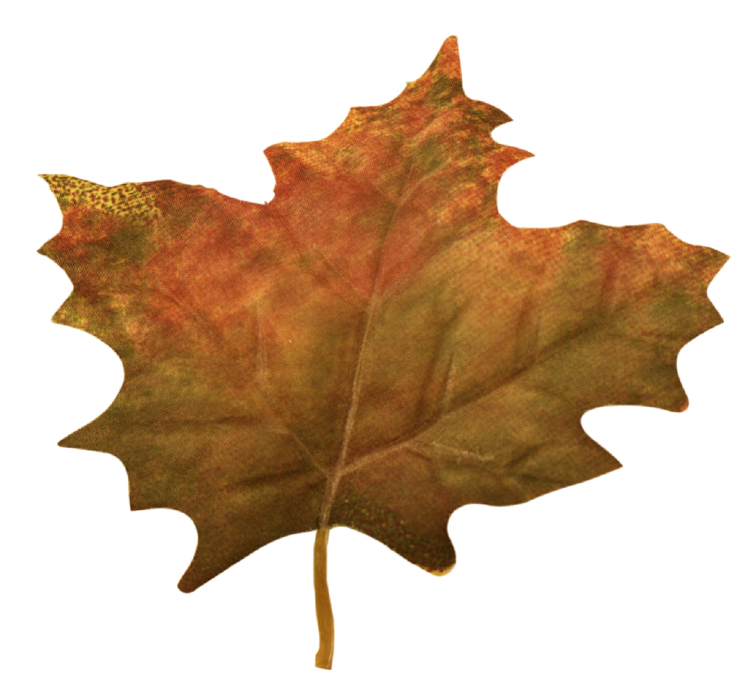
The ____________ changes the water and carbon dioxide into the food that the plant needs.
This food is a kind of sugar called ________.
This whole process of making food is called _________________.
While this is happening, the leaves give off a gas called ________.



Complete the word equation for photosynthesis

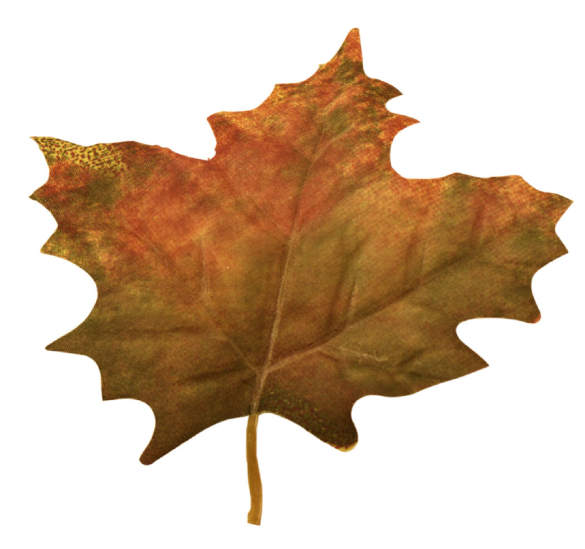
sunlight

     

