Solutions
Olive oil will not dissolve in water so we call it ___________ in water.
Coffee grains will dissolve in water so we call them __________ in water.
The coffee will be the ____________ and the water will be the ___________. The coffee drink produced is an example of a ____________.
The air around you is a solution of gasses. The main gas is Nitrogen (80%) it is the solvent. Other gasses like Oxygen are dissolved into the Nitrogen, so they are ______________.
Dust will not dissolve in the air so it forms a __________.
Carbon dioxide gas is also dissolved in the Air so it is a _________________.

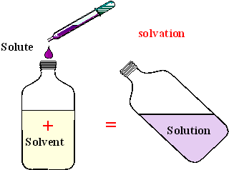
In the picture above food colouring is added to water. The water is the ____________ and the food colouring is the ___________.
Use your text to find definitions for the two words below.
Word | Meaning
Colloid
Emulsion

T | N | Q | C | Y | L | I | R | V | N | C | M | V | D | E
Z | N | L | P | N | W | T | N | O | B | A | G | L | L | Y
X | Q | E | W | N | J | H | I | S | T | E | W | B | P | W
Q | F | Q | V | V | V | S | N | E | O | B | U | R | K | W
H | H | R | V | L | N | F | R | C | O | L | L | O | I | D
P | S | A | H | E | O | I | O | L | O | Y | U | N | F | S
S | O | K | P | C | A | S | V | S | I | X | V | B | G | L
W | L | S | E | L | N | O | I | S | L | U | M | E | L | J
L | U | R | R | S | O | L | U | B | I | L | I | T | Y | E
S | T | C | U | Z | O | Y | J | N | J | X | G | U | G | Q
N | I | Z | T | W | K | L | I | P | G | S | D | Y | C | T
S | O | O | X | K | T | F | U | Y | D | E | H | R | D | T
Z | N | P | I | L | U | J | K | T | P | X | O | I | L | X
H | E | A | M | X | G | R | V | T | E | Z | W | H | Q | B
Y | I | X | H | H | M | K | J | Q | Y | R | R | R | F | R

COLLOID | EMULSION | INSOLUBLE
MATERIAL | MIXTURE | SOLUBILITY
SOLUBLE | SOLUTE | SOLUTION
SOLVENT | SUSPENSION

