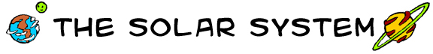
Year 7 Earth in Space Homework
NAME: Form: Due on:
Neptune  solar  asteroids  orbit  dinosaurs  Mercury |  | gas giants  Mars  Jupiter  water  Earth | Pluto  nine  temperature  Saturn  Venus | planetoids  comets  terrestrial  Uranus  tail
The Solar System
The _______________ system is the group of planets that _____________ our Sun. There are _________________ known planets in our solar system, but some observers think they have spotted others beyond the orbit of _______________.

The Terrestrial Planets
Mercury, Venus, Earth, and Mars are called _________________ planets because they have rocky surfaces. _______________, of course, is the planet we live on. _______________ is the closest planet to the sun. ________________, which is also called the evening star, has a ______________ of 500 degrees Celsius and clouds of sulfuric acid. _________________ is known as the red planet. Recently, frozen ______________ was discovered there.

The Gaseous Planets
Jupiter, Saturn, Uranus, and Neptune are called __________________ because they are big and made mostly of gas. _______________ is the largest planet in the solar system. _________________ is famous for its rings.
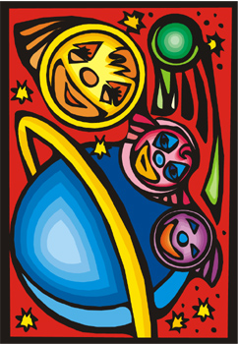 | _______________ also has rings but is not as famous as Saturn. _____________ is named after the god of the sea.  Planetoids: Asteroids and Comets  There are many other ______________ in the solar system. Between Mars and Jupiter there is a belt of small rocky objects called _______________. As well, balls of ice and rock called _______________ occasionally come close to the sun creating a bright ________________ that can be seen from Earth. Some scientists think the _____________ became extinct when one of these comets came crashing into the Earth.

