Acceleration
Acceleration=the rate that an objects velocity changes.
Velocity=
We can graph this.
Time (seconds) | Velocity(km/h)
 | Car 1 | Car 2
0 | 0 | 0
1 | 10 | 15
2 | 20 | 30
3 | 30 | 45
4 | 40 | 60
5 | 50 | 75
Which car was accelerating the fastest?
What do you notice about the slope (gradient) of the line of the fastest accelerating car?

Look at this graph.
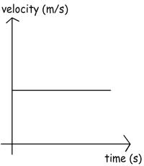
Does this show acceleration?
What do you think is happening in the graph below?


