Chapter 8: Forces, energy and motion
Answers

Think about forces, energy and motion
Could a kangaroo win the Melbourne cup? | It is unlikely. The average speed of a Melbourne Cup winner is about 16 m/s. The average speed of a kangaroo in flight is about 14 m/s.
How do radar guns measure the speed of cars? | They send out radio waves, which are reflected from the vehicle. The frequency of the returning radio waves changes as a result of the movement of the vehicle. The faster the vehicle, the greater the change in frequency.
Why do feel pushed to the left when the bus you are in turns right? | You are not really pushed. The force that makes the bus turn right does not act on you. You continue moving at the original speed and in the same direction until something, such as the inside wall of the bus or another passenger, stops you.
Why does the space shuttle seem to take forever to get off the ground? | Due to its very large mass during the launch, the shuttle speeds up (accelerates) very slowly at first. As its fuel is burned, its mass decreases and it begins to speed up more quickly.
Why does it hurt when you catch a fast-moving ball with your bare hands? | When you apply a force to stop the ball, the ball applies an equal and opposite force to your hand. Ouch!
What does doing work really mean? | It means applying a force to an object so that the object moves in the direction of the force.
Why can't a tennis ball bounce higher than the height from which it is dropped? | If a ball were to bounce higher than its drop height, this would mean that it has gained more energy than it was originally given — a violation of the Law of Conservation of Energy.
Why are cars deliberately designed to crumple in a road crash? | Crumple zones absorb and spread much of the energy transferred to the vehicle during a collision. As a result, less energy is transferred to the occupants, reducing the chance of injuries. This design feature also allows the vehicle to stop more gradually.

Your quest
1.
Person | Forces acting on person
Parachutist (3) | Weight (or gravity), tension (in ropes), air resistance
Bungee jumper (3) | Weight (or gravity), tension (in ropes), air resistance
Skier (2) | Weight (or gravity), air resistance
Cyclist (5) | Weight (or gravity), upward push of road, friction, thrust (forward push of road on wheels), air resistance
Reader (2) | Weight (or gravity), upward push of ground on chair
In-line skater (5) | Weight (or gravity), upward push of road, friction, thrust (forward push of road on wheels)
Swimmer (4) | Weight (or gravity), buoyancy (upward push of water), resistance of water, thrust (forward push of water on arms, hands, legs and feet)
2. Weight (gravity)
3. (a) Bungee jumper, skier, in-line skater. They have a non-zero net force acting on them.
(b) Parachutist, cyclist, swimmer. They are in motion but the total force on each of them is most likely to be zero. These answers assume that the in-line skater’s right foot is still in contact with the ground.
4. (a) Water
(b) Road
(c) Footpath
5. The parachutist, bungee jumper and skier.
6. The bungee jumper: transformed into kinetic energy.
The skier: transformed into kinetic energy. Some is transferred to the snow as kinetic energy.
The parachutist: most is being transferred to the air as kinetic energy.

8.1 Ready, set, go
1. 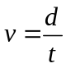, where v = average speed, d = distance travelled and t = time taken.
2. Average speed is a measure of how quickly distance is covered, whereas average velocity is a measure of how quickly position changes. They are different because you can travel a distance without changing your position. For example, while running one complete lap around a running track in 60 seconds, you travel a distance of 400 metres but your position has not changed. Your average speed is 400 m/60 s (6.7 m/s) but your average velocity is zero. A non-zero velocity must include direction, just as a change in position.
3. (a) 16 m/s
(b) 14 m/s
(c) 40 km/h
(d) 32 km/h
(e) 6 km/h
(f) 50 cm/s
4. A kangaroo is unlikely to win a Melbourne Cup and the dolphin would comfortably beat the turtle and leave the Olympic swimmer far behind.
5. (a) 180 hours (7.5 days)
(b) 18 days
(c) 167 hours
6. (a) 24 cm
(b) 1440 cm (14.4 m)
7. (a) 1.47 m/s
(b) 1.43 m/s due north
(c) Zero
8. (a) 1.72 m/s
(b) 6.25 km/h.
9. Responses will vary.

8.2 Measuring speed
1. Instantaneous speed is the actual speed at a particular instant of time. Average speed is the speed obtained by dividing the distance travelled by a time taken. For example, an athlete taking 10 seconds to run 100 metres has an average speed of 10 m/s. However, the athlete’s instantaneous speed is zero at the beginning of the race and is greater than 10 m/s in the middle of the race.
2. (a) Laser guns, digitectors (formerly known as amphometers)
(b) Radar guns and mobile radar units
3. Responses may include: incorrect calibration of the speedometer; non-standard tyres with a larger or smaller diameter than those which are typical for the car make and model; over-inflated or under-inflated tyres (which will cause the diameter to be slightly larger or smaller than normal).
4. Responses may include: they can be used in heavy traffic; they are easier to set up to work automatically; the equipment is robust and less expensive than radar or laser guns; angle of car approach is not critical to getting a reading.
5. Second interval: 4.2 cm/0.1 s = 42 cm/s; third interval: 5.6 cm/0.1 s = 56 cm/s
6. Responses will vary.

8.3 Speeding up
1. This is because pushing the pedal down usually makes the car accelerate.
2. Deceleration is the name given to a negative acceleration. For example, an acceleration of −5 km/h/s could be described as a deceleration of 5 km/h/s.
3. (a) (i) 5 m/s
(ii) 10 m/s
(iii) 21 m/s
(b) 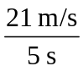 = 4.2 m/s²
4. (a) A typical graph is shown below.
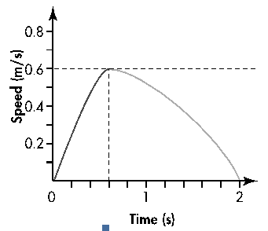
(Note: Responses (b)–(e) are based on the example graph shown in (a). Individual student responses may vary.)
(b) Maximum speed = 0.6 m/s
(c) Time at which maximum speed reached = 0.6 s
(d) The graph would have a steeper incline.
(e) Average acceleration = 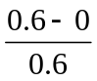 = 1 m/s
(f) Variable answers

8.4 Let’s go for a ride
1. The upwards push of the road prevents a bus from falling through the surface of a road.
2. (a) (i) You’d be thrown quickly backwards in your seat.
(ii) There would be no tendency to move in any particular direction.
(iii) You’d feel as if you were being pushed hard to the
forward-left.
(iv) You’d feel very little change in your motion.
(v) You would be thrown forwards from your seat at a high speed.
(vi) You would be thrown backwards; how hard would depend on the size of the other vehicle and the speed with which it ran into the bus.
(b) In (ii) and (iv).
(c) Properly fitting seatbelts keep the passenger in contact with the seat so that they are affected as a single system. This way, if the vehicle decelerates rapidly, car, seat and passenger should all decelerate at roughly the same rate, reducing the risk of passenger injury due to inertia carrying them forward into the seatbelt or dashboard.
(d) It would prevent the passenger’s head travelling backwards as the bus accelerates forward as a result of the rear impact.
3. Air resistance and friction
4. An object will remain at rest, or will not change its speed or direction, unless it is acted upon by an outside, unbalanced force.
5. Inertia is the property of an object to resist changes to their motion.
6. (a) Thrust
(b) Resistance forces
(c) They are equal.
7. When you step off you will have the same speed as the vehicle from which you have stepped. Your body will, therefore, continue to move with that speed until acted upon by a force. Newton’s First Law of Motion describes this behaviour. When stepping off a moving vehicle, you are likely to be pulled down to the ground before you can stop yourself with your feet.
8. (a) The two forces are friction and air resistance.
(b) The sizes of forces A and C are equal in size.
(c) Either a decrease in A or an increase in C would slow the car down.
9. (a) Turbulence caused sudden changes in the motion of the aircraft and the unrestrained passengers and crew continued to move with their original motion. They were injured as a result of impact with other people, the interior fittings or floor of the aircraft.
(b) The aircraft. During turbulence, there are rapid changes to the degree of lift acting on the aircraft wings, causing it to drop, tilt, yaw and rise in response.
(c) The seatbelts prevent the passengers from moving relative to the inside of the aircraft.
10. On Mars, a 60 kg student would have a weight of 60 kg × 3.7 N/kg = 222 N.

8.5 Newton’s Second Law of Motion
1. F = ma, where F = the total force on the object, m = the mass of the object and a = acceleration.
2. According to Newton’s Second Law of Motion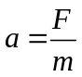. Even though there is a very large force pushing the space shuttle up, its mass is very large, and so its acceleration is small. As the mass of the space shuttle decreases due to the rapid burning of fuel, the force remains large, and so the acceleration increases.
3. A total force of 0.45 N
4. 4. 1.2 m/s²
5. (a) Cart B contains the brick. Because , the cart with the greater mass will have the least acceleration for a given force.
(b) For Cart A, m = 1.0 kg, a = 2.0 m/s²
Therefore, F = ma
= 1.0 kg × 2.0 m/s²
= 2.0 N
The total force on each cart is 2.0 N.
(c) For Cart B, F = 2.0 N, a = 0.5 m/s²
Therefore, 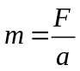
= 2.0 N / 0.5 m/s²
= 4.0 kg
The total mass of Cart B is 4.0 kg.
The mass of Cart B is 1.0 kg.
The mass of the brick is 3.0 kg.

8.6 What’s your reaction?
1. When an object applies a force to a second object, the second object applies an equal and opposite force to the first object.
2.
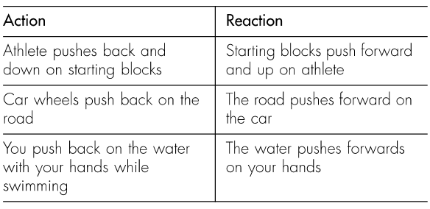
3. The surface that you are walking on provides the forward push.
4. They both push gases backwards. As they push back on the gases, the gases push forwards with an equal and opposite force. Jet engines and rockets differ in the way that the gases are pushed backwards. Jet engines use oxygen in the air through which they fly to rapidly burn their fuel to produce gases. Rockets, on the other hand, have no air intake — they carry their own supply of oxygen to make their fuel burn rapidly.
5. The ‘reaction’ is the push of the sails on the air.
6. The ‘reaction’ force is provided by the water that pushes forward on the blades of the paddle wheel. The ‘action’ force is the backwards push of the blades on the water.
7. to 9. Responses may vary.

8.7 Getting down to work
1. You are only doing work if an object to which you are applying a force moves in the direction of the force.
2. Two examples are: the Earth doing work on a falling object; a charged plastic pen lifting a small piece of paper from a table.
3. The work done on an object can be calculated by multiplying the force applied by the distance travelled in the direction of the force.
4. A magnetic force
5. (a) 1500 J
(b) None
6. (a) 5400 J
(b) Almost all of it. Some of the gravitational potential energy would be transferred to the air that the diver pushes forward and aside as kinetic energy and thermal energy.
7. (a) Answers will vary. Examples include trampoline and pogo stick.
(b) Answers will vary. Answers include wind-up toys, pop-up cars and water guns.
8. to 10. Responses will vary.

8.8 Systems: Energy ups and downs
1. (a) The ‘missing’ energy goes into heating your body and the slide itself.
(b) The energy transferred to your body and the slide can be reduced by decreasing the size of the friction force that the slide applies to your body and the air resistance. This can be achieved by keeping your hands and feet away from the surface of the slide and sitting or laying flat without moving your body as you slide down. The best way is to sit on a low friction mat that does not stick to the slide surface.
2. The girl is doing a small amount of work with her legs by pushing off against the trampoline at the bottom of the jump. This makes up for the energy ‘lost’ in the form of heat and air resistance. If the system were 100% efficient, the girl would not need to use her legs at all, and she would continue to bounce without effort.
3. (a) To the ball, the concrete surface and the air
(b) Elastic potential energy, heat, sound.
4. h₁ = 1.40 m; h₂ =35 cm = 0.35 m
Efficiency = 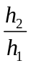× 100 %
= 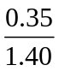× 100%
= 25%
5. (a) Weight = mg
= 50 kg × 9.8 m/s²
= 49 N
(b) Work = mgh
= 50 kg × 9.8 m/s² × 1.0 m
= 49 Joules
(c) All of it
(d) 49 Joules
6. Responses will vary.
7. Responses will vary.

8.9 Making cars safe
1. They are seat belts, collapsible steering wheels, padded dashboards, head restraints, air bags and crumple zones.
2. Engineers model collisions using computers and then perform real crash tests with dummies.
3. The occupants keep moving at the speed the vehicle had before the collision until acted upon by a force.
4. (a) Seat belts provide an immediate force on the occupants so that they don’t continue moving forwards.
(b) Airbags slow the upper body down as it continues moving towards the steering wheel, dashboard or windscreen.
(c) Head restraints push the head forwards with the rest of the body, in a rear-end collision. Without them, the head would be left behind, causing neck strain and spinal injuries.
5. Crumple zones are regions of the car at the front and rear that are designed to crumple during a collision, absorbing and spreading energy transferred to the vehicle. It allows the vehicle to stop more gradually, reducing the risk of death or serious injury to occupants.
6. The strong and rigid zone between the crumple zones protects objects from outside the zone from entering it and causing injuries during a collision.

8.10 Cycle maps and story boards
1. (a) The missing energy changes are as follow (clockwise from the top).
- Between stages 2 and 3: losing gravitational potential energy, gaining kinetic energy
- Between stages 4 and 5: gaining gravitational potential energy, gaining kinetic energy
- Between stages 6 and 1: gaining gravitational potential energy, losing kinetic energy.
(b) (i) Stage 4 (or between stages 3, 4 and 5)
(ii) Stages 1, 2 and 6
(iii) Stages 3 (or between stages 3 and 4) and 6.
(iv) Stages 1 and 4
(c) (i) Between stages 3, 4 and 5
(ii) Stages 1, 2 and 6 (also between stages 2 and 3 and between stages 5 and 6.)
(d) All stages
(e) Energy is being transferred to the mat of the trampoline as elastic potential energy.
2. Throughout the cycle, energy is transferred from the ball to the air and the ground, until it has no kinetic or gravitational energy. When that happens, it stops bouncing.
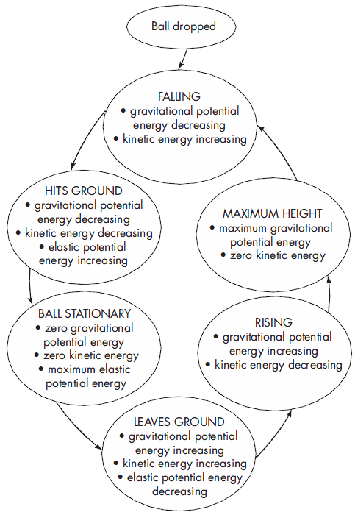
3. Answers will vary.

Looking back
1. (a) Distance travelled
(b) Change in position
(c) Change in speed
(d) Change in velocity
2.
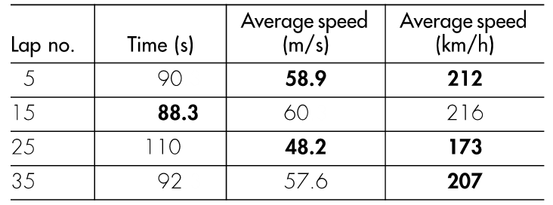
(b) Possible reasons are: mechanical problems, a fuel stop, a tyre change (two required). Other answers possible.
3. (a) An object remains at rest, or will not change its speed or direction unless it is acted upon by an outside, unbalanced force.
(b) When an unbalanced force acts on an object, the mass of an object affects the amount of inertia it has or the way it moves.
(c) For every action, there is an equal and opposite reaction.
4. There are always at least two forces acting on a car on a straight road, even if it is not in motion. The force of gravity and the upwards push of the road always act on the car. If the car is moving, resistance forces will also be acting. If the car is moving and the wheels are being turned by the engine, the road will be pushing on the car. If the car is travelling in a straight line at constant speed, the sum of all of the forces acting on it is zero.
5. (a) (i) A
(ii) B, D
(b) (i) C
(ii) A
(c) C
(d) A
(e) 0.1 s
(f) 32 cm/s
6. Because objects do not change their speed and direction unless acted upon by a force, if the car stops or turns suddenly, the loose objects will continue to move in the original direction with the original speed. They will continue to move until they are stopped by an object — possibly the driver’s or passenger’s head.
7. F = total force, m = mass, a = acceleration
8. The student writing the answer to this question. The body-builder is doing no work because the barbell is not moving. The student is doing work by pushing on an object (a pencil, pen or key), which is moving in the direction of the push.
9. (a) Gravitational potential energy is being converted into kinetic energy.
(b) Kinetic energy is converted into gravitational potential energy, which is converted into the elastic potential energy of the ball.
(c) The elastic potential energy of the ball is transferred to the ball as kinetic energy.
10. (a) Gravity, air resistance
(b) Gravity, upwards push of the ground
11. Answers will vary, but should indicate that newer cars are deliberately designed to crumple during a collision, absorbing and spreading energy transferred to the vehicle. This allows the vehicle to stop more gradually, reducing the risk of death or serious injury to occupants.
12. (a) F = m a
= 1 400 kg × 3 m/s²
= 4200 N
(b)
= 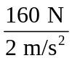
= 80 kg
(c)
= 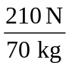
= 3 m/s²
13.
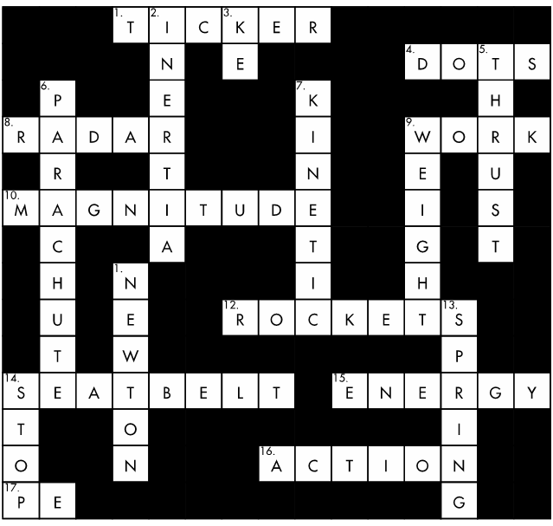
14. Answers will vary, but should indicate that newer cars are deliberately designed to crumple during a collision, absorbing and spreading energy transferred to the vehicle. This allows the vehicle to stop more gradually, reducing the risk of death or serious injury to occupants.
15 (a) F
(b) T
(c) T
(d) F
(e) F
16. W = F × d
17. W = 49 J

