ENERGY: WHAT DO YOU REMEMBER?

WORD | USE AN ARROW TO JOIN THE CORRECT WORD TO THE CORRECT MEANING | MEANING
SCIENCE |  | THE ability to do work
Physics |  | Anything has mass and takes up space.
CHEMISTRY |  | How much matter an object has. Measured in grams and kilograms
BIOLOGY |  | The study of living things
MASS |  | The study of energy
MATTER |  | The study of matter
ENERGY |  | The study of everything in the universe in attempt to find information, explanations and predictions about the universe

- In this term we will be studying Physics. The study of E____________.
- Energy is the ability to do ___________.
- Onto this sheet write down as many types of energy as you can think of. E.g. heat.

- What kinds of energy can you see below? Write it besides the picture. Use the words: wind, light, sound, solar, heat, wave and electric. You can use some twice(or 3 times).
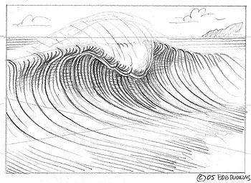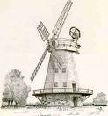
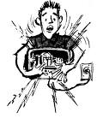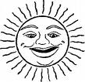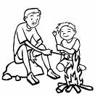

Energy can be divided into two groups:
Kinetic energy and potential energy.

Potential energy is stored energy.
The person on this diving board has stored up energy(potential). As they climbed up above the pool they stored up energy.


Kinetic energy is energy of movement.
The person falling from the diving board is moving so has kinetic energy
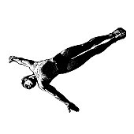
- Classify the following as potential or kinetic energy.
Situation | Kinetic or potential
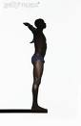a diver before they jump. Stored energy
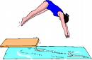a diver jumping and moving downwards to the pool.
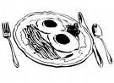Food has energy stored in the chemicals that makes up the food.
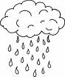falling rain
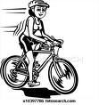moving bike
The suns light hitting your skin. The light energy is moving from the sun to you
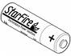energy stored in a battery

