Name:_____________________________
Newton & His Laws
Force= a push or a pull on an object. It is measured in newtons (N).

Newtons first law of Motion=
A tendency of an object to ________ a change in its motion. Also called i___________.
-an object that is moving will continue to move at the same ________ and in the same __________ unless an _______ force acts upon it.

Newtons second law of motion=

Acceleration is produced when a force acts on a mass. The greater the m________ (of the object being accelerated) the greater the amount of f_________ needed (to accelerate the object).

F = _______________ and is measured in ______________
M= _______________ and is measured in ______________
A= _______________ and is measured in ______________

Example
What force is needed to make a 7kg rock accelerates at 2.5 m/s?
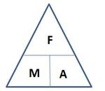
F:_________
M: ________ F = m x a
A: _________ F =
= N

A 10 kg ball is thrown with a force of 20 N. What will its acceleration be?
F:_________
M: ________ A=f/m
A: _________ /
= m/s²
Questions
- A force of 100N is applied to a ball of mass 2kg. What will the acceleration be?

- A 21kg steel ball is accelerating at 3m/s². What force was needed to bring this about?

- What force will be needed to make a 2kg rock accelerate at 10m/s²?

- A force of 10N is applied to a toy car of mass 1kg. What will the acceleration be?

- A 200kg car has a force of 4000N applied to it. What will the acceleration be?

- A car accelerates at 5m/s. It required a force of 5000N to do accelerate at this rate. What is its mass?

Newtons third Law of Motion=

For every __________ there is an ______ and______________ reaction.

Give an example where you have experienced this:

Explain what is going on in the diagrams below:

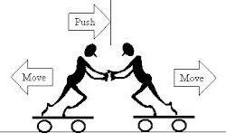
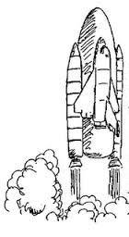

Bob hits a live bullet with a hammer. The bullet explodes. The lead projectile (part 1) flies forward and the brass casing of the bullet (parts 2 and 4) fly backwards and hits Bob in the hand.
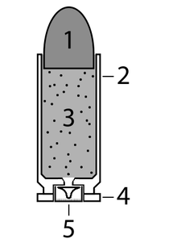
Explain what has happened here according to newtons 3 law of motion.

