Data Intensive Computing for Bioinformatics

Judy Qiu1, Jaliya Ekanayake 1,2, Thilina Gunarathne1,2, Jong Youl Choi1,2, Seung-Hee Bae1,2, Yang Ruan1,2, Saliya Ekanayake1,2, Scott Beason1, Geoffrey Fox1,2, Mina Rho2, Haixu Tang2

1Pervasive Technology Institute, 2School of Informatics and Computing,

Indiana University

Bloomington IN, U.S.A.

{xqiu, jekanaya, tgunarat, jychoi, sebae, yangruan, sekanaya, smbeason, gcf,mrho, hatang@indiana.edu}

[1 Introduction 2](#_Toc249112669)

[1.1 Overview 2](#_Toc249112670)

[1.2 Architecture for Data Intensive Biology Sequence Studies 3](#_Toc249112671)

[2 Innovations in algorithms for data intensive computing 4](#_Toc249112672)

[2.1 Visualization analysis by using parallel MDS and GTM 4](#_Toc249112673)

[2.1.1 Parallel MDS and GTM 5](#_Toc249112674)

[2.1.2 Experimental Results 6](#_Toc249112675)

[2.2 Metagenomics Studies with Clustering 8](#_Toc249112676)

[2.3 Metagenomics Studies with Hierarchical MDS 11](#_Toc249112677)

[3 Innovations in programming models using cloud technologies 13](#_Toc249112678)

[3.1 Runtimes and Programming Models 13](#_Toc249112679)

[3.1.1 Parallel frameworks 13](#_Toc249112680)

[3.1.2 Science in clouds ─ dynamic virtual clusters 15](#_Toc249112681)

[3.2 Pairwise sequence alignment using Smith-Waterman-Gotoh 16](#_Toc249112682)

[3.2.1 Introduction to Smith-Waterman-Gotoh (SWG) 16](#_Toc249112683)

[3.2.2 Implementations 17](#_Toc249112684)

[3.2.3 Performance comparison 19](#_Toc249112685)

[3.3 Sequence assembly using Cap3 21](#_Toc249112686)

[3.3.1 Introduction to Cap3 21](#_Toc249112687)

[3.3.2 Implementations 22](#_Toc249112688)

[3.3.3 Performance 22](#_Toc249112689)

[4 Iterative MapReduce with Twister 23](#_Toc249112690)

[4.1 MapReduce Extensions 24](#_Toc249112691)

[4.2 Performance of Twister for Iterative Computations 26](#_Toc249112692)

[4.3 Related Work 28](#_Toc249112693)

[4.4 Future Work on Twister 28](#_Toc249112694)

[Acknowledgements 29](#_Toc249112695)

[Appendix A Different Clusters used in this Analysis 29](#_Toc249112696)

# Introduction

## Overview

Data intensive computing, cloud computing and multicore computing are converging as frontiers to address massive data problems with hybrid programming models and/or runtimes including MapReduce, MPI and parallel threading on multicore platforms. A major challenge is to utilize these technologies and large scale computing resources effectively to advance fundamental science discoveries such as those in life sciences. The recently developed next-generation sequencers have enabled large-scale genome sequencing in areas such as environmental sample sequencing leading to metagenomic studies of collections of genes. Metagenomic research is just one of the areas that present a significant computational challenge because of the amount and complexity of data to be processed.

This chapter builds on research we have performed (Ekanayake, et al., 2009) (Ekanayake, Pallickara, & Fox, 2008) (Ekanayake, Qiu, Gunarathne, Beason, & Fox, 2010) (Fox, et al., 2009) (Fox, Bae, Ekanayake, Qiu, & Yuan, 2008) (Qiu, et al., 2009) (Qiu & Fox, Data Mining on Multicore Clusters, 2008) (Qiu X. , Fox, Yuan, Bae, Chrysanthakopoulos, & Nielsen, 2008) (Twister, 2009) on the use of Dryad (Microsoft’s MapReduce) (Isard, Budiu, Yu, Birrell, & Fetterly, 2007) and Hadoop (open source) (Apache Hadoop, 2009) for several applications areas including particle physics and several biology problems. The latter often have the striking all pairs (or doubly data parallel) structure highlighted by Thain (Moretti, Bui, Hollingsworth, Rich, Flynn, & Thain, 2009). We chose to focus on the MapReduce frameworks as these stem from the commercial information retrieval field which is perhaps currently the world’s most demanding data analysis problem. Exploiting commercial approaches offers a good chance that one can achieve high-quality, robust environments and MapReduce has a mixture of commercial and open source implementations. In particular, we have looked at MapReduce and MPI and shown how to analyze metagenomics samples with modest numbers of genes on a modern 768 core 32 node cluster. We have learnt that current MapReduce cannot efficiently perform perform clustering and MDS (Multidimensional Scaling) steps even though the corresponding MPI implementation only needs reduction and broadcast operations and so fit architecturally functions supported in MapReduce. In addition, we need to support iterative operations and propose Twister to support this. An early prototype described in section 4 has been run on kernels but as yet not on complete bioinformatics applications. Research issues include fault tolerance, performance and support of existing MPI programs with the Twister run time invoked by the subset of MPI calls supported by Twister.

We have robust parallel Dimension Reduction and Deterministic Annealing clustering and a matching visualization package. We have parallel implementations of two major dimension reduction approaches – the SMACOF approach to MDS and Generative Topographic Mapping (GTM) described in section 2. MDS is O(N2) and GTM O(N) but only MDS can be applied to most sequences samples as GTM requires that the points have (high dimensional) vectors associated with them. As simultaneous multiple sequence alignment MSA is impractical for interesting datasets, MDS is best approach to dimension reduction for sequence samples as it only requires sequences to be independently aligned in pairs to calculate a dissimilarity. On the other hand GTM is attractive for analyzing high dimension data base records where well defined vectors are associated with each point – here each database record.

Hierarchical operations are not supported for MDS and clustering except in a clumsy manual fashion. Distance calculations (Smith-Waterman-Gotoh) MDS and clustering are all O(N2) and will not properly scale to multi-million sequence problems. In the final part of section 2, we propose a new multiscale (hierarchical) approach to MDS that could reduce complexity from O(N2) to O(NlogN) using ideas related to approaches already well understood for O(N2) particle dynamics problems.

Section 3 describes our work on MapReduce where we take “all-pairs” or “doubly data parallel” computations in two bioinformatics applications and compare two implementations of MapReduce (Dryad and Hadoop) with MPI. We describe interesting technology developed to support rapid changes of operating environment of our clusters and also look at overhead of virtual machines for Hadoop. We focus on effect of inhomogeneous data and set the scene for discussion of Twister in section 4. One of the biology applications – sequence assembly by Cap3 – is purely “Map” and has no reduction operation. The other – calculation of Smith-Waterman dissimilarities for metagenomics – has a significant reduction phase to concentrate data for later MDS and Clustering.

## Architecture for Data Intensive Biology Sequence Studies

The data deluge continues throughout science and all areas need analysis pipelines or workflows to propel the data from the instrument through various stages to scientific discovery often aided by visualization. It is well known that these pipelines typically offer natural data parallelism that can be implemented within many different frameworks.



1. Pipeline for analysis of metagenomics Data

Figure 1 shows the data analysis pipeline shared by many gene sequence studies and in particular by our early work on metagenomics. Apart from simple data manipulation, there are three major steps – calculation of the pairwise distances between sequences followed by MDS and Clustering. We focus on the former here as it can use current MapReduce technologies and exhibits a doubly data parallel structure as dissimilarities can be calculated independently for the N distinct labels of sequences *i* and *j*. Note that currently one cannot reliably use multiple sequence analysis (MSA) on large samples and so one must use techniques that only use pairwise distances between sequences (that can be reliably calculated) and not methods relying on vector representations of the sequences. The lack of vector representation of sequences implies that many approaches to dimension reduction (such as GTM (Bishop & Svensén, GTM: A principled alternative to the self-organizing map, 1997)) and clustering (such as original vector-based Deterministic annealing clustering (Rose K. , Deterministic Annealing for Clustering, Compression, Classification, Regression, and Related Optimization Problems, 1998) cannot be used. We have published several earlier papers (Fox, et al., 2009) (Fox, Bae, Ekanayake, Qiu, & Yuan, 2008) (Qiu, et al., 2009) describing our work on this pipeline and related problems. The pairwise distances for metagenomics and other gene family problems are calculated using the algorithm developed by Smith-Waterman (Smith & Waterman, 1981) and Gotoh (Gotoh, 1982) (SW-G) and the process is complicated by the need to exploit the symmetry and to arrange results in a form suitable for the next steps in the pipeline. We have performed detailed performance measurements on MPI, Hadoop and Dryad with results summarized in section 3. This section also describes work on CAP3 which only involves the initial doubly data parallel read alignment stage.

In section 2, we use data from the NIH database PubChem that records properties of chemical compounds. Currently there are 26 million compounds but in our initial studies we use random subsets of up to 100,000 compounds. For each we use 166 binary properties to define 166 dimensional vectors associated with each compound. In follow up work we are using interpolation and other methods to extend analysis to full NIH dataset.

# Innovations in algorithms for data intensive computing

## Visualization analysis by using parallel MDS and GTM

Dimension reduction and follow-up visualization of large and high-dimensional data in low dimensions is a task of growing importance in many fields of data mining and information retrieval to understand data structures, verify the results of data mining approaches, or browse them in a way that distance between points in visualization space (typically 2D or 3D) tracks that in original high dimensional space. There are several well understood approaches to dimension reduction for this purpose but they can be very time and memory intensive for large problems. Here we discuss parallel algorithms for Scaling by MAjorizing a COmplicated Function (SMACOF) to solve Multidimensional Scaling (MDS) problem and Generative Topographic Mapping (GTM). The former is particularly time consuming with complexity that grows as square of data set size but has advantage that it does not require explicit vectors for dataset points but just measurement of inter-point dissimilarities. We also present a comparison between MDS and GTM by using Canonical Correlation Analysis (CCA).

**Multidimensional Scaling (MDS)**: MDS (Kruskal & Wish, 1978), (de Leeuw, Applications of convex analysis to multidimensional scaling, 1977), (de Leeuw, Convergence of the majorization method for multidimensional scaling, 1988), (Borg & Groenen, 2005) is a technique for mapping generally high-dimensional data into a target dimension (typically a low dimension L), such that each distance between a pair of points in the mapped configuration is an approximation to the corresponding given pairwise proximity value as measured by a weighted least squares sum. The given proximity information is represented as an dissimilarity matrix , where is the number of points (objects) and is the dissimilarity between point and . The output of MDS algorithms can be represented as an configuration matrix , whose rows represent each data points in -dimensional space. We are able to evaluate how well the given points are configured in the -dimensional space by using a least squares style objective functions for MDS, called STRESS (Kruskal J. , 1964) or SSTRESS (Takane, Young, & de Leeuw, 1977). Definitions of STRESS (2.1) and SSTRESS (2.2) are given in the following equations:

|  |  |  |
| --- | --- | --- |
|  |  |  |
|  |  |  |

where , in the L-dimensional target space, and is a weight value, with .

**Generative Topographic Mapping (GTM)**: GTM is an unsupervised learning algorithm for modeling the probability density of data and finding a non-linear mapping of high-dimensional data in a low-dimension space. GTM is also known as a principled alternative to Self-Organizing Map (SOM) (Kohonen, 1998) which does not have any density model, GTM defines an explicit probability density model based on Gaussian distribution (Bishop & Svensén, GTM: A principled alternative to the self-organizing map, 1997) and seeks the best set of parameters associated with Gaussian mixtures by using an optimization method, notably the Expectation-Maximization (EM) algorithm (Dempster, Laird, & Rubin, 1977).

**Canonical Correlation Analysis (CCA)**: CCA is a classical statistical method to measure correlations between two sets of variables in their linear relationships (Hotelling, 1936). In distinction from ordinary correlation measurement methods, CCA has the ability to measure correlations of multidimensional datasets by finding an optimal projection to maximize the correlation in the subspace spanned by features. The projected values, also known as *canonical correlation variables*, can show how two input sets are correlated. In our experiments, we have measured similarity of MDS and GTM results by measuring correlation in CCA. More details of CCA can be found in (Hardoon, Szedmak, & Shawe-Taylor, 2004) (Campbell & Atchley, 1981) (Thompson, 1984).

### Parallel MDS and GTM

Running MDS or GTM with large dataset such as PubChem requires memory-bounded computation, not necessarily CPU-bounded. For example, GTM may need a matrix for 8,000 latent points, corresponding to a 20x20x20 3D grid, with 100,000 data points, which requires at least 6.4 GB memory space for holding 8-byte double precision numbers and this single requirement easily prevents us from processing GTM by using a single process. Also, memory requirement of SMACOF algorithm increases quadratically as increases. For example, if , then one matrix consumes 80 GB of memory for holding 8-byte double precision numbers. To make matters worse, the SMACOF algorithm generally needs six matrices, so at least 480 GB of memory is required to run SMACOF with 100,000 data points excluding other memory requirement. To overcome this problem, we have developed parallel MDS(SMACOF) and GTM algorithms by using MPI Message Passing Interface (MPI, 2009), which we discuss in more detail.

**Parallel SMACOF**: Scaling by MAjorizing a COmplicated Function (SMACOF) (de Leeuw, Applications of convex analysis to multidimensional scaling, 1977), is an algorithm to solve MDS problem with STRESS criterion based on an iterative majorization approach, and one iteration consists of two matrix multiplications. For the mathematical details of SMACOF algorithm, please refer to (Borg & Groenen, 2005). To parallelize SMACOF, we decompose each matrix with a block decomposition, where is the number of block rows and is the number of block columns, to make use of a total of processes. Thus, each process requires only approximately a of the sequential memory requirement of SMACOF algorithm. Figure 2 illustrates how a matrix multiplication between an matrix and an matrix is done in parallel using MPI primitives when each matrix is decomposed with , , and each arrow represents a message passing. For simplicity, we assume in Figure 2.

|  |  |
| --- | --- |
| SMACOF_matMult.eps | GTM_decomposition.eps |
| 1. Parallel matrix multiplication of matrix and matrix based on the block decomposition with 6 processes. | 1. Data decomposition of parallel GTM for computing responsibility matrix by using mesh of 6 processes. |

**Parallel GTM**: To develop parallel GTM algorithm, we have analyzed the original GTM algorithm. The GTM algorithm is to seek a non-linear manifold embedding of user-defined latent discrete variables , mapped from a low -dimension space called *latent space*, which can optimally represent the given data points in the high -dimension space, called *data space* (usually ). To define optimality, GTM uses the following log-likelihood function using Gaussian noise model:

|  |  |  |
| --- | --- | --- |
|  |  |  |

where represents variance in Gaussian distribution. Since the detailed derivations of GTM algorithm is out of this paper's scope, we recommend readers to refer to the original GTM papers (Bishop & Svensén, GTM: A principled alternative to the self-organizing map, 1997) (Bishop, Svensén, & Williams, GTM: The generative topographic mapping, 1998).

In GTM, the most memory consuming step for optimization is a process to compute the posterior probabilities, known as *responsibilities*, between K latent points and N data points, which is represented by a matrix. The core of parallel GTM algorithm is to decompose the responsibility matrix into sub-blocks (Figure 3) and each sub-block holds responsibilities for only approximately mapped point ’s and data point ’s. Then, each compute node of mesh compute grids can process one sub-block which requires only of the memory spaces for the original full responsibility matrix.

### Experimental Results

We have performed performance analysis of parallel MDS (SMACOF) and parallel GTM discussed above by using 20K PubChem dataset having 166 dimensions and measured correlation of MDS and GTM results for a 100K PubChem dataset. For this performance measurement, we have used our modern cluster systems (Cluster-C, Cluster-E, and Cluster-F) as shown in Appendix.

**Parallel MDS**: Figure 4 shows the performance comparisons for 20K PubChem data with respect to decomposition methods for the matrices with 32, 64, and 128 cores in Cluster-E and Cluster-C. A significant characteristic of those plots in Figure 4 is that skewed data decompositions, such as or , which decompose by row-base or column-base, are always worse in performance than balanced data decompositions, such as block decomposition which and are as similar as possible. There might be several reasons of the performance results in Figure 4. First, one of the reasons might be cache line effect that affects cache reusability, and generally balanced block decomposition shows better cache reusability so that it occurs less cache misses than the skewed decompositions (Bae, 2008) (Qiu & Fox, Data Mining on Multicore Clusters, 2008). The difference of overhead in message passing mechanism for different data decompositions, specially for computing , is another reason for the results in the Figure 4.

|  |  |  |
| --- | --- | --- |
| MDS_32core_20k_Both.eps | MDS_64core_20k_Both.eps | MDS_128core_20k_Tempest.eps |

1. Performance of Parallel SMACOF for 20K PubChem data with 32,64, and 128 cores in Cluster-E and Cluster-C w.r.t. data decomposition of matrices.

**Parallel GTM**: We have measured performance of parallel GTM with respect to each possible decomposition of the responsibility matrix to use at most cores for (Cluster-F), plus and cores in Cluster-E and using the 20k PubChem dataset.

|  |  |  |
| --- | --- | --- |
| GTM_16core_20k_Gridfarm.eps | GTM_32core_20k_Madrid.eps | **GTM_64core_20k_Madrid.eps** |
| *(a) 16 cores on Linux (Cluster-F)* | *(b) 32 cores on Windows (Cluster-E)* | *(c) 64 cores on Windows (Cluster-E)* |

1. Performance of Parallel GTM for 20K PubChem data with 16, 32 and 64 cores running on Cluster-E (32 and 64 cores) and Cluster-F (16 cores) plotted with absicca defining the the data decomposition running on compute grids.

As shown in Figure 5, the performance of parallel GTM is very sensitive on the choice of decomposition of responsible matrix and, especially, the size of affects greatly to the performance. This is because the large value increases the number of row-communications for exchanging sub-matrix of , while the submatrices of doesn’t need to re-distribute after starting processing since they are not changed throughout the whole process. Also, the results show that the worst case performance is not changed as much as we increase the number of cores. This implies that the worst performance is mainly due to the overheads caused by the use of MPI and their communications, not the process computing time in each core. The outperformance on Linux (Figure 5(a)) is because our parallel GTM implementation is using the statistics package R which is better optimized in Linux than Windows. In Windows (Figure 5(b) and (c)), we have obtained overall performance gains of about 16.89 (%) ~ 24.41 (%) by doubling the number of cores. Further current algorithm has an inherently sequential component. So we have succeeded in distributing the memory but we need further study of compute performance.

**Correlation measurement by CCA**: We have processed 100,000 PubChem data points by using our parallel MDS and GTM and measured similarity between MDS and GTM outputs by using CCA. As shown in Figure 6 as a result, the correlation measured by CCA shows a strong linear relationship between MDS and GTM outputs.

|  |  |  |
| --- | --- | --- |
| MDS_100k_2kmeans.eps | GTM_100k_2kmeans.eps | cca_gtm_vs_mds_100k.png |
| *(a) MDS for 100K PubChem* | *(b) GTM for 100K PubChem* | *(c) Canonical correlation variable plot for 100K PubChem MDS and GTM* |

1. SMACOF and GTM outputs of 100K PubChem dataset are shown in (a) and (b). SMACOF and GTM correlation computed by CCA is shown in (c) as a plot with canonical correlation variables. In this result, the optimal correlation, so-called canonical correlation coefficient, is 0.90 (maximum is 1.00) which shows strong correlation between SMACOF and GTM.

In this section, we have tried to deal with large data sets using parallelism in two different data mining algorithms, called SMACOF and GTM. However, there are important problems for which the data set size is too large for even our parallel algorithms to be practical. Because of this, we are now developing interpolation approaches for both algorithms. Here we run MDS or GTMs with a (random) subset of the dataset and the dimension reduction of the remaining points are interpolated, so that we can deal with much more data points to visualize without using the infeasible amount of memory.

## Metagenomics Studies with Clustering

Our initial work on Metagenomics has exploited our earlier work on clustering (Rose K. , Deterministic Annealing for Clustering, Compression, Classification, Regression, and Related Optimization Problems, 1998) (Rose, Gurewitz, & Fox, A deterministic annealing approach to clustering, 1990) (Rose, Gurewitz, & Fox, 1990) (Hofmann & Buhmann, 1997) for determining families and dimension reduction using MDS for visualization (Klock & Buhmann, 2000) (Kearsley, Tapia, & Trosset, 1995) (Kruskal J. , 1964) (Takane, Young, & de Leeuw, 1977) (Kruskal & Wish, 1978) (Borg & Groenen, 2005) (de Leeuw, Applications of convex analysis to multidimensional scaling, 1977). We will propose in section 2.3 to research the use of MDS to reliably divide the sequence space into regions and support fast hierarchical algorithms. Typical results are shown in Figure 7 from an initial sample of 30,000 sequences.

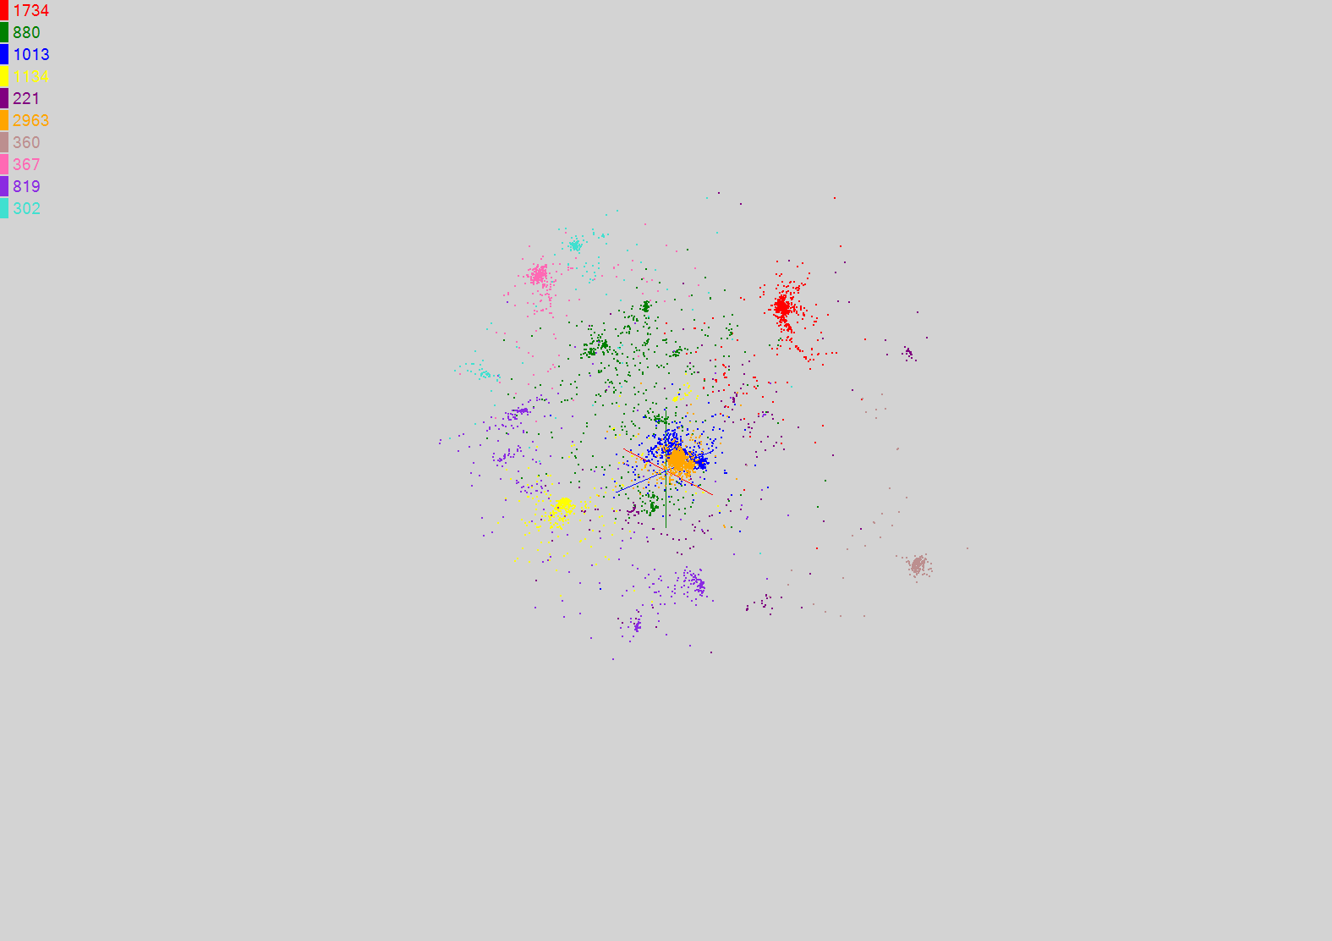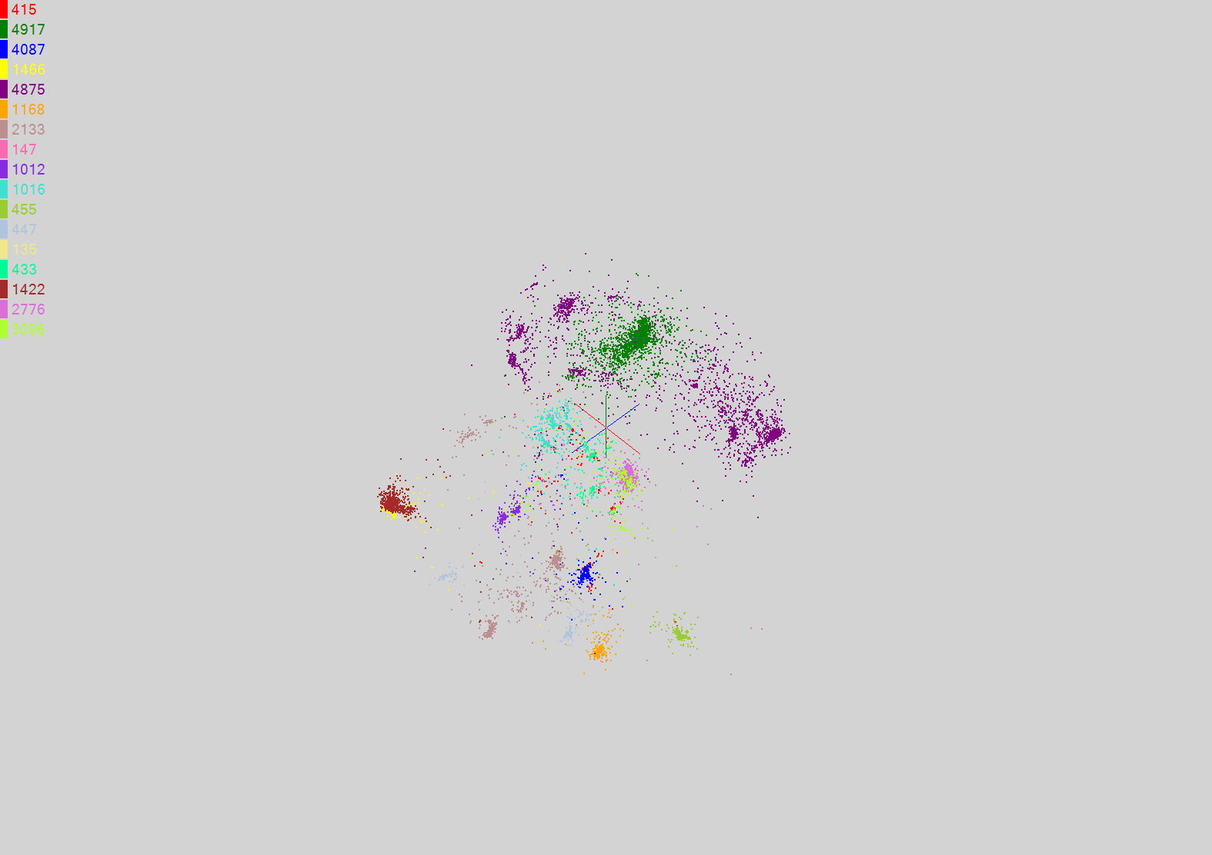

(a)

(b)

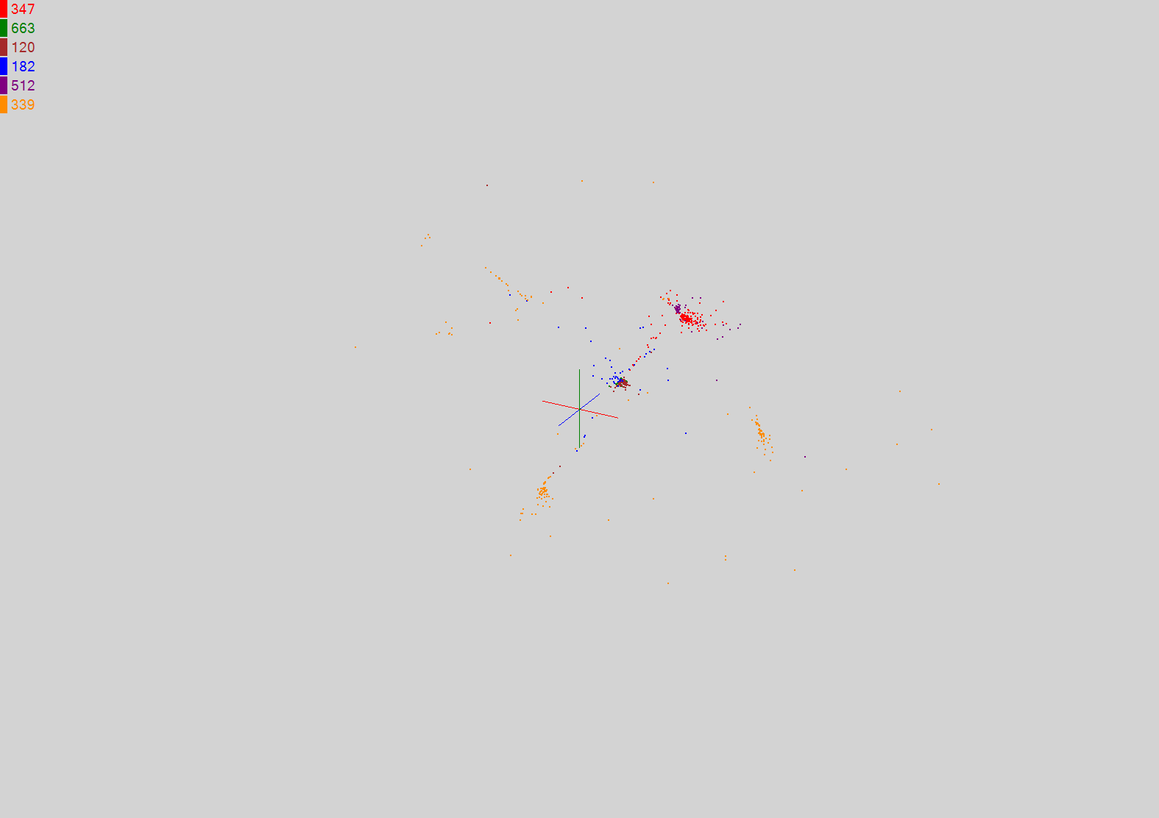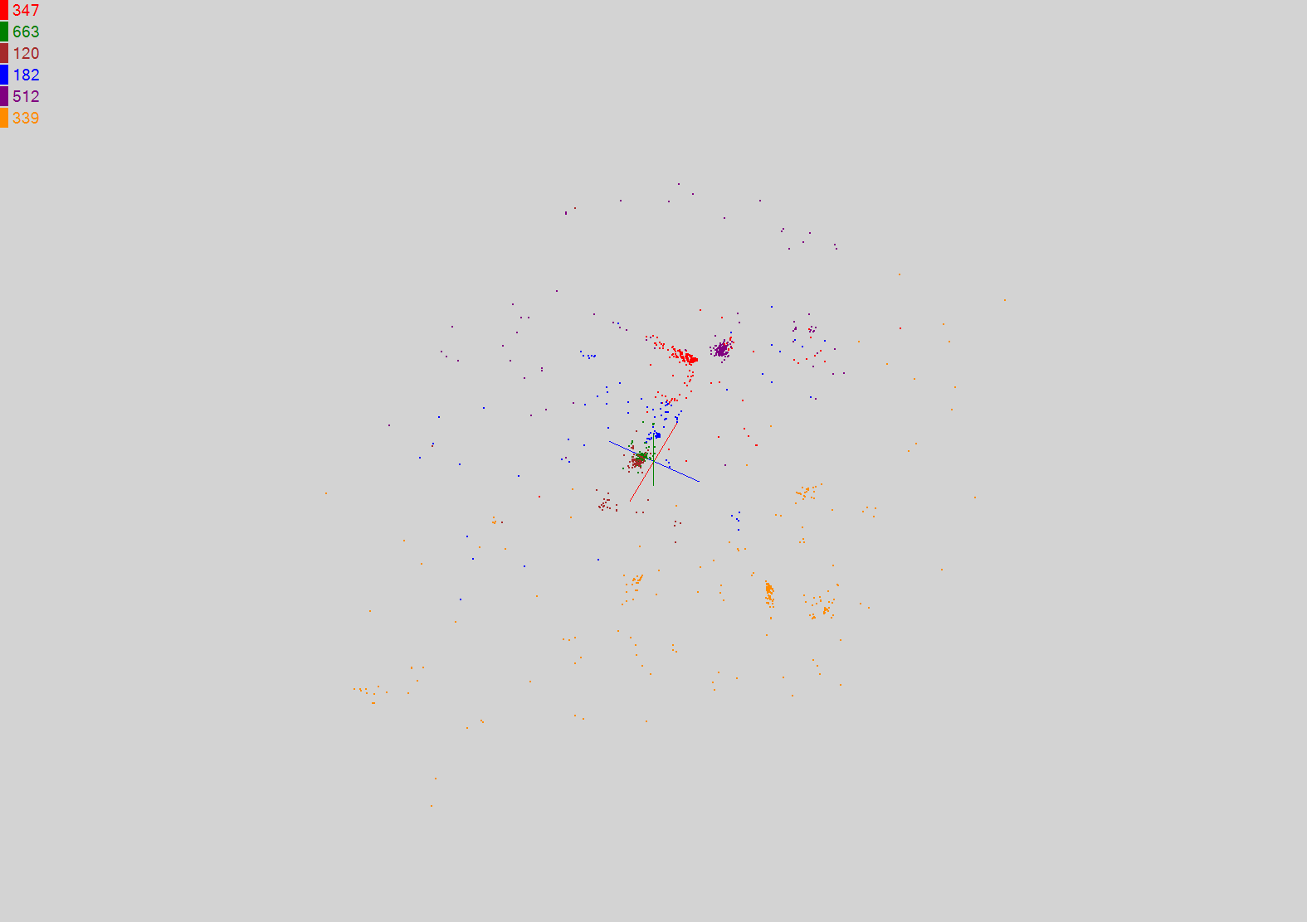

(c)

(d)

1. Results of Smith-Waterman distance Computation, Deterministic Annealing Clustering and MDS visualization pipeline for 30,000 Metagenomics sequences. (a) shows 17 clusters for full sample using Sammon’s version of MDS for visualization. (b) shows 10 sub-clusters with a total of 9793 sequences found from purple and green clusters in (a) using Sammon’s version of MDS for visualization.

Sub clustering of light brown cluster in Figure 7(a) with 2163 sequences decomposed further into 6 sub-clusters. In (c) Sammon’s ansatz is used in MDS and in (d) SMACOF with less emphasis on small distances: weight(i,j) = 1 in equation (2.4).

This figure illustrates clustering of a Metagenomics sample using the robust deterministic annealing approach described in (Rose, Gurewitz, & Fox, A deterministic annealing approach to clustering, 1990) (Rose K. , Deterministic Annealing for Clustering, Compression, Classification, Regression, and Related Optimization Problems, 1998) (Hofmann & Buhmann, 1997) (Klock & Buhmann, 2000) (Klock & Buhmann, 2000) (Qiu X. , Fox, Yuan, Bae, Chrysanthakopoulos, & Nielsen, 2008). This is implemented in MPI and runs in 30 minutes for 10 clusters and over 2 hours for 17 clusters on the 768 core cluster for the full 30,000 sequences. This processing time is proportional to the square of both the number of sequences and number of clusters and so we need hierarchical methods to process large data samples and/or large number of clusters. This is illustrated for clusters in figures Figure 7 (b, c, d). We will develop more automatic approaches to this as discussed in section 2.3.

We can generalize equations (2.1) and (2.2) to state that MDS finds the best set of vectors **x***i* in any chosen dimension *d* (*d*=3 in our case) minimizing:

|  |  |  |
| --- | --- | --- |
|  |  |  |

The form of the weights weight( is chosen to reflect importance of a point or perhaps a desire (Sammon’s method with = 1/ as opposed to SMACOF with weight weight(=1) to fit smaller distance more precisely than larger ones. The index *n* is typically 1 (Euclidean distance) but 2 also useful. The index *m* is 1 in Figure 7 but *m*=0.5 is also interesting. Figures 7(c and d) show the sensitivity to MDS heuristic with SMACOF producing better results than Sammon for the sub-clustering of the smallish 2163 sequence sample. Generally we use Sammon as giving best results.

We have MDS implementations with three different methods – the classic expectation maximization approach (Kruskal & Wish, 1978) (Borg & Groenen, 2005) described in section 2.1, a deterministic annealing version (Klock & Buhmann, 2000) (Klock & Buhmann, 2000) and a distinct version that uses nonlinear χ2 solution methods (Kearsley, Tapia, & Trosset, 1995) which was used in figure 7. All have efficient parallel implementations (Fox, Bae, Ekanayake, Qiu, & Yuan, 2008) and we will describe the second and third approaches in detail elsewhere.

Deterministic annealing (Rose K. , Deterministic Annealing for Clustering, Compression, Classification, Regression, and Related Optimization Problems, 1998) is a powerful idea to avoid local minima in optimization methods (and both clustering and MDS can be considered this way) by simplifying the notoriously slow simulated annealing by calculating averages explicitly using mean field theory. For clustering, Hofmann and Buhmann (Hofmann & Buhmann, 1997) first showed how to do this in a formulation that only uses pairwise distances. Define an energy function

|  |  |  |
| --- | --- | --- |
|  |  |  |

and C(*k*) = ∑*i*=1N M*i*(*k*) is the expected number of points in the k’th cluster. D(i,j) is as before the pairwise distance or dissimilarity between points  *i*  and *j*. One minimizes equation (2.5) for the cluster probabilities M*i*(*k*) that point *i* belong to cluster *k*. One can derive deterministic annealing from an informatics theoretic (Rose K. , Deterministic Annealing for Clustering, Compression, Classification, Regression, and Related Optimization Problems, 1998) or a physics formalism (Hofmann & Buhmann, 1997). In latter case one smoothes out the cost function (2) by integrating it with the Gibbs distribution exp(-H/T) over all degrees of freedom. This implies in a physics language that one is minimizing not H but the free energy F at temperature T and entropy S

|  |  |  |
| --- | --- | --- |
|  |  |  |

As explained in detail in (Rose K. , Deterministic Annealing for Clustering, Compression, Classification, Regression, and Related Optimization Problems, 1998), the temperature T can be interpreted as a distance scale so that gradually reducing the temperature T in equations (2.5) and (2.6) corresponds to increasing resolution with which one considers distance structure.

Our parallel implementations of equations (2.5) and (2.6) are quite mature and have been used extensively although there is ongoing activity in improving the overall infrastructure to support the many linked runs needed. There are also some sophisticated options in these methods that are still being implemented. Figure 7 illustrates that we perform manual hierarchical analyses already but as explained in the next subsection, we propose to build on current technology to dramatically improve the scaling to large numbers of sequences which is currently limited by O(N2) complexity of all stages of the processing pipeline in Figure 1.

## Metagenomics Studies with Hierarchical MDS

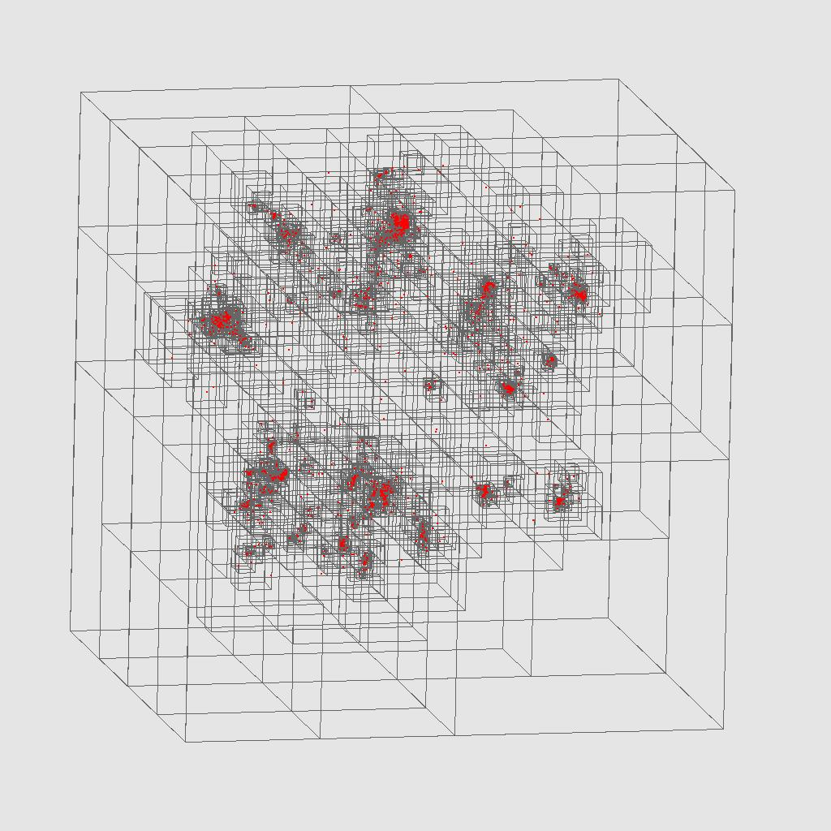

1. Barnes-Hut Oct tree generated from MDS dimension reduced Metagenomics data

Even though the annealing algorithm is looking at genes with a decreasing distance scale, the current clustering algorithm is of O(N2) complexity and its behavior as distance scale is lowered tracks the "worst region" because the criteria for success are global. We can develop new algorithms and dissociate convergence criteria in different regions by a fully hierarchical algorithm using ideas developed for making particle dynamics simulations O(NlogN). The essential idea is to run MDS on a subset of data (say 20,000 to 100,000 sequences) to map sequences to a 3D Euclidean space. This would take hours to days on our 768 core cluster. Then use orthogonal recursive bisection to divide 3D mapped space into geometrically compact regions. This allows both MDS mapping of full dataset and a proper decomposition to allow efficient hierarchical clustering to find detailed sequence families. The best way to define regions is a research issue with both visual interface and automatic methods possible,

We want to find a way of converting O(N2) algorithms like MDS to O(NlogN) in same way that “Barnes-Hut trees” and “Fast Multipole” methods convert O(N2) particle dynamics to O(NlogN). The latter is described on many places (Barnes-Hut Simulation, 2009) including PhD thesis of John Salmon (Salmon, 1991). The idea is illustrated in figure 8 which shows a 2D projection of the data of fig. 7(a) with a hierarchical quad tree superimposed. This was generated by an open source Barnes Hut Tree code (Berg, 2009).

The essential idea can be stated as follows: consider a collection of points, which are MDS mapped points in our case, and would be galaxies or stars in astrophysics. Divide them up by “orthogonal recursive bisection” to produce quad-trees in 2D or oct-trees in 3D (as in figure 8). This is impractical in high dimensional space (as it generates 2D children at each node) but quite feasible in two or three dimensions. Thus in our case of sequences, we need to use MDS to map the original sequences which are both high dimensional and without defined universal vector representations (until we solve Multiple Sequence Alignment MSA problem). Note that the orthogonal recursive bisection divides space into regions where all points in a region are near each other. Given the nature of MDS, “near each other” in 3D implies “near each other” in original space. Note this approach builds a tree and each internal or terminal node is a cubic region. User-defined criteria (such as number of points in region) establish if this region should be further split into 8 (in 3D) other regions. These criteria need to be designed for MDS but is naturally the number of points as this determines performance of part d) of algorithm below.

So our proposed algorithm proceeds as follows:

1. Perform a full O(Nsubset2) MDS for a subset Nsubset of points.
2. Find centers or representative (consensus) points for each region in oct-tree. The centers could be found in at least two ways. First one can use heuristic algorithms to find the center by a heuristic algorithm in the original space. A simple heuristic that has been successful for us is to find the point in the region with the minimum value for maximum distance from all other points in that region. A second approach is to find the geometric center in the mapped 3D MDS space (or a set of representative points around a 3D region), then find the nearest sequences to the center – these become representative points for the region. One does this for all nodes of the tree – not just the final nodes. Note that representative points are defined both in original space and in MDS mapped 3D space.
3. We now have a tree with regions and consensus points (centers) associated with all nodes. The next step is performed for remaining N – Nsubset points – call a typical point *p*. Take each of the points *p* and start at the top of the tree. Calculate distance of *p* to each tree node at a given level. Assign *p* to the node with the minimum distance from its center to *p* and continue down the tree looking at 8 sub-nodes below this node. Continue until you have reached bottom of tree.
4. Now we have assigned each N – Nsubset points *p* to a region of 3D space – let the assigned region have Nregion points. Now one performs MDS within this region using 1+ Nregion points (*p* plus points in region) to define the MDS mapping of point *p* with the mapping of original Nregion points fixed. Note our criterion for dividing nodes probably includes Nregion < a cutoff value so we can control computational complexity of this step d). The criterion appropriate for dividing nodes is as mentioned above, an important research issue.

There are many refinements that can be evaluated. Maybe our point *p* is at boundary of a region. This could be addressed by either looking at quality of fit in step d) or the discrimination of distance test in step c). One would choose if necessary not a terminal node at step c) but the larger region corresponding to an internal node. There are tradeoffs between performance (which scales like the number of points in chosen region) and accuracy of method, which need to be researched. Finally all steps of the pipeline in figure 1 have choices of heuristic parameters that can be significant and need study. In particular there is the optimal choice for weight functions and distance measures to use in equations (2.4) and (2.5).

Step a) of the above algorithm has time complexity of O(Nsubset2). MDS interpolation to get the full dataset mapped to 3D (steps c) and d)) has a complexity that depends on implementation -- simplest is O((N – Nsubset) (logNsubset + Nregion)). Clustering and MDS can use the same tree decomposition but clustering will likely use different size (larger) regions. The complexity for clustering is O(N2/# regions) for the simplest algorithm. We call this approach “stage 1” and it will be our initial focus as it can reuse a lot of our existing software base.

Later we will attempt to derive a properly O(NlogN) clustering approach that is based not on clustering sequences but rather on clustering "regions" and sequences. Here we will modify the double sum over sequences in equation (2.5). One preserves the form of sum if sequences are nearby but replaces sequence-sequence interaction by sequence-region or region-region terms if sequences are far away. Here, a region can be represented by its consensus (mean in particle dynamics analogue) sequence for regions with a weight equal to number of sequences in region. The further sequences are apart, the larger regions can be (i.e. one chooses representation nearer the root of the tree formed by orthogonal recursive bisection). We call this speculative approach “stage 2”. It is a natural generalization of the O(N) or O(NlogN) particle dynamics algorithms (Fox, Williams, & Messina, 1994) (Barnes-Hut Simulation, 2009).

This approach needs totally new software and significant algorithm work -- in particular to develop an error estimate to decide which level in tree (region size) to use -- this is done by multipole expansion in particle case. It can possibly provide not just scalable O(NlogN + Nsubset2) clustering but also a viable approach to Multiple Sequence Alignment for large numbers of sequences.

# Innovations in programming models using cloud technologies

## Runtimes and Programming Models

This section presents a brief introduction to a set of parallel runtimes we use our evaluations.

### Parallel frameworks

#### Hadoop

Apache Hadoop (Apache Hadoop, 2009) has a similar architecture to Google’s MapReduce runtime (Dean & Ghemawat, 2008), where it accesses data via HDFS, which maps all the local disks of the compute nodes to a single file system hierarchy, allowing the data to be dispersed across all the data/computing nodes. HDFS also replicates the data on multiple nodes so that failures of any nodes containing a portion of the data will not affect the computations which use that data. Hadoop schedules the MapReduce computation tasks depending on the data locality, improving the overall I/O bandwidth. The outputs of the *map* tasks are first stored in local disks until later, when the *reduce* tasks access them (pull) via HTTP connections. Although this approach simplifies the fault handling mechanism in Hadoop, it adds a significant communication overhead to the intermediate data transfers, especially for applications that produce small intermediate results frequently.

#### Dryad

Dryad (Isard, Budiu, Yu, Birrell, & Fetterly, 2007) is a distributed execution engine for coarse grain data parallel applications. Dryad considers computation tasks as directed acyclic graphs (DAG) where the vertices represent computation tasks and while the edges acting as communication channels over which the data flow from one vertex to another. In the HPC version of DryadLINQ the data is stored in (or partitioned to) Windows shared directories in local compute nodes and a meta-data file is use to produce a description of the data distribution and replication. Dryad schedules the execution of vertices depending on the data locality. (Note: The academic release of Dryad only exposes the DryadLINQ (Yu, et al., 2008) API for programmers. Therefore, all our implementations are written using DryadLINQ although it uses Dryad as the underlying runtime). Dryad also stores the output of vertices in local disks, and the other vertices which depend on these results, access them via the shared directories. This enables Dryad to re-execute failed vertices, a step which improves the fault tolerance in the programming model.

#### Twister

Twister (Ekanayake, Pallickara, & Fox, 2008) (Fox, Bae, Ekanayake, Qiu, & Yuan, 2008) is a light-weight MapReduce runtime (an early version was called CGL-MapReduce) that incorporates several improvements to the MapReduce programming model such as (i) faster intermediate data transfer via a pub/sub broker network; (ii) support for long running *map/reduce* tasks; and (iii) efficient support for iterative MapReduce computations. The use of streaming enables Twister to send the intermediate results directly from its producers to its consumers, and eliminates the overhead of the file based communication mechanisms adopted by both Hadoop and DryadLINQ. The support for long running *map/reduce* tasks enables configuring and re-using of *map/reduce* tasks in the case of iterative MapReduce computations, and eliminates the need for the re-configuring or the re-loading of static data in each iteration.

#### MPI Message Passing Interface

MPI (MPI, 2009), the de-facto standard for parallel programming, is a language-independent communications protocol that uses a message-passing paradigm to share the data and state among a set of cooperative processes running on a distributed memory system. The MPI specification defines a set of routines to support various parallel programming models such as point-to-point communication, collective communication, derived data types, and parallel I/O operations. Most MPI runtimes are deployed in computation clusters where a set of compute nodes are connected via a high-speed network connection yielding very low communication latencies (typically in microseconds). MPI processes typically have a direct mapping to the available processors in a compute cluster or to the processor cores in the case of multi-core systems. We use MPI as the baseline performance measure for the various algorithms that are used to evaluate the different parallel programming runtimes. Table 1 summarizes the different characteristics of Hadoop, Dryad, Twister, and MPI.

1. Comparison of features supported by different parallel programming runtimes.

|  |  |  |  |  |
| --- | --- | --- | --- | --- |
| **Feature** | **Hadoop** | **DryadLINQ** | **Twister** | **MPI** |
| Programming Model | MapReduce | DAG based execution flows | MapReduce with a  *Combine* phase | Variety of topologies constructed using the rich set of parallel constructs |
| Data Handling | HDFS | Shared directories/ Local disks | Shared file system / Local disks | Shared file systems |
| Intermediate Data Communication | HDFS/  Point-to-point via HTTP | Files/TCP pipes/ Shared memory FIFO | Content Distribution Network (NaradaBrokering (Pallickara and Fox 2003) ) | Low latency communication channels |
| Scheduling | Data locality/  Rack aware | Data locality/ Network  topology based run time graph optimizations | Data locality | Available processing capabilities |
| Failure Handling | Persistence via HDFS  Re-execution of map and reduce tasks | Re-execution of vertices | Currently not implemented  (Re-executing map tasks, redundant reduce tasks) | Program level  Check pointing  OpenMPI ,  FT MPI |
| Monitoring | Monitoring support of HDFS, Monitoring MapReduce computations | Monitoring support for execution graphs | Programming interface to monitor the progress of jobs | Minimal support for task level monitoring |
| Language Support | Implemented using Java. Other languages are supported via Hadoop Streaming | Programmable via C#  DryadLINQ provides LINQ programming API for Dryad | Implemented using Java  Other languages are supported via Java wrappers | C, C++, Fortran, Java, C# |

### Science in clouds ─ dynamic virtual clusters



1. Software and hardware configuration of dynamic virtual cluster demonstration. Features include virtual cluster provisioning via xCAT and support of both stateful and stateless OS images.

Deploying virtual or bare-system clusters on demand is an emerging requirement in many HPC centers. The tools such as [xCAT (xCAT, 2009)](http://xcat.sourceforge.net/) and MOAB (Moab Cluster Tools Suite, 2009) can be used to provide these capabilities on top of physical hardware infrastructures. In this section we discuss our experience in demonstrating the possibility of provisioning clusters with parallel runtimes and use them for scientific analyses.

We selected Hadoop and DryadLINQ to demonstrate the applicability of our idea. The SW-G application described in section 3.2 is implemented using both Hadoop and DryadLINQ and therefore we could use that as the application for demonstration. With bare-system and XEN (Barham, et al., 2003) virtualization and Hadoop running on Linux and DryadLINQ running on Windows Server 2008 operating systems produced four operating system configurations; namely (i) Linux Bare System, (ii) Linux on XEN, (iii) Windows Bare System, and (iv) Windows on XEN. Out of these four configurations, the fourth configuration did not work well due to the unavailability of the appropriate para-virtualization drivers. Therefore we selected the first three operating system configurations for this demonstration.

We selected xCAT infrastructure as our dynamic provisioning framework and set it up on top of bare hardware of a compute cluster. Figure 9 shows the various software/hardware components in our architecture. To implement the dynamic provisioning of clusters, we developed a software service that accept user inputs via a pub-sub messaging infrastructure and issue xCAT commands to switch a compute cluster to a given configuration. We installed Hadoop and DryadLINQ in the appropriate operation system configurations and developed initialization scripts to initialize the runtime with the start of the compute clusters. These developments enable us to provide a fully configured computation infrastructure deployed dynamically at the requests of the users.

We setup the initialization scripts to run SW-G pairwise distance calculation application after the initialization steps. This allows us to run a parallel application on the freshly deployed cluster automatically.

We developed a performance monitoring infrastructure to monitor the utilization (CPU, memory etc..) of the compute clusters using a pub-sub messaging infrastructure. The architecture of the monitoring infrastructure and the monitoring GUI are shown in Figure 10.

|  |  |
| --- | --- |
|  |  |

1. Architecture of the performance monitoring infrastructure and the monitoring GUI.

In the monitoring architecture, a daemon is placed in each computer node of the cluster which will be started with the initial boot sequence. All the monitor daemons send the monitored performances to a summarizer service via the pub-sub infrastructure. The summarizer service produces a global view of the performance of a given cluster and sends this information to a GUI that visualizes the results in real-time. The GUI is specifically developed to show the CPU and the memory utilization of the bare-system/virtual clusters when they are deployed dynamically.

With all the components in place, we implemented SW-G application running on dynamically deployed bare-system/virtual clusters with Hadoop and DryadLINQ parallel frameworks. This will be extended in the FutureGrid project (FutureGrid Homepage, 2009)

## Pairwise sequence alignment using Smith-Waterman-Gotoh

### Introduction to Smith-Waterman-Gotoh (SWG)

Smith-Waterman (Smith & Waterman, 1981) is a widely used local sequence alignment algorithm for determining similar regions between two DNA or protein sequences. In our studies we use Smith-Waterman algorithm with Gotoh’s (Gotoh, 1982) improvement for Alu sequencing. The Alu clustering problem (Price, Eskin, & Pevzner, 2004) is one of the most challenging problems for sequencing clustering because Alus represent the largest repeat families in human genome. As in metagenomics, this problem scales like O(N2) as given a set of sequences we need to compute the similarity between all possible pairs of sequences.

### Implementations

#### Dryad Implementation

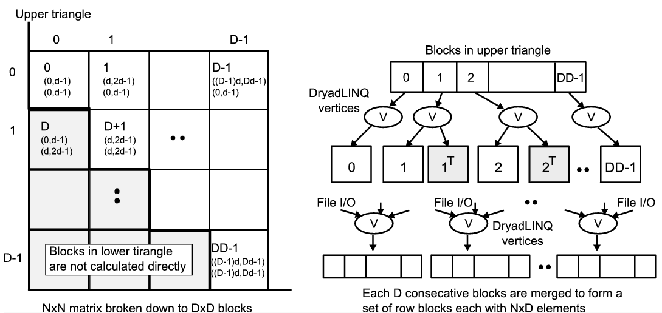

1. Task decomposition (left) and the DryadLINQ vertex hierarchy (right) of the DryadLINQ implementation of SW-G pairwise distance calculation application.

We developed a DryadLINQ application to perform the calculation of pairwise SW-G distances for a given set of genes by adopting a coarse grain task decomposition approach which requires minimum inter-process communication requirements to ameliorate the higher communication and synchronization costs of the parallel runtime. To clarify our algorithm, let’s consider an example where N gene sequences produces a pairwise distance matrix of size NxN. We decompose the computation task by considering the resultant matrix and group the overall computation into a block matrix of size DxD where D is a multiple (>2) of the available computation nodes. Due to the symmetry of the distances and= we only calculate the distances in the blocks of the upper triangle of the block matrix as shown in Figure 11(left). The blocks in the upper triangle are partitioned (assigned) to the available compute nodes and an “Dryad Apply” operation is used to execute a function to calculate (N/D)x(N/D) distances in each block. After computing the distances in each block, the function calculates the transpose matrix of the result matrix which corresponds to a block in the lower triangle, and writes both these matrices into two output files in the local file system. The names of these files and their block numbers are communicated back to the main program. The main program sort the files based on their block number s and perform another “Apply” operation to combine the files corresponding to a row of blocks in a single large row block as shown in the Figure 11 (right).

#### MPI Implementation

The MPI version of SW-G calculates pairwise distances using a set of either single or multi-threaded processes. For N gene sequences, we need to compute half of the values (in the lower triangular matrix), which is a total of M = N x (N-1) /2 distances. At a high level, computation tasks are evenly divided among P processes and execute in parallel. Namely, computation workload per process is M/P. At a low level, each computation task can be further divided into subgroups and run in T concurrent threads. Our implementation is designed for flexible use of shared memory multicore system and distributed memory clusters (tight to medium tight coupled communication technologies such threading and MPI).

#### Apache Hadoop Implementation

We developed an Apache Hadoop version of the pairwise distance calculation program based on the JAligner (JAligner, 2009) program, the java implementation of the NAligner code used in Dryad version. Similar to the other implementations, the computation is partitioned in to blocks based on the resultant matrix. Each of the blocks would get computed as a map task. The block size (D) can be specified via an argument to the program. The block size needs to specified in such a way that there will be much more map tasks than the map task capacity of the system, so that the Apache Hadoop scheduling will happen as a pipeline of map tasks resulting in global load balancing of the application. The input data is distributed to the worker nodes through the Hadoop distributed cache, which makes them available in the local disk of each compute node.

A load balanced task partitioning strategy according to the following rules is used to identify the blocks that need to be computed (green) through map tasks as shown in the Figure 12(a). In addition all the blocks in the diagonal (blue) are computed. Even though the task partitioning mechanisms are different, both Dryad-SWG and Hadoop-SWG ends up with essentially identical computation blocks, if the same block size is given to both the programs.

*When* β *>=* α*, we calculate D(*α*,*β*) only if* α*+*β *is even,*

*When* β *<* α*, we calculate D(*α*,*β*) only if* α*+*β *is odd.*

The Figure 12 (b) depicts the run time behavior of the Hadoop-swg program. In the given example the map task capacity of the system is “k” and the number of blocks is “N”. The solid black lines represent the starting state, where “k” map tasks (blocks) will get scheduled in the compute nodes. The solid red lines represent the state at t1 , when 2 map tasks, m2 & m6, get completed and two map tasks from the pipeline gets scheduled for the placeholders emptied by the completed map tasks. The gray dotted lines represent the future.



1. (a)Task (Map) decomposition and the reduce task data collection (b) Application run time

Map tasks use custom Hadoop writable objects as the map task output values to store the calculated pairwise distance matrices for the respective blocks. In addition, non-diagonal map tasks output the inverse distances matrix as a separate output value. Hadoop uses local files and http transfers to transfer the map task output key value pairs to the reduce tasks.

The outputs of the map tasks are collected by the reduce tasks. Since the reduce tasks start collecting the outputs as soon as the first map task finishes and continue to do so while other map tasks are executing, the data transfers from the map tasks to reduce tasks do not present a significant performance overhead to the program. The program currently creates a single reduce task per each row block resulting in total of (no. of sequences/block size) Reduce tasks. Each reduce task to accumulate the output distances for a row block and writes the collected output to a single file in Hadoop Distributed File System (HDFS). This results in N number of output files corresponding to each row block, similar to the output we produce in the Dryad version.

### Performance comparison

We compared the Dryad, Hadoop and MPI implementations of ALU SW-G distance calculations using a replicated data set and obtained the following results. The data sets were generated by taking a 10000 sequence random sample from a real data set and replicating it 2-5 times. Dryad and MPI tests were performed in cluster *ref D* (Table 2)and the Hadoop tests were performed in cluster *ref* *A* (Table 2) which is identical to cluster *ref D*, which are two identical Windows HPC and Linux clusters. The Dryad & MPI results were adjusted to counter the performance difference of the kernel programs, NAligner and the JAligner in their respective environments, for fair comparison with the Hadoop implementation.

1. Comparison of Dryad, MPI and Hadoop technologies on ALU sequencing application with SW-G algorithm

Figure 13 indicates that all three implementations perform and scale well for this application with Hadoop implementation showing the best scaling. As expected, the times scaled proportionally to the square of the number of distances. On 256 cores the average time of 0.017 milliseconds per pair for 10k data set corresponds to roughly 4.5 milliseconds per pair calculated per core used. The coarse grained Hadoop & Dryad applications perform and scale competitively with the tightly synchronized MPI application.

We can notice that the Hadoop implementation showing improved performance with the increase of the data set size, while Dryad performance degrades a bit. Hadoop improvements can be attributed to the diminishing of the framework overheads, while the Dryad degradation can be attributed to the memory management in the Windows and Dryad environment.

#### Inhomogeneous data study

Most of the data sets we encounter in the real world are inhomogeneous in nature, making it hard for the data analyzing programs to efficiently break down the problems. The same goes true for the gene sequence sets, where individual sequence lengths and the contents vary among each other. In this section we study the effect of inhomogeneous gene sequence lengths for the performance of our pairwise distance calculation applications.

The time complexity to align and obtain distances for two genome sequences A, B with lengths *m* and *n* respectively using Smith-Waterman-Gotoh algorithm is approximately proportional to the product of the lengths of two sequences (O(*mn*)). All the above described distributed implementations of Smith-Waterman similarity calculation mechanisms rely on block decomposition to break down the larger problem space in to sub-problems that can be solved using the distributed components. Each block is assigned two sub-sets of sequences, where Smith-Waterman pairwise distance similarity calculation needs to be performed for all the possible sequence pairs among the two sub sets. According to the above mentioned time complexity of the Smith-Waterman kernel used by these distributed components, the execution time for a particular execution block depends on the lengths of the sequences assigned to the particular block.

Parallel execution frameworks like Dryad and Hadoop work optimally when the work is equally partitioned among the tasks. Depending on the scheduling strategy of the framework, blocks with different execution times can have an adverse effect on the performance of the applications, unless proper load balancing measures have been taken in the task partitioning steps. For an example, in Dryad vertices are scheduled at the node level, making it possible for a node to have blocks with varying execution times. In this case if a single block inside a vertex takes a larger amount of time than other blocks to execute, then the whole node have to wait till the large task completes, which utilizes only a fraction of the node resources.

Since the time taken for the Smith-Waterman pairwise distance calculation depends mainly on the lengths of the sequences and not on the actual contents of the sequences, we decided to use randomly generated gene sequence sets for this experiment. The gene sequence sets were randomly generated for a given mean sequence length (400) with varying standard deviations following a normal distribution of the sequence lengths. Each sequence set contained 10000 sequences leading to 100 million pairwise distance calculations to perform. We performed two studies using such inhomogeneous data sets. In the first study the sequences with varying lengths were randomly distributed in the data sets. In the second study the sequences with varying lengths were distributed using a skewed distribution, where the sequences in a set were arranged in the ascending order of sequence length.

1. Performance of SW-G pairwise distance calculation application for randomly and skewed distibuted inhomogeneous data with ‘400’ mean sequence length

Figure 14 presents the execution time taken for the randomly distributed and skewed distributed inhomogeneous data sets with the same mean length, by the two different implementations. The Dryad results depict the Dryad performance adjusted for the performance difference of the NAligner and JAligner kernel programs. As we notice from the Figure 14, both Dryad implementation as well as the Hadoop implementation performed satisfactorily for the randomly distributed inhomogeneous data, without showing significant performance degradations with the increase of the standard deviation. This behavior can be attributed to the fact that the sequences with varying lengths are randomly distributed across a data set, effectively providing a natural load balancing to the execution times of the sequence blocks. In fact Hadoop implementation showed minor improvements in the execution times, which can be attributed to the fact that the actual workload gets reduced (effect of O(*mn*)) with the increase of the standard deviation even though the mean and the number of sequences stay the same.

For the skewed distributed inhomogeneous data, we notice clear performance degradation in the Dryad implementation. Once again the Hadoop implementation performs consistently without showing significant performance degradation, even though it does not perform as well as its randomly distributed counterpart. The Hadoop implementations’ consistent performance can be attributed to the global pipeline scheduling of the map tasks. In the Hadoop Smith-Waterman implementation, each block decomposition gets assigned to a single map task. Hadoop framework allows the administrator to specify the number of map tasks that can be run on a particular compute node. The Hadoop global scheduler schedules the map tasks directly on to those placeholders in a much finer granularity than in Dryad, as and when the individual map tasks finish. This allows the Hadoop implementation to perform natural global level load balancing. In this case it might even be advantageous to have varying task execution times to iron out the effect of any trailing map tasks towards the end of the computation. Dryad implementation pre allocates all the tasks to the compute nodes and does not perform any dynamic scheduling across the nodes. This makes a node which gets a larger work chunk to take considerable longer time than a node which gets a smaller work chunk, making the node with a smaller work chuck to idle while the other nodes finish.

## Sequence assembly using Cap3

### Introduction to Cap3

Cap3 (Huang & Madan, 1999) is a sequence assembly program which assembles DNA sequences by aligning and merging sequence fragments. Cap3 algorithm works in several steps after reading a collection of gene sequences from an input file in the FASTA format. In the first two steps the poor regions of the fragments are removed and the overlaps between the fragments are calculated. Third step takes care of identifying and removing the false overlaps. In the next step, the fragments are joined to form contigs, while the last step constructs multiple sequence alignments and generates consensus sequences. This program outputs several files as well as standard output.

### Implementations

Cap3 is often used with lots of input files making it an embarrassingly parallel application requiring no inter-process communications. We implemented parallel applications for Cap3 using Microsoft DryadLINQ (Yu, et al., 2008) (Isard, Budiu, Yu, Birrell, & Fetterly, 2007) and Apache Hadoop (Apache Hadoop, 2009). This fits as a “map only” application for the MapReduce model. The Hadoop application is implemented by creating map tasks which execute the Cap3 program as a separate process on the given input FASTA file. Since the Cap3 application is implemented in C, we do not have the luxury of using the Hadoop file system (HDFS) directly. Hence the data needs to be stored in a shared file system across the nodes. However we are actively investigating the possibility of using Hadoop streaming and mountable HDFS for this purpose.

For the DryadLINQ application, the set of input files are best effort equally partitioned across the compute nodes and stored in the local disks of the compute nodes. A data partition file is created for each node containing the list of data files that resides in that particular node. We used the DryadLINQ “Select” operation to apply a function on the input files. The function will execute Cap3 program passing the input file name together with other parameters and will save the standard output from the program. All the outputs will get moved to a predefined location by both the implementations.

### Performance

First we performed a scalability test on out Cap3 implementations using a homogeneous data set. This data set is created by replicating a single file for a given number of times. The file we chose contained 458 sequences.

1. Cap3 scalability test with homogeneous data

As we can see from the above figure, the Hadoop implementation shows good scaling for the Cap3 application, with even slightly increased performance with the increase of data size. The increase must be happening due to the overheads of the framework getting diminished over the larger workload. On 256 cores the average time 0.4 seconds on the Hadoop implementation to execute Cap3 program on a single data set corresponds to approximately 102 seconds per file executed per core. The Dryad implementation shows linear performance up to 2048 files and then from the 3072 files. We are still investigating the possible reason behind the performance increase that happens from 2048 files to 3072 files.

#### Inhomogeneous Data Study

Unlike in Smith-Waterman Gotoh implementations, Cap3 program execution time does not directly depend on the file size or the size of the sequences, as it depend mainly on the content of the sequences. This made is hard for us to artificially generate inhomogeneous data sets for the Cap3 program, forcing us to use real data. When generating the data sets, first we calculated the standalone Cap3 execution time for each of the files in our data set. Then based on those timings, we created data sets that have approximately similar mean times while the standard deviation of the standalone running times is different in each data set. We performed the performance testing for randomly distributed as well as skewed distributed (sorted according to individual file running time) data sets similar to the SWG inhomogeneous study. The speedup is taken by dividing the sum of sequential running times of the files in the data set by the parallel implementation running time.

1. Cap3 inhomogeneous data performance

Above figure depicts the Cap3 inhomogeneous performance results for Hadoop & Dryad implementations. Hadoop implementation shows satisfactory scaling for both random as well as sorted data sets, while the Dryad implementation shows satisfactory scaling in the randomly distributed data set. Once again we notice that the Dryad implementation does not perform well for the skewed distributed inhomogeneous data due to its’ static non-global scheduling.

# Iterative MapReduce with Twister

MapReduce is a programming model introduced by Google to support large scale data processing applications (Ghemawat, January, 2008). The simplicity of the programming model and the ease of supporting quality of services make it more suitable for large scale data processing applications. Our experience in applying MapReduce for scientific analyses reveals that the programming model is suitable for many scientific analyses as well. However, we noticed that the current MapReduce programming model and its implementations such as Apache Hadoop do not support iterative MapReduce computations efficiently. Iterative computations are common in many fields such as data clustering, machine learning, and computer vision and many of these applications can be implemented as MapReduce computations. In Twister(an early version was known as CGL-MapReduce) (Ekanayake, Pallickara, & Fox, 2008) (Fox, Bae, Ekanayake, Qiu, & Yuan, 2008) (Twister, 2009), we present an extended MapReduce programming model and a prototype implementation to support iterative MapReduce computations efficiently. Note (Chu, 2006) emphasized that the MapReduce approach is applicable to many data mining applications but the performance will often be poor without the extra capabilities of Twister.

## MapReduce Extensions

Many iterative applications we analyzed show a common characteristic of operating on two types of data products called static and variable data. Static data is used in each iteration and remain fixed throughout the computation whereas the variable data is the computed results in each iteration and typically consumed in the next iteration in many expectation maximization (EM) type algorithms. For example, if we consider K-means clustering algorithm (MacQueen), during the nth iteration the program uses the input data set and the cluster centers computed during the (n-1)th iteration to compute the next set of cluster centers.

Although some of the typical MapReduce computations such as distributed sorting, information retrieval and word histogramming consume very large data sets, many iterative applications we encounter operate on moderately sized data sets which can fit into the distributed memory of the computation clusters. This observation leads us to explore the idea of using long running map/reduce tasks similar to the long running parallel processes in many MPI applications which last throughout the life of the computation. The long running (cacheable) map/reduce tasks allow map/reduce tasks to be configured with static data and use them without loading again and again in each iteration. Current MapReduce implementations such as Hadoop (Apache Hadoop, 2009) and DryadLINQ (Yu, et al., 2008) do not support this behavior and hence they initiate new map/reduce tasks and load static data in each iteration incurring considerable performance overheads. This distinction is shown in Figure 17. By supporting long running map/reduce tasks we do not encourage users to store state information in the map/reduce tasks violating the “side-effect-free” nature of the map/reduce computations rather achieving considerable performance gains by caching the static data across map/reduce tasks. The framework does not guarantee the use of same set of map/reduce tasks throughout the life of the iterative computation.

In addition, we also add an optional reduction phase named “combine” to the MapReduce computation to allow programs to access the outputs of the reduce phase as a single value. Combine phase is another reduction phase which can be used to combine the results of the reduce phase into a single value. The user program and the combine operation run on a single process space allowing its output directly accessible to the user program. This enables the user to check conditions based on the output of the MapReduce computations.

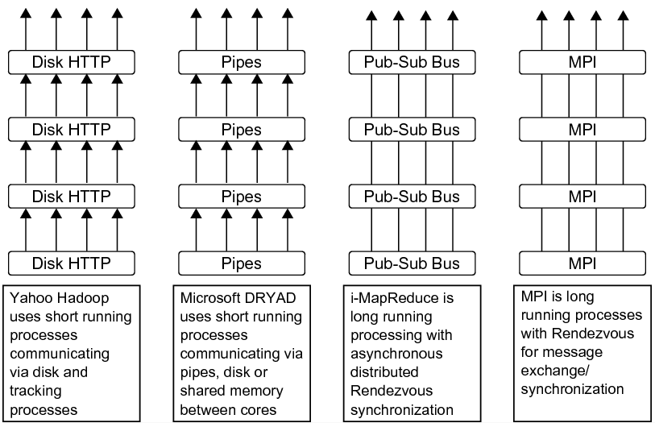

1. Long running and short running processes in various parallel programming runtimes.

Twister uses streaming for all the communication/data transfer requirements which eliminates the overhead in transferring data via file systems as in Hadoop or DryadLINQ. The output <Key,Value> pairs produced during the map stage get transferred directly to the reduce stage and the output of the reduce stage get transferred directly to the combined stage via the pub-sub broker network. Currently Twister use the publish-subscribe messaging capabilities of NaradaBrokering (Pallickara & Fox, 2003) messaging infrastructure, but the framework is extensible to support any other publish-subscribe messaging infrastructure such as Active MQ (ActiveMQ, 2009).

We provide two mechanisms to access data in Twister*;* (i) from the local disk of the computer nodes, (ii) directly from the pub-sub infrastructure. For the simplicity of the implementation, we provide a file based data access mechanism for the map/reduce tasks. The data distribution is left for the users to manage and we plan to provide tools to perform such operations. Once distributed, Twister provides a mechanism to generate a meta-data file that can be used in the framework to run MapReduce computations. Apart from the above the use of streaming enables Twisterto support features such as directly sending input <Key,Value> pairs for the map stage from the user program and configuring map/reduce stages using the data sent from the user program. Figure 18 shows the programming model of Twister and how iterative MapReduce computations are executed using it.



1. Iterative MapReduce programming model using Twister.

## Performance of Twister for Iterative Computations

We have used the Twister framework to implement a series of scientific data analyses applications ranging from simple Map-only type operations to applications with multiple iterative computations. Here we are presenting the results of four such applications, namely (i) CAP3 (Huang & Madan, 1999) gene sequence assembly, (ii) High Energy Physics data analysis, (iii) K-means clustering, and (iv) Matrix multiplication. We have also implemented the above applications using Apache Hadoop and DryadLINQ and also some applications using MPI as well. The details of these applications and the parallel implementations are explained in more details in our previous publications (Fox, Bae, Ekanayake, Qiu, & Yuan, 2008). Figures 19 through 22 present the results of our evaluations. Note that to obtain these results we have used two computation clusters from those shown in table 2. All the DryadLINQ applications were run on cluster ref. B while Hadoop, Twister and MPI applications were run on cluster ref. A. The overhead calculation is based on the formula (4.1) presented below.

Overhead f(p) = [p \*T(p) –T(1)] / T(1) (4.1)

In the above formula p denotes the number of parallel processes used and T(p) denotes the time when p processes were used. T(1) gives the sequential time for the program.

|  |  |
| --- | --- |
| D:\academic\phd\Publications\eScience2009\gnuplot\cap3_perf_color.eps   1. Performance of CAP3 gene assembly programs under varying input sizes. | D:\academic\phd\Publications\eScience2009\gnuplot\hep_perf_color.eps   1. Performance of High Energy Physics programs under varying input sizes. |
| D:\academic\phd\Publications\eScience2009\gnuplot\kmeans_perf_color.eps   1. Overhead of K-means clustering implementations under varying input sizes. | D:\academic\Research\Clouds\CloudTests\iDataplexCloud\gnuplot\idataplex\mpi_hadoop_cglmr_oh_color.eps   1. Overhead of matrix multiplication implementations under varying input sizes. |

The CAP3 application is a map-only (or typically named as pleasingly parallel) application in which the parallel processes require no inter process communications. The High Energy Physics (HEP) application is a typical MapReduce application aiming to produce a histogram of identified features from a large volume of data obtained during fusion experiments. The above results indicate that all the runtimes, Hadoop, DryadLINQ and Twister perform equally well for these two types of applications. Note: The higher running time observed in Hadoop in the case of HEP data analysis was due to the placement of data in a different parallel file system than the Hadoop’s built in distributed file system named HDFS (Apache Hadoop, 2009). This is because the ROOT (ROOT, Data Analysis Framework, 2009) data analysis framework used for HEP analysis could only read input files from local disks. Apart from above, these two analysis show that the Twister has not introduced any additional overheads for the typical MapReduce applications.

K-means clustering and matrix multiplication applications resemble typical iterative application characteristics. The graphs in Figure 21 and Figure 22 highlight the applicability of Twister to the iterative applications. The performance of Twister in the case of K-means clustering and the parallel overhead in the case of matrix multiplication are close to the values of MPI where as both Hadoop and DryadLINQ shows relatively higher parallel overheads. Our approach of using long running map/reduce tasks and the use of streaming for the data transfers have eliminated many overheads present in other runtimes and enabled Twister to perform iterative MapReduce applications efficiently.

## Related Work

MapReduce was first introduced in the Lisp programming language in which the programmer is allowed to use a function to map a data set into another data set, and then use a function to reduce (combine) the results (G. L. Steel, 1995). J. Dean and S. Ghemawat introduce Google MapReduce and the associated programming model for large scale data intensive applications. Their framework supports fault tolerance and is able to run on a large clusters built using commodity hardware. Swazall is an interpreted programming language for developing MapReduce programs based on Google's MapReduce implementation. R. Pike et al. present its semantics and its usability in their paper (Pike, Dorward, Griesemer, & Quinlan, 2005). The language is geared towards processing large document collections, which are typical operations for Google.

Sector/Sphere (Gu, 2009) is a parallel runtime developed by Y. Gu, and R. L. Grossman that can be used to implement MapReduce style applications. Sphere adopts a streaming based computation model used in GPUs which can be used to develop applications with parallel topologies as a collection of MapReduce style applications. Sphere stores intermediate data on files, and hence is susceptible to higher overheads for iterative applications.

Disco (Disco project, 2009) is an open source MapReduce runtime developed using a functional programming language named Erlang (Erlang programming language, 2009). Disco architecture shares clear similarities to the Google and Hadoop MapReduce architectures where it stores the intermediate results in local files and access them later using HTTP from the appropriate reduce tasks. However, Disco does not support a distributed file system as HDFS but expects the files to be distributed initially over the multiple disks of the cluster.

All the above runtimes focus on computations that can fit into a single cycle of MapReduce programming model. In Twister our focus is on iterative map reduce computations and hence we introduce optimizations to the programming model and to the implementation to support these computations efficiently.

All-Pairs (Moretti, Bui, Hollingsworth, Rich, Flynn, & Thain, 2009) is an abstraction that can be used to solve a common problem of comparing all the elements in a data set with all the elements in another data set by applying a given function. This problem can be implemented using typical MapReduce frameworks such as Hadoop. We have shown a similar application in section 3.2.

M. Isard et al. present Dryad - a distributed execution engine for coarse grain data parallel applications (Isard, Budiu, Yu, Birrell, & Fetterly, 2007). It combines the MapReduce programming style with dataflow graphs to solve the computation tasks. DryadLINQ exposes a LINQ (LINQ Language-Integrated Query, 2009) based programming API for Dryad. The Directed Acyclic Graph (DAG) based programming model of Dryad can support more classes of applications than pure MapReduce programming model. DryadLINQ also provides a “loop unrolling” feature that can be used to create aggregated execution graphs combing a few iterations of iterative computations. However, as we have shown in Figure 21 it could not reduce the overhead of the programming model for large (in number of iterations) iterative applications.

## Future Work on Twister

In our current research we are focusing on adding fault tolerance support for the Twister runtime as this is a key feature of Hadoop and Dryad. Saving system state at every iteration will add considerable overheads for iterative applications and therefore we are trying to add features to Twister so that it can save system state after a given number of iterations (Gropp & Lusk, 2004) (Fagg & Dongarra, 2000) (Hursey, Mattox, & Lumsdaine, 2009). Apart from the above we are researching further MapReduce extensions which expand its use into more classes of parallel applications. We intend to support all applications that can be implemented using MPI Reduce, Broadcast and Synchronization primitives. We will present our findings under the umbrella project MapReduce++.

In this section we have discussed our experience in developing an extended MapReduce programming model and a prototype implementation named Twister. We have shown that with Twister one can apply MapReduce to iterative applications and obtain considerable performance gains comparable to MPI implementations of the same applications.

# Acknowledgements

We would like to thank Microsoft for their collaboration and support. Tony Hey, Roger Barga, Dennis Gannon and Christophe Poulain played key roles.

# Appendix A Different Clusters used in this Analysis

1. Different computation clusters used for this analysis.

| **Feature** | **Linux Cluster**  **(Ref A)** | **Windows Cluster (Ref B)** | **Windows Cluster (Ref C)** | **Windows Cluster (Ref D)** | **Windows Cluster (Ref E)** | **Linux Cluster (Ref F)** |
| --- | --- | --- | --- | --- | --- | --- |
| CPU | Intel(R) Xeon(R) L5420 2.50GHz | Intel(R) Xeon(R) L5420 2.50GHz | Intel(R) Xeon(R) E7450 2.40GHz | Intel(R) Xeon(R) L5420 2.50GHz | AMD Opteron 8356  2.3 GHz | Intel(R) Xeon(R) E5345  2.33 GHz |
| # CPU  # Cores | 2  8 | 2  8 | 4  6 | 2  8 | 4  16 | 2  4 |
| Memory | 32 GB | 16 GB | 48 GB | 32 GB | 16 GB | 20 GB |
| # Disk | 1 | 2 | 1 | 1 | 1 | 1 |
| Network | Giga bit Ethernet | Giga bit Ethernet | 20 Gbps Infiniband or 1 Gbps | Giga bit Ethernet | Giga bit Ethernet | Giga bit  Ethernet |
| Operating System | Red Hat Enterprise Linux Server release 5.3 -64 bit | Microsoft Window HPC Server 2008 (Service Pack 1) - 64 bit | Microsoft Window HPC Server 2008 (Service Pack 1) - 64 bit | Microsoft Window HPC Server 2008 (Service Pack 1) - 64 bit | Microsoft Window HPC Server 2008 (Service Pack 1) - 64 bit | GNU/Linux x86\_64 |
| # Cores | 256 | 256 | 768 | 256 | 128 | 64 |

References

*ActiveMQ.* (2009). Retrieved December 2009, from http://activemq.apache.org/

*Apache Hadoop.* (2009). Retrieved December 2009, from http://hadoop.apache.org/

*Barnes-Hut Simulation.* (2009). Retrieved December 2009, from http://en.wikipedia.org/wiki/Barnes-Hut\_simulation

*Disco project.* (2009). Retrieved December 2009, from http://discoproject.org/

*Erlang programming language.* (2009). Retrieved December 2009, from http://www.erlang.org/

*FutureGrid Homepage.* (2009). Retrieved December 2009, from http://www.futuregrid.org

*Hadoop Distributed File System HDFS.* (2009). Retrieved December 2009, from http://hadoop.apache.org/hdfs/

*JAligner.* (2009). Retrieved December 2009, from Smith Waterman Software: http://jaligner.sourceforge.net

*LINQ Language-Integrated Query.* (2009). Retrieved December 2009, from http://msdn.microsoft.com/en-us/netframework/aa904594.aspx

*Moab Cluster Tools Suite.* (2009). Retrieved December 2009, from http://www.clusterresources.com/products/moab-cluster-suite.php

*MPI.* (2009). Retrieved December 2009, from Message Passing Interface: http://www-unix.mcs.anl.gov/mpi/

*ROOT, Data Analysis Framework.* (2009). Retrieved December 2009, from http://root.cern.ch/

*Twister*. (2009). Retrieved December 2009, from www.iterativemapreduce.org

Bae, S.-H. (2008). Parallel Multidimensional Scaling Performance on Multicore Systems. *Proceedings of the Advances in High-Performance E-Science Middleware and Applications workshop (AHEMA) of Fourth IEEE International Conference on eScience* (pp. 695-702). Indianapolis: IEEE Computer Society.

Barham, P., Dragovic, B., Fraser, K., Hand, S., Harris, T., Ho, A., et al. (2003). Xen and the art of virtualization. *Proceedings of the nineteenth ACM symposium on Operating systems principles, Bolton Landing* (pp. 164-177). NY, USA: ACM Press.

Berg, I. (2009). *Simulation of N-body problems with the Barnes-Hut algorithm.* Retrieved December 2009, from http://www.beltoforion.de/barnes\_hut/barnes\_hut\_de.html

Bishop, C. M., & Svensén, M. (1997). GTM: A principled alternative to the self-organizing map. *Advances in neural information processing systems*, 354--360.

Bishop, C. M., Svensén, M., & Williams, C. K. (1998). GTM: The generative topographic mapping. *Neural computation, 10*, 215--234.

Borg, I., & Groenen, P. J. (2005). *Modern Multidimensional Scaling: Theory and Applications.* Springer.

Campbell, N., & Atchley, W. R. (1981). The geometry of canonical variate analysis. *Systematic Zoology*, 268--280.

Chu, C. T. (2006). Map-Reduce for Machine Learning on Multicore. *NIPS* (pp. 281--288). MIT Press.

de Leeuw, J. (1977). Applications of convex analysis to multidimensional scaling. *Recent Developments in Statistics*, 133-145.

de Leeuw, J. (1988). Convergence of the majorization method for multidimensional scaling. *Journal of Classification, 5*, 163-180.

Dean, J., & Ghemawat, S. (2008). MapReduce: simplified data processing on large clusters. *Commun. ACM, 51*(1), 107-113.

Dempster, A., Laird, N., & Rubin, D. (1977). Maximum Likelihood from incomplete data via the EM algorithm. *Journal of the Royal Statistical Society. Series B*, 1--38.

Ekanayake, J., Balkir, A., Gunarathne, T., Fox, G., Poulain, C., Araujo, N., et al. (2009). DryadLINQ for Scientific Analyses. *Fifth IEEE International Conference on eScience: 2009.* Oxford: IEEE.

Ekanayake, J., Gunarathne, T., Qiu, J., Fox, G., Beason, S., Choi, J. Y., et al. (2009). *Applicability of DryadLINQ to Scientific Applications.* Community Grids Laboratory, Indiana University.

Ekanayake, J., Pallickara, S., & Fox, G. (2008). MapReduce for Data Intensive Scientific Analyses. *Fourth IEEE International Conference on eScience* (pp. 277-284). IEEE Press.

Ekanayake, J., Qiu, X., Gunarathne, T., Beason, S., & Fox, G. (2010). High Performance Parallel Computing with Clouds and Cloud Technologies. In *Cloud Computing and Software Services: Theory and Techniques.* CRC.

Fagg, G. E., & Dongarra, J. J. (2000). FT-MPI: Fault Tolerant MPI, Supporting Dynamic Applications in a Dynamic World. *Lecture Notes in Computer Science 1908* (pp. 346-353). Springer Verlag.

Fox, G. C., Williams, R. D., & Messina, P. C. (1994). *Parallel computing works! (section http://www.old-npac.org/copywrite/pcw/node278.html#SECTION001440000000000000000).* Morgan Kaufmann Publishers, Inc.

Fox, G., Bae, S.-H., Ekanayake, J., Qiu, X., & Yuan, H. (2008). Parallel Data Mining from Multicore to Cloudy Grids. *High Performance Computing and Grids workshop.*

Fox, G., Qiu, X., Beason, S., Choi, J. Y., Rho, M., Tang, H., et al. (2009). Biomedical Case Studies in Data Intensive Computing. *The 1st International Conference on Cloud Computing (CloudCom 2009).* Springer Verlag.

G. L. Steel, J. (1995). Parallelism in Lisp. *SIGPLAN Lisp Pointers vol. VIII(2)*, 1-14.

Ghemawat, J. D. (January, 2008). Mapreduce: Simplified data processing on large clusters. *ACM Commun. vol 51*, 107-113.

Gotoh, O. (1982). An improved algorithm for matching biological sequences. *Journal of Molecular Biology, 162*, 705-708.

Gropp, W., & Lusk, E. (2004). Fault Tolerance in Message Passing Interface Programs. *International Journal of High Performance Computing Applications, 18*, 363-372.

Gu, Y. G. (2009). Sector and Sphere: The Design and Implementation of a High Performance Data Cloud. *Crossing boundaries: computational science, e-Science and global e-Infrastructure I. Selected papers from the UK e-Science All Hands Meeting 2008 Phil. Trans. R. Soc. A, 367*, 2429-2445.

Hardoon, D. R., Szedmak, S., & Shawe-Taylor, J. (2004). Canonical correlation analysis: an overview with application to learning methods. *Neural Computation, 16*, 2639--2664.

Hofmann, T., & Buhmann, J. M. (1997, 0 0). Pairwise data clustering by deterministic annealing. *Pattern Analysis and Machine Intelligence, IEEE Transactions on, 19*, 1--14.

Hotelling, H. (1936). Relations between two sets of variates. *Biometrika, 28*, 321--377.

Huang, X., & Madan, A. (1999). CAP3: A DNA sequence assembly program. *Genome Res. 9(9)*, 868-77.

Hursey, J., Mattox, T. I., & Lumsdaine, A. (2009). Interconnect agnostic checkpoint/restart in Open MPI. *Proceedings of the 18th ACM international symposium on High Performance Distributed Computing HPDC* , (pp. 49-58).

Isard, M., Budiu, M., Yu, Y., Birrell, A., & Fetterly, D. (2007). Dryad: Distributed data-parallel programs from sequential building blocks. *ACM SIGOPS Operating Systems Review.* *41*, pp. 59-72. ACM Press.

Kearsley, A. J., Tapia, R. A., & Trosset, M. W. (1995). *The Solution of the Metric STRESS and SSTRESS Problems in Multidimensional Scaling Using Newton’s Method.* Houston, Tx: Rice University.

Klock, H., & Buhmann, J. M. (2000). Data visualization by multidimensional scaling: a deterministic annealing approach. *Pattern Recognition, 33*, 651-669.

Kohonen, T. (1998). The self-organizing map. *Neurocomputing, 21*, 1--6.

Kruskal, J. (1964, 03 27). Multidimensional scaling by optimizing goodness of fit to a nonmetric hypothesis. *Psychometrika, 29*, 1--27.

Kruskal, J. B., & Wish, M. (1978). *Multidimensional Scaling.* Sage Publications Inc.

MacQueen, J. B. (n.d.). Some Methods for classification and Analysis of Multivariate Observations. *5-th Berkeley Symposium on Mathematical Statistics and Probability* (pp. 281-297). University of California Press.

Moretti, C., Bui, H., Hollingsworth, K., Rich, B., Flynn, P., & Thain, D. (2009). All-Pairs: An Abstraction for Data Intensive Computing on Campus Grids. *IEEE Transactions on Parallel and Distributed Systems, 21*, 21-36.

Pallickara, S., & Fox, G. (2003). NaradaBrokering: a distributed middleware framework and architecture for enabling durable peer-to-peer grids. *ACM/IFIP/USENIX 2003 International Conference on Middleware.* Rio de Janeiro, Brazil: Springer-Verlag New York, Inc.

Pike, R., Dorward, S., Griesemer, R., & Quinlan, S. (2005). Interpreting the data: Parallel analysis with sawzall. *Scientific Programming Journal Special Issue on Grids and Worldwide Computing Programming Models and Infrastructure vol. 13, no. 4*, 227–298.

Price, A. L., Eskin, E., & Pevzner, P. A. (2004). Whole-genome analysis of Alu repeat elements reveals complex evolutionary history. *Genome Res, 14*, 2245–2252.

Qiu, X., & Fox, G. C. (2008). Data Mining on Multicore Clusters. *In Proceedings of 7th International Conference on Grid and Cooperative Computing GCC2008* (pp. 41-49). Shenzhen, China: IEEE Computer Society.

Qiu, X., Ekanayake, J., Beason, S., Gunarathne, T., Fox, G., Barga, R., et al. (2009). Cloud Technologies for Bioinformatics Applications. *2nd ACM Workshop on Many-Task Computing on Grids and Supercomputers (SuperComputing09).* ACM Press.

Qiu, X., Fox, G. C., Yuan, H., Bae, S.-H., Chrysanthakopoulos, G., & Nielsen, H. F. (2008). Performance of Multicore Systems on Parallel Data Clustering with Deterministic Annealing. *Computational Science – ICCS 2008* (pp. 407-416). Kraków, POLAND: Springer Berlin / Heidelberg.

Rose, K. (1998, 0 0). Deterministic Annealing for Clustering, Compression, Classification, Regression, and Related Optimization Problems. *Proceedings of the IEEE, 86*, 2210--2239.

Rose, K., Gurewitz, E., & Fox, G. (1990). A deterministic annealing approach to clustering. *Pattern Recogn. Lett., 11*, 589--594.

Rose, K., Gurewitz, E., & Fox, G. C. (1990, Aug). Statistical mechanics and phase transitions in clustering. *Phys. Rev. Lett., 65*, 945--948.

Salmon, J. K. (1991). *Parallel hierarchical N-body methods.* PhD. California Institute of Technology.

Smith, T. F., & Waterman, M. S. (1981, March 25). Identification of common molecular subsequences. *Journal of molecular biology, 147*(1), 195-197.

Takane, Y., Young, F. W., & de Leeuw, J. (1977). Nonmetric individual differences multidimensional scaling: an alternating least squares method with optimal scaling features. *Psychometrika, 42*, 7-67.

Thompson, B. (1984). *Canonical correlation analysis uses and interpretation.* Sage.

xCAT. (2009). *Extreme Cluster Administration Toolkit*. Retrieved December 2009, from http://xcat.sourceforge.net/

Yu, Y., Isard, M., Fetterly, D., Budiu, M., Erlingsson, U., Gunda, P., et al. (2008). DryadLINQ: A System for General-Purpose Distributed Data-Parallel Computing Using a High-Level Language. *Symposium on Operating System Design and Implementation (OSDI).*