Event-Based Model for Reconciling Digital Entries

Ph.D. Proposal Report

Ahmet Fatih Mustacoglu
Department of Computer Science
Indiana University, Bloomington, IN 47404, USA
amustaco@cs.indiana.edu

Abstract

There has been a growing trend in development of tools and services to provide online collaboration and sharing between users and communities. Blogs (blogger.com, Google Blog), Wikis (Wikipedia, Wikitravel), Social Networking Tools (MySpace, LinkedIn), Social Bookmarking Tools (del.icio.us, Flickr, YouTube), Syndication Feed Aggregators (Netvibes, YourLiveWire) and other related tools are quickly being adopted by an growing user base. This wave of new Web-based tools are represented by the term “Web 2.0”, and these tools and services have generated multiple sources of dynamic metadata information about the same object accessible by users over the web. We provide a generic and flexible service based architecture based on the event-based model for reconciling these dynamic possibly inconsistent multiple sources of metadata information.

Contents

1. Introduction and Background 3
1.1 Online Collaboration Tools 3
1.2. Motivation 9
1.3 Objective 10
2. Event-Based Infrastructure and Update Model 12
3. Creation of Datasets and Application to the Digital Entry (DE) Metadata 16
4. Our Prototype System: Semantic Research Grid (SRG) 18
4.1 SRG Architecture 18
4.2. Prototype SRG System Research Modules 20
5. Summary 21
6. References 21

1. Introduction and Background

1.1 Online Collaboration Tools

In recent years there has been a rapid development of tools and services aimed at fostering online collaboration and sharing between users and communities. Blogs (blogger.com, Google Blog), Wikis (Wikipedia, WikiWikiWeb, Wikitravel), Social Networking Tools (MySpace, LinkedIn), Social Bookmarking Tools (del.icio.us, Flickr, YouTube), Syndication Feed Aggregators (Netvibes, YourLiveWire) and other related tools are quickly being embraced by an expanding user base. The term “Web 2.0” [1] is now a widely accepted term representing this wave of new Web-based tools and the belief that they indicate a qualitative change in today’s Web.
This change is also apparent in the domain of scientific research, with the recent creation of a number of online tools that enable the annotation and sharing of scientific content, such as CiteULike [2], Connotea [3], and Bibsonomy [4]. Perhaps, the best known annotation (or, social bookmarking) web site is del.icio.us (henceforth referred to as Delicious) [5], a tool designed to enable the annotation and sharing of URLs. A number of other annotation tools are now in widespread use; they support annotation and sharing of a variety of resources, such as photos (Flickr), videos (YouTube), books (LibraryThing) and goals (43things). In particular, there are several online tools specializing in the annotation of scholarly publications, including Connotea, CiteULike, and Bibsonomy. The core service offered by these annotation tools is the capability that allows users to quickly annotate their favorite resources (URLs, photos, or citations) using a small number of tags (keywords) and to share their tagged content with other users. Tagging represents a significant shift in the metadata creation methodology. Traditionally, metadata creation has been handled by: (a) specialized professionals working with complex categorization schemes; or (b) the authors of scholarly content. Both of these methods suffer from various problems [6]. Among the cited shortcomings of professional metadata creation are the complexity and the lack of scalability of cataloguing systems, especially when applied to the vast amount of data in today’s Web. Author metadata creation is vulnerable to inadequate or purposefully inaccurate descriptions by authors. The new approach of metadata creation, namely tagging, puts the task of metadata creation in the hands of general users. This practice of collaborative categorization (which is now commonly referred to as folksonomy [7]) aims to harness the collective intelligence of a large number of people. It has met with widespread acceptance by the Web users, as shown by the sharp increase in the number of subscribers to such tools. Recently, there have been preliminary attempts to look into the cognitive underpinnings of the popularity of tagging [8] and some dynamic discussions about the bottom-up tagging versus top-down categorization trade-off [9, 10]. While tagging remains a new practice whose long-term benefits are not yet well-understood, some of its advantages and disadvantages have been already pointed out [7]. Among the benefits of tagging are: (a) the ease of use and access of the tagging tools; (b) the ease of discovering new content; (c) the support for the creation of niche communities. The shortcomings include: (i) the lack of a standard set of keywords; (ii) the difficulty of dealing with misspelling errors, synonyms, and acronyms, which are commonly found in tagging; (iii) the difficulty of inferring hierarchical relationships between tags (i.e., creating a taxonomy). Each social bookmarking tool can be described in terms of: (a) A model of data and metadata adopted by the tool; (b) A user interface that allows users and groups to subscribe to the service, manage their tagged content, share it with other users, and discover new content; (c) An input/output interface that allows the data and metadata to be exported to various formats or applications, and enables programmatic interaction with the system. An overview of these features for the case of Delicious is given next. Table 1 summarizes the features of three other tools (CiteULike, Connotea, and Bibsonomy) in addition to Delicious.
a) Data and Metadata: There are two main data objects handled by Delicious: users and URLs. Anyone can register by creating a user name and a password. Users maintain lists of (annotated) URLs which they can share with other users. In addition to these two data objects, there are several types of metadata:
User network: Users self-organize into a network through a simple process whereby any user A can designate any other user B as being “in her network”. In this case, user A is said to be a fan of B. This process leads to the creation of a directed graph whose nodes denote users and where an arc (u, v) means that user v is in user u’s network (or, that u is a fan of v).
Bookmarks: Users can add annotations to their favorite URLs, thereby expanding URLs into bookmarks. There are three different types of annotation in Delicious: descriptions, notes, and tags. The description of a URL is the title of the web page addressed by that URL (i.e., the text between <title> </title> HTML tags in the source code of that page). Notes and tags are user-defined annotations. Notes are expressions or sentences that describe the content of a URL. Tags are single-word, freely chosen descriptors of a URL and represent the most widely used type of annotation. A user can assign as many tags as she likes to a URL and can even rename or delete these tags later. There are no restrictions in choosing tags (except that a tag can’t contain a space); thus, a tag can be an English word, an abbreviation, an acronym, a sequence of non-alphabetic symbols, etc. A user can group her tags into bundles. A bundle should be composed of a set of tags which are somehow related (the name of a bundle should reflect the way in which its tags are related). A tag may belong to several bundles.
b) User Interface: The user interface of Delicious provides a number of ways in which the users can add, share, and discover bookmarks.
Adding bookmarks: Each user maintains a list of favorite bookmarks. This list can be populated in two ways: (i) by installing a bookmarklet—a button which when clicked triggers the execution of a piece of Javascript code—in the browser and clicking it while visiting a web page that is to be bookmarked; (ii) by manually creating bookmarks while logged into the system.
Sharing bookmarks: A simple way in which a user can share her bookmarks is by emailing the URL of the web page containing her favorite bookmarks to the people she would like to share her bookmarks with (this URL has the format http://del.icio.us/<uname>). A member can share a bookmark with a specific other member by tagging the bookmark with the “for: uname” tag; this bookmark will appear in the “links for you” page of the other member.
Discovering new bookmarks: In addition to discovering new web pages through standard methods, such as search engines and topic directories, one can also discover interesting pages by browsing or searching the data and metadata stored in Delicious. Currently, Delicious provides support for the easy browsing of the recent and popular bookmarks and tags, the bookmarks and tags of a particular user, the bookmarks tagged with a particular tag or the ones with a certain media type. Another way of discovering new bookmarks is to subscribe to one or more tags of interest. After you subscribe to a set of tags, Delicious keeps track of all bookmarks subsequently tagged with those tags and shows them to you under the “subscription” page. A user can see the favorite bookmarks of all users in her network. Finally, it is also possible to search for bookmarks by keyword.
By default all information in Delicious is publicly viewable. However, it is possible for a user to declare one or more bookmarks, or her network, as private.
c) Input/Output Interface: There are several ways in which a program can exchange data with Delicious:
- The Delicious API is, as of this writing, in the initial phase of development. Currently, it provides methods for (i) checking the time when a user last posted a bookmark; (ii) obtaining the list of tags of a user, and renaming them; (iii) obtaining the list of bookmarks of a user, modifying, or deleting them and adding new bookmarks; (iv) obtaining the bundles (i.e., tag sets) of a user, deleting bundles, or creating new ones. All communication with the API is done over HTTPS. A delay between queries of at least 1s is required by the system.
- JSON (JavaScript Object Notation) feeds are available for: bookmarks, tags, network, and fans.
- RSS feeds are available on most pages within Delicious; no RSS feed is allowed to be polled more frequently than once every 30 minutes.
While we expect that annotation tools will constantly improve, it seems unlikely that all of them will “prosper”. This uncertainty will clearly inhibit adoption; therefore, we adopt a philosophy that is different from the one that specializes Delicious to scientific content in Connotea and CiteULike. We do not intend to replace any of these systems but rather add to them by building tools that add new capabilities. We will achieve this by building wrappers (constructed as Web services) which allow us to both extract information from these tools and to store information in them.
TABLE 1: A summary of the features of Delicious, CiteULike, Connotea and Bibsonomy.
 | Delicious | CiteULike | Connotea | Bibsonomy
Data Model | >> users  >> general URLs | >> users  >> groups  >> citations | >> users  >> groups  >> citations | >> users  >> groups  >> general URLs or citations
Metadata | >> user network  >> other networks (users-tags, bookmarks-tags, users-bookmarks)  >> descriptions of URLs  >> tags, bundles of tags  >> notes on URLs | >> authors  >> tags  >> notes | >> tags  >> descriptions  >> comments  >> geographical metadata (by GoogleEarth)  >> tag notes (i.e., tag annotations) | >> network of “friend” users  >> tags  >> descriptions  >> tag relations (subtag, supertag)
User Interface | >> adding bookmarks  - bookmarklet  - importing from favorites stored in browser  - manual  >> modifying bookmarks  - add/delete/rename all annotations  - delete bookmarks  >> sharing bookmarks  - email bookmark page’s URL  - tag with “for: uname”  >> discovering bookmarks  - browse (hot now, recent, popular, specific tag, specific media type, history)  - for a particular tag, see related tags, active users  - for a particular bookmark, see common tags, related bookmarks, posting history  - see bookmarks of all users in my network  - “links for you” page  - subscribe to specific tags  - search:  - by default search tags, notes, descriptions  - may search only tags  - operators: AND, OR, -, NOT, XOR | >> adding bookmarks  - bookmarklet (only for supported publisher sites)  - manual  - import from Bibtex  >> modifying bookmarks  - can add/delete/rename allcitations fields  - can delete citations  >> sharing bookmarks  - email bookmark page’s URL  - automatically exported to “Everyone’s library”  >> discovering bookmarks  - browse  - everyone’s library  - everyone’s tags  - a specific tag  - a specific author  - a specific user  - a specific group  - create a watchlist of tags, users, groups  - search by keyword one of: title, author surname, abstract, journal name, tag | >> adding bookmarks  - bookmarklet (only for supported publisher sites)  - copy another user’s bookmarks  - manual (supports DOIs)  - import from local file (RIS, Bibtex, Endnote)  >> modifying bookmarks  - add/delete/rename all citation fields  - delete citations  >> sharing bookmarks  - email bookmark page’s URL  >> discovering bookmarks  - browse  - popular bookmarks  - popular tags  - a specific tag  - a specific user  - a specific group  - related tags  - search  can choose to search one of: my library, user, tags, all) | >> adding bookmarks  - bookmarklet  - copy another user’s bookmarks  - manual  - import from Bibtex snippet  >> modifying bookmarks  - add/delete/rename all citation fields  - delete citations  >> sharing bookmarks  - email bookmark page’s URL  >> discovering bookmarks  - browse  - popular bookmarks  - popular tags  - a specific tag  - a specific user  - a specific group  - related tags  - suggested tags  - search  can choose to search a user’s metadata or all users’ metadata
I/O Interface | >> API  - support for tags, bundles, bookmarks, posting times  - over HTTPS  - delay between queries > 1s  >> JSON feeds  - bookmarks, tags, user network, user fans  >> RSS feeds  - available for most pages  - delay between polls > 30 min | >> RSS feeds  >> Export to Endnote, Bibtex | >> API  - over HTTP  - retrieve list of bookmarks  - retrieve list of posts  - retrieve list of tags  - create a new post  - edit existing post  - remove existing post  >> RSS feeds  >> Export to RIS, Endnote, Bibtex, MODS | >> RSS feeds  >> SWRC feeds  >> Export to Endnote, Bibtex

1.2. Motivation
There are a zillion of annotation tools, each having their own structure and design, their own interface, their own format of their holding and very few examples exist of any of these being able to communicate in some form with other annotation tools. Users of these tools and services can update or modify descriptive fields of their entries such as title, description, tag etc. Hence, these tools and services maintain all the annotations and the metadata about their users’ entries in their system. These online collaboration tools, peer to peer systems and internet have generated multiple sources of information about the same data. These multiple sources of information are all dynamic, and each of them has value but no one has total value. Hence, there is a need for architecture or a framework to reconcile these dynamic possibly inconsistent sources of metadata about the same Digital Entry (DE). In this kind of environment, multiple copies of a same object will be in different places, and the users of these systems will suffer from having the multiple copies of the same data in different versions.
The ideal approach to reconcile different sources of annotation and metadata for digital entries in architecture is to have an event-based model. Moreover, we also need to have a well defined update model to be used for updating digital entries (Described in detail in section 2). By having an event-based model, we can also detect the updates for a digital entry, which might be in a different version in a user’s another database(s) or might be in a different version in different users’ databases, as time-stamped events by running updates periodically. The insight here is that by having an event-based model, a user of the system can also have flexible choices to rollback among versions of a digital entry and thus provide a flexible way to merge and change the content of a digital entry.

1.3 Objective
In our PhD thesis, we will focus on event-based infrastructure to reconcile different sources of annotation and metadata for digital entries and build a test application based on our proposed event-based infrastructure to evaluate our proposed solution. Our prototype test application is called Semantic Research Grid (SRG) and it will integrate various existing major online collaboration tools such as Connotea, CiteULike, and Delicious for our scientific research.
The challenges to reconciliation of multiple sources of information about the same DEs are: (a) having an event-based model for reconciling DEs, (b) powerful update model should be defined, (c) the system should be flexible enough to allow individual users of the system to add/modify/delete/share digital entries and at the same time it should allow users to have flexible choices to merge/change the content of digital entries. We propose that service based architecture for reconciling multiple sources of metadata about the common entries can be achieved through an event-based model, a well-designed update model to update digital entries, and a flexible mechanism to dynamically merge and change the content of a digital entry.
In this work, we will investigate the event-based model and reconciliation of multiple sources of metadata about the same DEs in a generic way. We are going to design and develop a prototype system called Semantic Research Grid (SRG) to apply our event-based infrastructure to reconcile different sources of metadata about same DEs. Our proposed framework is a collaboration system based on Web Services technologies and it integrates various major online collaboration tools, which maintains metadata about scientific entries, such as Connotea, Delicious, and CiteULike. Our prototype system is going to allow users to manage their digital entries and their annotations. This architecture will be scalable allowing clients to connect to the system to collaborate and to share with each other. The reconciliation will be achieved by having an event-based model, and it will be backed up with a rollback mechanism and an update model. This architecture will be based on the Web Services standards and technologies.
This architecture will provide a framework for reconciling DEs by using event-based model, which allows users to rollback in a flexible fashion. Our event-based model will be based on the concept of event and dataset; it will ensure the working of the system as defined. We adopt the view of an event as a time-stamped action on a digital entry, which only maintains the modifications to an object. We distinguish between minor and major events: insertion of a new digital entry into the system or deletion of an existing digital entry from the system is considered a major event; modifications to existing digital entries are considered minor events. A dataset is a collection of minor events related to a user. Datasets allow users to group the modifications to a digital entry. Our proposed event-based core model and update model is described in detail in section 2.
In this architecture; we will provide a service, which runs automatically, to retrieve the updates within the system periodically as time-stamped events. Then users will have the option to apply the desired updates based on the update model (Described in detail in section 2).
Another feature of this architecture is that it will allow managing digital entries and their annotations. With this feature, it is possible to edit or modify any metadata field of a digital entry. It will also allow users to be able to annotate General URIs (electronic entries).
This framework will also provide interfaces to transfer, to download or to upload metadata between these web sites and research databases as our testing environment.
We are going to investigate performance and scalability tests in the system. Our scalability tests will measure number of requests per second. We are also going to perform performance tests to measure the total time necessary to deliver an updated version of a digital entry to other users, who has access to see details of the digital entry. Initially, we are planning to keep updates (minor events) in a user’s session until the user creates a dataset(s) by selecting minor events and applies it so that it modifies the digital entry. But later, we are also going to keep the updates (minor events) both in user’s session and in the cache/temporary database to prevent losing a user’s updates saved in the user’s session in case of a system or session crash.

2. Event-Based Infrastructure and Update Model
In our system, we need to have a powerful update model, which is built on top of event-based model, to provide user with flexible choices to manage their DEs. Our update model will be using events for updating digital entries and it will be based on the following concepts:
- Keep the existing version
- Replace the existing version with the new one
- Merge the existing and the new version
In our update model, we can provide user with an ability to select an option from the above update model to be applied for all matching digital entries or an each individual digital entry. By doing that, updates can be applied to an each individual or all digital entries as a default based on the selected choice.
We should also consider another issue in keep tracking the updates for the digital entries in the system. Since, users can have same digital entries in their multiple research databases, or different users can have the same digital entries in their research databases. If there are any modifications to any of those digital entries, then we should be able to detect the changes for the updated digital entries as events. By keep tracking the updated events, we can provide the owner of the digital entries with ability to update their digital entries with the new updated ones based on the update model.
Furthermore, collaborative systems allow people to work together on a common task and share resources to pursue their goals. A mechanism to avoid undesired changes in the system is a critical issue in such systems. Because people work on a common set of resources, they could modify the same resources. So, data is exposed to unintentional user mistakes.
To avoid undesired changes and to have flexible choices in the system, it is necessary to have a mechanism for restoring the system to any previous state. There are several existing systems that provide mechanisms for restoring the state of the system to any previous state. For example, in the Windows XP operating system, if the system crashes, then the tool called “System Restore” can be used for restoring the system to the last working point. As another example, many developers of the same project works on the same source code and they use one of the versioning systems such as Concurrent Versions System (CVS) [12] or Subversion (SVN) [13] to access and submit their changes. They do modifications on the code and they submit their changes into the repository. If any of the developer needs to retrieve the previous version of the code, then they can obtain it through the versioning system that they are using in their project. As a final example, Wiki systems allow their users to add, remove, change and edit a common digital content. By using “Recent Changes” page and “Revision History” function from the change log are being used for restoring the previous version of the content [14]. To allow users to restore the state of the system to any previous state we will implement a module that allows the user to view the history of each DE and to undo any changes (rollback). In the history tool of prototype SRG system, each digital entry will have an initial entry and a list of time stamped datasets, which represents the changes made to the digital entry if there is any, in their history. Once, a user selects a time-stamped dataset, the selected state of the dataset will be shown and compared with the latest metadata of the DE in a new page to the user. Furthermore, users will be able to rollback to the selected state by using the rollback button at the bottom of the new page.
To solve such problems described above, we have designed a novel event-based model based on the concepts of event and dataset. And we will apply our event-based model to our prototype SRG system. An event is commonly defined as the act of changing the value of an attribute of some object [15]. Storing all the events about an object enables the actions on this object to be reviewed and undone [16]. An event may also be defined as an action with a time stamp and a message [17]. In our model, we adopt the view of an event as a time-stamped action on a digital entry, which only maintains the modifications to an object. Every event is tied to a particular user in prototype SRG system. We distinguish between minor and major events: insertion of a new digital entry into the system or deletion of an existing digital entry from the system is considered a major event; modifications to existing digital entries are considered minor events. Examples of modification are: deleting one or more fields of a digital entry, changing the value of one or more fields of a digital entry by adding or deleting metadata, and so on.
Another concept underlying the event-based model of prototype SRG system is that of dataset. A dataset is a collection of minor events related to a user. Datasets allow users to group the modifications to a digital entry. Once a user logged into the system, all minor events will be stored in the current user session [18]. In prototype SRG system, once a user logs in, the user’s session will be instantiated and later accessed through the JavaServer Pages (JSP) which provide a mechanism to build web content that has both static and dynamic components. During the user’s session, minor events will be saved into the user’s session until they are used for creating datasets. There are two important issues requiring attention during the process of dataset creation (described in section 3 in detail): (a) Events that are selected as members of a dataset must belong to the same digital entry (we do not want to include into a dataset events belonging to different digital entries). (b) The order of the events is a key factor in that the events related to a DE will be applied in the order they occur.
A dataset may be created by a user from the available minor events in the current session. Associated with each digital entry, there will be an initial set of digital entry metadata. This initial set of metadata is represented by a major event, and it may come from different sources such as social bookmarking websites, academic search tools or manual insertion through the SRG user interface for new DE entry. DE metadata of a record at a certain point is the result of applying all the available ordered datasets to the initial digital entry metadata (explained in detail in section 3).
As a result, data, annotations and metadata can be entered into prototype SRG system from various online sources, such as online collaboration tools, peer to peer system, social bookmarking websites, academic search tools, scientific databases, and journal and conference content management systems. So, it is inevitable to have an event-based model to reconcile those multiple sources of metadata information for digital entries.

3. Creation of Datasets and Application to the Digital Entry (DE) Metadata

By using the initial metadata of a digital entry and by applying dataset(s) on top of it, one can retrieve any version of a DE. Hence, in case of an error or users’ request, we will be able to restore the system to a previous safe state by using the related dataset for that state.
Users will be able to select any existing minor events belonging to the same digital entry to create datasets. Also, in the current prototype design a user can apply the selected minor events during the dataset creation process to simulate the current digital entry metadata after creating a dataset. Minor events have no affects on the digital entry until they are used for creating datasets. Once the dataset(s) are created for a digital entry, then they are going to have effects on the latest digital entry metadata based on their metadata, which comes from this dataset’s events. Hence, each dataset and their events are evaluated to apply their metadata during the retrieval of a digital entry metadata. Unless the user defines one or more datasets on the collection of events for a particular user session, all the stored events will be lost when the session ends.
The example in Figure 1 shows N datasets, named Dataset-1… Dataset-N, for a given digital entry. Each dataset is composed of a number of minor events, and each dataset modifies the digital entry metadata based on the events in the dataset. In our event-based model, all available datasets of a digital entry will be applied on top of the initial digital entry metadata based on their increasing creation time to retrieve the latest digital entry metadata. During the application process, we apply each dataset and its associated events in the increasing order of their creation time.

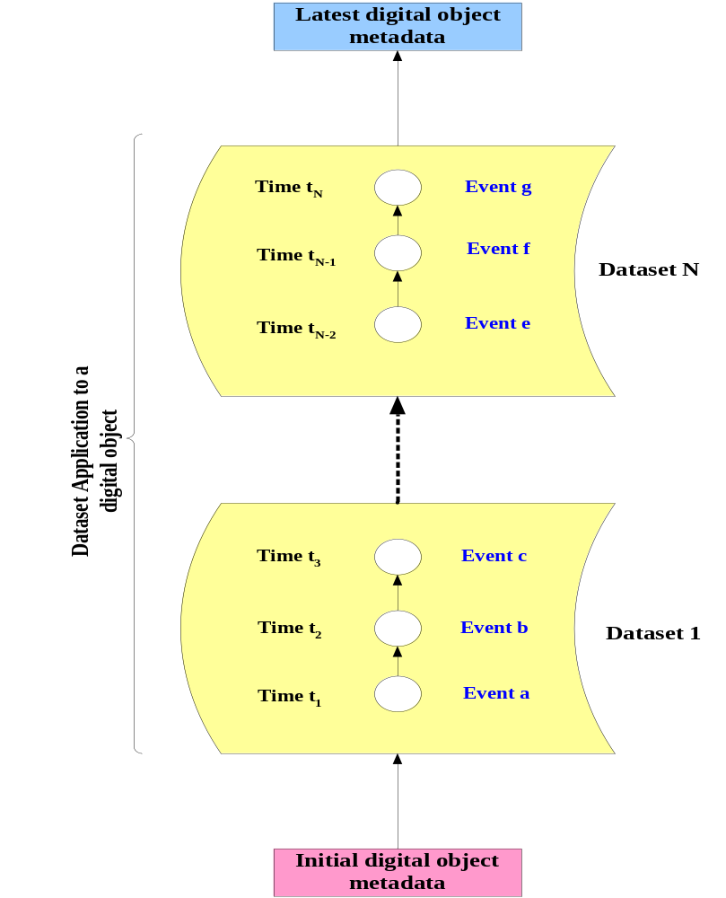

Figure 1. Retrieving the latest digital entry metadata

To build a digital entry metadata for a certain point, we just apply the related dataset(s) on top of the initial digital entry metadata based on their creation time, and the plus sign (+) in the formula indicates the application of the related dataset(s) on top of the initial digital entry metadata. As a result, we have:
Current DE Metadata = Initial DE Metadata + .

4. Our Prototype System: Semantic Research Grid (SRG)

4.1 SRG Architecture
Prototype Semantic Research Grid (SRG) will provide a collaborative Cyberinfrastructure based scientific research environment. Its tools and services will be backed by databases which store user and community specific data and metadata and will be configured into three applications: (1) A model for scientific research which links both traditional simulations and observational analysis to the data mining of existing scientific documents; (2) A model for a journal web site supporting both readers and the editorial function; (3) A model for a natural collection of related documents such as those of a research group or those of a conference.
Figure 1 shows the overall architecture of prototype SRG system. This system consists of three main layers: (a) the client layer; (b) the Web layer; and (c) the data layer. The client layer is made up of Java Server Pages (JSP) which is translated into servlets by an Apache Tomcat J2EE Web container and generates dynamic content for the browser. The client layer communicates with the Web layer over the HTTP protocol through SOAP messages encapsulating WSDL-formatted objects. The Web layer consists of several Web services who handle communication with the existing online tools. The Web layer communicates with the data layer through JDBC connection. Finally, the data layer is composed of several local or remote databases.
Our research is mainly focused on the red bordered area for implementing and using event-based core model as our base. We are also going to investigate the issues: (a) the update model (b) history and rollback mechanism, (c) event and dataset management within the system for a digital entry.
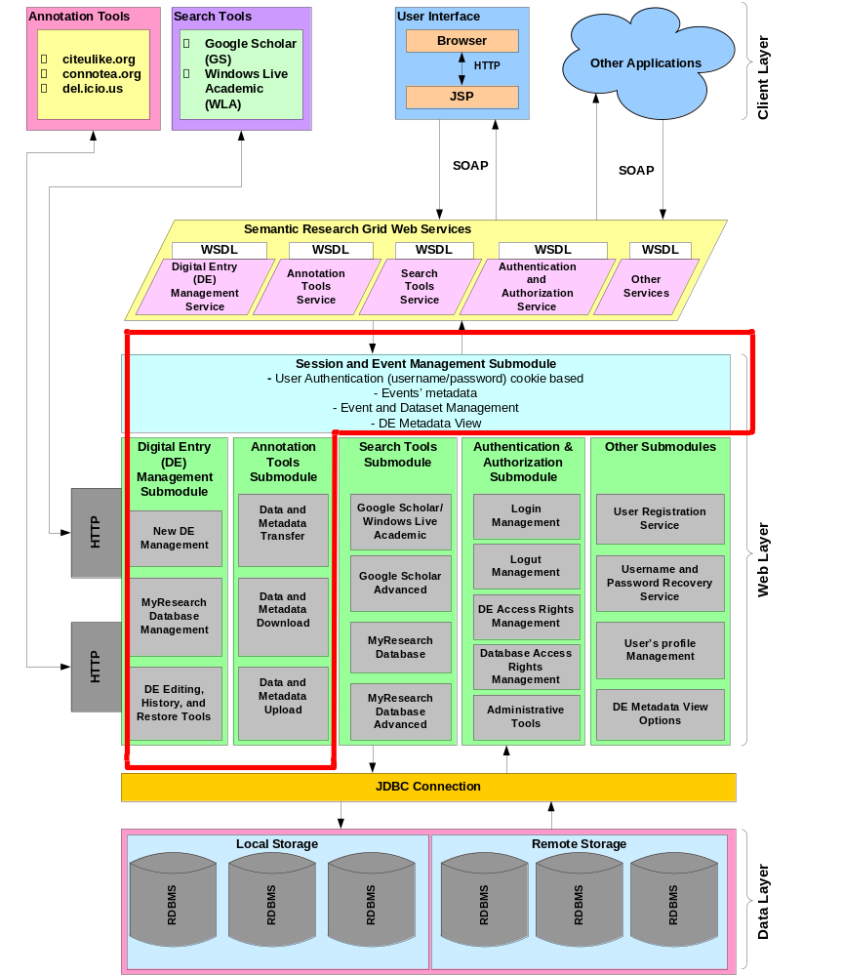

Figure 2. Semantic Research Grid (SRG) Architecture

4.2. Prototype SRG System Research Modules
My research mainly focuses on the event-based model as a base for the SRG prototype system and the following modules of the SRG system: (A) Session and Event Management; (B) Digital Entry Management; (C) Annotation Tools. Next, we give a brief description of the functionality provided by each module:
(A) Session and Event Management Module
The goal of this module is to store user specific data such as user credentials (password/username) cookie based, minor events to a DE, and the “view options”, which control the level of detail with respect to the metadata fields displayed for each DE.
A session is a user’s state information, and maintained on the server side [18]. From the moment user logged in the SRG system, user credentials, any changes made to a DE, and view options for metadata fields of a DE are all saved in the user session. When a user logs out from the SRG system, all unused minor events (modifications to a DE) for a dataset creation are removed. Users of the system can access and simulate the minor events, which represents the updates for a digital entry, before creating a dataset(s) by selecting available minor events for a digital entry.
(B) Digital Entry Management Module
This module: (1) allows the user to manually insert a DE into one of the local/remote SRG databases; (2) Integrates PubsOnline software—“an open source tool for management and presentation of databases of citations via the Web” [11]—into the SRG system and provides an interface for searching the local/remote databases of SRG. (3) Provides access to the history of a DE and rollback mechanism, from its entry into SRG system to present; (4) Allows a user to view detailed information about a DE; (5) Allows a user to update any metadata fields of a DE, which is saved into session as a minor event for this DE (Update Model).
(C) Annotation Tools Module
This module provides an interface to the annotation tools: Delicious, CiteULike, and Connotea. It allows a user: (1) to upload DEs data and metadata to one of these annotation websites; (2) to download DEs data and metadata from one of the annotation websites into one of the local/remote SRG system databases; (3) to transfer DEs data and metadata between these annotation websites.

5. Summary

In summary, this architecture reconciles multiple sources of annotation and metadata for digital entries by having event-based model, which allows users to rollback or roll-forward in a flexible fashion. It is based on Web Service standards and technologies to provide easier capability extension and easier integration in grid systems.

6. References

