Building a Culturally Sensitive portal for Indigenous Nations

Abstract

The eHumanity Project, developed by Indiana University in collaboration with the American Indian Higher Education Consortium (AIHEC), aims to create an evolving online cultural repository for the native tribes of the North American continent. By establishing a database from the collections of the Smithsonian Natural Museum of the American Indian and Autry Southwest Museum of the American Indian, a further means of accessing and researching these artifacts is offered to the public free of cost. eHumanity is a social portal providing access to Native American digital artifacts and discussions regarding them. We describe the requirements, implementation, user testing, and speculate as to its generalization for supporting indigenous nations and their heritage. We also present an opportunity space that is ripe for more research and investigation. We conclude by describing a preliminary vision for the next generation of culturally collaborative platform(s) for Native Americans and other indigenous nations.

1. Introduction

“Because living on the reservation is something like living at a prison… oppression becomes a culture in and of itself, along with a hatred of perceived culture.”

This comment might easily be credited to a Lakota tribesman of the 19th century, angry and bitter at their subjugation by the United States military. The very tribe forever immortalized as victors of the Battle of Little Bighorn against General George Armstrong Custer found themselves swept away in the end, forced into an exodus from their most sacred lands and condemned to live out their days in a territory both shrunken and surrounded by hostiles.

It may then be a surprise to learn that the previous quotation actually came from a 21st-century Blackfeet woman working in a high administrative position at the United Tribes Technical College (UTTC) in Bismarck, North Dakota. The original people of America are not just a thing of the past. They endure even today, as does a cultural decimation that has attended so many of them for hundreds of years.

It is no secret that in the United States of America there exists a separate sub-culture, indigenous but hardly ever noticed, belonging to those people who trace their cultural ancestry to roots that predated all European colonization and settlement. Their names are practically a part of the national lexicon. Ask any average American to list off ten Indian tribes, and they will quickly respond with Apache, Sioux, Pueblo, Navajo, Lakota, Chippewa, Algonquin, Nez Perce, Iroquois, Cheyenne. Still others will mention the Blackfeet, Huron, Cherokee, Mohawk, and even Inuit. These names are bandied about in all aspects of our popular culture, and exist in terms of geography, topography, and an established national perception of America itself. They form a part of our past inasmuch as the emotions they evoke continue to endure. Some might think the best way to do good by the American Indian tribes is to preserve their memory in our education, as a reminder that these people did indeed exist. A history lesson, serving only to teach us how we should never again repeat such drastic mistakes that led to the extermination of so many lives, stories, and beliefs.

Instead it is our belief that education, while of no mean importance, pales in comparison to not only honoring but also preserving and indeed promoting the culture of American Indian tribes.
Our project, eHumanity, is an online portal originally developed as a repository for the collections of two of the nation’s most prominent American Indian museums: the Smithsonian’s National Museum of the American Indian (NMAI) and the Autry Southwest Museum of the American Indian (SMAI). Initially as a mean of disseminating information, through continuous development eHumanity came to represent a greater purpose: to utilize modern social technology in the promulgation of cultural ties amongst members of tribes within the North American continent. Our project was developed through the Indiana University Pervasive Technology Institute Community Grids Lab, funded by grants from the National Endowment for the Humanities through the American Indian Higher Education Consortium (AIHEC). The goal was to establish an online cultural repository whose entire presentation could be tailored by exposure to the expectations and preferences of the American Indian tribes themselves. By adapting previously existing social media, our free website evolved into something with the potential for a far more personal experience on the part of its users.

This paper chronicles the story of eHumanity [8] up to the present day. First we have an overview of literature related to the establishment of the site’s content and features. This includes references to other journal papers dealing with a similar situation as our own, in addition to those sites and public offerings that encouraged us to adopt more creative strategies in terms of usability and reference. Afterwards comes a detailed explanation as to the actual technological design process. It includes a summary of the website’s development, the studies and tests we engaged in, and feedback from potential users; everything from color choices to portal sign-in and interaction. Then we include a more in-depth analysis of the actual user input derived from various sources. A number of focus groups, surveys, web seminars, and usability testing processes took place that led to the finished product. Finally, we will detail not only the conclusions reached in regards to eHumanity, but also its potential.

2. Literature Review

While the incentive behind an indigenous cultural portal seems obvious, actual journal studies on the topic are not so easy to come by. Attempts to locate similar works for comparison did yield at least one such submission conducted under the auspices of Polytechnic of Namibia in Africa. The project was divided into two papers; the first detailing field research, and the second concerning trial runs. In the article ‘Determining Requirements within an Indigenous Knowledge System of African Rural Communities’ [1], Winschiers-Theophilus et al undertook expeditions to two villages in eastern Namibia to record and interview various residents in order to highlight user-culture areas wherein their proposed venture would require attention. A lead-up to the actual work of building the system, their year-long inquiry yielded insights into how native users express and communicate information, whether it be social or intellectual. A similar issue has always been recognized with eHumanity. In order to fashion a service that would meet the tribes’ expectations, throughout 2011 we engaged in fact-finding missions of this nature at the United Tribes Technical College (UTTC) of North Dakota and the Institute of American Indian Arts (IAIA) in New Mexico.

2.1 Similarities and Differences in Approach
The initial Namibia study differed from our own in that it had no finished product to demonstrate. Instead they hoped to ascertain cultural norms and build from there. Another challenge they faced was linguistic in nature, being that several researchers did not speak the native dialect and had to rely on translations, which in and of itself represented a loss of information. Our respondents all knew English so there was no inherent confusion. In addition, our participants were for the most part computer proficient, while the Namibia natives did not rely on technology to any great extent beyond cell phones. Despite these differences, certain shared experiences and conclusions can be drawn between their work and ours. The Namibia expedition relied on handheld video cameras distributed to residents so they could record their responses to direct questioning or matters of daily life. In contrast to simple audio recordings, it was determined that “…video and digital storytelling (linking photos to audio) may suit people that emphasize direct, oral communication in every-day life…” [1]. Similarly, many of the subjects at UTTC expressed greater facility navigating the eHumanity site when guided by visual imagery rather than textual prompts. They expressed the opinion that video recordings would be more engaging to elder tribesmen who were not technologically proficient.

2.2 Comparing Results
In both studies there was enthusiasm on the part of the respondents at the potential yielded from such shared knowledge systems. In addition to aiding them in academic work, several UTTC and IAIA users communicated an intention to contribute crafts and photographs held in their families for hosting on the portal, along with the stories behind them. The eHumanity site was further nominated to showcase the enterprises of modern-day artists and not solely ancient historical artifacts, as means to propagate as well as preserve culture. Likewise in the Namibia study, “Participants articulated various goals for sharing digital content… ranging from the wide benefit of TLK (Traditional Local Knowledge) for ‘nature and people’ to addressing the loss of wisdom and know-how by clan members who, for economic reasons, spend time living in urban areas.” [1]. One woman interviewed at UTTC also pointed out that many young native people living on reservations are eager to leave these confines and set out into the world owing to a strong sentiment that there is no future in reservation life. Faced with this exodus on the part of the young, elder generations feel that there is no longer an audience for the traditions, languages and experiences they themselves have conserved. The opinion was expressed on the part of one ethnographic interviewee was that elders fostered a strong distrust of anyone approaching them for the purpose of acquiring knowledge owing to the impression that these seekers did so for the wrong intentions. In Winschiers-Theophilus [1], people also deduced that the prima facie verisimilitude of the individual offering information in videos was just as important as the lesson itself in terms of whether or not they could be trusted. According to them, this “...confirms earlier results from other projects in which the presented information must be attached to a trustworthy person to be accepted.”

2.3 Difference of Aspirations
A final product was eventually realized in the separate aforementioned study. Winschiers-Theophilus et al went on to utilize the results of their research in developing a 3-D representation of a Namibian village in which various aspects of rural culture were visible through recorded videos situated throughout a digital environment. The development and subsequent testing is documented in another paper, ‘A New Visualization Approach to Re-Contextualize Indigenous Knowledge in Rural Africa’ [2].

While the eHumanity site could be considered mainly static in terms of its visual elements, the Namibia environment heavily depended on motion; traveling through a computer-generated environment and interacting with figures to precipitate videos to play. In this study the researchers found that, as in our case, a final product could still contain unexpected social flaws. Whereas their approach demonstrated a lack of knowledge concerning local flora and fauna in terms of landscape design, we discovered that even something simple like a font choice could lead to misconceptions and loss of interest. Two people invited to contribute their comments regarding eHumanity on a blog at IAIA expressed displeasure that the Papyrus font was being used in the site’s logo. This font was considered to be unoriginal, representing an outsider’s opinion of what writing style might be associated with the tribes. Some even disapproved of the word ‘artifacts’ to describe our collections, preferring ‘treasures’ so as not to imply vanished history.

Complaints may be universal in any attempt to create something for others. But in terms of useful comparisons, there is actually little relation between our project and the Namibia study, nor is it simply owing to expression and design. An essential difference in future objectives is what separates us from the articles mentioned so far. Since the Winschiers-Theophilus 3-D environment was never intended for its viewers to establish an online presence of their own, it is entirely self-contained, designed to offer information without receiving input in return. This seems to be a crucial disparity between what we intend to create and their product. Though it was mentioned before that eHumanity content might be described as ‘static’, in actuality there is more growth and progress inherent to our site than one that relies entirely upon what might be called ‘moving parts’. Since its first inception, eHumanity was never intended to be just an online museum. The transfer of knowledge is a two-way street. Our site would stagnate and die in terms of interest if nothing ever changed. This motivation compelled every aspect of the portal’s continuing development.

3. eHumanity Technological Growth
The core mission of the eHumanity project is to create a more favorable environment for Native Americans to share their stories, preserve their heritage and motivate learning about their culture at the same time. This requires attention to technological development from the outset. A technical comparison of several social networking websites such as Facebook, YouTube, Twitter etc. was performed for purposes of deciding appropriate database architecture and technologies to use for the e-humanity portal with the following goals:
- Sustainability and scalability of the data
- High performance & efficiency of technical operations. e.g. database calls
- Dynamic interactivity with independent applications
We finally decided to use MySQL for our database storage, PHP for server-side scripting language, different third-party authentication APIs for easing user registrations, and heavy use of JavaScript/CSS/XHTML framework with various AJAX libraries such as jQuery [7] for front-end web development in order to achieve the most cross-compatibility across different browsers. Several iterations of wireframes and sketches were completed to ensure a good visual design before implementation. Wireframes are constantly being edited and changed with results from quick but informal usability testing until the desired result was achieved for a particular webpage. After this is finished, the actual page is created on the server. Useful features are added or dropped depending on outside input or perceived benefit. These decisions came about as a result of user testing and long discussion on various topics related to these results.

3.1 Database and Storage
Among the features provided, one of the key components is the ability to collect and store cultural material from a variety of sources. For the first phase the portal contained artifacts from the NMAI and SMAI. The following technological review will detail how this information was parsed in order to arrive at a suitable standard for web viewing.

The data derived from both museums came in their own preferred XML format. We chose a relational database system to store and query XML data instead of using a file system or an object-oriented database. This is because it provides support for querying the XML data and is mature enough to handle complex queries [3]. The data from the museums did not map well. For example, NMAI usually had a detailed description of geographic information in a specific format, while data from SMAI merged geographic information into a general description that might also include other details such as date, culture and how the object was created. In order to make a scalable database, we analyzed the total data and tried to see if there were similar patterns in it. The idea was to make a general table that contained common information from NMAI and SMAI so that we could index them and make it easy to search later on. The following figure shows a rough database structure of how an “artifact” object is stored.
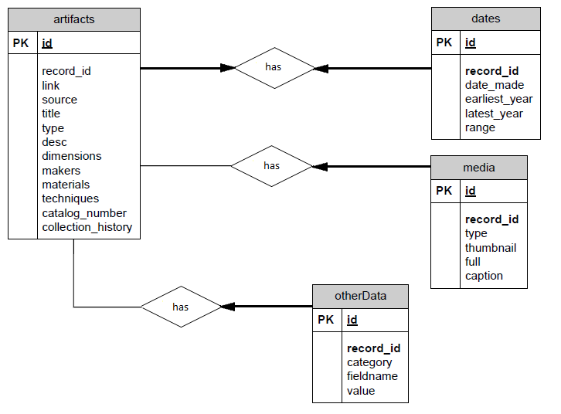
Figure 1: eHumanity Database Storage Model

The artifacts table in Figure 1 contains common data from both museums as shown above. Each artifact shown has exactly one and only one date information. The media table stores the pointers to the actual images of the artifacts. Notice that an artifact can have multiple or no images. The otherData table has any other information that is hard to map. Such data is preserved in this table in order to avoid losing any valuable information.

3.2 REST API and AJAX: Why Use REST Architecture for Web Services
After importing all the information into a database, we wanted to make a simple RESTful interface so that our data access and data output could be standardized for current and future use. In the future, any data that would need to be imported into eHumanity would most likely have to follow certain formatting guideline for easy import. RESTful service is a lightweight system that makes the data easily readable so that the developers can create interfaces for their own need [4]. The benefit of this approach is that developers no longer have to worry about the details in the backend. Examples of popular RESTful services include Facebook [5] and Google [6] APIs. For example, we can call REST API for searching and browsing without knowing what is happening at the server side. In addition, external developers who are interested in our datasets would be able to make use of it for their own purposes. The following figure shows only a partial search result for “basket” by calling http://e-humanity.org/rest/rest.php?query=basket .
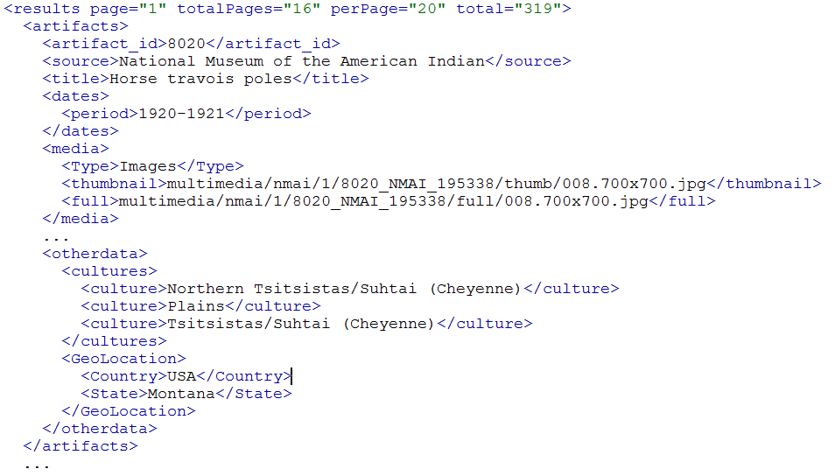
Figure 2: Search Query Result Format Example

A user could easily go to the next page by providing an optional parameter in the REST API: rest.php?query=basket&page=2, or make a request by providing a specific id: rest.php?id=145.
Much of eHumanity uses AJAX (Asynchronous JavaScript and XML) in order to provide a more streamlined and satisfying user experience. AJAX allows server requests to be made in the background of a web page. This provides fluidity while browsing because it enables the user to interact with the server without reloading the page. Not having to reload and allowing multiple server requests on the same page greatly increases browsing speed, and therefore yields a more satisfying user experience. Most professional websites have taken advantage of this technology, and it is becoming a standard in today’s web. On the eHumanity portal, examples of features that use AJAX include commenting, notifications, recent activity, artifact browsing, and user profiles.

3.3 Visitor Features of the eHumanity Portal
As a cultural preservation tool, eHumanity needs to be more than a folder filled with images. It must allow for input and interaction from anyone who uses it. Commenting on an artifact is one of the most important features on the portal, enabling users to interact with each other. They may ask or answer questions, or simply share their knowledge about the artifacts. Certain qualified users are designated Subject Matter Experts (SME). These are informed individuals on native culture who can provide insights to other users. We hope that commenting can be useful the way it has been in other social networking websites.

Browsing/searching for artifacts is a crucial means of interaction on the portal. Artifacts are populated on the browse page via AJAX/REST calls to the web server. The artifact data response is presented in XML format that is parsed appropriately at client-side. On mouse hover, the artifact’s name and period of time are shown, and a closer view of the artifact is presented. Figure 2 contains a group of several artifacts corresponding to a search query. Notice the closer view with the artifact’s name with time-period for the top-left item. The zoom-in feature is useful for users who might not be able to see the full view, but upon zoom it could be more apparent what visual details it includes. It is important that the images are visually appealing, as presenting artifacts is one of the main reasons for eHumanity’s conception. This is done using CSS for positioning and JavaScript/jQuery for the image zooming.

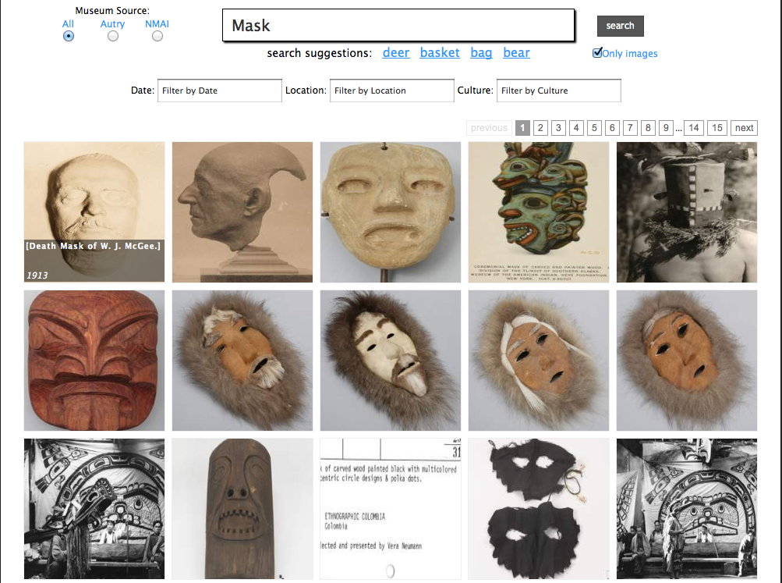
Figure 3: Search Results for query "Mask"

‘Recent Activity’ feature is also an integral part of the portal. Allowing people to see their previous activity can help them organize their interactions. For instance, if a user commented on an artifact that they found profound yesterday, it might be difficult to trace back to that artifact without looking at their recent activity. This interaction can also help users see what others have been doing. For example, say there is a Native American SME that likes to post valuable information about artifacts; it could be in our best interest to check to see what specific items the expert has commented on by looking at their recent activity. Similar to notifications, recent activity is implemented in the same way, as shown on the user’s profile.

User profiles were introduced to eHumanity to give everyone the power of identity. As important as it is to host some of the most desired and historical Native American artifacts in the U.S., it is just as essential to give people a way to share what they know about certain artifacts. Others may want to learn the identity of a user who is contributing excellent information on the portal. eHumanity offers profiles to save user information such as personal details, their own artifact collections, and account settings. The profile is created by AJAX requests made whenever the user clicks the corresponding link on every page. Once clicked, the main content area in the center of the page is populated with information uploaded by the user. Afterwards they are able to visit their profile page where they can access their personal image collections. Collections in eHumanity allow users to organize and remember artifacts that they are interested in. Members can add artifacts through the artifact’s page. The collection is then available for viewing on their profile where they can also choose to remove artifacts. eHumanity plans on expanding the collection concept, as there is a great deal of room for it to grow.

3.4 Social Networking Inclusive
The eHumanity portal allows the use of third-party logins through Facebook and Google. This feature is included to afford visitors a method of signup with which they are already familiar. It is also quicker to login through a third party than to fill out a registration form and verify their account through email. Although eHumanity has its own authentication service available, Facebook and Google’s authentication services are being used by millions worldwide, and therefore can provide a level of security higher than our own. When a user logs in through the social network option, they are taken to the corresponding authentication page, and redirected back to our site with an access token. This token is then used to log the user in. Such a method is also effective because eHumanity can interact with the other sites’ API (Application Programming Interfaces). Therefore, it is possible to access valuable information such as the user’s real name and profile picture. If one logs in with Facebook or Google, their public profile data associated with those accounts is used as eHumanity’s default username and profile picture. The user then does not have to upload anything personal other than what is already available publicly via Facebook or Google.

When one thinks of notifications, the first thing that comes to mind is Facebook. But why would they be useful in a portal such as this? Similar to Facebook, eHumanity shows how many notifications a user has on every web page. This provides a strong way to keep users active while on the portal. Rather than having to check your posting periodically to see if anyone commented on it, it is easier to simply be notified when a comment is made on your posting. eHumanity alerts users when someone comments or likes something they posted via email. These are updated based on a timer and user clicks. Whenever the timer is complete an AJAX request is sent to the server that checks the database to see if there are new comments on any of the current user’s posts. A number is sent back updating the notification count on the page. The actual notifications (what and when the user posted something) are displayed upon click via AJAX request to the server.

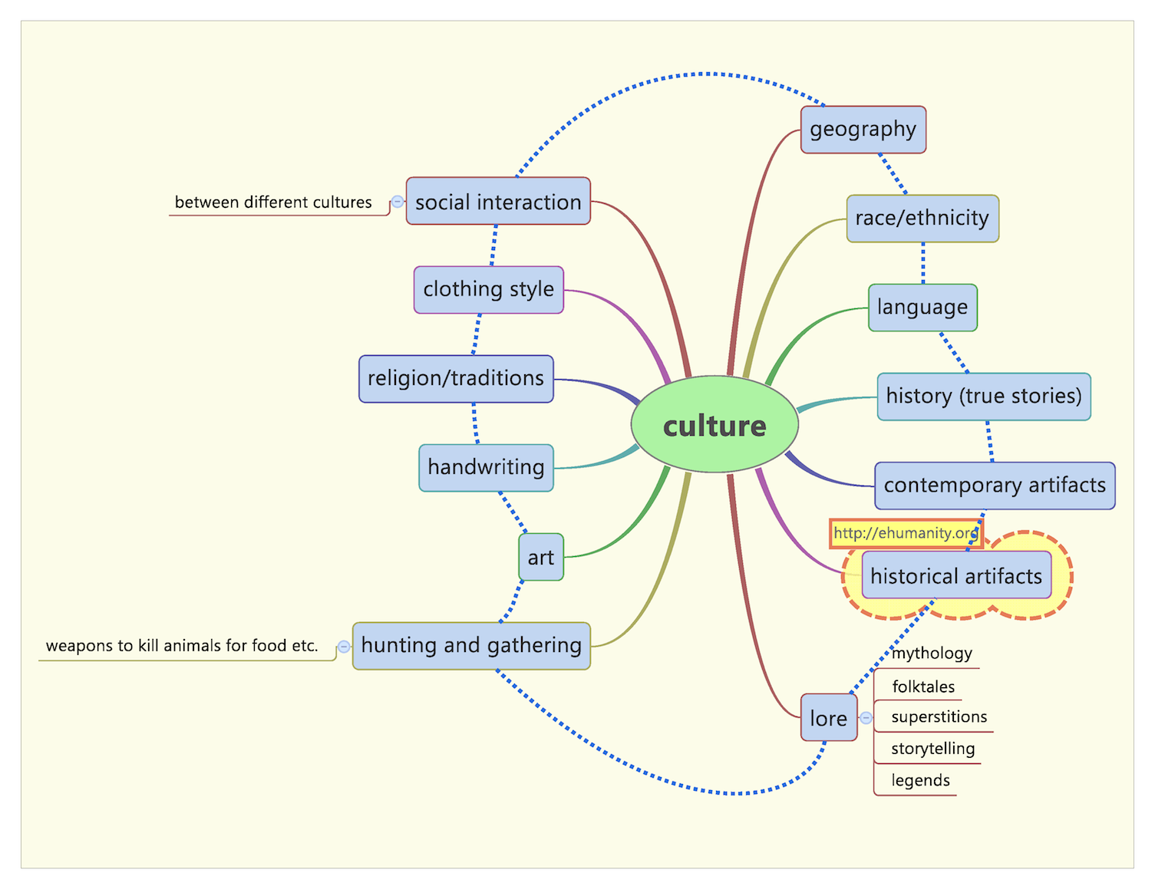
Figure 4: Aspects of “Culture” in relation to eHumanity

4. Design Process

The innovation of eHumanity lies in that we are not attempting to form a bare-bones stand-alone portal. Its goal has always been to facilitate sharing and collaboration of content amongst others in the hopes of creating meaningful dialogue, similar to a storytelling approach. The eHumanity portal has two main purposes: 1) to motivate Native Americans and their relatives to share and learn information about their tribes and culture and, 2) to be a reliable research tool for educators and enthusiasts.

However our own perception of objectives changed over time. While discussing the topic, we outlined several salient aspects that define the idea of ‘culture’, listed in Figure 4. Of those, it was eventually determined that eHumanity in its untested form only satisfied one aspect, that being ‘Historical Artifacts’. After conducting user research at the United Tribes Technical College (UTTC) campus, this seemed inadequate for growth and stability, prompting further exploration into how the portal might qualify for more cultural categories. The most obvious areas in which eHumanity could establish a presence were Social Interaction, History, Contemporary Artifacts, and Language. With these in mind the portal was retooled in the interest of attracting a stronger demographic of audience.

The target audience is very unique. There are actually two main categories: Native Americans along with their relatives; and educators, researchers, students, and interested parties. This poses some challenging design issues. How can we make the portal simple enough for not-so tech-savvy users while maintaining interesting visuals and interactions? The eHumanity team addressed this issue by trying to keep designs simple and interactivity as intuitive as possible. For example, the height for most web pages on the portal was kept at a minimum in order to limit vertical scrolling and allow it to fit its entire length on the screen. If a user must scroll down to see that they can leave a comment, there is a chance that they may miss out on that feature entirely. However, if the information is presented in front of them, they will be likely to read it over and possibly comment. Even the color scheme of eHumanity is meant to be simple and warm. As time went on and our choices were proven accurate or not, we saw a different kind of web portal emerge.

4.1 First Phase Development
Initially eHumanity was envisioned as an educational resource. Both museums participating did so in the hopes that previously unrecorded tribal lore regarding their artifacts might come to light as a result. This could be in the form of a family member recognizing a person or location in a photograph, or someone revealing a history of ownership and possibly creation regarding an item. The purpose behind making these exhibitions more widely available was to engage a segment of the population that was most knowledgeable about them and thereby open up new avenues of information regarding their history, utility, and social context. The most difficult portion of this approach was generating groundswell; that is, notifying people such a portal existed in the first place. Whether or not we could develop an engaging web experience proved secondary to actually allowing the public to know it was there.

Our first attempt to foster interest in the site was aimed at an educational audience. After the initial beta version of eHumanity was established in April 2011, open access was granted to interested members of the Indiana University American Indian Student Association and staff at the Mathers Museum in Bloomington, Indiana. This included an online survey asking them to mention their expectations about the portal and offer their comments/feedback on the site’s potential. Overall our respondents found favor with the concept in terms of personal appeal, especially the included social networking components. Still, several people were of the opinion that certain elements and themes might be considered offensive to American Indians. Through contact with the American Association of Museums, we then received a list of museums across the country that had significant interests in native tribal antiquities. From June to July of 2011 mass emails were sent to over 200 staff members in these institutions informing them of the site’s existence and aspirations, as well as asking any interested personnel to consider volunteering to be SMEs on the portal. What reception we received was positive in regards to the collection’s availability and the social networking aspects, proving that eHumanity did have its appeal. The portal was finally released with major interface changes in the summer of 2011 following some feedback provided in ad hoc usability sessions. The Eiteljorg Museum in Indianapolis, which is devoted to the American Indian, was also contacted but declined to participate owing to their involvement in a similar project under different auspices.

4.2 User Research
Post summer of 2011, our team focused on developing portal features that allowed an easy means of capturing any portal-related feedback or complaints. We also wanted to do some post-development usability testing and primary user research on our target audiences to gain a better understanding of their point of view and identify the success level of the portal. In order to accomplish this goal, we conducted a two-day research/usability session at the United Tribal Technical College (UTTC) in North Dakota amongst students and staff member who were paid for their efforts. Fifteen people ranging in age from early twenties to fifties volunteered to participate in the focus group sessions. Seven were subsequently recorded on video as part of the usability testing while perusing all that the current eHumanity had to offer. Our onsite staff member interviewed them during this testing phase, and upon his return the principal eHumanity staff observed the videos and research notes to discuss their results. Three of those interviewed had great difficulty determining how to locate the collection search feature from the main page. A similar number pointed out that older users would not be as adept as themselves and consequently might not recognize the worth in trying. As per the recommendations of one and observations of four users, it was concluded that a global search that would span across the entire portal would be a better idea so as to have ready access the feature as and when required. Over half those interviewed expressed interest in site content in terms of their own personal tribal heritage. A member of the Blackfeet tribe pointed out a photograph of an ‘earth home’ while relating how his mother had lived in one just like it up until her early teens.

Following this a blog study was conducted among students at the Institute of American Indian Arts in Santa Fe, New Mexico. Of three students involved, the most significant revelation proved to be the idea of featuring modern artists and their works on the site. In addition a woman descended from Chippewa Cree revealed that a collection of ‘star blankets’ in our collection whose online information associated them with her tribe could not be considered truly traditional since the practice had actually been introduced by means of the Christian church. This proved to be the first specific instance in which a user contributed a legitimate amendment to the information provided by the museums regarding their collections. A video webinar with the instructor of the blog study assignment and four of the students took place as means of follow up on their blog posts and/or to capture any information that was not mentioned explicitly in the blog posts. All students were of an opinion of making eHumanity as a one-stop shop for researching on their tribal culture with strong emphasis on language. They were, however, concerned about how culturally sensitive artifacts or information would be addressed on the portal in the future.

4.3 Amending Perceptions
The ‘star blankets’ example might seem to be exactly the very thing we set out to accomplish. However, by that stage a new incentive was motivating us beyond the wholly educational implications. It had become apparent through group discussions that the most appealing quality of eHumanity was in its approach to social networking. Four people in the UTTC trial specifically mentioned their approval of Facebook being associated with eHumanity in terms of comforting first-time users. This was considered to be the most user-friendly aspect of the design as it catered to a recognizable trend in modern social consciousness. Video and audio recordings of native languages were encouraged as a feature in order to preserve examples of these tongues before the elders who knew them passed away. Our focus then shifted from seeking out information to encouraging people to engage in discussion and tell their stories. The museum collections served as a trigger to bring individuals who might otherwise never meet into contact. Correspondence would result, hopefully promoting the continued use of eHumanity. In short, it had become as much about the people on the site as the artifacts themselves.

Further discussion amongst the eHumanity staff solidified a growing perception that rather than an educational tool, we had in fact established a cultural component in and of itself; one that could evolve to meet the needs of its constituents in addition to providing them with an opportunity to view and promote their personal heritage. In place of leaving comments on the objects, the majority of them were more interested in developing the personal image collections for their profile pages. This confirmed the previously mentioned emphasis on graphic rather than written appeal in terms of user interest. One person proposed that eHumanity offer to host a feature by which users could rate images on the entire web in terms of whether or not they qualified as authentic representations of American Indian tribes. It was the social aspect that drew their interest in the end.

5. Potential and Opportunities

Language, History, Contemporary Artifacts, and Social Interaction. These are the aspects of culture from Figure 4 we seek to invest in our new eHumanity design. And for the most part we feel that eHumanity is capable of expressing those qualities. The journey from stable online resource to variegated communication strata lasted a year. In that time, it became evident that certain perceptions were working against us. What we considered inoffensive and perhaps even evocative of tribal life invariably seemed to come under fire as patronizing if not outright unhelpful.

5.1 eHumanity: Language and History
As illustrated in the quote beginning this article, there existed a sentiment in the tribal community itself that American-Indian culture is not only dying, but also constricted and not worth living in. A knowledge gap existed between older generations invested in their long-held ways and the youth of today less concerned with heritage than they are about simply surviving in a modern society that demands they get an education before heading out into a world which exists separate and apart from the one they experienced growing up on a reservation.

This is not to assert that no interest remains amongst today’s tribe members in exploring their unique tribal panoply. In point of fact, a great many respondents resonated with the idea that a new avenue of interaction was available in eHumanity, and would be of help in their own explorations of native culture. It could offer a way to save wellsprings of knowledge on the cusp of vanishing forever along with the people who know them. This includes the traditional language of each tribe (Language). However, given the delicate nature of recording the spoken word and our own relative inexperience in developing a concept that revolved around learning languages, we feel that such a feature requires thorough investigation and can be addressed in future versions of the portal. As we learned early on, one must give culturally sensitive topics their due consideration rather than a quick and hasty treatment.

The realization that our product might qualify on many levels of culture led to site capabilities worthy of present-day human/computer interaction. One of the most intriguing aspects of our development cycle was the way in which new uses for eHumanity seemed to occur at unexpected times. It is actually a very versatile implementation we have created. Staff discussion over the recorded usability testing videos highlighted how our portal could serve as a template for other indigenous nations across the world in danger of losing their traditional way of life to cultural sprawl and decline. The Maori tribe of New Zealand, the Hmong of Laos; anyone could take the basic setup of eHumanity and convert it to their own use owing to its ease of adaptability. An entire family of related sites could appear as a result, all under the banner of eHumanity and each with a different past waiting to be explored (History).

5.2 eHumanity: Contemporary Artifacts and Social Interaction
Perhaps most gratifying was the insistence by several user study participants and staff members that the portal would prove easily adaptable to handheld devices which have proliferated amongst modern society. This implies developing technology that would be amenable to our needs. In addition, it was recommended by one of the UTTC respondents that there be an option for promoting up-and-coming artists. This paralleled an idea suggested in our regular round table staff discussions. The original site design included a display on the main page for ‘Featured Artifacts’ taken from our current collection. User testing revealed very little interest in these images, perhaps owing to what members of individual tribes might consider important in comparison to the site developers. But the promotion of living talent holds significantly greater appeal than objects that, while steeped in tradition, lack certain recognizable factors such as the name of the artist or even where they come from. New examples of cultural and personal expression are being created every day amongst the natives of North America. It seems condescending to imply that we must wait a hundred years before offering them any sort of meaningful recognition. For this reason we will soon replace the ‘Featured Artifacts’ section with ‘Featured Artists’ (Contemporary Artifacts).

Over time it became evident that just as important (if not more) as the worth of the cultural treasures being put on display was the way in which the users can absorb them. Not simply by offering wider access to these artifacts, but also allowing those who view them to establish intellectual and emotional claim in them (Social Interaction). It became necessary to foresee the most salient aspects of social networking sites as something that could entice viewers into creating virtual residences for themselves on this portal, just as they do in Facebook, Flickr, and Second Life. We were basically inviting people to found one more settlement of social interaction amongst the established brands. But while those previously mentioned networks did not start out with anything specific in mind, we had the added impetus (or burden) of first offering an intellectual resource in the form of our online collection.

This potentially limited our appeal: who would come searching for eHumanity except those people already concerned with learning more about American Indian heritage? And should that prove to be the case, how do we tailor our offering so as to not only capture their interest but also refrain from alienating the very people these images relate to most strongly, through some cultural faux pas or ignorant assumption? In short, what was once thought as an educational tool had graduated into a complicated aspect of culture itself-- not an archive or a database set in stone, but a dynamic network that must match the expectations and preferences of its target audience in order to survive. To fail meant relegation to the void of underused, unappreciated websites that proliferate and perish on the dark fringes of the Web. eHumanity set out to create an online community in which American Indian heritage could be recognized, explored, and perhaps even rescued.

6. Conclusion

Conclusions have been drawn that visitors to eHumanity are favorably inclined towards the services offered. It is considered to be a tribute, not a detriment to the societies featured therein. The connections with Google/Facebook yield much approbation since they offer a friendly familiar face through which to access something heretofore unknown. Viewers respond best to picture formats rather than text-based ones, and the option of generating their own private galleries from these archives is a source of great interest. We speculate that with some server upgrades and technical development, we will be able to host audio clips of American Indian languages as well as video feeds. Social networking is one of the most valuable features of eHumanity since it is connected to Facebook where many people already have established ties to their identities. In addition, it is hard to predict what might be considered offensive to people with such a sensitive attention to how their public image might be further mistreated. But ultimately, response to eHumanity was overwhelmingly positive in terms of professional, academic, and target audiences. Considering the extent of tribal influence remaining in the world, there is a large opportunity space for more endeavors like our own to flourish.

Acknowledgements: The eHumanity Project was funded by a grant from the American Indian Higher Education Consortium (AIHEC). Al Kuslikis from the AIHEC has been a very helpful resource. User research at UTTC and the blog study at IAIA wouldn’t have been possible without his co-operation. We would also like to thank Jen Janecek Hartman from UTTC and Craig Thompkins from IAIA for helping organize the user research and blog study respectively. We would also like to thank Pascal Lola and Yohanand Gopal for their early role in development of the eHumanity portal.

7. References

- Winschiers-Theophilus, H., Bidwell, N., Chivuno-Kuria, S., Koch Kapuire, G. 2010. Determining Requirements within an Indigenous Knowledge System of African Rural Communities. SAICSIT 2010, pp. 332-339.
- Rodil, K., Winchiers-Theophilus, H., Bidwell, N., Eskildsen, S., Rehm, M., Koch Kapuire, G. 2011. A New Visualization Approach to Re-Contextualize Indigenous Knowledge in Rural Africa. SAICSIT 2011.
- D. Florescu, D. Kossmann: Storing and Querying XML Data using an RDMBS. Data Engineering Bulletin, 22(3), 1999.
- RESTful Web services: The basics. http://www.ibm.com/developerworks/webservices/library/ws-restful/. Accessed Jan 1st, 2012.
- Graph API - Facebook Developers. https://developers.facebook.com/docs/reference/api/. Accessed Jan 3rd, 2012.
- Picasa Web Albums Data API. http://code.google.com/apis/picasaweb/overview.html . Accessed Jan 3rd, 2012.
- jQuery: The Write Less, Do More, JavaScript Library. http://jquery.com.
- e-Humanity: Free Portal for Native-American Artifacts. http://e-humanity.org

