Service Oriented Architecture for VoIP conferencing
Wenjun Wu¹, Geoffrey Fox¹, Hasan Bulut¹ , Ahmet Uyar², Tao Huang¹
¹ Community Grids Computing Laboratory, Indiana University, USA
² Department of Electrical Engineering and Computer Science, Syracuse University, USA
{wewu, gcf, hbulut, auyar, taohuang}@indiana.edu
Indiana University Research Park, 501 N Morton St. 222, Bloomington, IN, 47408, USA

Abstract
Most current Voice/Video over IP (VoIP) systems are either highly centralized or dependent on IP multicast. We propose the Global Multimedia Collaboration System as a scalable, integrated and service-oriented VoIP conferencing system, based on a SOAP-based collaboration framework and advanced messaging oriented middleware. This system can provide media and session services to heterogeneous endpoints including H.323, SIP, Access Grid, and RealPlayer as well as accommodating diverse clients such as cellular phones. We suggest that our approach opens up new opportunities for extending classic VoIP systems by using these new technologies designed for scalable Internet based service-oriented computing.

Keywords
Videoconference, Service-Oriented Architecture, Global-MMCS, XGSP, NaradaBrokering,

- Introduction
VoIP and videoconferencing systems are increasingly becoming important and popular applications on the Internet. There are various approaches to such multimedia communication applications, among which H.323 [1], SIP [2], and Access Grid [3] are well-known. Most VoIP systems currently are designed to support relatively small size meetings. However new applications such as international scientific collaborations and real-time streams for monitoring require larger scale meetings which may have as many as hundreds of participating sites, and more sophisticated collaboration services such as video annotation and streaming visualization.
These emerging advanced distributed multimedia systems require a scalable, robust and adaptive service infrastructure. However, both the traditional telecommunication architecture based on client/server model and hardware multicast based Internet model have intrinsic limitations. Service-oriented architectures (SOA) have been developed for scalable Internet applications such as peer-to-peer computing, Grid and Web-Services computing and it is attractive to consider them for VoIP and videoconferencing systems. The architecture of the telecommunication monolithic service provision usually links the packet delivery, call control functions and service logic intelligence in the central hardware boxes. Service architectures suggest that one separates the MCU/Softswitch in VoIP into distinct services for media delivery, media processing and session management. These services can be distributed for large scale of conferencing and replicated for performance and fault tolerance. Further they can also be customized to support different client-side devices and application scenarios.
We propose a service-oriented VoIP conferencing framework which can interoperate with standards –based VoIP systems to forge an open software solution that will leverage existing conferencing resources. We define XGSP (XML based General Session Protocol) [4] as an interoperable control framework based on Web services technology for creating and controlling audio and videoconferences. XML is used to describe the XGSP protocol, similarly to the text messages in SIP, to enhance the interoperability with other Web based components. Based on this framework, we develop Global-MMCS (Global Multimedia Collaboration System) [5] to support scalable web-service based interoperable VoIP conferences and integrate multiple services including videoconferencing, instant messaging and streaming. Global-MMCS uses a unified, scalable, QoS aware “overlay” network – NaradaBrokering [6], to support medium and large size of real-time group communication over heterogeneous networking environments. Using XGSP schema, Global-MMCS specifies a distributed flexible conference management mechanism for integration of various VoIP conferencing services, and a common call signaling protocol for interactions between different conferencing endpoints.
The paper is organized in the following way. Section 2 introduces related work and our design principles. The system architecture is discussed in Section 3 while section 4 presents the implementation of the system and performance evaluation. Section 5 presents our conclusions and discusses future work.

- Related Work and Background
Here we introduce major VoIP systems and compare them in terms of system scalability and deployment. Further we will discuss how each of them provides capabilities for media delivery, media process and session management. The final subsection 2.4, presents the fundamental principles of Global-MMCS.

2.1 H.323 and SIP
Both H.323 and SIP are well known as call signaling protocols for real-time voice and video over IP. H.323, a VoIP standard produced by the ITU, is widely supported by many commercial vendors and used throughout the world in commercial and educational markets. It has binary protocols H.225 [8], H.245 [9], providing call set-up and call transfer of real-time connections to support small-scale multipoint conferences. SIP was defined by IETF to implement VoIP calls with text format and a request-response protocol style like HTTP for the control protocol. Since H.225 and H.245 follow the OSI (Open System Interconnection) style, SIP has advantages of interaction with the modern web protocols like HTTP.
Although H.323 and SIP have similar call signaling features, they do not share the same capabilities for conference control. The protocol H.243 [9] in the form of H.245 commands defines interactions between the MCU and H.323 terminals to implement audio mixing, video switching and a cascading MCU. Moreover the T.120 recommendation [11] contains a series of communication and application protocols and services that provide support for real-time, multi-point data collaborative applications. On the contrary, SIP does not define conference control procedures as is done by H.243 and T.120. Recently the SIP research group has begun to extend their framework but this work is still in its infancy and has not been widely accepted.
Most conferencing systems based on H.323 and SIP have a similar centralized architecture. A multipoint-control-unit (MCU) is the conference server handling media delivery, media process and session management. Sometimes the MCU can be implemented in two components: a multipoint-controller (MC) for the session management and media process, plus a multipoint-processor (MP) for media delivery. Conferencing terminals call the MCU to create and join audiovisual meetings. Another server termed the Gatekeeper in H.323 or Proxy server in SIP offers some call management services such as call routing, call admission and name resolution. This centralized architecture implies that the scale of H.323 and SIP based multiparty conferences are usually at most a few tens in size. Note that to overcome the problems of firewall and NAT during the deployment of H.323 and SIP system across the Internet, one either uses a Virtual Private Network VPN as underlying transport or builds application gateways and session boarder controllers.

2.2 IETF MMUSIC and Access Grid
The IETF's Multi-Party Multimedia (MMUSIC) working group proposed its own control protocol SCCP (Simple Conference Control Protocol) [12], but did not complete this and removed conference control from the WG charter in 2000.
The Access Grid project starts from the MBONE tools: VIC and RAT, which it improved, and defines its own conference control framework rather than SCCP. The Access Grid (AG) can support a large scale videoconference based on a multicast network and supports the group-to-group collaborations among 150 AG nodes connected to Internet 2 world wide. Permanent virtual meeting rooms were also introduced in Access Grid as “virtual venues” for the purpose of collaboration services management. Users are allowed to establish their own venue server which hosts the information about the user registration and venue addressing and offers rendezvous service to all the users. Users log into the venues server and start the multimedia clients in their nodes for communication through multicast and unicast bridges.
The major advantage of multicast used by Access Grid is the natural scalability in the architecture. In many current conference events, one can find as many as 50 AG video streams from various places in the world being transmitted to each client in a conference room. However, network administrators and service providers are often reluctant to deploy multicast because of complicated management, the NAT/Firewall barrier and potential security issues. All these problems discourage people without access to high-speed networks from using multicast and Access Grid. Furthermore, media processing and session management are not well defined and implemented in the Access Grid. Since every AG node has to handle all the media streams, the requirements for the client network link are quite high. Clients with limited bandwidth have no easy way to connect to AG and so most users of Access Grid are institutions connected to Internet 2.

2.3 Skype
Kazaa [13] is one of the most popular and widely used peer-to-peer (P2P) system, which initially just provided a file sharing service and has over 85 million downloads worldwide with an average of 2 million users online at any given time. Kazaa nodes dynamically elect ‘super-nodes’ that form an unstructured overlay network and use query flooding to locate content. Regular nodes connect to one or more super-nodes to query the network content and use HTTP protocol to directly download the selected content from the provider. In 2003, Kazaa extended its service to VoIP world by launching the Skype [14] P2P VoIP solution who success is indicated by its recent acquisition by eBay. Skype addressed some of the problems of legacy VoIP solutions by improving sound quality, achieving firewall and NAT traversal and using P2P overlay rather than expensive, centralized infrastructure. It also provided additional features like instant messaging. Skype nodes organize themselves into a peer-to-peer overlay, using the super-node architecture. Super-nodes are operated by the Skype Corporation, which also controls user names and authorization. All end-to-end communication, both voice and IM is encrypted for security. Skype uses iLBC [15], iSAC [16] implemented by GlobalIPSound [17]. These codecs are excellent audio codecs which have very good tolerance of packet loss and sophisticated echo cancellation algorithm.
Clearly the Skype peer-to-peer approach is very successful but it uses proprietary protocols and does not interoperate with other legacy VoIP clients such as H.323 and SIP. Moreover it can only support 4-party audio conferencing and currently has no video service.

 | H.323 | SIP | Access Grid | Skype
Media Delivery | Centralized MCU |  | Internet2  IP Multicast | Kazaa P2P overlay
Media  Processing | Centralized Media Processing:  Video Mixing/Switching  Audio Mixing | Similar to H.323 | Services are done by peer only | Select the most powerful peer for audio mixing
Session Management | Call signaling &  Conference Control:  H.243 & T.120 | Call signaling Only | No explicit session management | Not open standard
Table 1: Comparison of major VoIP systems

2.4 Our design principles
The current systems, summarized in table 1, are not sufficient to address the challenges of scalability, interoperability and heterogeneity in large scale VoIP conferencing system. We suggest that a new design approach based on scalable Internet system SOA can address the requirements of such VoIP applications. Internet has evolved from simple data communication network into an indispensable and sophisticated service delivery infrastructure with many up-to-date software technologies including XML, SOAP, Web-Service, publish/subscribe messaging as well as peer-to-peer computing. These new technologies enable our proposed service-oriented architecture for VoIP conference systems. There are three key features:
(1) A scalable, robust and QoS-aware “overlay” network is needed to support real-time group communication with good quality of service for heterogeneous networking environments. Such an overlay network can be structured to pass through firewall and NAT, provide multicast service using either unicast or multicast networks, make intelligent routing choices and offer reliable data delivery even in an unreliable network. It also can be configured either as P2P or distributed server-based overlay to provide differential services for VIP and regular users. This extends the very successful Skype style of messaging to a Grid and Web-Service environment. We use NaradaBrokering [22] here.
(2) A common AV signaling protocol needs to be designed to support interactions between different AV collaboration endpoints. For example, in order to get the H.323, SIP and MBONE endpoints to work in the same AV session, we have to translate their signaling procedures into a common procedure and build a single collaboration session. A core conference control mechanism is required for establishing and managing the multi-point conference. The structure of this part is similar to T.124 [18] (Generic Conference Control) in the T.120 framework but all description information for the applications and sessions will be kept in XML format rather than the H.323 binary format, which will lead to interoperability, easier development and ability to tap important useful capabilities like security and metadata frameworks being developed for web services. We design XGSP to play this XML-based signaling role.
(3) A distributed media and session service management mechanism has to be introduced to address the scalability issue of the media data in VoIP conferencing. Further heterogeneous clients need customized multimedia service to adapt media streams to their capability. The service overlay network allows the users to locate the suitable service resources and compose them into a service workflow for their purpose. We satisfy this requirement by building media servers using SOAP and XGSP for control and extended binary RTP for data.

3. Global-MMCS: A Service-Oriented Multimedia Communication System
Figure 1 shows the service-oriented architecture of Global-MMCS. As discussed in section 2.4, NaradaBrokering offers the media delivery, storage services and service discovery to various users. Media processing service defines the specific data processes necessary for collaborations such as media adaptation and media mixing. Session management service can control the associated media service instance, maintain the session membership, and enforce floor control.
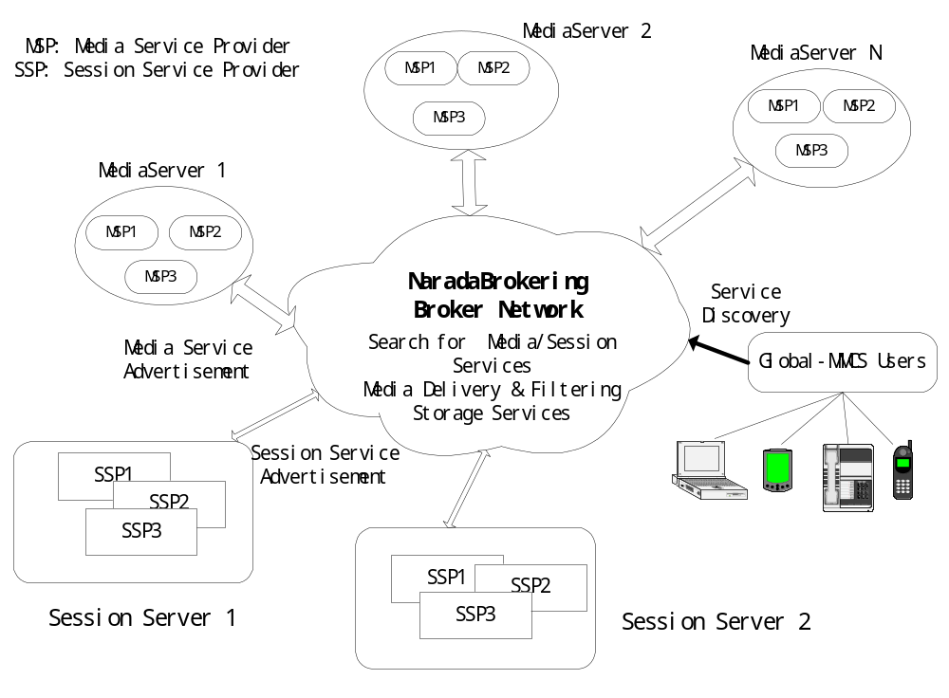

Figure 1. Global-MMCS: A Service-Oriented VoIP System

The NaradaBrokering Publish/subscribe system provides a messaging middleware that decouples producers and consumers in time, space and synchronization. In a wide-area VoIP conferencing system, the heterogeneity in clients is a big issue for the scalability, especially for video. A filter component in publish/subscribe model can make necessary media processes such as transcoding, traffic reshaping, resizing and color transformation to create the customized streams for receivers. The XGSP framework provides clients a rich XML syntax to describe their capabilities and characteristics of network connections. Whenever a client subscribes to a media stream, Global-MMCS checks the format and bitrate of this stream against the customization specification and inserts a proper filter in the media delivery path.

3.1 Media Delivery Service
NaradaBrokering is publish/subscribe a messaging overlay network supporting a dynamic collection of brokers, which can be self-organized into a hierarchical topology to give optimal routing. The performance of the broker connections is also monitored for the QoS routing decision. The NaradaBrokering transport framework facilitates easy addition of new transport protocols for communications between NaradaBrokering nodes. One of the most important elements in the transport framework is the Link primitive, which encapsulates operations between two communications endpoints and abstracts details pertaining to communications and handshakes. Currently we have TCP, UDP, RTP, Multicast, SSL and HTTP based implementations of the transport framework.

(1) RTP Topic and RTPEvent
Since publish-subscribe systems are not typically designed to serve real-time multimedia traffic, they are usually are configured for guaranteed message delivery employing reliable transport protocols. In addition, they do not focus on delivering high bandwidth traffic or reducing the sizes of the messages they transfer. It is usually more important for them to support more features than to reduce bandwidth requirements. In this regard, their messages tend to have many headers corresponding to the content description, reliable delivery, priority, ordering, distribution traces, etc. Since audio and video streams do not require them, many of these headers are unnecessary for the data transmission in our system. For example, a message in Java Message Service [19] has at least 10 headers and many of them are redundant in the context of audio and video delivery. These headers take around 200 bytes when they are serialized to transfer over the network and have significant cost associated with serializing and de-serializing their multimedia content. Therefore, we need to design a new event type with minimum headers and minimum computational overhead.
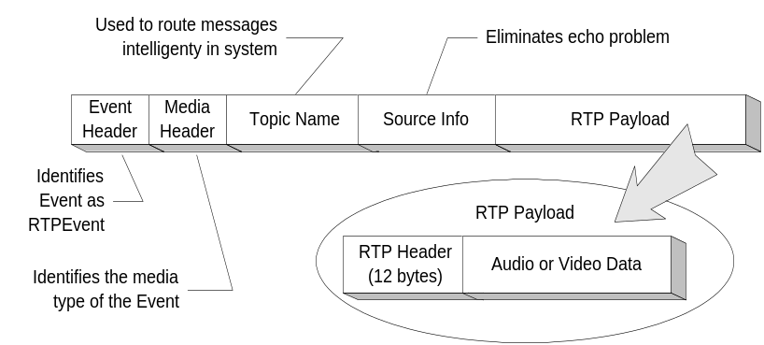

Figure 2. Serialized RTPEvent

We define an RTPEvent which encapsulates media content and consists of 4 elements. There are two headers identifying the event type. Both headers are 1 byte. Event header identifies the event as RTPEvent among other event types in NaradaBrokering system. Media header identifies the type of the RTPEvent such as audio, video, RTCP, etc. To eliminate echo problems arising from the system routing content back to the originator of the content, information pertaining to the source is also included. This information can be represented in an integer, which amounts to 4 bytes. Finally, there is the media content itself as the payload in the event. Although, Figure 2 shows an RTP package as the payload, the latter can be any data type. The total length of the headers in an RTPEvent is 14 bytes. Which is an acceptable overhead for each audio and video package transferred in the system.
Because many RTP based clients from H.323, SIP and Access Grid need to be supported in Global-MMCS, we have developed a specialized implementation of the NaradaBrokering transport framework called RTPLink for both UDP and Multicast. This process entailed an implementation of the Link interface which abstracts the communication link between two entities. The RTPLink can receive raw RTP packages over UDP or multicast from legacy systems, wrap them in RTPEvents and propagate through the protocol layer in the broker node. Once it reaches the protocol layer, the event is routed within the distributed broker network.
The RTPLink deals with the initialization, registration and data processing on the communication link. During the initialization process, the RTPLink is provided a port number to listen for packages from the legacy client at the other end, and also the IP address and the port number of the legacy client to be able to send packages. For registration purposes, the RTPLink is assigned a NaradaBrokering-ID and the RTPLink subscribes to the topic corresponding to its meeting. In the data processing part, the RTPLink constructs the RTPEvents for processing within the broker network when it receives media packages. On the other hand, when an RTPEvent is ready to be sent to the legacy application, the RTPLink retrieves the RTP payload from the RTPEvent and sends it to the legacy application based on the parameters specified during initializations.
We are independently relating these ideas to work on fast XML and use of the SOAP Infoset to properly structure this work as compliant with the web-service framework [21].

(2) Communication Performance Monitoring and QoS Routing
Every broker in NaradaBrokering incorporates a monitoring service that monitors the state of the links originating from the broker node. An implementation of the Link primitive can measure and report performance factors such as bandwidth, jitter, transit delays, loss rates and system throughputs. The Monitoring Service cycles through this list of links at regular intervals to retrieve performance information from each link. The Monitoring Service encapsulates performance data gathered from each link in an XML structure and reports these retrieved information to an Aggregation Node. Each Aggregation Node aggregates performance data from monitoring services running at multiple nodes. One queries the XML aggregated performance data using XPath to detect network conditions. All the metrics can be checked for thresholds and if a certain threshold is reached then the broker node can be informed to take appropriate corrective action.
Individual brokers maintain weighted broker network maps (BNMs) that are used to compute routes to the final destinations. The aggregated information described above is used to dynamically update the costs associated with traversal while routes can be invalidated to reflect network failures. Event routing includes identifying the destinations based on subscribed topics, and routing the content to these destinations by determining the next broker node that the event must be relayed to. As an event flows through the system, an associated trace is modified to snapshot the event’s dissemination within the broker network. These routing traces indicate – and can be used to verify – an event’s dissemination within various parts of the broker network.

3.2 Media Processing Service
Global-MMCS computation and storage resources are linked by NaradaBrokering brokers and consist of service containers that can host both media processing and session management services described by the XGSP framework. Each service provider can advertise its service XML description to the connected brokers. NaradaBrokering offers scalable resource search for service discovery through its routing and event matching mechanism which supports clients using XPATH or SQL-like queries.
Each broker may be associated with a registered media service container called the MediaServer, which hosts multiple compute intensive media processing services which it can create, start or stop. In addition, it advertises these service providers and reports the status information to the broker regarding the load on that machine. Media service customers which are usually XGSP audiovisual session servers can locate the best container and request a service instance to execute in the container.
A media service is a functional entity which can receive one or multiple media streams, perform some processing, and produce one or multiple media streams. In most cases media services should be organized as media filter chains. Filters can be as simple as bit-stream parsing, or as complicated as decoding and encoding. Composite media services are usually formed as acyclic computation graphs consisting of multiple filter chains.
Typical media services for VoIP include: stream adaption, transcoding, audio-mixing and video-mixing. Audio mixing is very important to those clients that can’t receive multiple RTP audio streams and mix them. Video mixing service improves the visual collaboration especially for those limited clients which can only handle a single video stream. Transcoding helps to generate a new stream which is encoded in the format wanted by the user. For examples, if a RealPlayer user needs to receive a video originally encoded in H.261 RTP, a RealStream producer is needed to first decode the H.261 video and generate a new RealFormat stream.
The media service container can also support third-party media processing service extensions with well defined service description interfaces. Moreover, even when only a codec is implemented, it is also possible for the intelligent engine in the container to adaptively organize the transcoding filter chain and automatically generate the media service template.

3.3 Session Management Service
Sessions are defined by the group of collaborating people and their clients as well as their associated media services. XGSP audiovisual sessions have five states: created, canceled, activated, deactivated and finished, which are managed by the XGSP AV session server. An XGSP user can initiate an audio-visual session which is then activated by the session server after the meeting time arrives and the needed service instances are created. Figure 3 shows the typical five steps of the interaction between users and services components during the session management procedure.

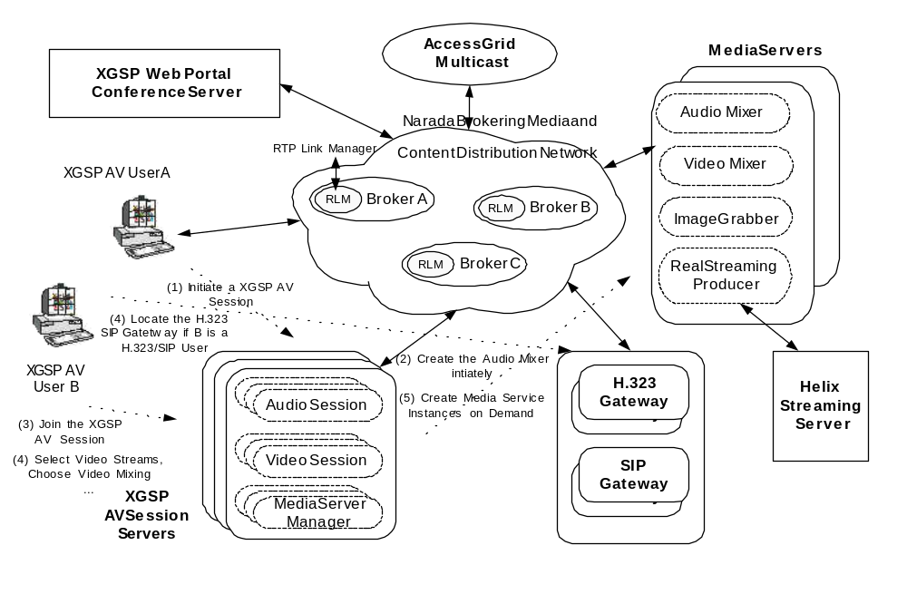

Figure 3 XGSP Session Management in a service-oriented way

Each session server may host limited numbers of active XGSP AV Session for the purpose of load balancing. The precise number depends upon the workload and the computation power of the machines. The session initiator will firstly locate the right session provider to create a session service instance – session server, for a particular XGSP AV session. Then, this session server will locate the necessary media service resource on demand. In the current implementation, a default audio mixer is created to handle all the audio in the session. Private audio mixers can be created for private sessions associated with subgroups in the session. Video mixers can be created by the session server on the request of the client while an image grabber is created whenever a new video stream is detected in the session. Customized transcoding services will be created when a user sends a matching request that requires them. For example, a mobile client such as a PDA connected via Wi-Fi, and with limited processing power, may wish to choose a 24 fps, 4-CIF MPEG-4 video, but then a transcoding process pipeline consisting of frame rate adapter , a video size downsampler and color transformation, is needed to adapt the stream for it. Another example is an H.323 terminal which can only handle H.261 and H.263 codecs may wish to display a MPEG-4 video, and then it will request the session server to start a MPEG-4-to-H.261 transcoder.
The AV Session Server also involves the management of XGSP sessions for other legacy clients like H.323, SIP and RealPlayer for which Global-MMCS has gateways. The XGSP AV Session Server needs to collaborate with these Gateway Servers to deal with the session border control issues in this heterogeneous collaboration environment. The H.323 and SIP gateway transform H323 and SIP messages into XGSP signaling messages. The RealStreaming Gateway gets the encoding jobs from the Session Server and generates the RealMedia streams from the selected conferencing AV streams. Some session border services have to be organized in the slightly different way from media service. For example, H.323/SIP gateways can only serve local users because of NAT/Firewall issues. Therefore, H.323/SIP users must use the H.323/SIP Consoles to launch a search for the local H.323/SIP Gateway and register to it. NaradaBrokering publishes performance monitor data in the form of an XML document, and the AV Session Server subscribes to this network performance topic. From these performance data and broker network maps, the Session Server can estimate the delay and bandwidth between the service candidates and the requesting user. Joining this with the workload of the media service providers, the Session Server can find the best service providers and initiate a media service instance. Furthermore, the AV Session Server monitors the running of each media service instance, through NaradaBrokering topics to which active media services publish heartbeat status information. The AV Session Server is responsible for restarting the service or locating a new service provider if the heartbeat data indicates a failure.

- Implementation and Performance
We have released the initial version of Global-MMCS as open source [5]. Following the description in section 3, it has many software components including: Media Server, Session Server, Web Server, H.323 Server, and Real Streaming packages. The whole system uses the NaradaBrokering system for communication overlay and this software is also freely available in open source [22]. All the audiovisual processing services, including the video mixer, audio mixer, the image grabber servers as well as the front end of RealStreaming Gateway are developed using Java Media Framework where we make available major performance improvements for this standard Java package. Extensive performance measurements have been made to evaluate the scalability of the system.

4.1 Performance of NaradaBrokering for Audio/Video Delivery
The performance of the event brokering network is critical to the success of our VoIP conference system. We tested a single audio meetings serviced by a single broker with varying number of participants as summarized in Table 2.

Total  Users | First user  Latency  (ms) | Last user  Latency  (ms) | Avg  Latency  (ms) | Avg  Jitter  (ms) | Avg  Late Arrivals | Output BW  (Mbps)
12 | 0.5 | 0.7 | 0.6 | 0.18 | 0 | 0.76
100 | 0.5 | 2.3 | 1.4 | 0.15 | 0 | 6.4
400 | 0.5 | 7.9 | 4.2 | 0.21 | 0 | 25.6
800 | 0.5 | 15.5 | 8 | 0.18 | 0 | 51.2
1200 | 0.5 | 22.6 | 11.6 | 0.22 | 0 | 76.8
1400 | 0.5 | 26.5 | 13.5 | 0.26 | 0 | 89.6
1500 | 3.3 | 32.3 | 17.8 | 0.44 | 25% | 96.0
1600 | 2260 | 2290 | 2275 | 1.2 | 100% | 102.4

Table 2 Test results of single audio meetings for one broker

All audio packets are the same size and they are evenly distributed in time (one packet every 30ms), and the routing of all packets in a stream takes the same amount of time on the broker. As long as the routing of a packet takes less than 30ms, the routing of one packet in the stream doesn’t affect the routing of the next one. Therefore, the latency values of consecutive packets are almost the same for each user in a meeting and this results in very small jitter values. Moreover, the latency values for the first client are always constant and very small until the broker is overloaded. In addition, the routing time of an audio packet increases linearly with the number of participants in the meeting. The broker is overloaded when the routing of a packet takes more than 30ms as there are “too many” meeting participants. In that case, the next packet arrives before the routing of the current packet is completed and delays the routing of the next one so that the latency increases continuously for the each arriving packets in the stream. In the test shown in table 1, the broker becomes overloaded when there are 1600 participants in the meeting. The system will of course allow more than 1600 audio participants but our data shows this requires more than one broker as described at the end of this subsection.

We also measured the performance of a single broker both with a single video meeting and with multiple smaller meetings. In multiple video meeting cases, all video meetings had 20 participants. The most important outcome of these tests was the fact that as seen in Figure 4, the broker was utilized much better for multiple smaller meetings than single large size meetings. It supported a higher number of participants with smaller latency and jitter values than in single meeting case with same number of total participants. Multiple meetings better balance the work of a broker within the 30ms inter-packet gap. The broker was able to provide services to 700 participants in 35 video meetings with very little late arriving packages while it was able to support only 400 participants in the single video meeting test.

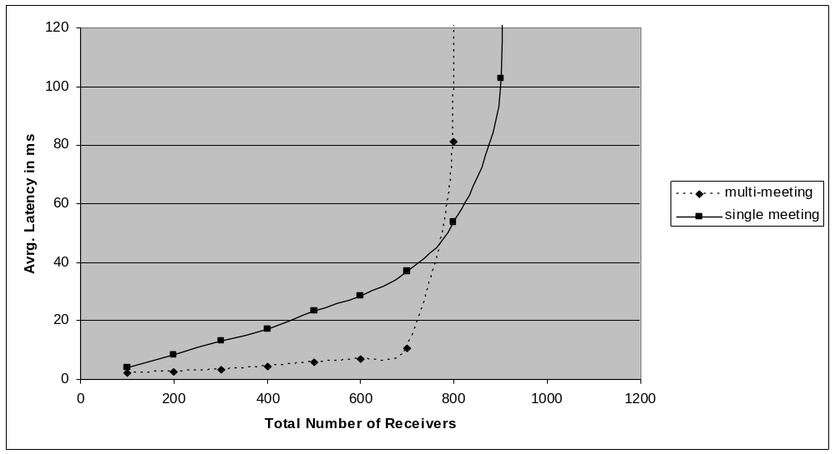

Figure 4 Average latencies of single and multiple video meetings

We also made experiments [23, 24] investigating the performance of the delivery of audiovisual streams to geographically distant locations. Our four sites included Indiana University in Bloomington Indiana, Florida State University in Tallahassee Florida, Syracuse University in Syracuse, New York and Cardiff University in Cardiff, UK. Our tests demonstrate that by running a broker in a remote site, significant bandwidth saving can be achieved and the bandwidth limitations can be overcome to support more participants. Moreover, running brokers in geographically distant locations can reduce the transit delays of packets considerably. Our analysis of the performance of the broker network shows that the NaradaBrokering has a very good scalability in supporting both voice and video communication. In our test setting, four brokers supported up to 6400 participants in an audio-conference and this number can be increased linearly by adding new brokers. The quality of stream delivery for large size meetings can be improved significantly by distributing clients among multiple brokers.

4.2 Media Service Performance
We investigated the performance of media services in controlled experiments. All the service providers running in a single server are configured to create more service instance so that the overhead increase in the terms of CPU and memory usage in the server could be measured. Although there is some difference in the computation overhead generated by services, they are all computation intensive tasks. Since individual service instances can run independently and be attached to different XGSP AV sessions, it is quite easy to distribute them into many different distributed hosting servers with streams software multicast by the NaradaBrokering messaging infrastructure. Provided we instantiate enough media service resources, the scalability of the Global-MMCS can be guaranteed. We imagine that there is either a “farm of CPU’s” in a Grid server based model or a P2P implementation, where these media services are provided on the peer clients themselves. One can trade-ff and mix these models to get needed capability, performance and fault-tolerance.
Table 3 shows the typical overhead caused by media services implemented on commercial PCs. In the audio mixing test, when all the audio streams are ULAW, a machine can support around 20 mixing sessions with each having 6 active speakers. When we made tests with another more computing intensive codec, G.723, one machine can run only 5 mixing sessions. Therefore, on the average one machine may support around 10 mixing sessions. If every mixed video stream is encoded in H.261 and has an average bandwidth of 150kbps, a machine can host up to 4 video mixers. For the image grabber which transcodes a H.261 stream into a series of JPEG pictures, an ordinary machine can run around 50 image grabbers. And the Real Streaming producer has the similar overhead to the video mixing service.

Media Services | Computation Overhead
Audio Mixing | 46% while 20 audio mixers ( six active speakers ) are running
Video Mixing | 94% while 4 video mixers ( 4-way mixing ) are running
Image Grabber | 70% while 50 image grabbers are running
RealStreaming Producer | 90% while 4 23fps stream producers are running

Table 3. Typical computation overhead caused by media services

4.3 JMF Implementation
Java Media Framework (JMF) [21] provides a unified architecture and messaging protocol for managing the acquisition, processing, and delivery of time-based media data. By exploiting the advantages of the Java platform, JMF delivers the promise of “Write Once, Run Anywhere” to developers who want to use media such as audio and video in their Java programs. Although JMF has some good quality for building multimedia service, it is well known to have the poor performance compared to Tcl/C++ based VIC intensively used by the AccessGrid community.
We introduced new data copying mechanisms into JMF to improve the rendering performance of JMF library. Table 4 shows CPU overhead of the rendering one to eight video stream by VIC, the Global-MMCS client based on the unmodified Sun JMF library and the client based on our optimized JMF library. Each video stream is a CIF-size 30-second video sequence encoded in H.261, and has average bandwidth 500kbps. It is obvious that the performance of JMF rendering has been improved by 200% and even outperforms VIC.

Stream Number | VIC | Sun JMF Client | Fast JMF Client
1 | 8% - 9% | 15% - 16 % | 6% - 7%
2 | 13% - 14% | 24% - 25 % | 9% - 10%
3 | 17% - 18% | 33% - 34 % | 15% - 16%
4 | 23% - 24% | 40% - 41% | 17% - 18%
5 | 26% - 27% | 46% - 47% | 23% -24%
6 | 32% - 33% | 51% - 52% | 27% - 28%
7 | 35% - 36% | 58% - 59% | 31% - 32%
8 | 40% - 41% | 62% - 63% | 34% - 35%

Table 4 rendering performance of VIC, Sun JMF and enhanced JMF

4.4 Scalability Discussion
On the basis of our measurement in controlled experiment environment which consists of at most 4 brokers, we can discuss the scalability of the system in a more general way and larger scale. Consider scenarios where users are connected in collaborative sessions such as supported in Access Grid rooms or text chat sessions with all communication performed by NaradaBrokering operating in broker mode or as web service handlers and giving a software overlay network to handle routing.
The overlay routers fall into two groups: Geographical routers handle traffic in a particular region and Functional routers cope with particular capabilities – for our example the different collaboration sessions can be handled by different broker . Hardware multicast is one approach to geographical multicast used by the Access Grid but here we ignore this possibility and assume software multicast although NaradaBrokering supports hybrid protocols that mix hardware unicast and multicast and can give efficient solutions. We will analyze the linkage of multiple institutions.
Assume there are N Institutions, R XGSP AV sessions and M participants per "session”. Let each person send out one native AV stream and receive 4+X streams. Let each client mix the (first) 4 streams to make one composite mixed stream that must also be output. The other X streams can either be other mixed streams or native webcam streams. Clients are also capable of generating these thumbnails of the received streams and publish over the NaradaBrokering. Note we are mixing and image grabbing in P2P mode as there is more CPU power on clients than on the Global-MMCS servers. One could mix on servers but as discussed above, currently low end Linux server can only produce up to 4 mixed streams where each mixed stream is made up of 4 native streams. Thus one needs to assign M*R/4 servers for mixing to make the M*R composite streams imagined here. The clients can display any of received streams and/or the mixed stream that it makes by itself. And it must send out 2 streams including the native stream from its webcam and mixed one it makes.
Assume each person can only be in one room. We configure S routing brokers at each institution each handling R/S rooms (sessions). Note in this model each session is spread among the N institutions and handled by one broker at each institution. So each broker is receiving per session 2*M streams and dispatching (N-1)* 2*M/N streams to remote sites. Here we assume uniform distribution M/N people per session per site, so that each server dispatches (4+X)*M/N streams per session to clients local to institution it is located at. Thus total traffic per session for the server is 4*M + (2+X)*M/N streams.
We can illustrate the result in a particular example: let R= 50, S= 25, N=2, M=20, X=4. Assume the bandwidth of each stream is 1/3 Mbps. Therefore each broker has 93 Mbps traffic summing input and output bandwidth which has basically reach the peak rate in a server with 100 Mbps network interface. Each client needs to handle up to 3.3 Mbps traffic. Each of the two institutions has 25 brokers and 500 clients to which we need to add servers for desired media services. Based on the measurement result in Table 2, one regular server can usually run up to 20 audio mixers. We need other 3 or 4 audio servers for 50 sessions. Many rooms can share a server for their session control Web Service and we can estimate that a safe number is 500 users per session server. Two session servers and two H.323/SIP gateways should be enough for the 1000 users in our example. If for each session we need to generate a RealMedia stream simultaneously, at least 12 servers are necessary for 50 sessions.

5. Conclusion and Future Work
In this paper we presented the design principle and experience of building a scalable service-oriented VoIP conferencing system. This system uses NaradaBrokering messaging middleware as QoS-aware service hosting and delivery infrastructure. Further the XGSP collaboration framework is defined for the media service and session management. Such a service-oriented and integrated collaboration environment greatly improves the scalability of traditional videoconferencing system, and benefits customers using diverse multimedia terminals through different network connections.
We have built a prototype system to verify our ideas and integrate a few common media service for VoIP conferences. Based on the flexible framework, we are working on new services like audio-video annotation and new media codecs such as MPEG-4 and H.264. Further extensions could include: extending the scalability of the system to over 10,000 users, adding archiving and replay services, and customizing the system for different application scenarios like collaborations in e-sports and e-science.

6. References
[1] ITU. Recommendation H.323 (1999), Packet-base multimedia communications systems.
[2] J. Rosenberg et al. (2002) “SIP: Session Initiation Protocol”, RFC 3261, Internet Engineering Task Force, http://www.ietf.org/rfc/rfc3261.txt.
[3] Access Grid (2003), http://www.accessgrid.org
[4] Wu W, Fox G. C, Bulut H, Uyar A, Altay H. Design and Implementation of A Collaboration Web-services system. Journal of Neural, Parallel & Scientific Computations, Volume 12, 2004.
[5] Global Multimedia Collaboration System (Global-MMCS), http://www.globalmmcs.org
[6] Fox G. C, Pallickara S. The Narada Event Brokering System: Overview and Extensions. proceedings of the 2002 International Conference on Parallel and Distributed Processing Techniques and Applications (PDPTA'02)
[7] Handley, M., Crowcroft, J., Bormann, C. and J. Ott. The Internet Multimedia Conferencing Architecture, Internet Draft, draft -ietf-mmusic -confarch-03.txt.
[8] ITU. Recommendation H.225(2000), Calling Signaling Protocols and Media Stream Packetization for Packet-based Multimedia Communication Systems.
[9] ITU. Recommendation H.245(2000), Control Protocols for Multimedia Communication.
[10] ITU. Recommendation H.243(2000), Terminal for low bit-rate multimedia communication.
[11] ITU. Recommendation T.120(1995),Multipoint Data Conferencing and Real Time Communication Protocols, 1995
[12] Bormann, C., Kutscher, D., Ott, J., and Trossen, D.. Simple conference control protocol service specification. Internet Draft, Internet Engineering Task Force, Work in progress.
[13] Kazaa, http://www.kazaa.com
[14] Skype, http://www.skype.com/
[15] ILBC codec, http://www.globalipsound.com/pdf/gips_iLBC.pdf
[16] iSAC codec, http://www.globalipsound.com/pdf/gips_iSAC.pdf
[17] Global IP Sound. http://www.globalipsound.com/partners/
[18] ITU. Recommendation T.124 (1995) Generic conference control, 1995.
[19] Java Message Service (JMS), http://java.sun.com/products/jms/
[20] Sangyoon Oh, Hasan Bulut, Ahmet Uyar, Wenjun Wu, Geoffrey Fox Optimized Communication using the SOAP Infoset For Mobile Multimedia Collaboration Applications Proceedings of the International Symposium on Collaborative Technologies and Systems CTS05 May 2005, St. Louis Missouri, USA.
[21] Sun Microsystems, Java Media Framework 2.1, (2001), http://java.sun.com/products/javamedia/jmf/2.1.1/index.html.
[22] NaradaBrokering open source Distribution http://www.naradabrokering.org
[23] Ahmet Uyar and Geoffrey Fox. Investigating the Performance of Audio/Video Service Architecture I: Single Broker Proceedings of the International Symposium on Collaborative Technologies and Systems CTS05 May 2005, St. Louis Missouri, USA. http://grids.ucs.indiana.edu/ptliupages/publications/SingleBroker-cts05-submitted.PDF
[24] Ahmet Uyar and Geoffrey Fox.Investigating the Performance of Audio/Video Service Architecture II: Broker Network. Proceedings of the International Symposium on Collaborative Technologies and Systems CTS05 May 2005, St. Louis Missouri, USA. http://grids.ucs.indiana.edu/ptliupages/publications/BrokerNetwork-cts05-final.PDF

