**Bluewaters Scientific Impact Analysis**

The well-used bibliometrics of the Bluewaters publications (Table 1):

Table 1: Summary of the bibliometrics

|  |  |
| --- | --- |
| Metric | Value |
| # pubs (raw from reports) | ~1300 |
| # pubs (ISI verified) | 3941 |
| # cites | 4085 |
| i10index (# pubs with citation count greater or equals 10) | 97 |
| h-index | 31 |
| g-index | 53 |
| Publication data latest as of July 2016; Staff publications since 2008, users’ publications since 2012. Citation data retrieved in Sept 2016. | |
| Note 1: Based on what was externally verified against ISI Web of knowledge | |
|  | |

A peer comparison study [1] was done to evaluate the relative performance of Bluewaters publications compared to their peers (appearing in the same journal issues). Table 2 shows the facts about how the peer comparison was done. Table 3 shows the summary results.

Table 2: Summary of the compared peers groups

|  |  |
| --- | --- |
| Years Range | 20081~ July 2016 |
| **verified # pubs (at the time of study)** | **394** |
| # distinct journals (when studied) | 105 |
| # journals studied | 18 |
| minimum # BW pubs in studied journals | 5 |
| **effective # BW pubs compared with peers** | **163** |
| **% coverage of pubs** | **41** |
| % pubs that the top 10% journals covered | 34 |
| # peer publications compared | ~23k |
| Note 1: Staff publications since 2008, users' since 2012 | |
|  | |
|  | |

List of journals where peers comparison study was done:

* ASTROPHYSICAL JOURNAL
* JOURNAL OF CHEMICAL THEORY AND COMPUTATION
* PHYSICAL REVIEW D
* PHYSICAL REVIEW B
* INTERNATIONAL JOURNAL OF HIGH PERFORMANCE COMPUTING APPLICATIONS
* PHYSICAL REVIEW LETTERS
* MONTHLY NOTICES OF THE ROYAL ASTRONOMICAL SOCIETY
* ASTROPHYSICAL JOURNAL LETTERS
* JOURNAL OF PHYSICAL CHEMISTRY B
* PROCEEDINGS OF THE NATIONAL ACADEMY OF SCIENCES OF THE UNITED STATES OF AMERICA
* NATURE COMMUNICATIONS
* JOURNAL OF APPLIED PHYSICS
* CLASSICAL AND QUANTUM GRAVITY
* JOURNAL OF CHEMICAL PHYSICS
* BIOPHYSICAL JOURNAL
* GEOPHYSICAL RESEARCH LETTERS
* PARALLEL COMPUTING
* JOURNAL OF COMPUTATIONAL PHYSICS

Table 3: Peers comparison results summary

|  |  |  |
| --- | --- | --- |
|  | BW | Peers |
| Mean citation | 13 | 7 |
| Median citation | 5 | 2 |
| Mean percentile ranking | 63 | 49 |
| Median percentile ranking | 68 | 48 |

Statistical testing shows both the results (for citation count or for percentile ranking) are significant.

Welch Two Sample t-test for ranking scores:

t = 6.4016, df = 164.13, p-value = 1.547e-09

95 percent confidence interval:

9.332384 17.657042

sample estimates:

mean of BW mean of Peers

62.93865 49.44394

Welch Two Sample t-test for citation count:

t = 3.0231, df = 162.695, p-value = 0.002908

95 percent confidence interval:

2.10169 10.01858

sample estimates:

mean of BW mean of Peers

12.957055 6.896918

Figure 1 and 2 show the ECDF and density distribution, respectively, of Bluewaters publications percentile ranking and the peers.

Figure 3 shows the Bluewaters publications median percentile ranking in each journal of the 18 studied journals, where at least 5 Bluewaters publications appeared.

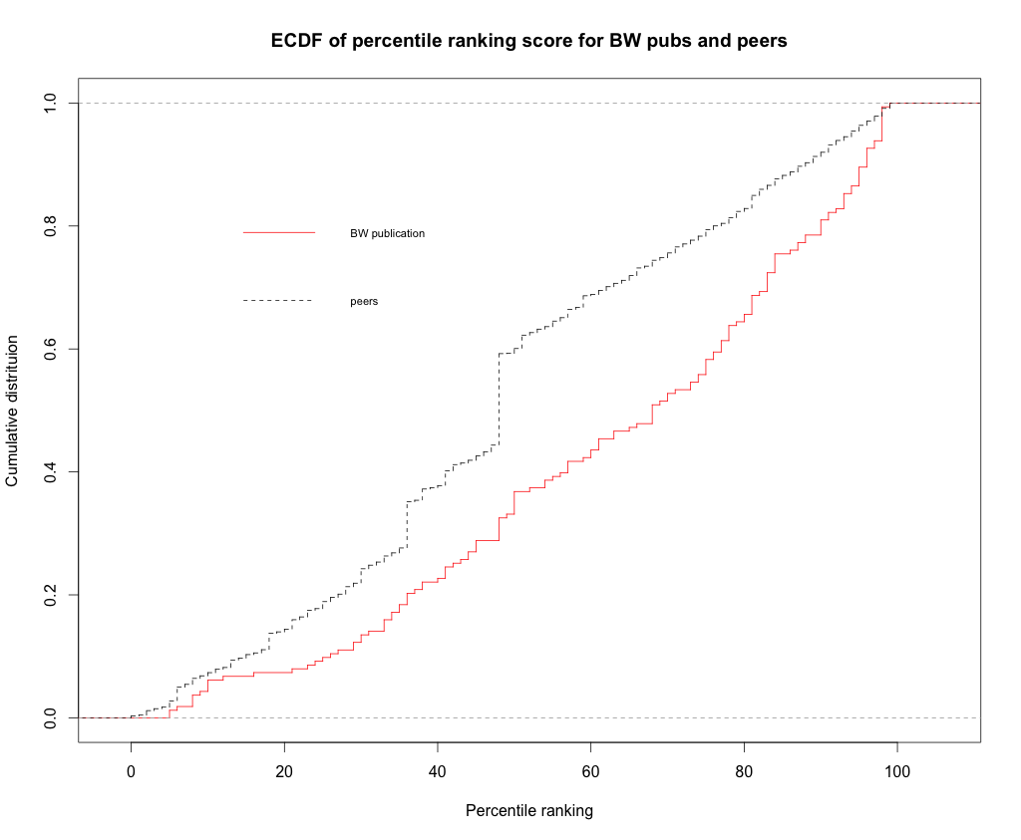

Figure 1. ECDF of percentile ranking score of Bluewaters publications and peers

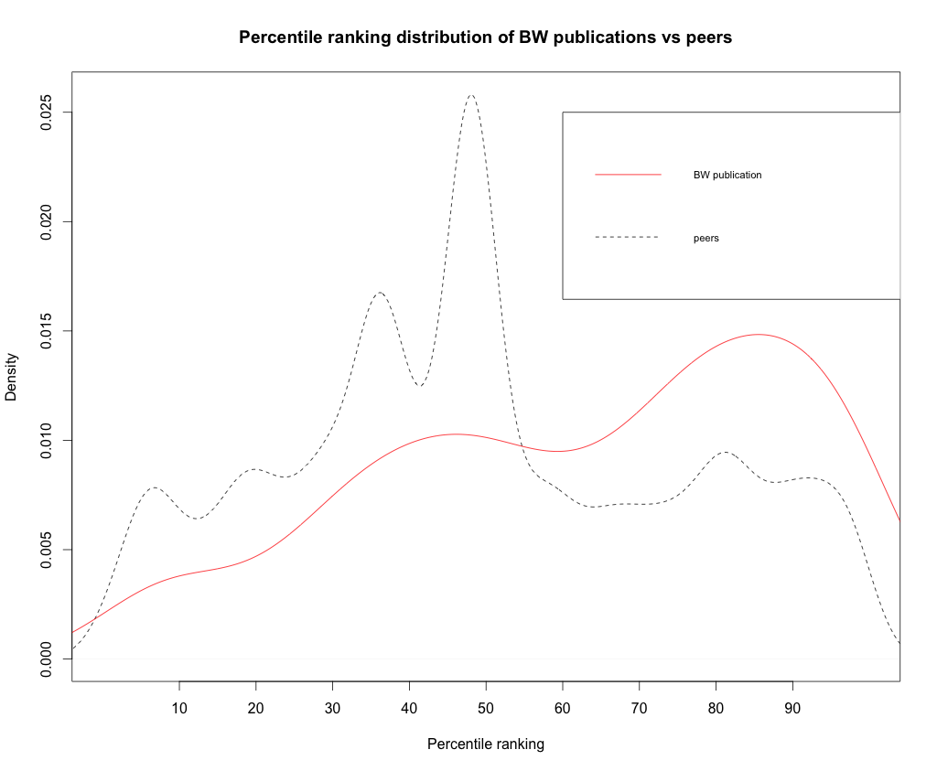

Figure 2. Percentile ranking distribution of Bluewaters publications and peers

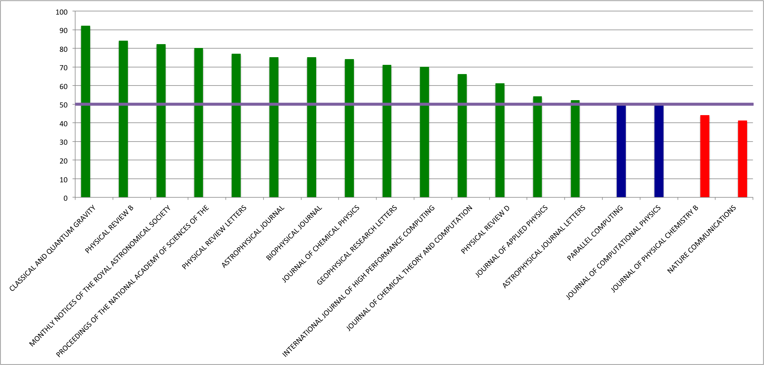

Figure 3. BW publications median percentile ranking in each journal

**References**

* [1] Gregor von Laszewski, Fugang Wang, Geoffrey C. Fox, David L. Hart, Thomas R. Furlani, Robert L. DeLeon, Steven M. Gallo, "Peer Comparison of XSEDE and NCAR Publication Data", *Cluster Computing (CLUSTER) 2015 IEEE International Conference on*, pp. 531-532, 2015. doi: 10.1109/CLUSTER.2015.98, <https://github.com/cyberaide/paper-tas-2/blob/master/vonLaszewski-tas-cluster.pdf>