**Peers Comparison of publications for TG/XD, NCAR, and BlueWaters**

Updated Oct 2016: Updated with the latest publication/citation data as of September 2016)

Updated Nov 2016: Added journals level and FOS level analysis and comparison

Table 1: Summary of the compared groups (2015 Analysis)

|  |  |  |  |  |
| --- | --- | --- | --- | --- |
|  | XSEDE | XD-ECSS | NCAR | BlueWater |
| Years Range | 2005~2014 |  | 2008~2014 | 20081~2015 |
| Raw Entries | >20,000 |  | ~10002 | ~300 |
| **verified # pubs (at the time of study)** | **5081** |  | **813** | **113** |
| # distinct journals (when studied) | 673 |  | 130 | 67 |
| # journals studied | 66 |  | 35 | 19(133) |
| minimum # pubs in studied journals | 10 |  | 5 | 2 |
| **effective # pubs compared with peers** | **2349** | **248** | **653** | **46** |
| **% coverage of pubs** | **46** |  | **80** | **41** |
| % pubs that the top 10% journals covered | 46 |  | 62 | 30 |
| Note 1: Staff publications since 2008, users' since 2012 | | | | |
| Note 2: Mostly curated already | | | | |
| Note 3: 6 conference venues included in which peers data cannot be queried | | | | |

Table 2: Summary of the compared groups (October 2016 Analysis)

|  |  |  |  |
| --- | --- | --- | --- |
|  | XSEDE | NCAR | BlueWater |
| Years Range | 2005~2016 | 2008~2014 | 20081~2016 |
| Raw Entries | >20,000 | ~10002 | ~1300 |
| **verified # pubs (at the time of study)** | **9426** | **813** | **394** |
| # distinct journals (when studied) | ~1400 | 130 | 105 |
| # journals studied | 122 | 37 | 18 |
| minimum # pubs in studied journals | 10 | 5 | 5 |
| **effective # pubs compared with peers** | **5078** | **665** | **163** |
| **% coverage of pubs** | **54** | **82** | **41** |
| % pubs that the top 10% journals covered | 29 | 62 | 34 |
| Note 1: Staff publications since 2008, users' since 2012 | | | |
| Note 2: Mostly curated already | | | |
|  | | | |

2015 Results:



Figure 1. Accumulative distribution of publication citation percentile ranking among peers, for the facilities/groups of TG/XD, XD-ECSS, NCAR, and BlueWater.



Figure 2. Boxplot comparison for the same groups. Box widths proportional to square roots of sizes compared (effective # of publications compared).

2016 Results:

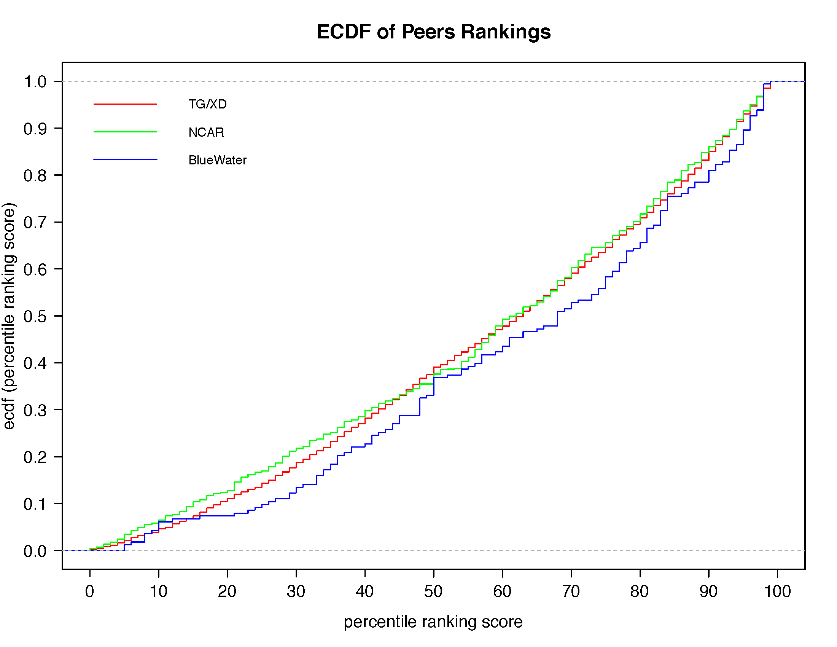

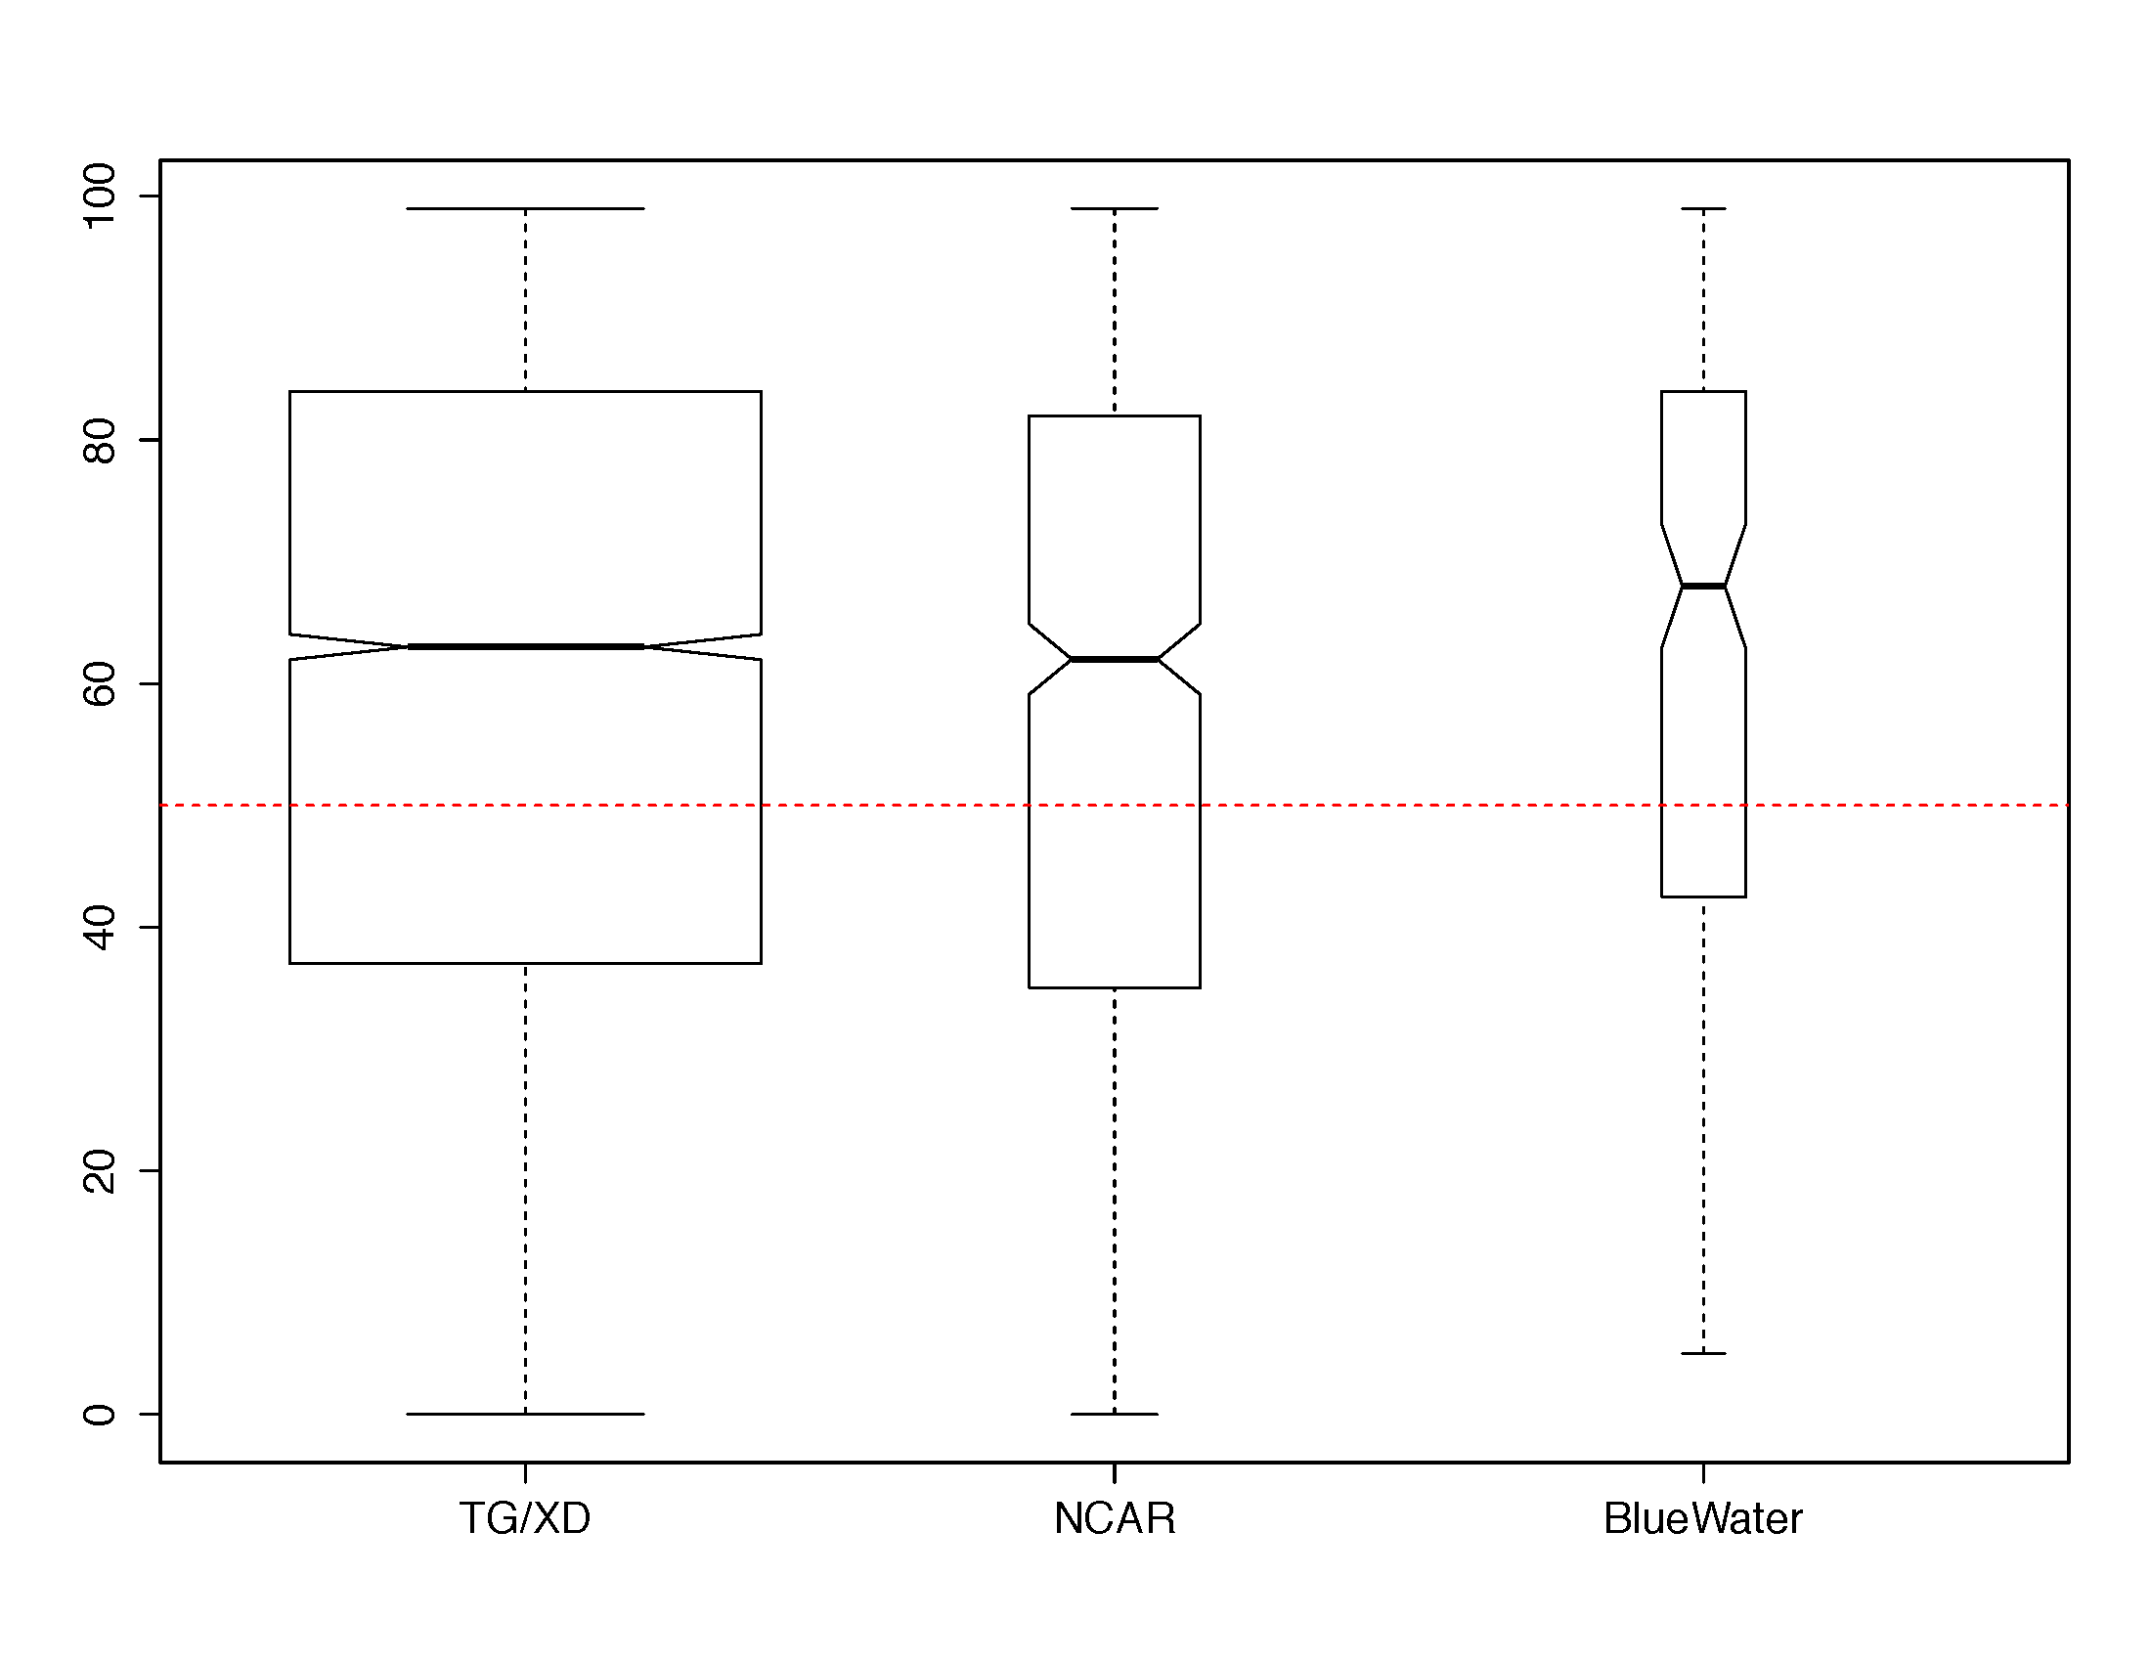

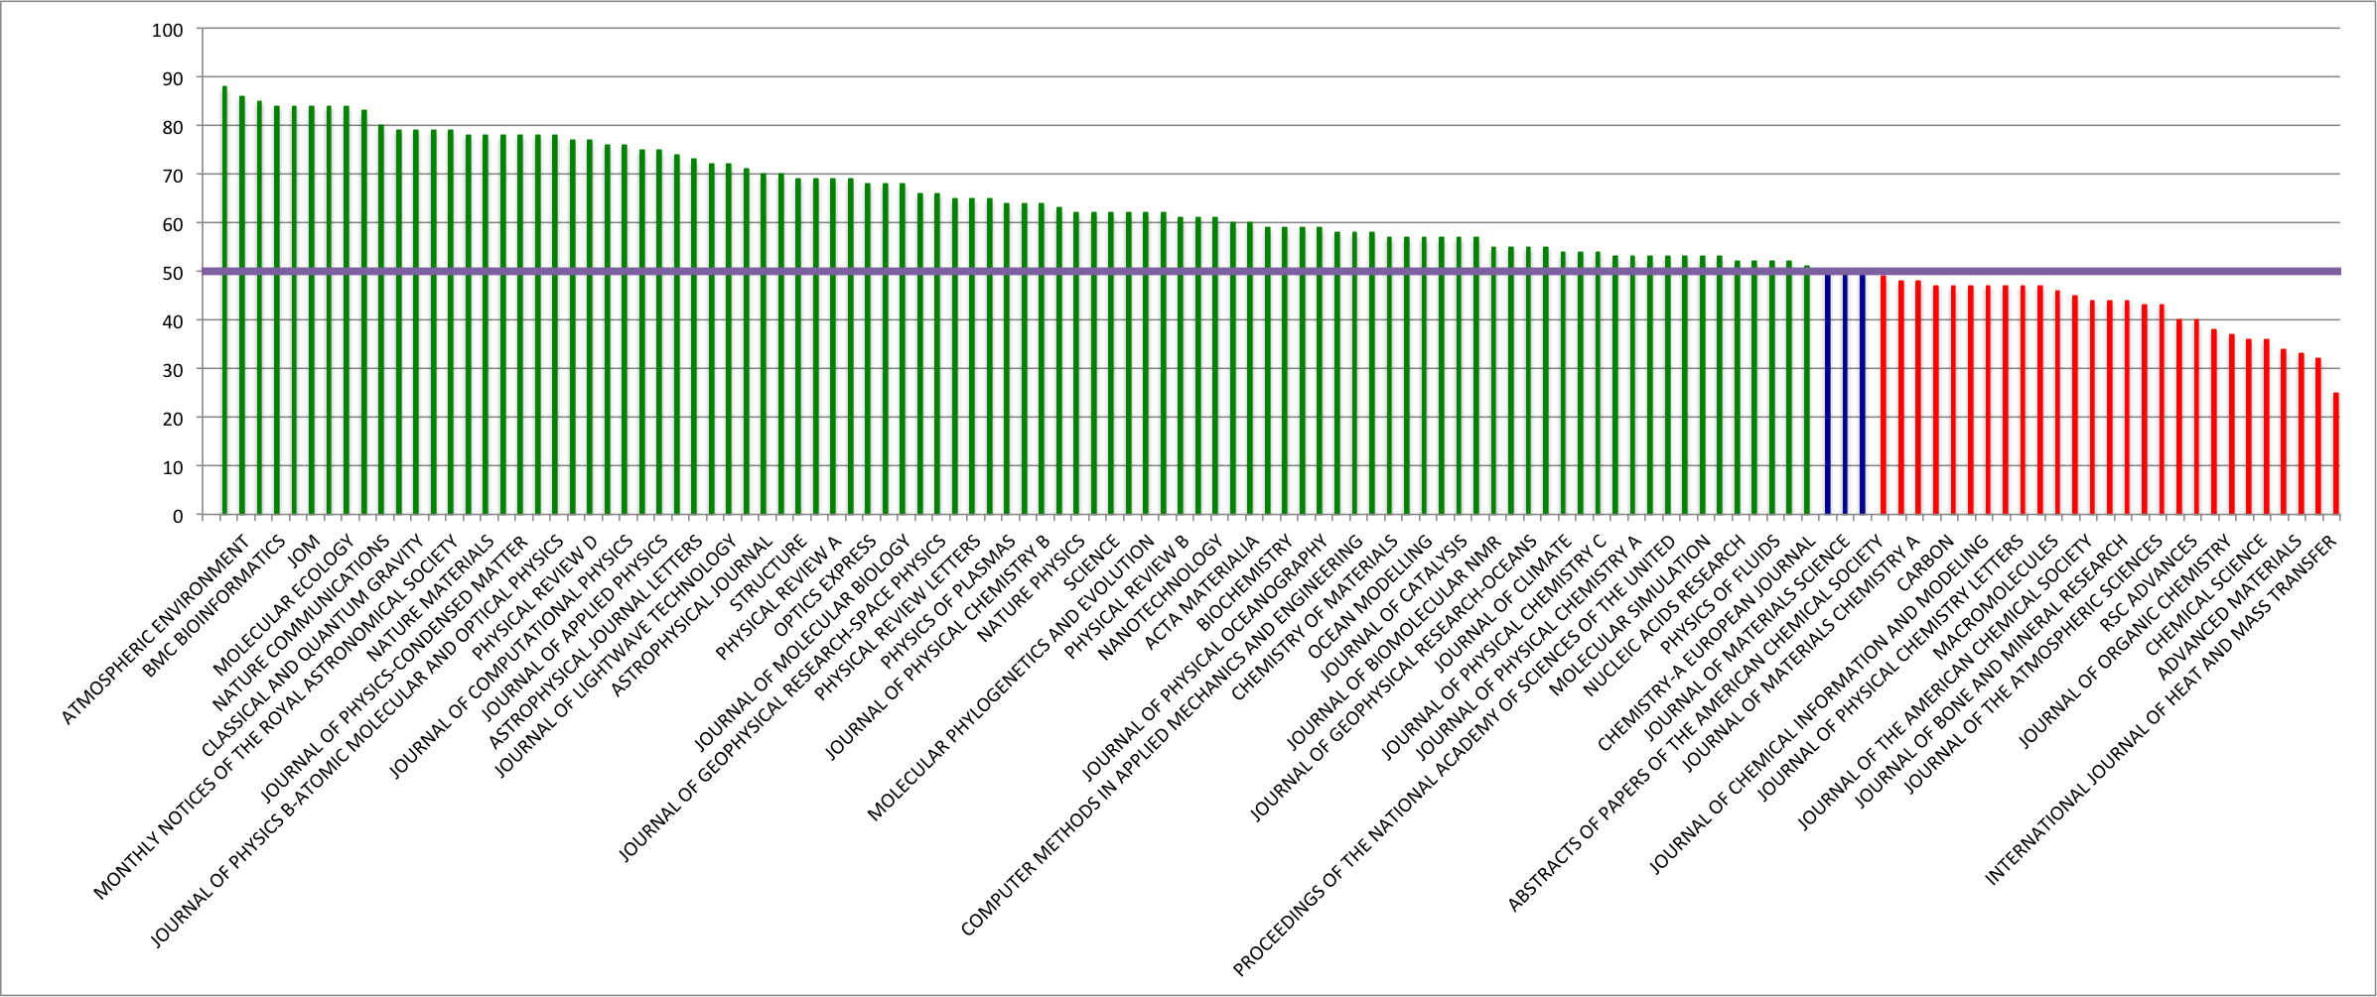

XD Journals median percentile ranking

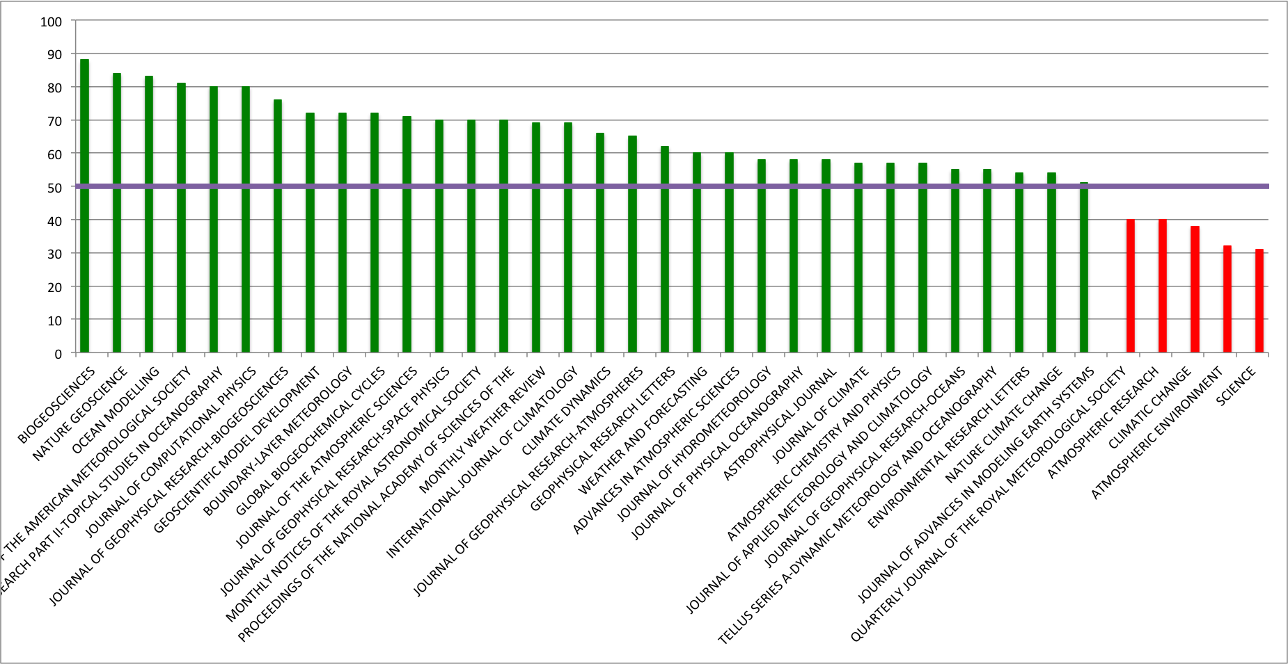

NCAR journals median percentile ranking

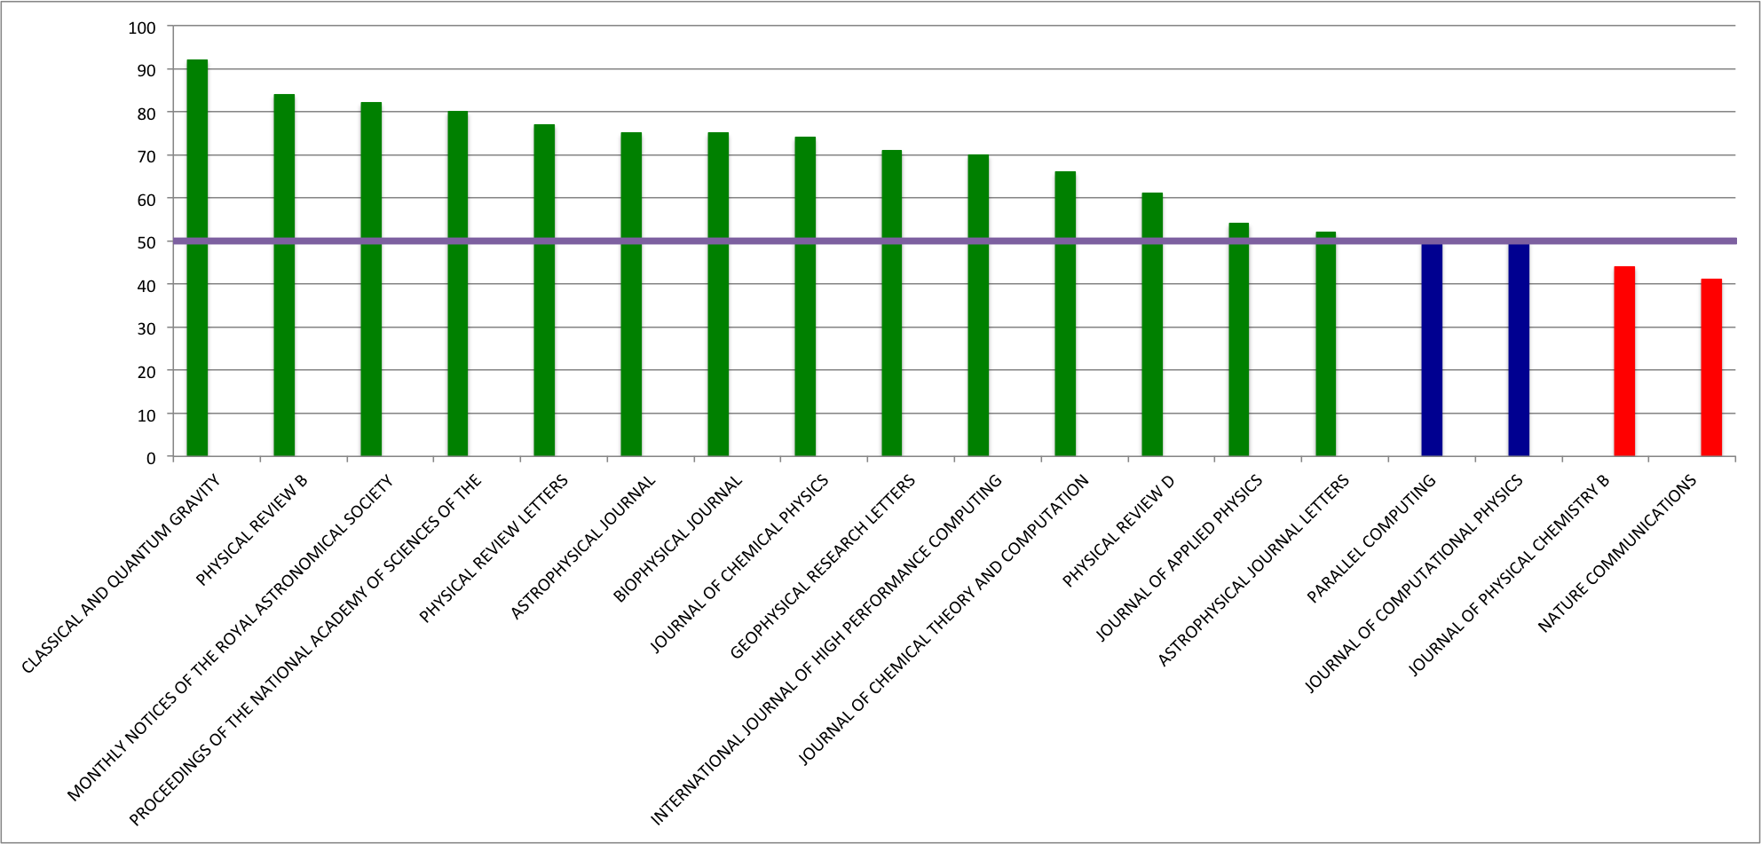

BW Journals median percentile ranking

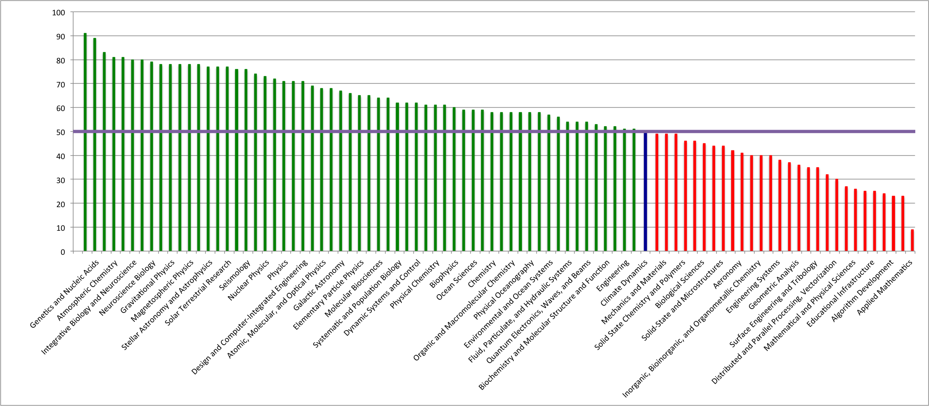

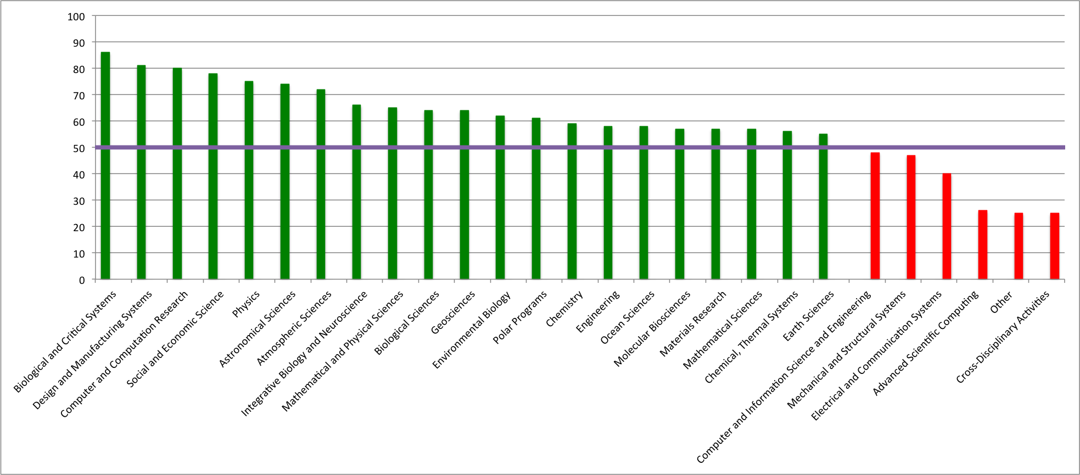

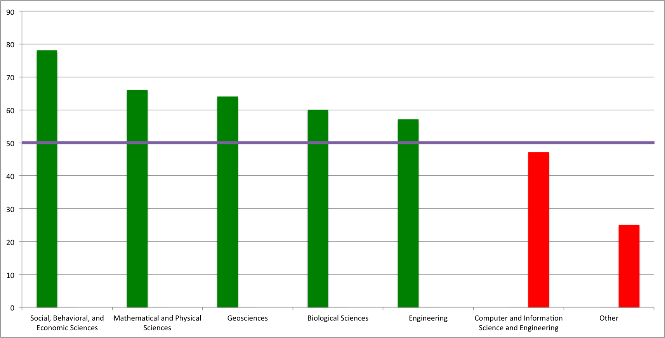

FOS, detailed level to top level

**(Based on the journals studied. Note the cutoff #pubs for each facility could be different)**

In BW but not XD:

* *INTERNATIONAL JOURNAL OF HIGH PERFORMANCE COMPUTING APPLICATIONS*
* *PARALLEL COMPUTING*

16 out of 18 IN XD

In NCAR but not in XD:

19 out of 37

In all three:

|  |
| --- |
| * *ASTROPHYSICAL JOURNAL* |
| * *GEOPHYSICAL RESEARCH LETTERS* |
| * *JOURNAL OF COMPUTATIONAL PHYSICS* |
| * *MONTHLY NOTICES OF THE ROYAL ASTRONOMICAL SOCIETY* |
| * *PROCEEDINGS OF THE NATIONAL ACADEMY OF SCIENCES OF THE UNITED STATES OF AMERICA* |

