**Scientific Impact Metrics for XSEDE2 at Report Year 2 for the period between Jan 1, 2017 to Apr 30, 2018**

Fugang Wang, Gregor von Laszewski  
Apr 30, 2018  
Technical Report, Indiana University, Bloomington, IN

# Impact Metrics of TG/XD publications since Sept 2016

**Table SIM-1**: *Overall Scientific Impact Metrics of TG/XD publications since start of XSEDE2*

|  |  |  |  |  |  |
| --- | --- | --- | --- | --- | --- |
|  | Number of externally verified unique publications* | i10-index (Number of publications cited at least 10 times) | Overall citation count* | h-index | g-index |
| TG/XD as of Sept 2016 | 9,505 | 3,805 | 181,148 | 148 | 258 |
| At end of April 2017 | 11,013 | 4,554 | 223,772 | 162 | 289 |
| Change since start of XSEDE 2 | +1,508 | +749 | +42,624 | +14 | +31 |
|  |  |  |  |  |  |
| At end of April 2018 | 13,385 | 5,959 | 297,850 | 182 | 324 |
| Change since start of XSEDE2 | +3,880 | +2,154 | +116,702 | +34 | +66 |
| Change since start of RY2 (May 2017) | +2,372 | +1,405 | +74,078 | +20 | +35 |
| * Data updated as of April 30th, 2018. | | | | | |

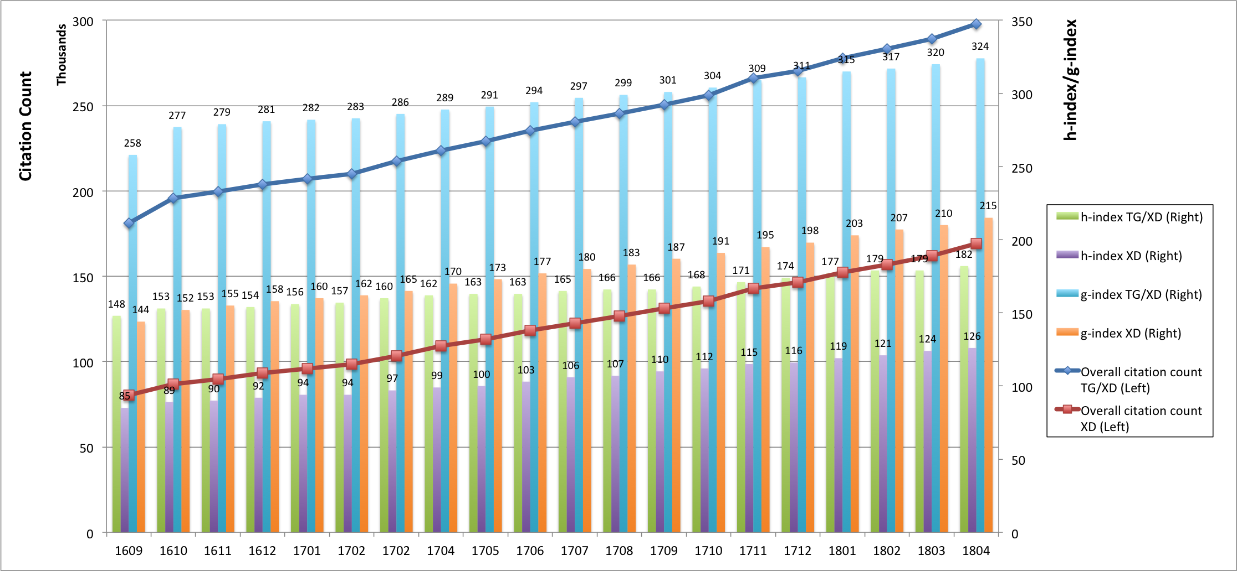

**Figure SIM-2**. *Accumulated citation count (line, left axis) as well as h-index and g-index metrics (bar, right axis) for TG/XD (since 2005) and XD (since 2011).*

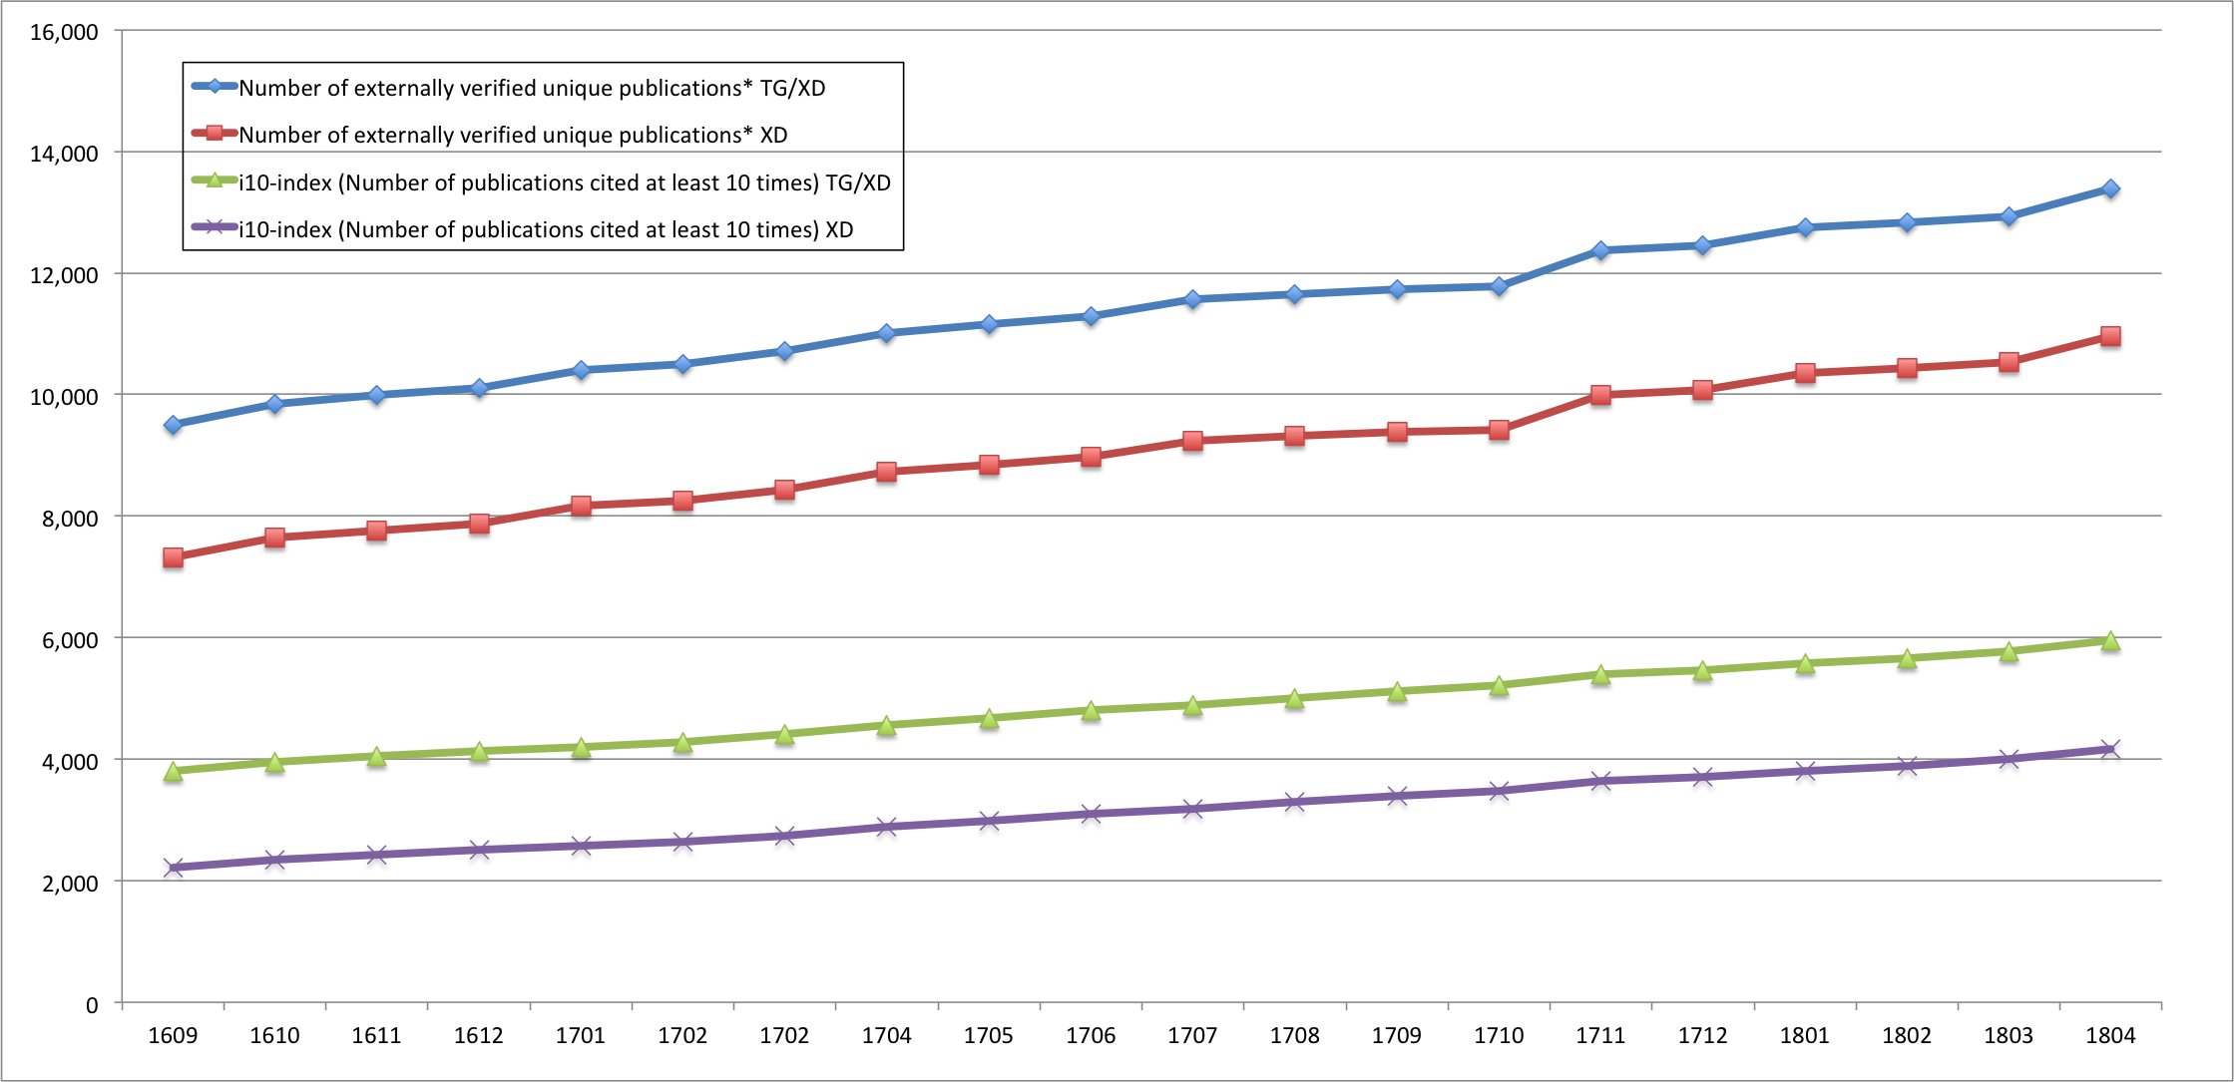

**Figure SIM-3**. *Counts of all externally verified publications for TG/XD (since 2005) and XD (since 2011) and of those being cited at least 10 times (i10-index).*

**Impact Metrics of XSEDE2 publications\***

(* calculated from start of year 2017)

**Table SIM-4**: *Scientific Impact Metrics of XSEDE2 publications (since Jan 2017)*

|  |  |  |  |  |  |
| --- | --- | --- | --- | --- | --- |
|  | Number of externally verified unique publications* | i10-index (Number of publications cited at least 10 times) | Overall citation count* | h-index | g-index |
| At end of April 2017 | 147 | 0 | 28 | 2 | 4 |
|  |  |  |  |  |  |
| At end of April 2018 | 1,611 | 83 | 3,887 | 20 | 31 |
| Change of RY2 | +1,464 | +83 | +3,859 | +18 | +27 |
| * Data updated as of April 30th, 2018. | | | | | |

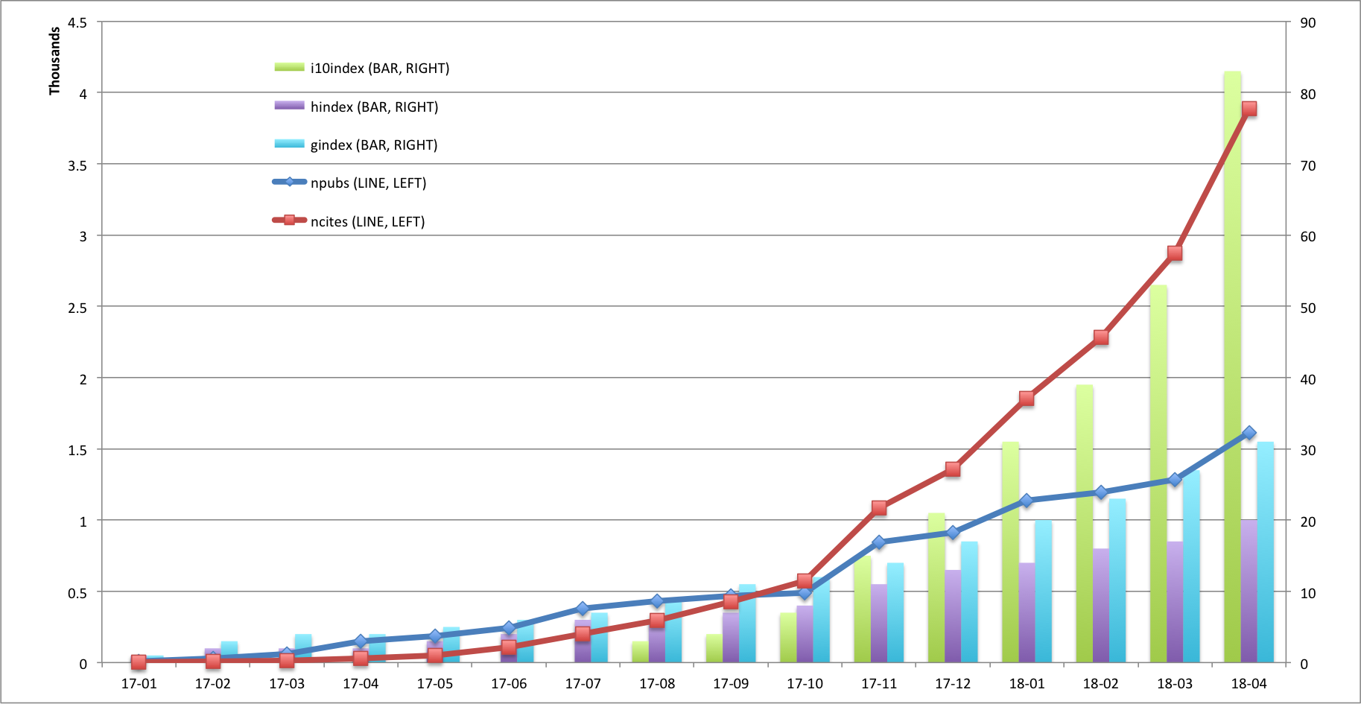

**Figure SIM-5**. *Monthly impact metrics (publication count; citation count; i-10index; h-index; g-index) of XSEDE2 publications (those published since 2017)*