**XSEDE Scientific Impact Metrics for the Period between Oct 1, 2016 to Dec 31, 2016**

Fugang Wang, Gregor von Laszewski  
Dec 31, 2016  
Technical Report, Indiana University, Bloomington, IN

## Scientific Impact Metrics (SIM)

This appendix presents the current Scientific Impact Metrics data as of end of year 2016. This is part of the *XD Metrics Service (*XMS*) (*previously NSF Technology Audit Service *(*TAS*) )* effort.

We are currently working on adapting the data and results structure so most of these results would be available as display via XDMoD in future.

### Summary Impact Metrics

Table SIM-1 shows the essential scientific summary impact metrics as of the end of Q4 2016. The increasing values for each metric are listed in the table indicating the changes during the last quarter. By calculating such metrics periodically we can show the trends, as depicted in Figure SIM-2 and Figure SIM-3. Both show steadily increasing trends.

Table SIM-1: Overall Scientific Impact Metrics Data

|  |  |  |  |  |  |
| --- | --- | --- | --- | --- | --- |
|  | Number of externally verified unique publications* | i10-index (Number of publications cited at least 10 times) | Overall citation count* | h-index | g-index |
| Since 2005 (TG+XD) | 10,101 | 4,129 | 203,704 | 154 | 281 |
| Since 2011 (XD) | 7,876 | 2,503 | 93,182 | 92 | 158 |
| Change from last quarter  (TG+XD) | +596 | +324 | +22,556 | +6 | +23 |
| Change from last quarter  (XD) | +566 | +287 | +12,814 | +7 | +14 |
| * Data updated as of Dec 31th, 2016. | | | | | |

### Historical Trend

Figure SIM-2 and SIM-3 show the increasing monthly trend regarding publications, citations, and other impact metrics such as H-Index and G-Index. Both suggest the increasing impact of XSEDE during the past years, based on verified unique publication count; citation count; h-index and g-index.

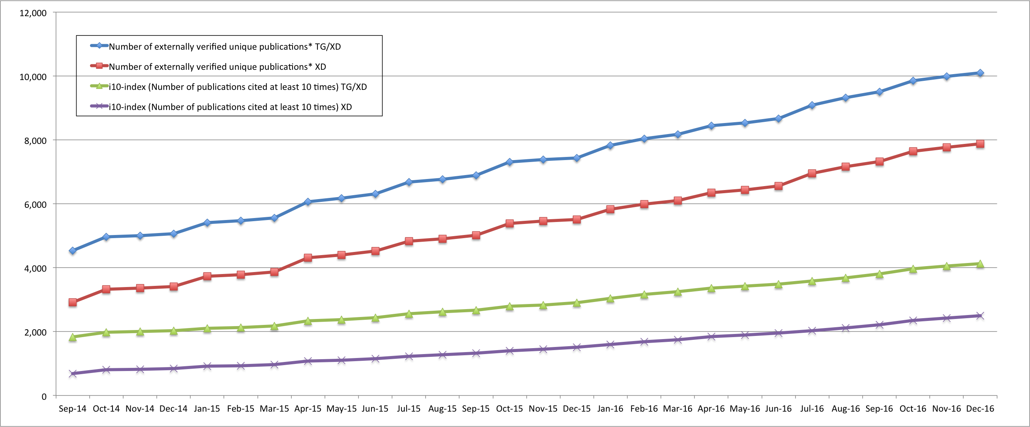

*Figure SIM-2. Counts of all externally verified publications for TG/XD (since 2005) and XD (since 2011) and of those being cited at least 10 times (i10-index). Note the hike in the beginning of each quarter (October, January, April, July) due to the publication submission for the quarterly XRAC meeting review.*

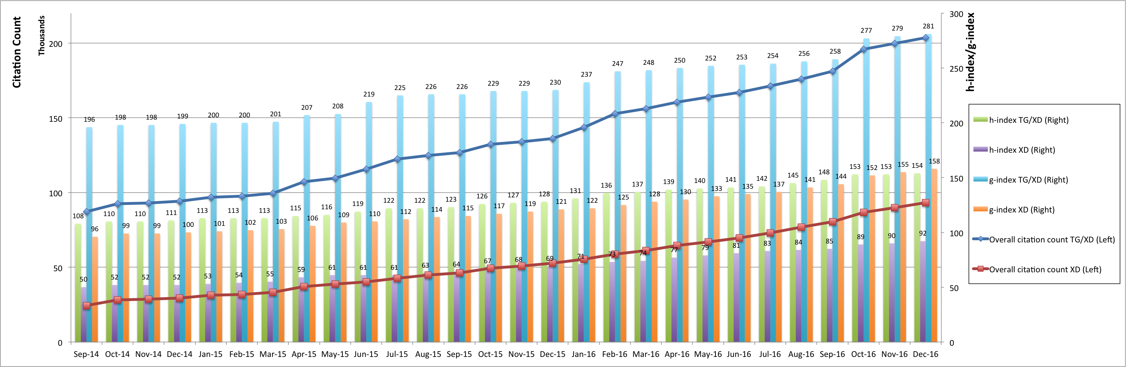

*Figure SIM-3. Accumulated citation count (line, left axis) as well as h-index and g-index metrics (bar, right axis) for TG/XD(since 2005) and XD(since 2011).*