**XSEDE Scientific Impact Metrics Yearly Report for the Period between July 1, 2016 to Jun 30, 2017 and the Period between July 1, 2017 to Sept 30, 2017**

Fugang Wang, Gregor von Laszewski  
Sep 30, 2017  
Technical Report, Indiana University, Bloomington, IN

## Scientific Impact Metrics (SIM)

This appendix presents the current Scientific Impact Metrics data as of end of June 2017. This is part of the *XD Metrics Service (*XMS*) (*formerly NSF Technology Audit Service *(*TAS*) )* effort.

We are currently working on adapting the data and results structure so most of these results would be available as display via XDMoD in future.

### Summary Impact Metrics

Table SIM-1 shows the essential scientific summary impact metrics as of the end of Q2 2017. The increasing values for each metric are listed in the table indicating the changes during the last quarter. By calculating such metrics periodically we can show the trends, as depicted in Figure SIM-2 and Figure SIM-3. Both show steadily increasing trends.

Table SIM-1: Overall Scientific Impact Metrics Data

|  |  |  |  |  |  |
| --- | --- | --- | --- | --- | --- |
|  | Number of externally verified unique publications* | i10-index (Number of publications cited at least 10 times) | Overall citation count* | h-index | g-index |
| Since 2005 (TG+XD) | 11,296 | 4,804 | 235,209 | 163 | 294 |
| Since 2011 (XD) | 8,970 | 3,102 | 118,200 | 103 | 177 |
| Change since last year  (TG+XD) | +2,634 | +1,323 | +68,223 | +22 | +41 |
| Change since last year  (XD) | +2,415 | +1,154 | +48,585 | +22 | +42 |
| * Data updated as of Jun 30th, 2017. | | | | | |

### Historical Trend

Figure SIM-2 and SIM-3 show the increasing quarterly trend regarding publications, citations, and other impact metrics such as H-Index and G-Index. Both suggest the increasing impact of XSEDE during the past years, based on verified unique publication count; citation count; h-index and g-index.

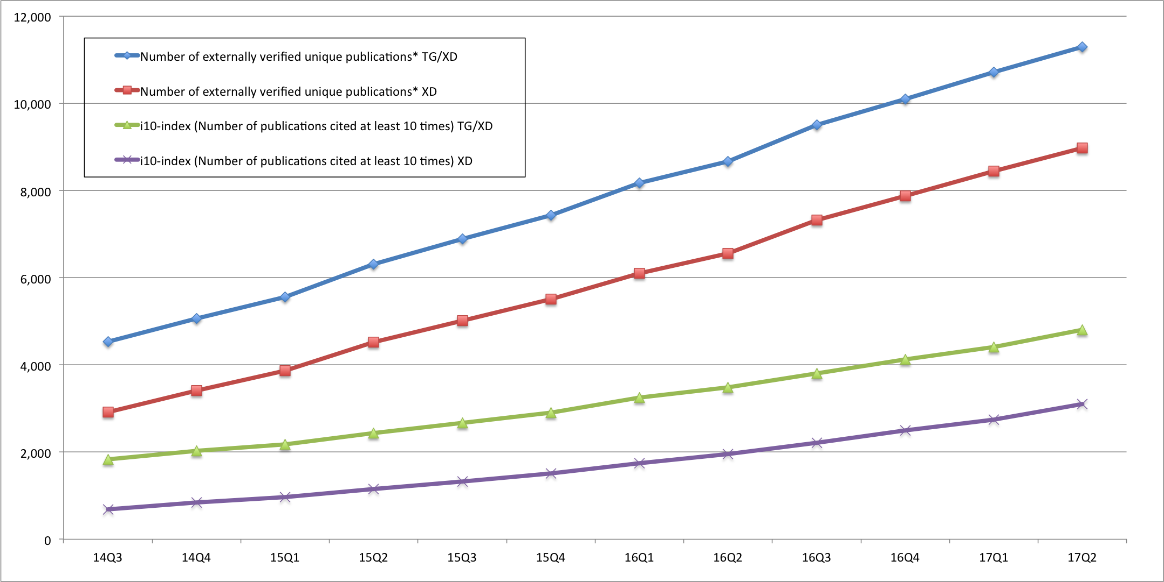

*Figure SIM-2. Counts of all externally verified publications for TG/XD (since 2005) and XD (since 2011) and of those being cited at least 10 times (i10-index).*

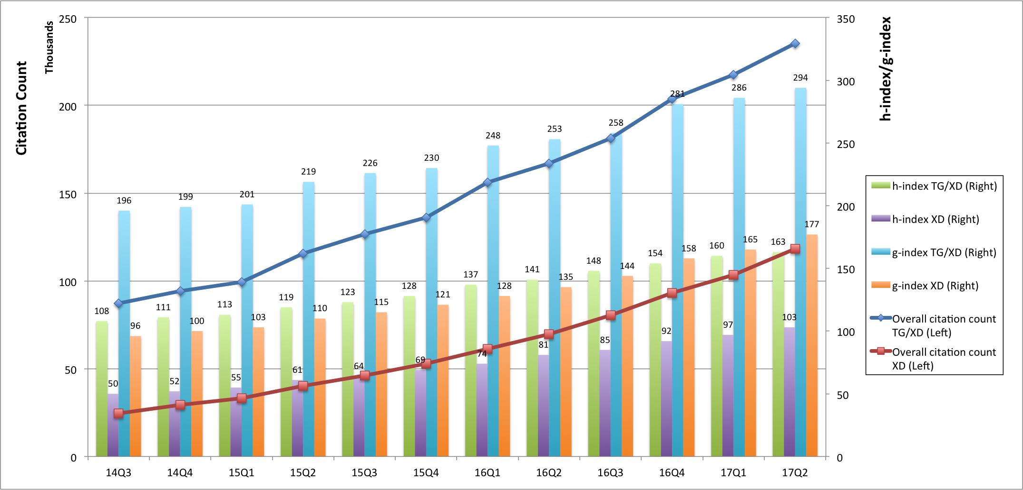

*Figure SIM-3. Accumulated citation count (line, left axis) as well as h-index and g-index metrics (bar, right axis) for TG/XD(since 2005) and XD(since 2011).*