**XSEDE Scientific Impact Metrics for the Yearly Period between May 1, 2018 to Apr 30, 2019 and the Period between Feb 1, 2019 - Apr 30, 2019**

Fugang Wang, Gregor von Laszewski  
Apr 30, 2019  
Technical Report, Indiana University, Bloomington, IN

## Scientific Impact Metrics (SIM)

This appendix presents the current Scientific Impact Metrics data as of April 30 of year 2019. This is part of the *XD Metrics Service (*XMS*) (*formerly NSF Technology Audit Service *(*TAS*))* effort.

### Summary Impact Metrics

Table SIM-1 shows the essential scientific summary impact metrics as of April 30 of year 2019. The increasing values for each metric are listed in the table indicating the changes during the last quarter. By calculating such metrics periodically we can show the trends, as depicted in Figure SIM-2 and Figure SIM-3. Both show steadily increasing trends.

Table SIM-1: Overall Scientific Impact Metrics Data

|  |  |  |  |  |  |
| --- | --- | --- | --- | --- | --- |
|  | Number of externally verified unique publications* | i10-index (Number of publications cited at least 10 times) | Overall citation count* | h-index | g-index |
| Since 2005 (TG+XD) | 15,595 | 8,383 | 483,3881 | 228 | 416 |
| Since 2011 (XD) | 13,095 | 6,402 | 299,587 | 170 | 294 |
| Change since last quarter  (TG+XD) | +572 | +1,387 | +125,712 | +34 | +65 |
| Change since last year  (TG+XD) | +2,664 | +2,605 | +194,202 | +49 | +96 |
| Change since last quarter  (XD) | +559 | +1,242 | +77,406 | +25 | +42 |
| Change from a year ago2  (XD) | +2,568 | +2,399 | +137,497 | +46 | +84 |
| * Data updated as of April 30th, 2019. * Note 1: We fixed an error that certain publications were not using the updated citation count in the report generation. The current count has latest citation data for all publications as of end of April 2019. Thus we saw a spike in citation related metrics in this report comparing to the previous ones. * Note 2: The reporting months inclusion was changed since last July. Previously we reported the metrics updated as of end of March, June, Sept, Dec, etc., and now we report the updated data as end of April, July, Oct, Jan, etc. So this yearly comparison was against the end of March 2018. | | | | | |

### Historical Trend

Figure SIM-2 and SIM-3 show the increasing quarterly trend regarding publications, citations, and other impact metrics such as H-Index and G-Index. Both suggest the increasing impact of XSEDE during the past years, based on verified unique publication count; citation count; H-index and G-index.

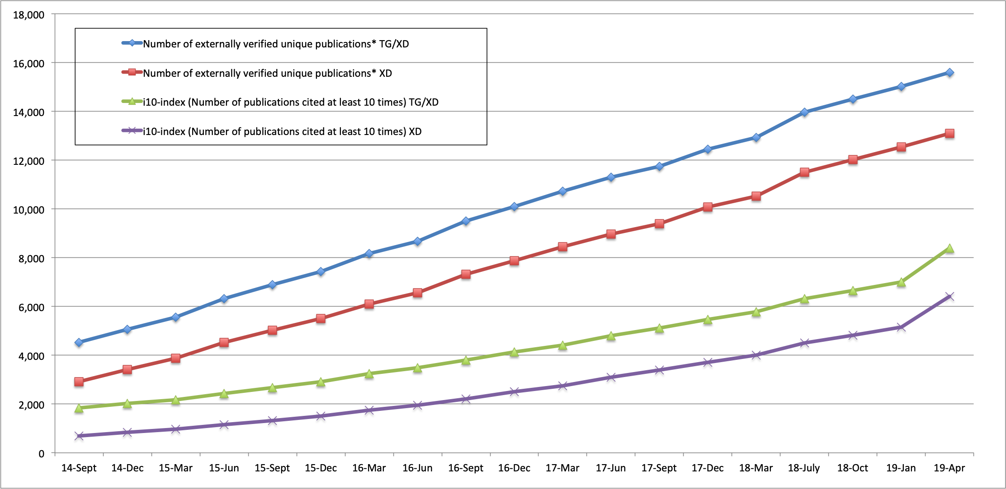

*Figure SIM-2. Counts of all externally verified publications for TG/XD (since 2005) and XD (since 2011) and of those being cited at least 10 times (i10-index).*

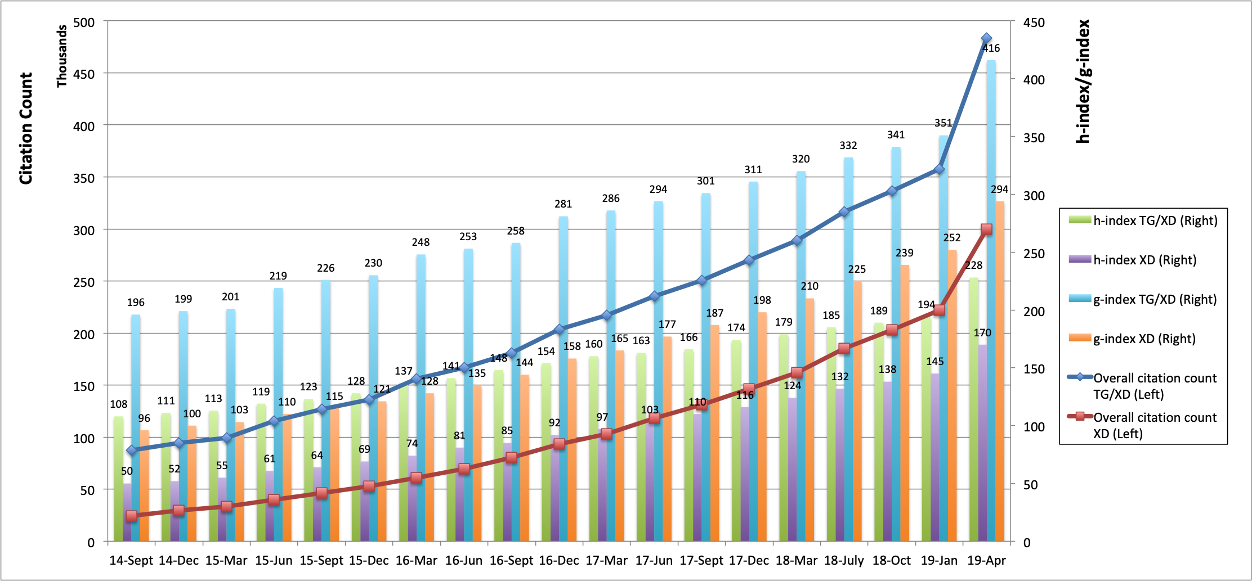

*Figure SIM-3. Accumulated citation count (line, left axis) as well as h-index and g-index metrics (bar, right axis) for TG/XD (since 2005) and XD (since 2011).*