**XSEDE Scientific Impact Metrics for the Period between May 1, 2019 to July 31, 2019**

Fugang Wang, Gregor von Laszewski  
Jul 31, 2019  
Technical Report, Indiana University, Bloomington, IN

## Scientific Impact Metrics (SIM)

This appendix presents the current Scientific Impact Metrics data as of July 31 of year 2019. This is part of the *XD Metrics Service (*XMS*) (*formerly NSF Technology Audit Service *(*TAS*))* effort.

### Summary Impact Metrics

Table SIM-1 shows the essential scientific summary impact metrics as of July 31 of year 2019. The increasing values for each metric are listed in the table indicating the changes during the last quarter. By calculating such metrics periodically we can show the trends, as depicted in Figure SIM-2 and Figure SIM-3. Both show steadily increasing trends.

Table SIM-1: Overall Scientific Impact Metrics Data

|  |  |  |  |  |  |
| --- | --- | --- | --- | --- | --- |
|  | Number of externally verified unique publications* | i10-index (Number of publications cited at least 10 times) | Overall citation count* | h-index | g-index |
| Since 2005 (TG+XD) | 15,996 | 8,784 | 513,763 | 236 | 428 |
| Since 2011 (XD) | 13,494 | 6,798 | 325,778 | 177 | 308 |
| Change from last quarter  (TG+XD) | +401 | +401 | +30,375 | +8 | +12 |
| Change from last quarter  (XD) | +399 | +396 | +26,191 | +7 | +14 |
| * Data updated as of July 31th, 2019. | | | | | |

### Historical Trend

Figure SIM-2 and SIM-3 show the increasing quarterly trend regarding publications, citations, and other impact metrics such as H-Index and G-Index. Both suggest the increasing impact of XSEDE during the past years, based on verified unique publication count; citation count; H-index and G-index.

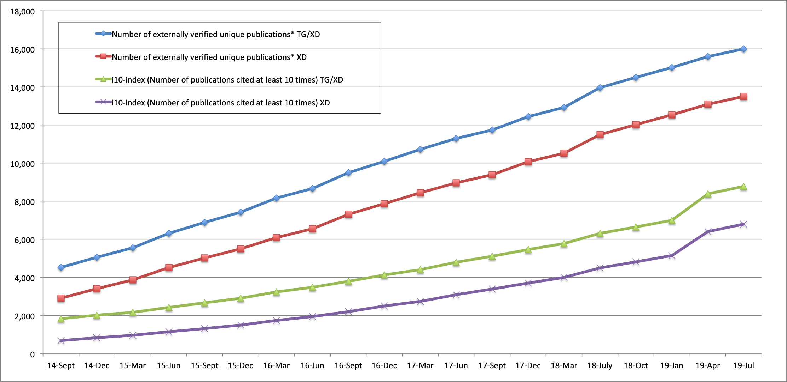

*Figure SIM-2. Counts of all externally verified publications for TG/XD (since 2005) and XD (since 2011) and of those being cited at least 10 times (i10-index).*

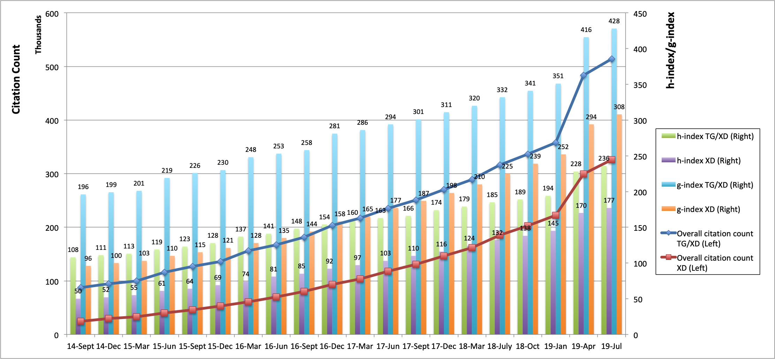

*Figure SIM-3. Accumulated citation count (line, left axis) as well as h-index and g-index metrics (bar, right axis) for TG/XD (since 2005) and XD (since 2011).*