To Err is Human: An Empirical Investigation
Daniel Lakens & Lisa DeBruine
2026-02-19
This paper demonstrates some good and poor practices for use with the {metacheck} R package. All data are simulated. The paper shows examples of (1) open and closed OSF links; (2a) citation of retracted papers, (2b) citations without a doi, (2c) citations with Pubpeer comments, (2d) citations in the FLoRA replication database, and (2e) missing/mismatched/incorrect citations and references; (3a) R files with code on GitHub that do not load libraries in one location, (3b) load files that are not shared in the repository, (3c) lack comments, and (3d) have absolute file paths; (4) imprecise reporting of non-significant p-values; (5) tests with and without effect sizes; (6) use of “marginally significant” to describe non-significant findings; (7) a power analysis reporting some of the essential attributes; and (8) retrieving information from preregistrations.

Introduction
Although intentional dishonestly might be a successful way to boost creativity (Gino & Wiltermuth, 2014), it is safe to say most mistakes researchers make are unintentional. From a human factors perspective, human error is a symptom of a poor design (Smithy, 2020). Automation can be used to check for errors in scientific manuscripts, and inform authors about possible corrections. In this study we examine the usefulness of metacheck to improve best practices.

Method
In this study we examine whether automated checks reduce the amount of errors that researchers make in scientific manuscripts. This study was preregistered at https://osf.io/48ncu and on AsPredicted at https://aspredicted.org/by8i8v.pdf.

Procedure
We randomly assigned 50 scientists to a condition where their manuscript was automatically checked for errors, and 50 scientists to a control condition with a checklist. Scientists had the opportunity to make changes to their manuscript based on the feedback of the tool. We subsequently coded all manuscripts for mistakes, and counted the total number of mistakes. We also measured the expertise of researchers (in years) to explore whether the automated tool would be more useful, the less research experience researchers had. We also asked researchers to rate how useful they found the checklist or app on a scale from 1 (not at all) to 7 (extremely useful).

Data Availability
Data and analysis code is available on GitHub from https://github.com/Lakens/to_err_is_human and from https://researchbox.org/4377. Data is also available from https://osf.io/5tbm9 and code is also available from https://osf.io/629bx.

Power Analysis
We conducted a sensitivity power analysis to determine that a Cohen’s d of 0.50 is the smallest effect size that we could detect with 50 participants in each group and 80% power.

Results
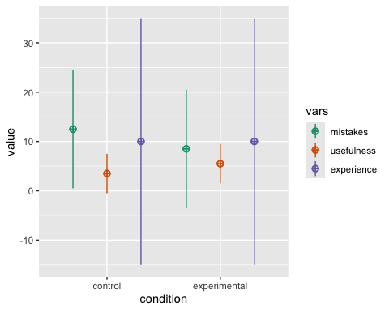
Figure 1: The simulated data
Table 1: The average number of mistakes and usefulness score for the control and experimental conditions.
Condition | Mistakes | Usefulness
control | 10.90 | 4.50
experimental | 9.12 | 5.06

On average researchers in the experimental (app) condition made fewer mistakes (M = 9.12) than researchers in the control (checklist) condition (M = 10.9), t(97.7) = 2.9, p = 0.005, d = 0.59.
On average researchers in the experimental condition found the app marginally significantly more useful (M = 5.06) than researchers in the control condition found the checklist (M = 4.5), t(97.2) = -1.96, p = 0.152.
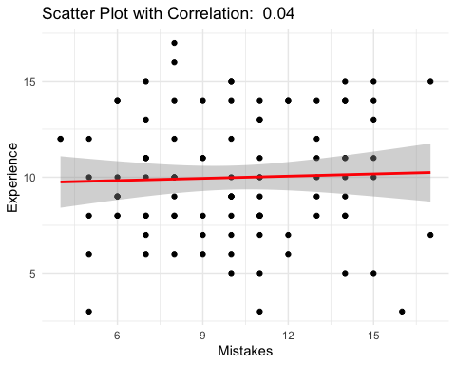
There was no effect of experience on the reduction in errors when using the tool (p > .05), as the correlation was non-significant.

Discussion
It seems automated tools can help prevent errors by providing researchers with feedback about potential mistakes, and researchers feel the app is useful. We conclude the use of automated checks has potential to reduce the number of mistakes in scientific manuscripts.

References
Eagly, A. H., & Wood, W. (1999). The origins of sex differences in human behavior: Evolved dispositions versus social roles. American Psychologist, 54(6), 408–423. https://doi.org/10.1037/0003-066x.54.6.408
Gino, F., & Wiltermuth, S. S. (2014). Evil Genius? How Dishonesty Can Lead to Greater Creativity. Psychological Science, 25(4), 973–981. https://doi.org/10.1177/0956797614520714
Lakens, D. (2018). Equivalence testing for psychological research. Advances in Methods and Practices in Psychological Science, 1, 259-270.
Smith, F. (2021). Human error is a symptom of a poor design. Journal of Journals, 0(0), 0. https://doi.org/10.0000/0123456789

