1. Maxwell equation in normalized unit
$$\frac{∂E}{∂t}=∇×B-2πJ$$

$$\frac{∂B}{∂t}=-∇×E$$

2. 2D Maxwell solver

$${E_{x}}_{i+\frac{1}{2},j}^{n+1}-{E_{x}}_{i+\frac{1}{2},j}^{n}=\frac{∆t}{∆y}\left({B_{z}}_{i+\frac{1}{2},j+\frac{1}{2}}^{n+\frac{1}{2}}-{B_{z}}_{i+\frac{1}{2},j-\frac{1}{2}}^{n+\frac{1}{2}}\right)-2π∆t{J_{x}}_{i+\frac{1}{2},j}^{n+\frac{1}{2}}$$

$${E_{y}}_{i,j+\frac{1}{2}}^{n+1}-{E_{y}}_{i,j+\frac{1}{2}}^{n}=-\frac{∆t}{∆x}\left({B_{z}}_{i+\frac{1}{2},j+\frac{1}{2}}^{n+\frac{1}{2}}-{B_{z}}_{i-\frac{1}{2},j+\frac{1}{2}}^{n+\frac{1}{2}}\right)-2π∆t{J_{y}}_{i,j+\frac{1}{2}}^{n+\frac{1}{2}}$$

$${E_{z}}_{i,j}^{n+1}-{E_{z}}_{i,j}^{n}=-2π∆t{J_{z}}_{i,j}^{n+\frac{1}{2}}$$

$$+\frac{∆t}{∆x}\left[b_{y}\left({B_{y}}_{i+\frac{1}{2},j}^{n+\frac{1}{2}}-{B_{y}}_{i-\frac{1}{2},j}^{n+\frac{1}{2}}\right)+a_{y}\left({B_{y}}_{i+\frac{1}{2},j+1}^{n+\frac{1}{2}}+{B_{y}}_{i+\frac{1}{2},j-1}^{n+\frac{1}{2}}-{B_{y}}_{i-\frac{1}{2},j+1}^{n+\frac{1}{2}}-{B_{y}}_{i-\frac{1}{2},j-1}^{n+\frac{1}{2}}\right)\right]$$

$$-\frac{∆t}{∆y}\left[b_{x}\left({B_{x}}_{i,j+\frac{1}{2}}^{n+\frac{1}{2}}-{B_{x}}_{i,j-\frac{1}{2}}^{n+\frac{1}{2}}\right)+a_{x}\left({B_{x}}_{i+1,j+\frac{1}{2}}^{n+\frac{1}{2}}+{B_{x}}_{i-1,j+\frac{1}{2}}^{n+\frac{1}{2}}-{B_{x}}_{i+1,j-\frac{1}{2}}^{n+\frac{1}{2}}-{B_{x}}_{i-1,j-\frac{1}{2}}^{n+\frac{1}{2}}\right)\right]$$

$${B_{x}}_{i,j+\frac{1}{2}}^{n+\frac{1}{2}}-{B_{x}}_{i,j+\frac{1}{2}}^{n-\frac{1}{2}}=-\frac{∆t}{∆y}\left({E_{z}}_{i,j+1}^{n}-{E_{z}}_{i,j}^{n}\right)$$

$${B_{y}}_{i+\frac{1}{2},j}^{n+\frac{1}{2}}-{B_{y}}_{i+\frac{1}{2},j}^{n-\frac{1}{2}}=\frac{∆t}{∆x}\left({E_{z}}_{i+1,j}^{n}-{E_{z}}_{i,j}^{n}\right)$$

$${B_{z}}_{i+\frac{1}{2},j+\frac{1}{2}}^{n+\frac{1}{2}}-{B_{z}}_{i+\frac{1}{2},j+\frac{1}{2}}^{n-\frac{1}{2}}=$$

$$-\frac{∆t}{∆x}\left[b_{y}\left({E_{y}}_{i+1,j+\frac{1}{2}}^{n}-{E_{y}}_{i,j+\frac{1}{2}}^{n}\right)+a_{y}\left({E_{y}}_{i+1,j+\frac{3}{2}}^{n}+{E_{y}}_{i+1,j-\frac{1}{2}}^{n}-{E_{y}}_{i,j+\frac{3}{2}}^{n}-{E_{y}}_{i,j-\frac{1}{2}}^{n}\right)\right]$$

$$+\frac{∆t}{∆y}\left[b_{x}\left({E_{x}}_{i+\frac{1}{2},j+1}^{n}-{E_{x}}_{i+\frac{1}{2},j}^{n}\right)+a_{x}\left({E_{x}}_{i+\frac{3}{2},j+1}^{n}+{E_{x}}_{i-\frac{1}{2},j+1}^{n}-{E_{x}}_{i+\frac{3}{2},j}^{n}-{E_{x}}_{i-\frac{1}{2},j}^{n}\right)\right]$$

$$a_{x}=a_{y}=0.125\frac{∆x}{∆y}$$

$$b_{x}=1-2a_{x}, b_{y}=1-2a_{y}$$

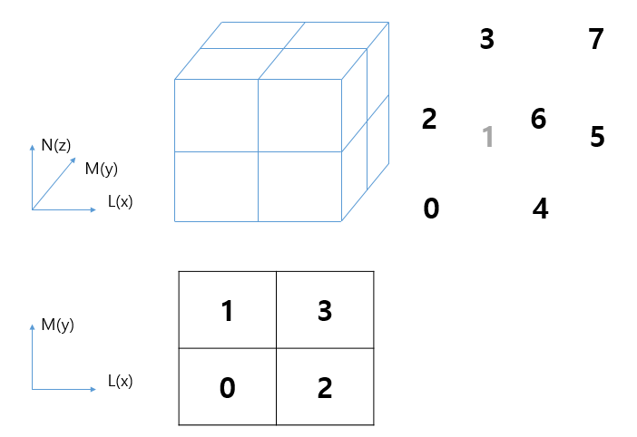

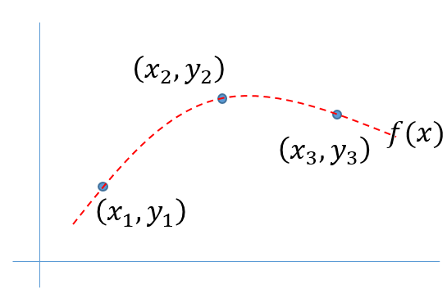

If $f\left(x\right)=ax^{2}+bx+c$*,*

$$a=\frac{y_{3}+y_{1}}{2}-y_{2}, b=\left(y_{2}-y_{1}\right)-\left(x_{1}+x_{2}\right)\left(\frac{y_{3}+y_{1}}{2}-y_{2}\right), c=y_{1}-a{x_{1}}^{2}-bx_{1}$$