class05.R

hitif

2020-01-22

#Class 5  
#Data visualization and graphics in R  
  
#GRAPH 1: practice plot  
plot(1:5, col="blue", typ="o")

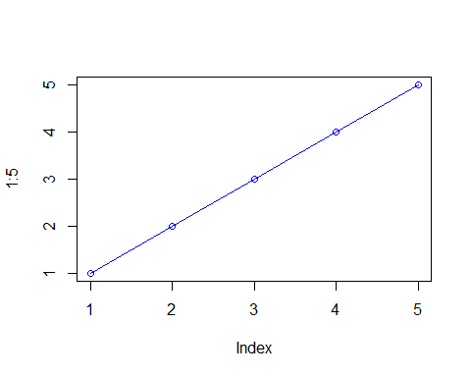

#following the lecture exercise  
#set WD to lecture_5  
setwd("C:/Users/hitif/Desktop/R_Shiny_Things/lecture_5")  
  
#read table for weight_chart  
weight <- read.table("bimm143_05_rstats/weight_chart.txt", header = TRUE)  
  
#GRAPH 2: HOW TO MAKE A LINE PLOT  
#change the scatterplot produced to a line plot  
#pch = point type  
#cex = point size  
#lwd = line density  
#ylim = limit the y-axis  
#xlab = x-axis label  
#ylab = y-axis label  
#main = title  
#col = pink  
plot(weight$Age, weight$Weight, typ="o", pch=15, cex=1.5, lwd=2, ylim=c(2,10), xlab = "Age (months)", ylab = "Weight (kg)", main = "Baby weight with age", col="pink")

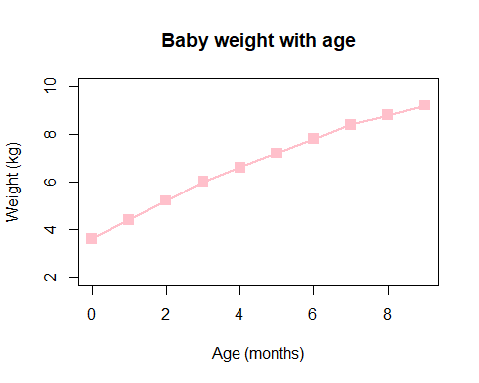

#sep="\t" SEPARATE BY TAB!!!! to include the row names  
mouse <- read.table("bimm143_05_rstats/feature_counts.txt", header = TRUE, sep="\t")  
  
#GRAPH 3: DotChart(X, labels)  
dotchart(mouse$Count, labels = mouse$Feature)

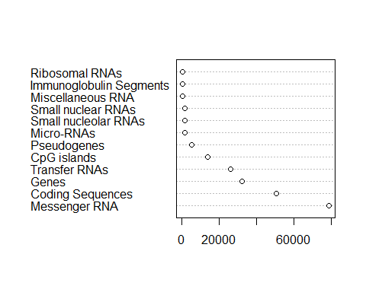

#GRAPH 4: barplot basic  
barplot(mouse$Count)

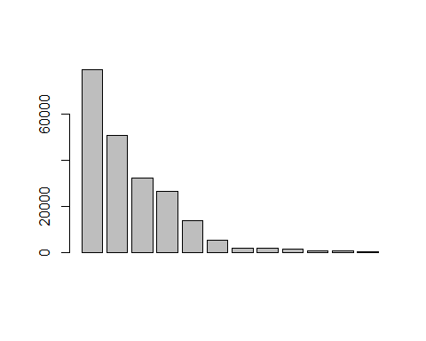

#make changes  
#PAR (bottom, left, top, right)  
par(mar=c(4, 12, 3, 5))  
  
#GRAPH 5: BARPLOT pretty  
barplot(mouse$Count, horiz= TRUE, names.arg = mouse$Feature, main = "# of features in the mouse GRCm38 genome", las=1, xlim=c(0,80000), col = "lightblue")

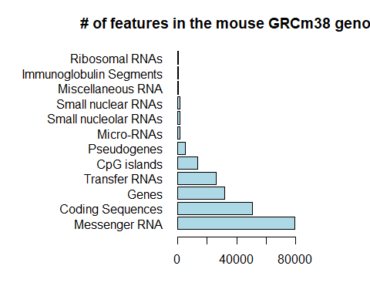

#Providing Color Vectors!  
mfcount <- read.delim("bimm143_05_rstats/male_female_counts.txt")  
  
#change the margins!  
par(mar=c(7,5,3,4))  
  
#GRAPH 6: hard code the number of rainbows  
barplot(mfcount$Count, names.arg = mfcount$Sample, col=rainbow(10))

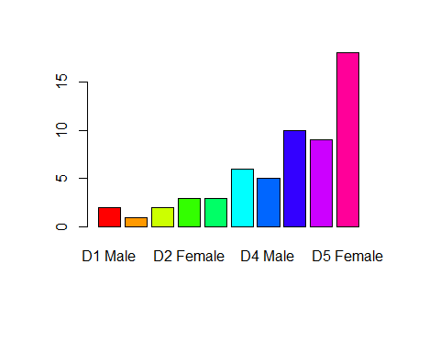

#GRAPH 7: code the number of rainbows by 'nrows'  
barplot(mfcount$Count, names.arg = mfcount$Sample, col=rainbow(nrow(mfcount)), las=2, ylab ="Counts")

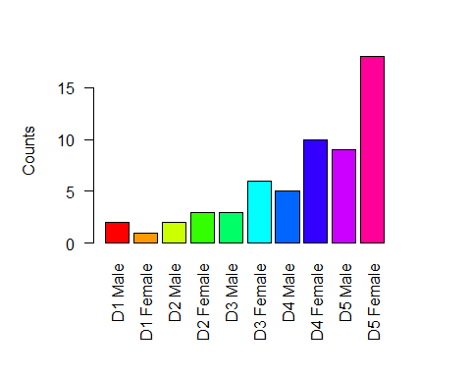

#GRAPH 8: code by every other color (list them)  
barplot(mfcount$Count, names.arg = mfcount$Sample, col=c("pink", "blue"), las=2, ylab ="Counts")

