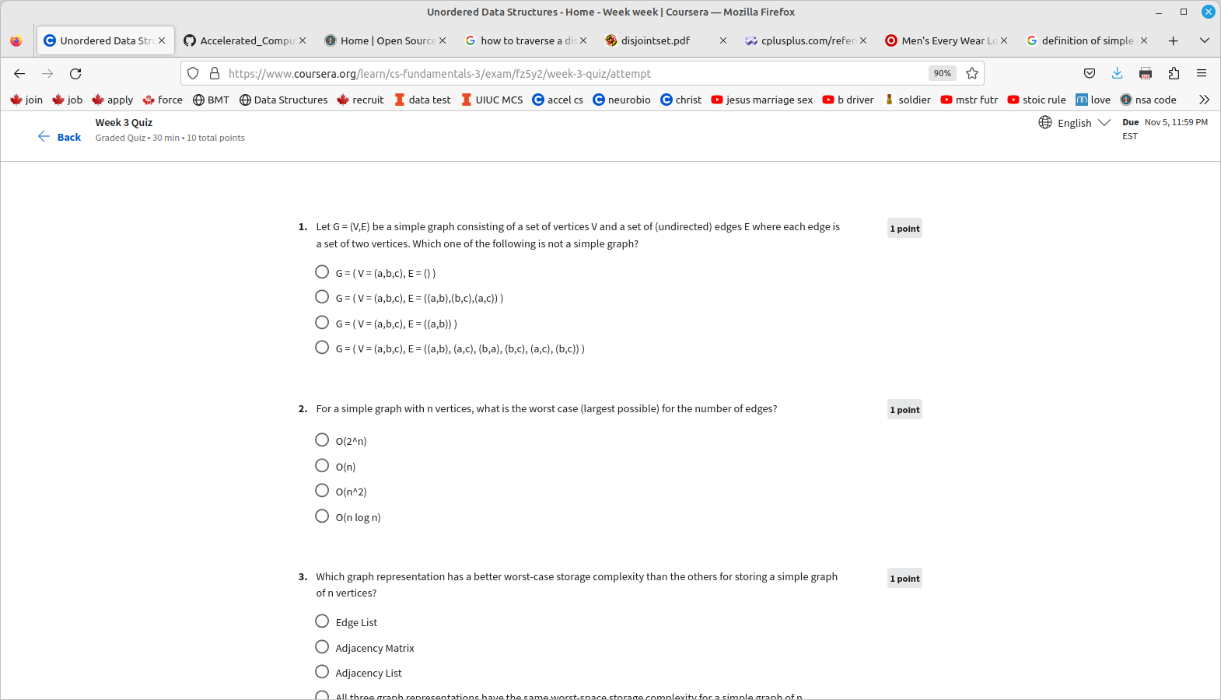

1. Simple Graph. A simple graph is a graph that does not have more than one edge between any two vertices and no edge starts and ends at the same vertex. In other words a simple graph is a graph without loops and multiple edges

3. edge list
adjacency matryx
adjacency list

An edge list is a data structure used to represent a graph as a list of its edges. An (unweighted) edge is defined by its start and end vertex, so each edge may be represented by two numbers.[1] The entire edge list may be represented as a two-column matrix.[2][3] An edge list may be considered a variation on an adjacency list which is represented as a length array of lists.[4] Since each edge contains just two or three numbers, the total space for an edge list is .[3] time complexity is Θ(|E|)

In graph theory, an adjacency matrix is nothing but a square matrix utilised to describe a finite graph. The components of the matrix express whether the pairs of a finite set of vertices (also called nodes) are adjacent in the graph or not. In graph representation, the networks are expressed with the help of nodes and edges, where nodes are the vertices and edges are the finite set of ordered pairs. o(n^2)

4. Adjacency List

The other way to represent a graph in memory is by building the adjacent list. If the graph consists of vertices, then the list contains elements. Each element is also a list and contains all the vertices, adjacent to the current vertex . By choosing an adjacency list as a way to store the graph in memory, this may save us space.
For instance, in the Depth-First Search algorithm, there is no need to store the adjacency matrix. At each algorithm step, we need to know all the vertices adjacent to the current one. This what the adjacency lists can provide us easily. We may also use the adjacency matrix in this algorithm, but there is no need to do it. Instead, we are saving space by choosing the adjacency list. (o(n^2)

https://algodaily.com/lessons/implementing-graphs-edge-list-adjacency-list-adjacency-matrix
https://www.baeldung.com/cs/adjacency-matrix-list-complexity

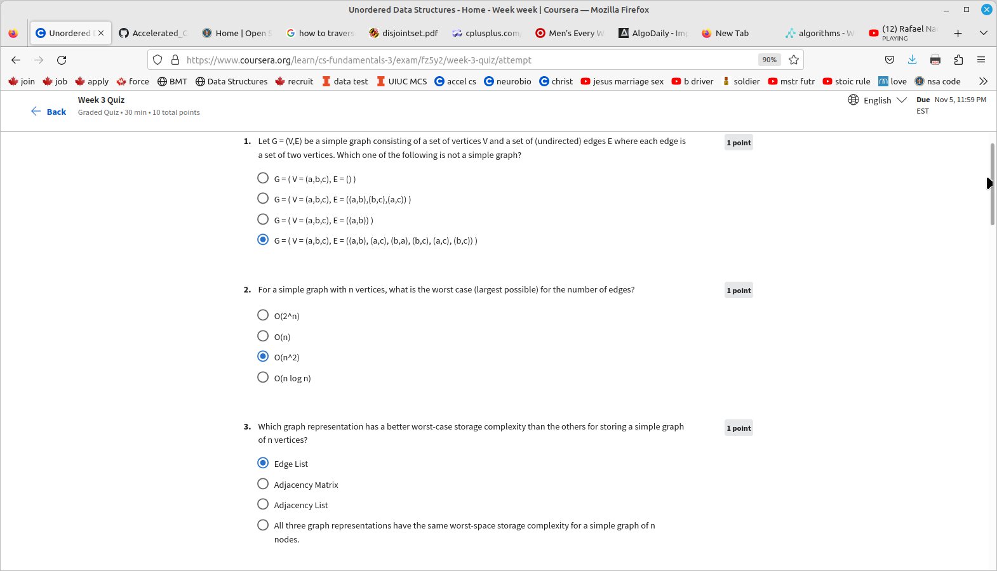
A Graph is a non-linear data structure consisting of nodes and edges. The nodes are sometimes also referred to as vertices and the edges are lines or arcs that connect any two nodes in the graph. In this article, we will understand the difference between the ways of representation of the graph.
A graph can be represented in mainly two ways. They are:

- Adjacency List: An Adjacency list is an array consisting of the address of all the linked lists. The first node of the linked list represents the vertex and the remaining lists connected to this node represents the vertices to which this node is connected. This representation can also be used to represent a weighted graph. The linked list can slightly be changed to even store the weight of the edge.
- Adjacency Matrix: Adjacency Matrix is a 2D array of size V x V where V is the number of vertices in a graph. Let the 2D array be adj[][], a slot adj[i][j] = 1 indicates that there is an edge from vertex i to vertex j. Adjacency matrix for undirected graph is always symmetric. Adjacency Matrix is also used to represent weighted graphs. If adj[i][j] = w, then there is an edge from vertex i to vertex j with weight w.
