In a disjoint set, each element has to point to another element,

The elements have to link together,
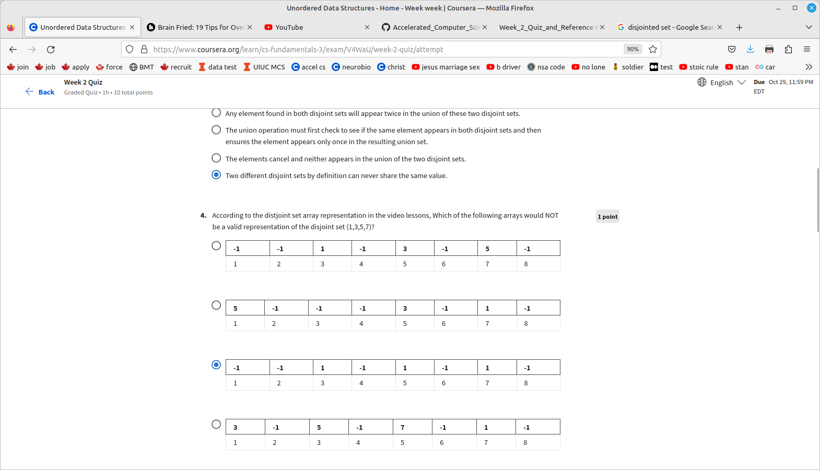
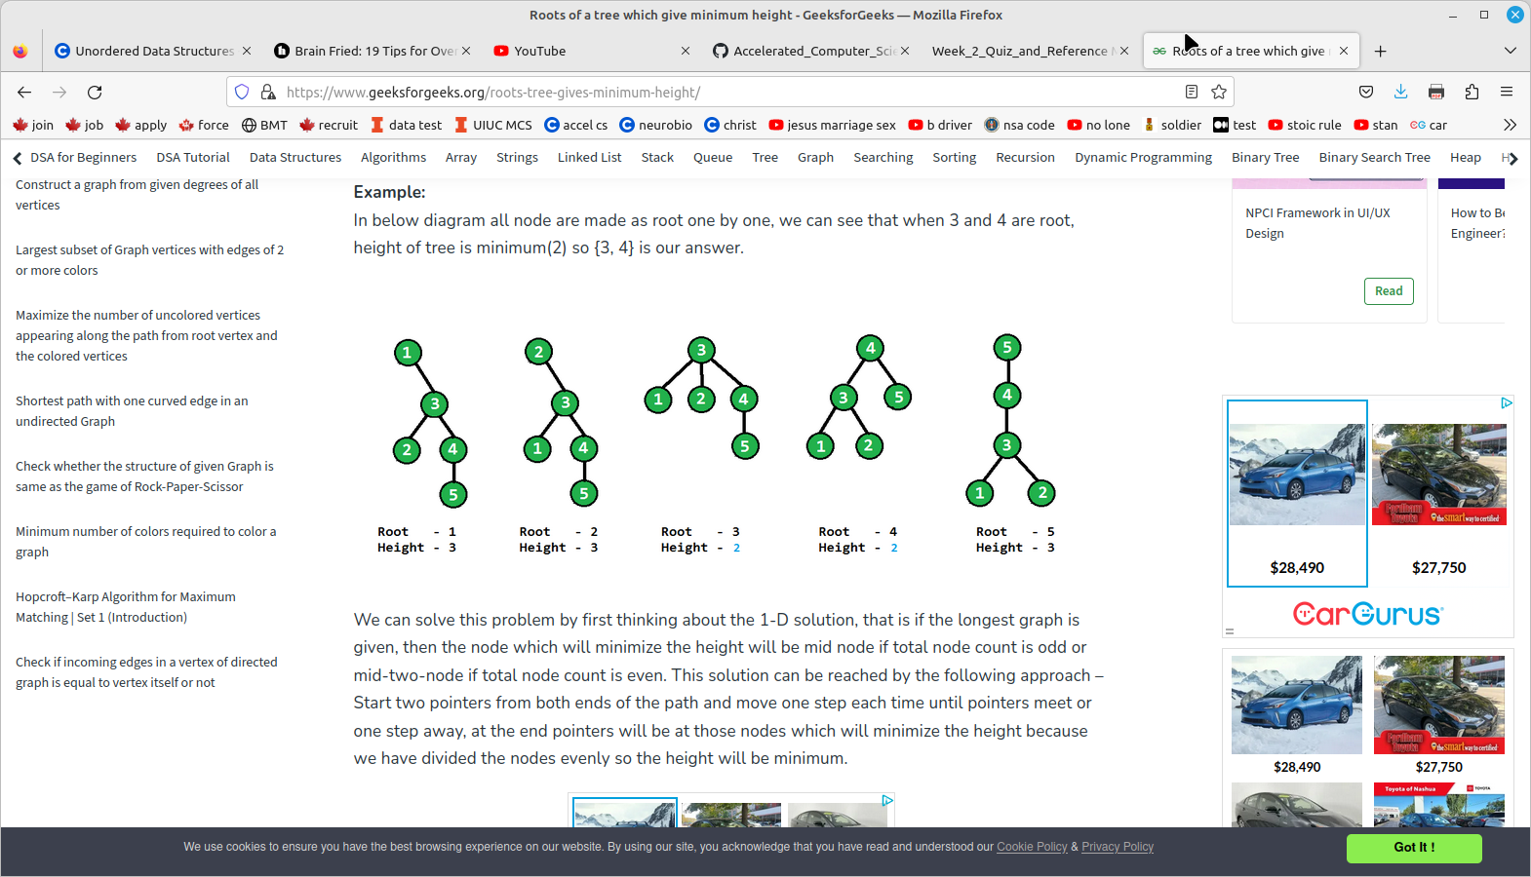

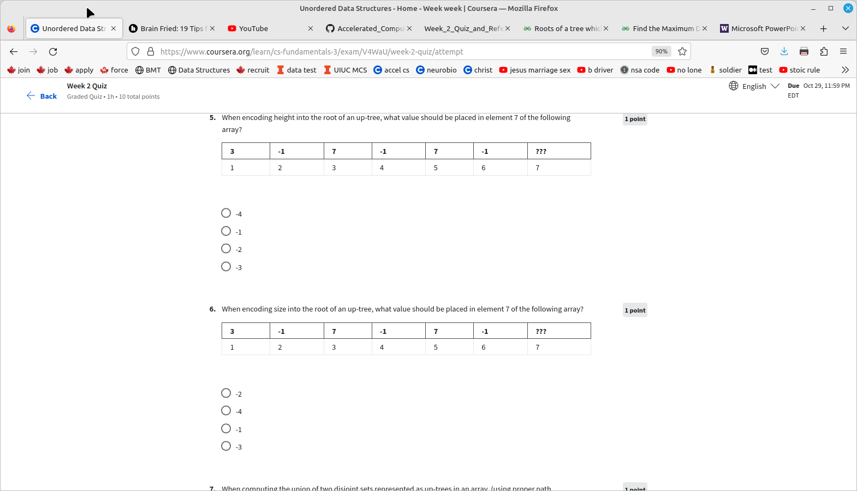
for the up-tree in #5
thing on top is the value of the element
thing on bottom is the element,
this is one implementation

The value of the element is:
-1 if we have found the representative element
the index of the parent, if we haven’t found the representative element
this is the up-tree in 2-1-3

so for #5, 6 , 2, 4 are representative elements

1’s parent is 3
3’s parent is 7
5’s parent is 7

so 7’s parent should be 0 because it is the top element

disjoint set – naive implementation#1,
in 2-1-2 video,

014 27 356

01234567
00230332

implementation #2

value of array is -1if we have found the representative element
the index of the parent, if we haven’t found the representative element

thee are up-trees.

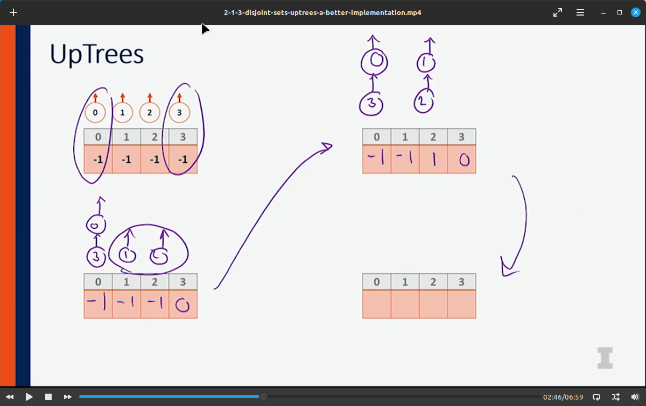

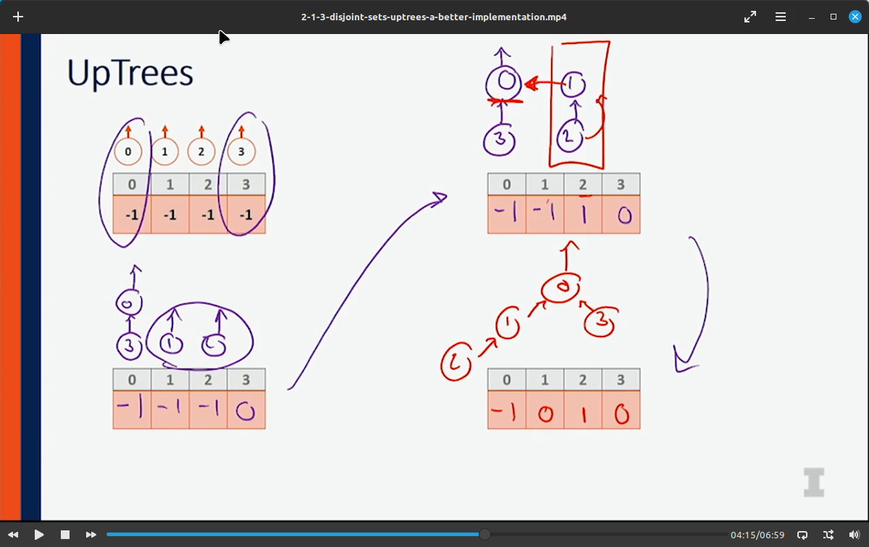

So value of -1 means it is the upper most value, i.e. the root

then the value of other nodes point to something above it.

3 -1 7 -1 7 -1 ???
1 2 3 4 5 6 7

so nodes 2 4 6 are roots

node 1 points to node 3
node 3 points to node 7
node 5 points to node 7
node 7 points to something,

if it is a root then it’s value is -1, try that

but since it is not a leaf node, it’s height is 2

so it’s height is -1 -2 = -3

#6,
3 -1 7 -1 7 -1 ???
1 2 3 4 5 6 7

2 4 6 are root nodes with value -1
1 points to 3
3 points to 7
5 points to 7
7 points to?

If 7 is a root node then it should be -1
Since 7 is 2 levels up from a leaf node it’s value is 2

so it’s overall value is -1 -(2) = -3 that is the height

but what is the size?

7(4)
3 (2) 5(1)
1(1)

size = size of left sub-tree + 1 + size of right sub-tree for a binary tree

but we want the size, so instead of (-1) which represents the fact it is a root node, we use (-height-1)

height = 3, size

however the answer = -4, according to Brian Chiang,
why is it negative?

https://www.geeksforgeeks.org/applications-of-tree-data-structure/

Why Tree to use Data Structure?
Unlike Array and Linked List, which are linear data structures, tree is hierarchical (or non-linear) data structure.

- Hierarchical Structure: Trees are used to model hierarchical structures, such as the file system in a computer or the organizational chart in a company. The tree structure allows for a natural representation of parent-child relationships, making it easy to understand and visualize the data.
- Searching Efficiency: Trees provide an efficient way to search for data. For example, in a binary search tree, searching for a value takes time proportional to the logarithm of the number of elements, which is much faster than searching in a linear data structure like an array or a linked list.
- Sorting: Trees can be used to sort data efficiently. For example, in a self-balancing binary search tree, the data is automatically sorted as it is inserted into the tree, making it easy to find the minimum, maximum, and other values in the tree.
- Dynamic Data: Trees are dynamic data structures, which means that they can grow and shrink as needed. This makes them well-suited for applications where the data changes frequently, such as in real-time systems.
- Efficient Insertion and Deletion: Trees provide efficient algorithms for inserting and deleting data, which is important in many applications where data needs to be added or removed frequently.
- Easy to Implement: Trees are relatively easy to implement, especially when compared to other data structures like graphs. This makes them a popular choice for many programming projects.

Other Applications of Tree Data Structure:
- Store hierarchical data, like folder structure, organization structure, XML/HTML data.
- Binary Search Tree is a tree that allows fast search, insert, delete on a sorted data. It also allows finding closest item
- Heap is a tree data structure which is implemented using arrays and used to implement priority queues.
- B-Tree and B+ Tree : They are used to implement indexing in databases.
- Syntax Tree: Scanning, parsing , generation of code and evaluation of arithmetic expressions in Compiler design.
- K-D Tree: A space partitioning tree used to organize points in K dimensional space.
- Trie : Used to implement dictionaries with prefix lookup.
- Suffix Tree : For quick pattern searching in a fixed text.
- Spanning Trees and shortest path trees are used in routers and bridges respectively in computer networks
- As a workflow for compositing digital images for visual effects.
- Decision trees.
- Organization chart of a large organization.
- In XML parser.
- Machine learning algorithm.
- For indexing in database.
- IN server like DNS (Domain Name Server)
- In Computer Graphics.
- To evaluate an expression.
- In chess game to store defense moves of player.
- In java virtual machine.
- Tree data structures are used to organize and manage files and directories in a file system. Each file and directory is represented as a node in the tree, with parent-child relationships indicating the hierarchical structure of the file system.
- Tree data structures are often used in parsing, such as in compilers and interpreters, to represent the structure of a program or a document.
- Tree data structures, such as binary search trees, are commonly used to implement efficient searching and sorting algorithms.
- Graphics and UI design
- Tree data structures are commonly used in decision-making algorithms in artificial intelligence, such as game-playing algorithms, expert systems, and decision trees.
- Tree data structures can be used to represent the topology of a network and to calculate routing tables for efficient data transmission.
Please write comments if you find anything incorrect, or you want to share more information about the topic discussed above.
Feeling lost in the world of random DSA topics, wasting time without progress? It's time for a change! Join our DSA course, where we'll guide you on an exciting journey to master DSA efficiently and on schedule.
Ready to dive in? Explore our Free Demo Content and join our DSA course, trusted by over 100,000 geeks!
- DSA in C++
- DSA in Java
- DSA in Python
- DSA in JavaScript

#7, disjoint sets as array implementation:
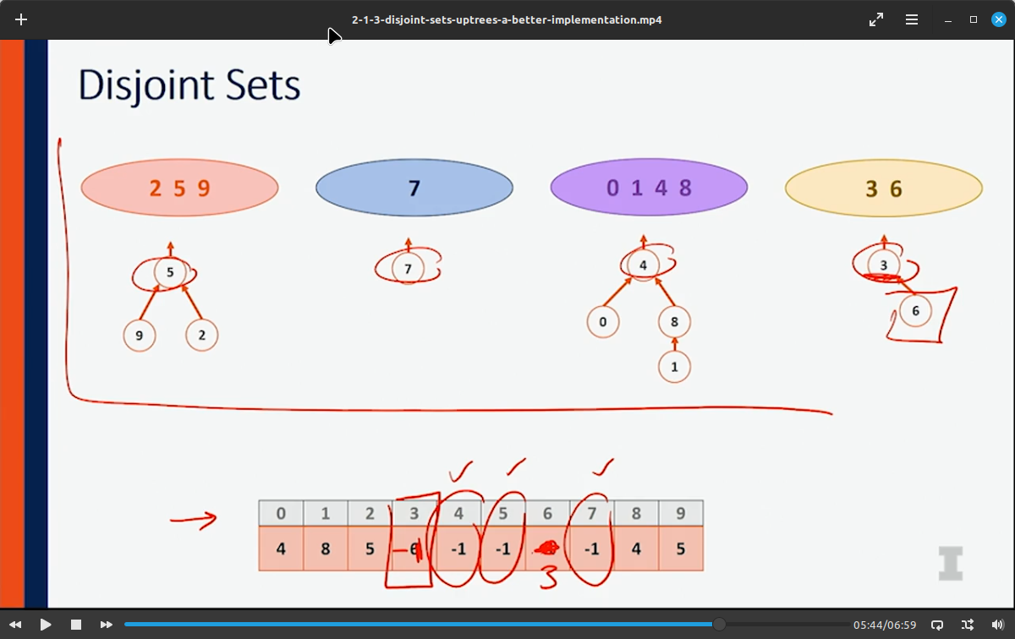

next to combine, you put the 4 tree under 7, by just assigning the value of node 4 to to 7.
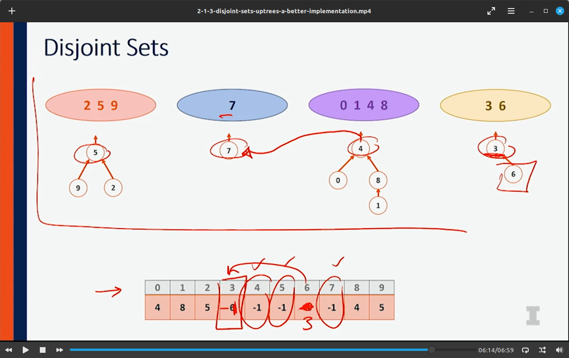

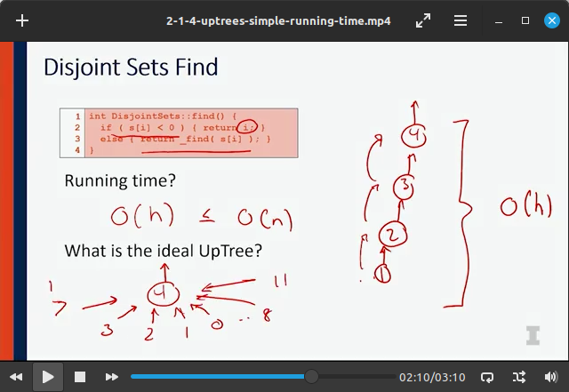
to compute the union of 2 disjoint sets represented as up-trees in an array, (using proper path compression), which one of these strategies result in a better overall run-time complexity than the other option?

