
AI AND DATA SCIENCE | PROJECT REPORT
BATON
A multi-agent AI research platform that researches, analyses and writes reports

PREPARED BY
ANUSHAY AYAT
AI and Data Science, SMIT
November 2026

Acknowledgements
I would like to thank SMIT and my instructors for the guidance, knowledge and encouragement that made this project possible. I am also grateful to the open-source communities behind CrewAI, FastAPI and the other tools used here, and to my classmates for their feedback during development.
Anushay Ayat

Abstract
Baton is a web platform in which a crew of three specialised AI agents (a Researcher, an Analyst and an Editor) collaborates to turn a single topic into a structured research report. The user chooses the topic, report length and writing voice, then follows the work live on a futuristic mission-control dashboard. Finished reports are stored privately for each signed-in user.
Users sign in with email and password or with Google, and the site opens at the login page. The system exists in two modes. In local mode a FastAPI server runs a real CrewAI crew. In cloud mode the same three roles run as separate short API requests on Vercel, with Firebase Authentication and Firestore handling accounts and storage, and LangSmith tracing every agent run. This report presents the problem, requirements, design, implementation, user interface, deployment, testing and lessons learned.
Keywords: multi-agent systems, CrewAI, Groq, LangSmith, FastAPI, Firebase, Vercel, research automation

Contents
1 Introduction 4
2 Background and technology 5
3 Requirements analysis 6
4 System design 7
5 Implementation 10
6 User interface walkthrough 12
7 Deployment 18
8 Testing 19
9 Challenges and solutions 19
10 Security, privacy and ethics 20
11 Limitations and future work 20
12 Conclusion 20
Appendix A Local setup 21
Appendix B Environment variables 21
References 21
List of figures
Figure 1: Cloud architecture
Figure 2: Sequence of one mission
Figure 3: Data model and access rule
Figure 4: Landing page hero with navigation and key figures
Figure 5: Mission control ready: command bar, reactor and agent cards on standby
Figure 6: Mission control while an agent is working (amber)
Figure 7: All agents complete with time, words and output previews
Figure 8: The finished report with copy, download and print options
Figure 9: Features section
Figure 10: How it works: three steps
Figure 11: Frequently asked questions
Figure 12: Sign in page
Figure 13: Create account with password strength meter
Figure 14: Access granted confirmation after login
Figure 15: Responsive layout on a phone
Figure 16: Deployment pipeline

1 Introduction

1.1 Background
Researching a topic normally means searching, reading, analysing and writing, often across several tools. A single chatbot reply gives a quick answer but hides how it was produced and is hard to review, repeat or keep. Multi-agent systems split the work between specialists, which makes each step clearer and easier to inspect.

1.2 Problem statement
There is a need for a simple tool that guides a topic through research, analysis and writing, shows each stage as it happens, and keeps the results organised for each user.

1.3 Objectives
- Divide the work between three specialist agents with clear hand-offs.
- Show progress live with timings, word counts and previews.
- Provide secure accounts and a private report archive.
- Trace every agent run with LangSmith for debugging.
- Deploy the product on Vercel and Firebase with a professional interface.

1.4 Scope
The project covers the web interface, the agent pipeline, accounts, report storage, tracing and deployment configuration. It does not include payments, team sharing or automatic source verification, which are listed as future work.

1.5 Report organisation
Chapter 2 introduces the technologies. Chapter 3 states the requirements. Chapter 4 presents the design, and Chapter 5 the implementation. Chapter 6 walks through the interface. Chapters 7 to 9 cover deployment, testing and challenges. Chapters 10 to 12 discuss security, limitations, future work and the conclusion.

2 Background and technology

2.1 AI agents and multi-agent systems
An AI agent is a language model given a role, a goal and instructions. In a multi-agent system several agents work on parts of a task and pass results to each other. Giving each agent a narrow job usually makes behaviour easier to reason about than asking one prompt to do everything.

2.2 CrewAI
CrewAI is an open-source Python framework for organising role-playing agents into a crew that executes tasks in a defined process. Baton uses it in local mode with a sequential process, where each task receives the earlier tasks as context.

2.3 Groq and the GPT-OSS model
Groq provides hosted, fast inference for open models. Baton calls an open GPT-OSS model through Groq, configured by an environment variable so the model can be changed without editing code.

2.4 LangSmith
LangSmith records traces of language-model applications. Each run shows its inputs, outputs, timing and errors, which helps when debugging prompts or slow stages.

2.5 Firebase
Firebase Authentication provides email and password sign in. Cloud Firestore is a document database with security rules that can restrict access to the signed-in owner of a document.

2.6 Vercel
Vercel hosts static websites and serverless functions. Its documentation lists a 300 second maximum duration on the Hobby plan with Fluid compute and a 500 MB limit for Python functions, which influenced the cloud design described in Chapter 4.

3 Requirements analysis

3.1 Users
The main users are students, founders and analysts who want a structured starting point for a topic and want to see how it was produced.

3.2 Functional requirements
ID | Requirement
FR1 | The user can enter a topic and choose report length (short, standard, deep) and voice (five options).
FR2 | Three agents run in order: Researcher, Analyst, Editor, each using the earlier output.
FR3 | The interface shows live status, timing, word count and a preview for every agent.
FR4 | The finished report is shown as formatted text and can be copied, downloaded as Markdown or printed.
FR5 | Users can create an account, sign in with email and password or with Google, and sign out.
FR6 | Each user can reopen and delete their own past reports and cannot see anyone else's.
FR7 | Every agent run is traced in LangSmith.
FR8 | The site requires login: visitors who are not signed in are sent to the login page and see the main page after signing in.

3.3 Non-functional requirements
Quality | Requirement
Usability | Clear status at every step, helpful error messages, works on phones.
Security | Token-verified API calls, per-user data rules, secrets kept in environment variables.
Performance | Each agent runs as a short request that stays inside serverless time limits.
Maintainability | Model name, keys and origins are configuration; the code is split into small files.
Accessibility | Keyboard focus styles, text labels on controls, reduced-motion support.

4 System design

4.1 Architecture
The browser signs users in with Firebase Authentication and calls the Vercel API once per agent. The API verifies the Firebase ID token, runs the agent on Groq, and sends traces to LangSmith. The browser saves and loads reports in Firestore.
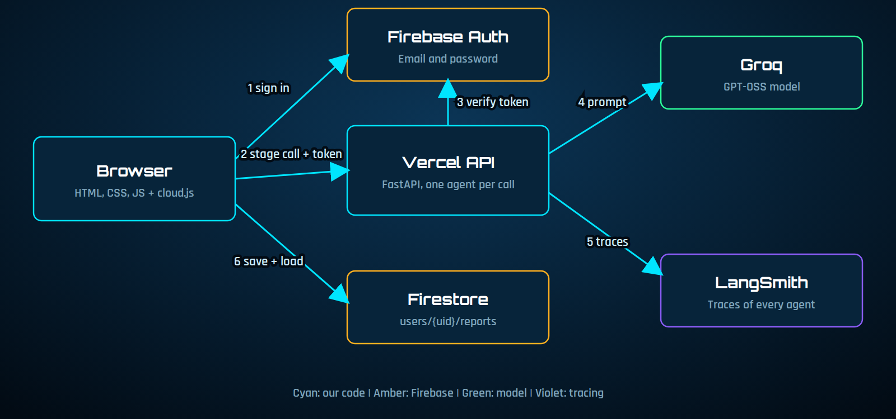
Figure 1: Cloud architecture

4.2 Agent relay
The output of each agent becomes the input of the next. The browser sends the earlier text with every call, so the API stays stateless.
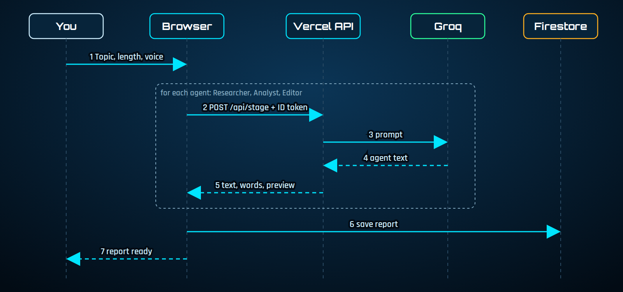
Figure 2: Sequence of one mission
Agent | Input | Responsibility
R-01 Researcher | Topic | Gathers facts, key concepts, developments, applications, benefits, challenges and future opportunities. Told not to invent facts or references.
A-02 Analyst | Research notes | Produces insights, strengths, weaknesses, risks, opportunities and recommendations using only the research provided.
E-03 Editor | Notes and analysis | Writes the final Markdown report: executive summary, introduction, findings, analysis, benefits and challenges, recommendations, conclusion.

4.3 Data model
Reports are stored under the signed-in user. A Firestore rule allows reads and writes only when the request is authenticated and the user id matches the path.
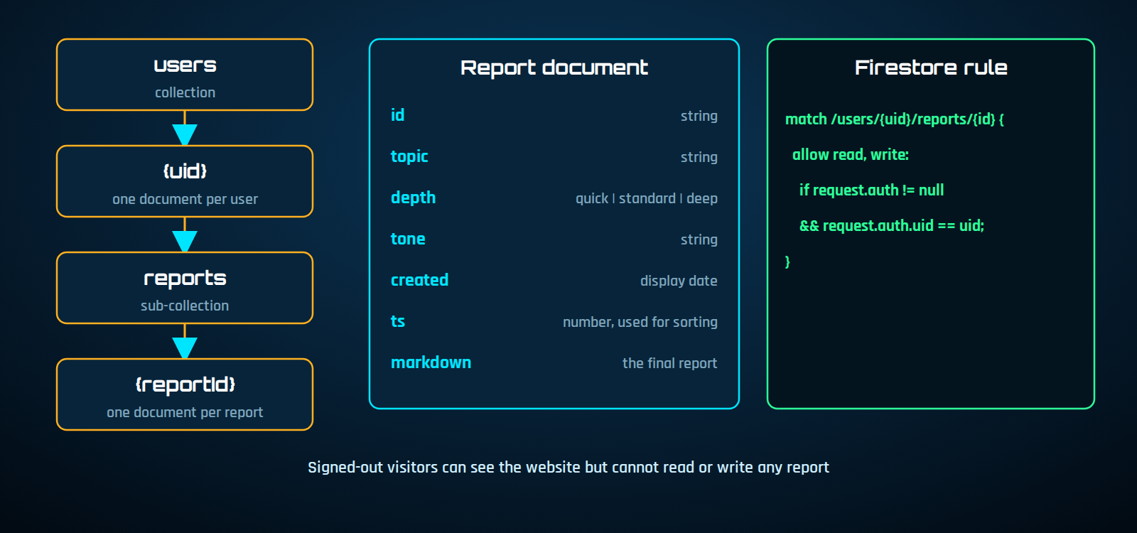
Figure 3: Data model and access rule

4.4 Local mode and cloud mode
Aspect | Local mode | Cloud mode
Agents | Real CrewAI crew | Same roles and prompts, one API call each
Server | main.py with FastAPI | api/index.py on Vercel
Accounts | SQLite with hashed passwords | Firebase Authentication
Reports | JSON files in reports/ | Firestore under users/{uid}/reports
Tracing | One trace per crew run | One trace per agent

CrewAI is a heavy dependency and a full crew run can take minutes, so the cloud mode calls the model directly in three short requests. This keeps each request well inside serverless limits and gives natural live progress.

4.5 User interface design
The interface follows a heads-up-display style: glass panels with corner brackets, scanlines, a live particle network and an arc-reactor progress visual. Colour carries meaning: amber means an agent is working and cyan means it is done.
Colour | Value | Use
Void | #020B14 | Page background
Panel | #07243A | Cards and panels
Cyan | #00E5FF | Primary accent, completed state
Blue | #1E90FF | Rotating rings
Amber | #FFB020 | Agent working
Green | #2DFF9A | Online indicator

Headings use Orbitron and body text uses Rajdhani. Motion is disabled for users who prefer reduced motion.

5 Implementation

5.1 Project structure
crewai-baton/
api/index.py Vercel API (agent stages)
public/index.html Website and mission control (markup)
public/login.html Sign in and create account (markup)
public/css/ hud, agents, effects, site, login
public/js/ mission, agents, particles, effects, reveal,
nav-auth, auth-guard, login, cloud, firebase-config
main.py Local server with CrewAI
llm_patch.py Groq cache_breakpoint fix
vercel.json firebase.json firestore.rules
requirements.txt Cloud
requirements-local.txt Local
DEPLOY.md README.md

5.2 Frontend
The site is plain HTML, CSS and JavaScript, kept in separate files: HTML for markup, css/ for styles and js/ for behaviour. It has a sticky navigation bar, a hero section, mission control, features, a three-step explanation, use cases, a FAQ and a footer. Mission control shows a reactor with three arc segments (one per agent), three agent cards, a mission log and the report viewer. Reports are rendered from Markdown and sanitised before display.

5.3 Local backend with CrewAI
main.py defines the three agents and tasks and runs them with a sequential process. A small patch (llm_patch.py) removes a cache_breakpoint key that CrewAI adds to system messages, because Groq rejects it. Progress is published as events that the browser reads through a server-sent events stream.

5.4 Cloud API
A single endpoint, POST /api/stage, runs one agent. Each call verifies the Firebase ID token, runs the agent inside a LangSmith traced run and returns the text, word count and a short preview. The core of the implementation is shown below.
@traceable(run_type="llm", name="groq-completion", client=ls)
def llm(system: str, prompt: str) -> str:
r = Groq(api_key=os.environ["GROQ_API_KEY"]).chat.completions.create(
model=MODEL, temperature=0.3,
messages=[{"role": "system", "content": system}, {"role": "user", "content": prompt}])
return r.choices[0].message.content or ""

@traceable(run_type="chain", client=ls)
def run_agent(role: str, system: str, prompt: str, topic: str = "") -> str:
return llm(system, prompt)

Endpoint | Method | Description
/api/stage | POST | Runs the Researcher (0), Analyst (1) or Editor (2) after verifying the token
/api/health | GET | Reports model name, whether auth is on and whether tracing is enabled

5.5 Browser adapter
cloud.js connects the same interface to the cloud services. It calls the API three times, passing earlier output forward, and then saves the report to Firestore:
async function go(r, user) {
const E = (t, x) => r.events.push({ type: t, ...x });
let research, analysis, text;
try {
for (let i = 0; i < 3; i++) {
E("stage", { index: i, state: "working" });
const tok = await user.getIdToken();
const res = await rf(API + "/api/stage", { method: "POST", headers: { "Content-Type": "application/json", Authorization: "Bearer " + tok },
body: JSON.stringify({ stage: i, topic: r.topic, depth: r.depth, tone: r.tone, research, analysis }) });
const d = await res.json();
if (!res.ok) throw new Error(d.detail || "Request failed");
if (i == 0) research = d.text; if (i == 1) analysis = d.text; if (i == 2) text = d.text;
E("stage", { index: i, state: "done", words: d.words, preview: d.preview });
}
const { fs, db } = await fb();
await fs.setDoc(fs.doc(db, "users", user.uid, "reports", r.id), { id: r.id, topic: r.topic, depth: r.depth, tone: r.tone,
created: new Date().toLocaleString([], { day: "2-digit", month: "short", year: "numeric", hour: "2-digit", minute: "2-digit" }), ts: Date.now(), markdown: text });
E("done", { report_id: r.id });
} catch (e) { E("error", { message: e.message }); }
}

5.6 Authentication
Users sign up and sign in with Firebase Authentication, using email and password or a Google popup. In local mode the browser sends the Firebase ID token to the server, which verifies it and starts a session; in cloud mode the Firebase session is used directly. A small guard script (auth-guard.js) sends visitors who are not signed in to the login page, and the login page sends signed-in users to the main page. The login page shows clear errors, a password strength meter and an access-granted confirmation. The browser attaches the Firebase ID token to every agent request, and the API rejects calls without a valid token when authentication is enabled.

5.7 Observability with LangSmith
Each agent call is wrapped in a traced chain run with the model call nested inside it. Metadata records the agent name and user id, and tags mark the run as a Baton run. Tracing is switched on with three environment variables. In local mode the whole CrewAI crew run is traced as one run.

6 User interface walkthrough
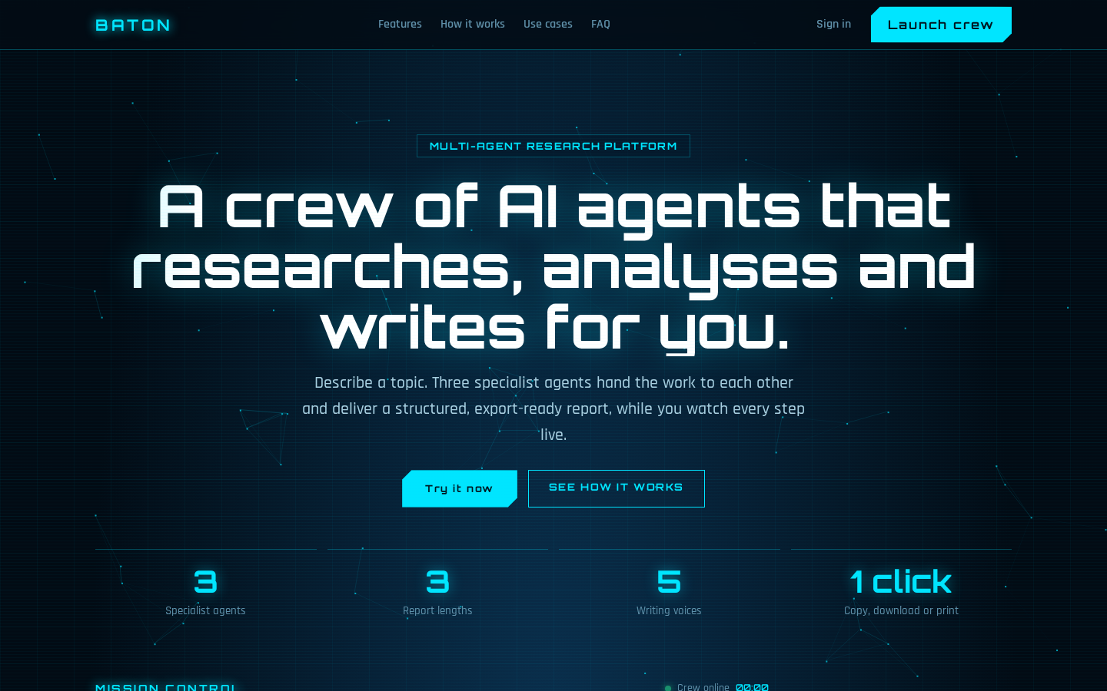
Figure 4: Landing page hero with navigation and key figures
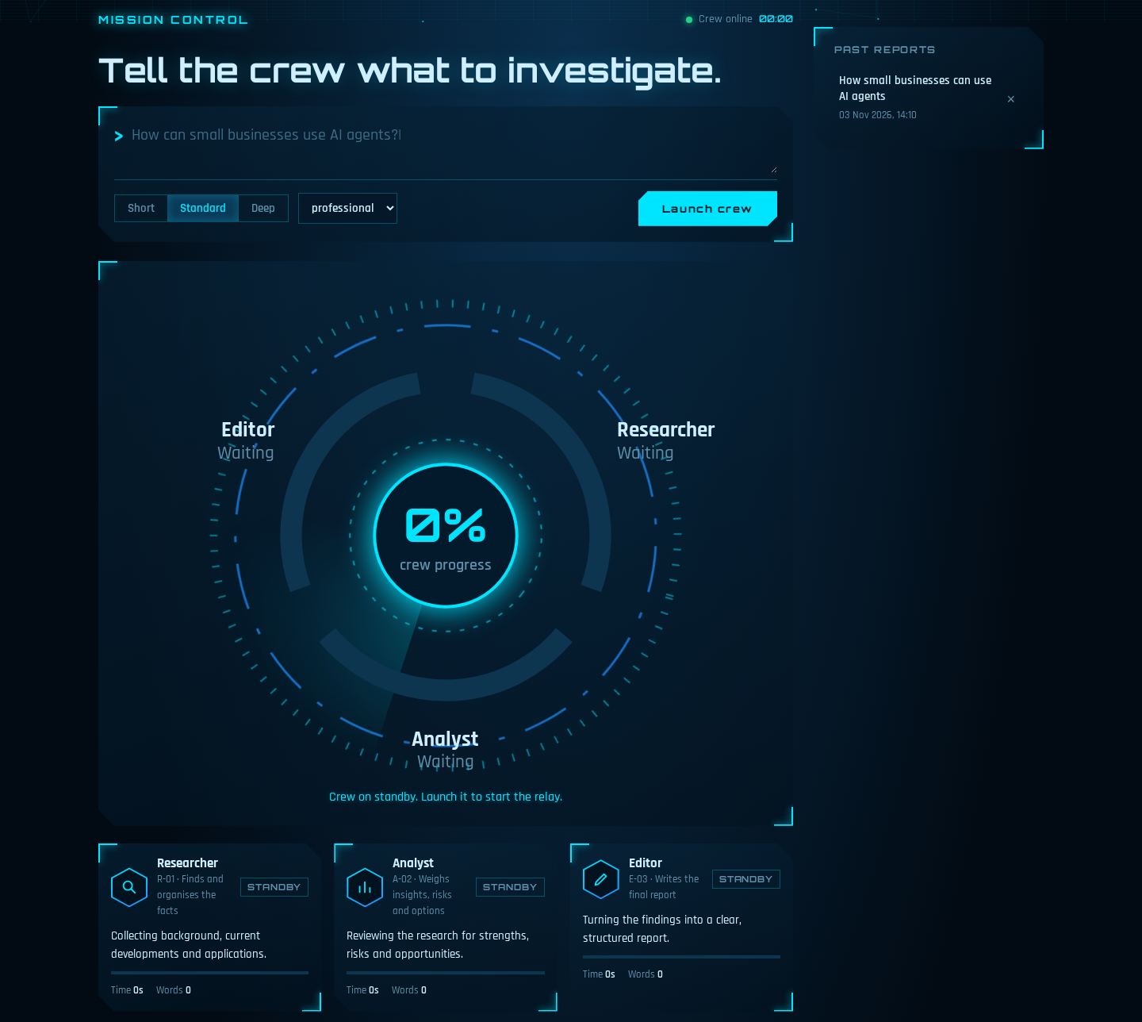
Figure 5: Mission control ready: command bar, reactor and agent cards on standby
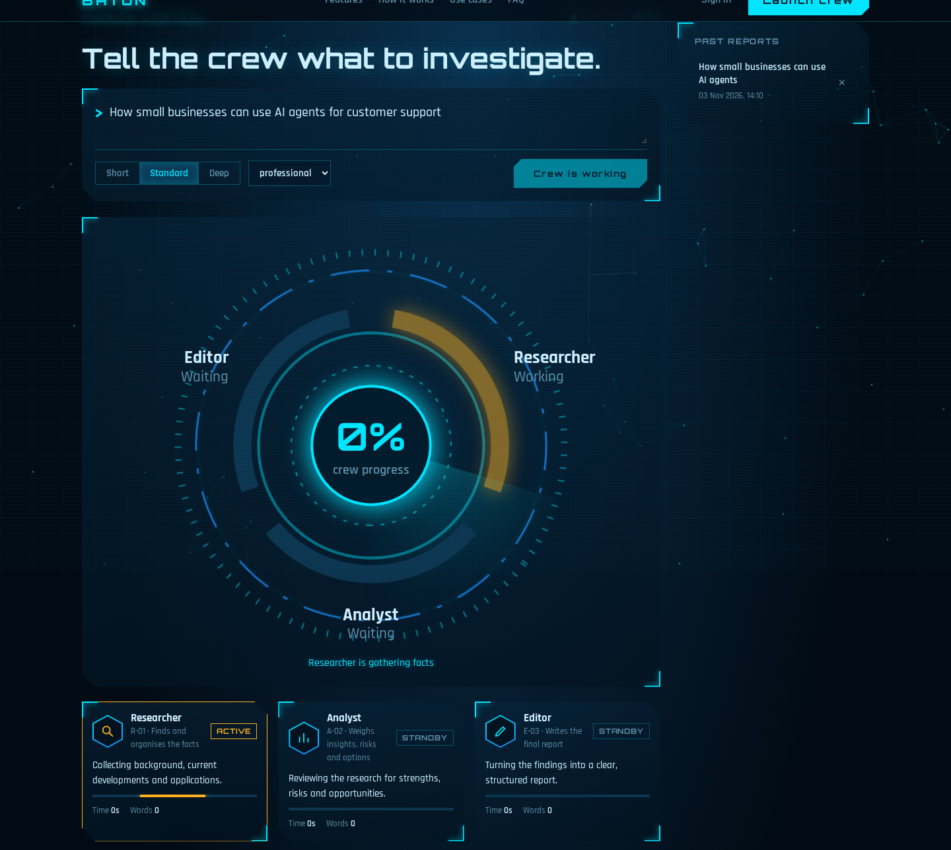
Figure 6: Mission control while an agent is working (amber)
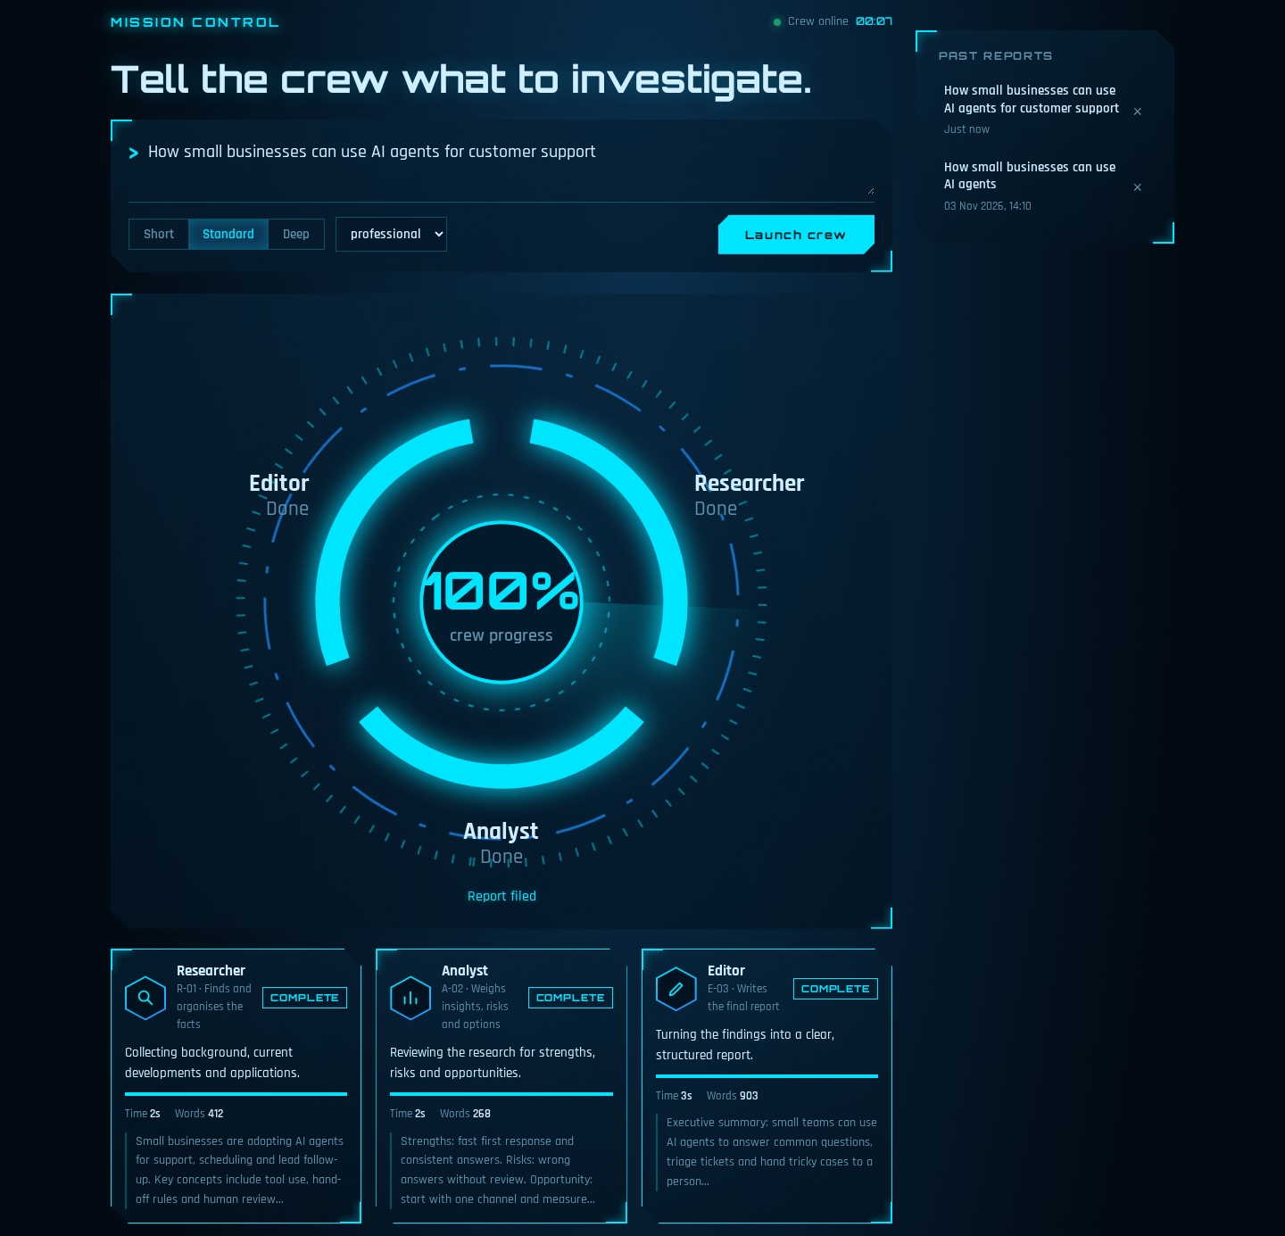
Figure 7: All agents complete with time, words and output previews
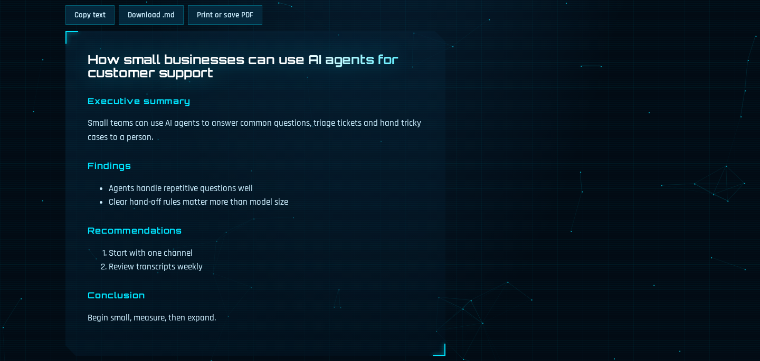
Figure 8: The finished report with copy, download and print options
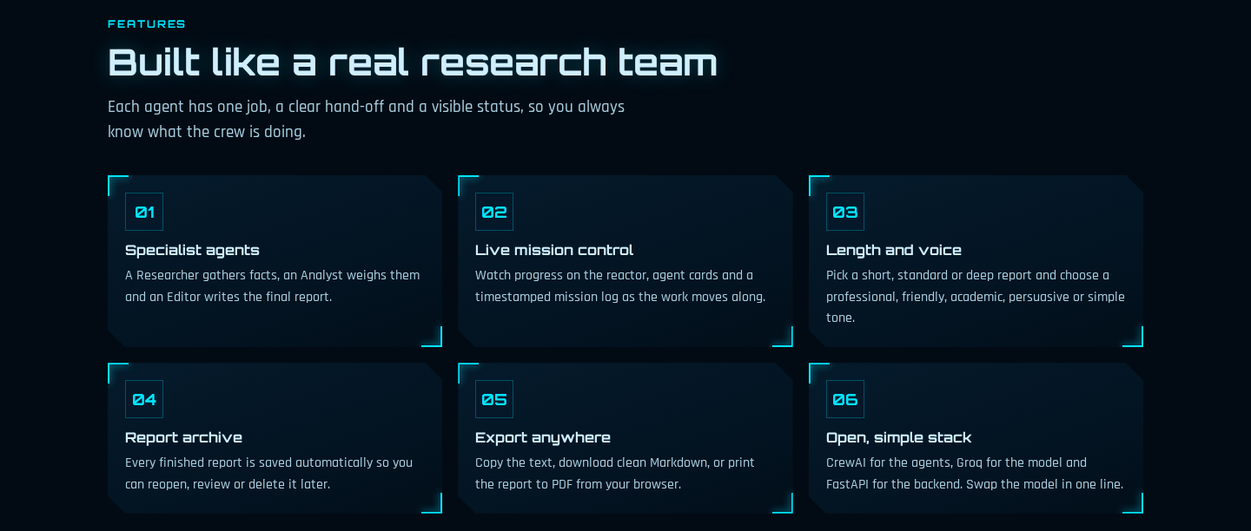
Figure 9: Features section
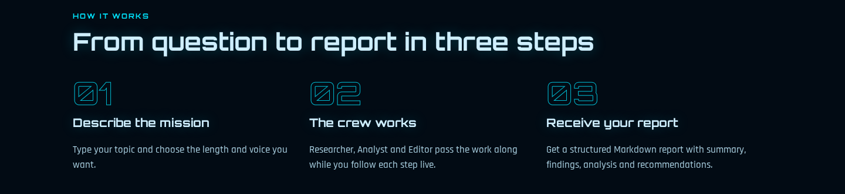
Figure 10: How it works: three steps
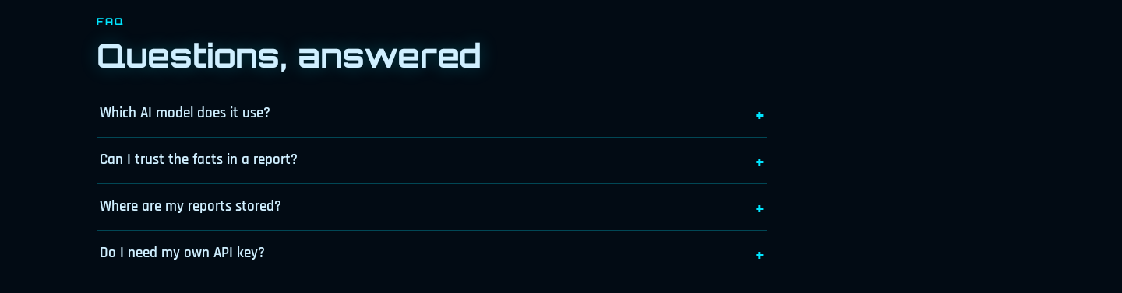
Figure 11: Frequently asked questions
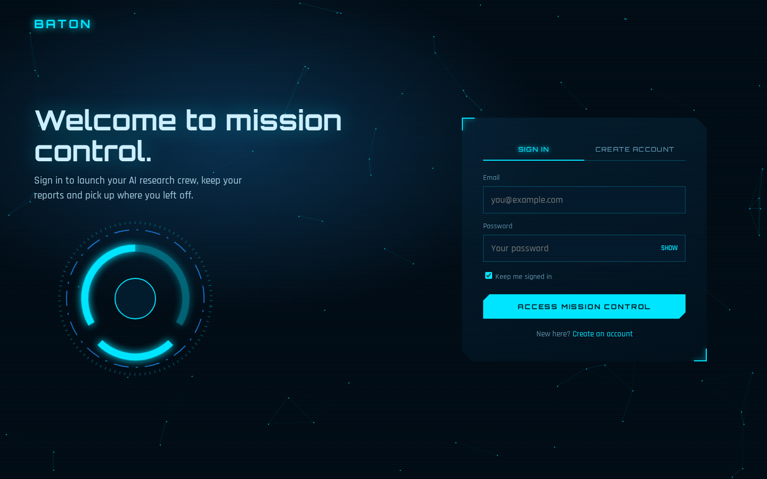
Figure 12: Sign in page
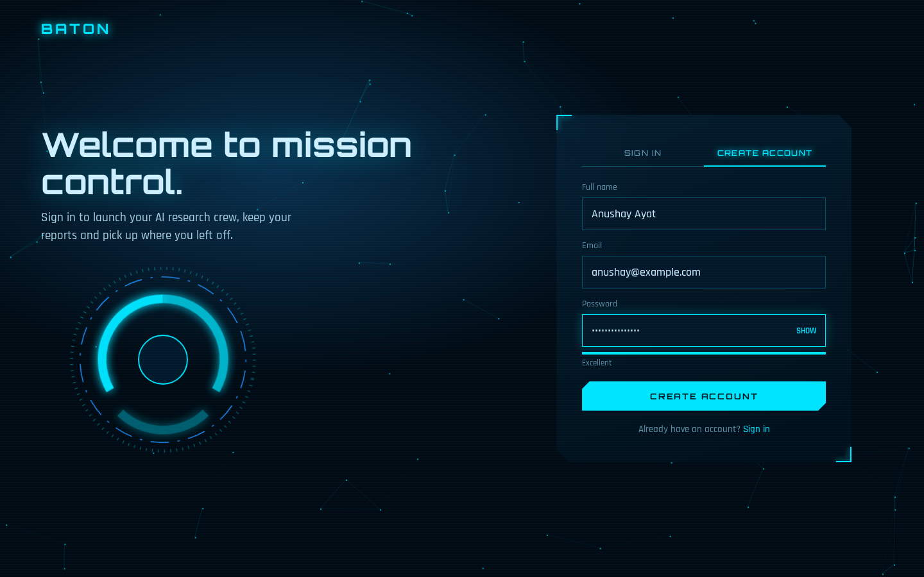
Figure 13: Create account with password strength meter
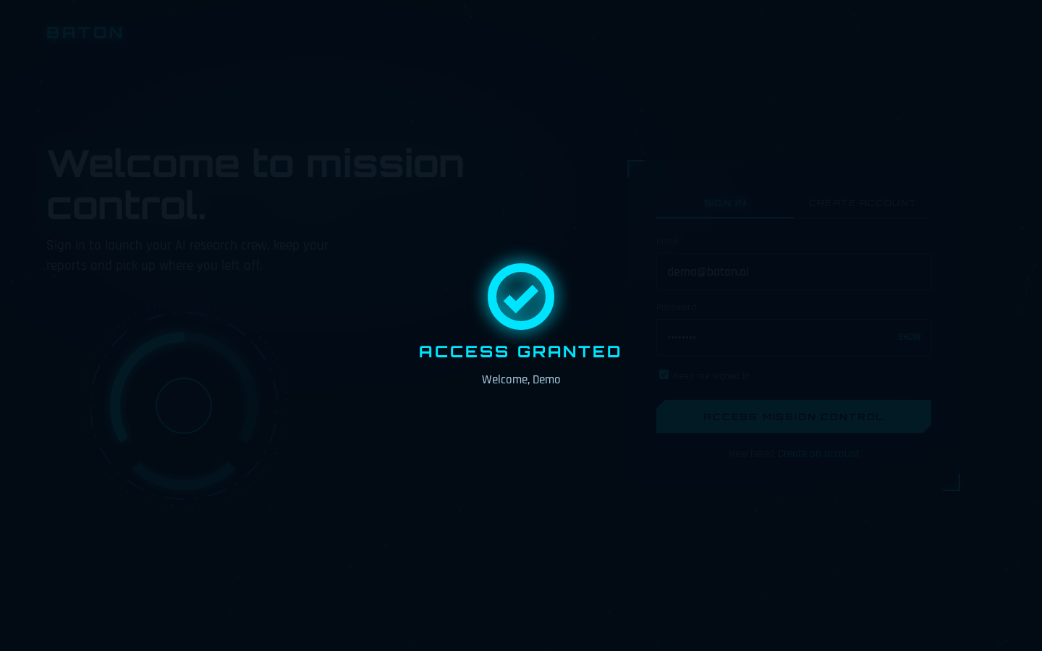
Figure 14: Access granted confirmation after login
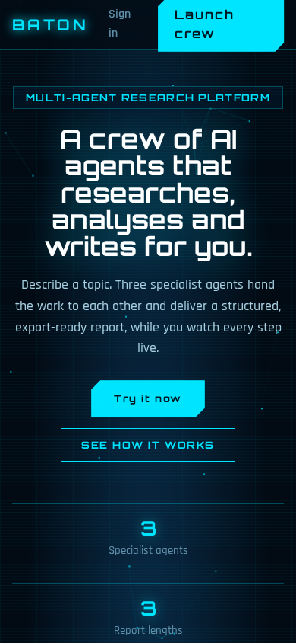
Figure 15: Responsive layout on a phone
The screenshots were captured from the demo build of the interface, which uses sample data in place of live model output.

7 Deployment
The project is deployed on Vercel (website and API) and Firebase (Authentication and Firestore). The live site runs at crewai-baton.vercel.app.
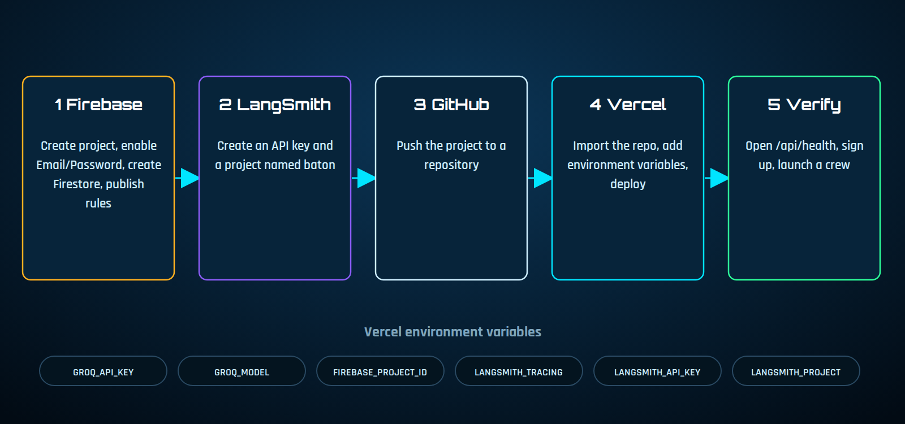
Figure 16: Deployment pipeline
- Firebase: create a project, enable Email/Password, create Firestore, paste the web config into firebase-config.js and publish firestore.rules.
- LangSmith: create an API key and a project named baton.
- Vercel: import the GitHub repository, add the environment variables and deploy.
- Authorised domains: add the Vercel domain in Firebase Authentication settings.
- Verify: open /api/health, create an account and launch a crew.

Problem | Fix
Redirected to login repeatedly | Add the domain to Firebase authorised domains
401 session expired | FIREBASE_PROJECT_ID on Vercel must match the Firebase project
502 from the API | Check GROQ_API_KEY and the model name in the Vercel logs
CORS error on Firebase Hosting | Set CORS_ORIGINS and BATON_API
No traces | Check the three LangSmith variables and redeploy

8 Testing
Automated and simulated tests were run during development, followed by a live run on the deployed site.
ID | Test | Method | Result
T1 | API stage order | Stubbed model: stages 0, 1 and 2 return Researcher, Analyst and Editor | Passed
T2 | API validation | Stage 1 without research returns 400 | Passed
T3 | API authentication | With auth on, a call without a token returns 401 | Passed
T4 | Cloud browser flow | Simulated browser with fake Firebase and API: login, launch, three stages, report saved | Passed
T5 | History and sign out | Saved report appears in history; sign out and logged-out landing page behave correctly | Passed
T6 | Login errors | Wrong password shows an error; correct password shows access granted | Passed
T7 | Password strength | Strong password reports Excellent | Passed
T8 | Script syntax | Syntax check of every inline and external script | Passed
T9 | Live end-to-end | Deployed on Vercel with Firebase and Groq: Google sign-in and a full crew run | Passed
T10 | Token claims | Firebase token check with realistic claims (user_id and sub); found and fixed a bug that read a missing uid field | Passed

All tests passed, including a live run on the deployed site at crewai-baton.vercel.app. Agent runs can also be reviewed as traces in the LangSmith project dashboard.

9 Challenges and solutions
Challenge | Cause | Solution
Circular import error | The file was named app.py and imported from app | Import from the crewai package instead
Groq rejected requests | CrewAI added a cache_breakpoint key to system messages | llm_patch.py removes the key before the request is sent
Serverless limits | CrewAI is heavy and a run takes minutes | Run each agent as a short API stage
No saved files in the cloud | Serverless storage is temporary | Store reports in Firestore per user
Buttons did not respond | A quoting error in the script stopped it from running | Script syntax checks and simulated browser tests
Session expired after login | The token check read a uid field that Firebase tokens do not contain | Read user_id or sub from the verified token

10 Security, privacy and ethics
- API keys are kept in environment variables and are never stored in the repository.
- The API verifies the Firebase ID token and Firestore rules isolate each user's reports.
- The Firebase web config is a public identifier; security relies on Authentication and the rules.
- Passwords in local mode are stored as salted hashes, never in plain text.
- Topics are sent to the model provider to produce a report, so users should avoid entering confidential information.
- AI output can contain mistakes. Reports are a starting point and important claims must be checked against trusted sources.

11 Limitations and future work

11.1 Limitations
- Cloud mode uses direct model calls instead of the CrewAI library, so behaviour can differ slightly from local mode.
- Reports do not include verified source links.

11.2 Future work
- Add more agents, such as a fact checker and a reviewer.
- Include source links and citations in reports.
- Add PDF export and report sharing.
- Add password reset and email verification.
- Evaluate report quality using LangSmith datasets.

12 Conclusion
Baton shows how a small crew of specialised agents can turn one question into a structured report while keeping the process visible and traceable. The project combines a multi-agent backend, secure accounts, per-user storage, tracing and a polished interface, and it is deployed on Vercel and Firebase.

Appendix A Local setup
pip install -r requirements-local.txt
copy .env.example to .env and add GROQ_API_KEY
python main.py
open http://127.0.0.1:8000

Appendix B Environment variables
Variable | Purpose
GROQ_API_KEY | Access to the Groq model
GROQ_MODEL | Model name, for example openai/gpt-oss-20b
FIREBASE_PROJECT_ID | Used to verify login tokens
LANGSMITH_TRACING | Turns tracing on
LANGSMITH_API_KEY | LangSmith access
LANGSMITH_PROJECT | Project name, for example baton
CORS_ORIGINS | Optional, used when the site is on Firebase Hosting

References
- CrewAI documentation: docs.crewai.com
- Groq documentation: console.groq.com/docs
- LangSmith documentation: docs.smith.langchain.com
- Firebase documentation: firebase.google.com/docs
- Vercel function limits: vercel.com/docs/functions/limitations

