PROJECT REPORT
◆ PropMind
AI Real Estate Intelligence Platform
Price prediction · Explained recommendations · AI advisor · Document RAG
Submitted by
Anushay Ayat
Program
Artificial Intelligence and Data Science
Institute
SMIT (Saylani Mass IT Training)
Date
October 2026

Abstract
PropMind is an AI-powered real estate intelligence platform that analyzes properties, predicts prices, recommends homes with explanations and answers questions through a generative AI advisor and a document-grounded RAG assistant. It is built on the Ames Housing dataset (1,458 cleaned home sales) and delivered as a FastAPI application with a premium web interface.
After cleaning and exploratory analysis, three regression models were compared. The deployed Random Forest reaches an R² of 0.885 and a mean absolute error of $17,782 on unseen homes, with 77% of predictions within 15% of the real price. A transparent recommender ranks homes by budget fit, value against the AI fair price, quality and preferences and explains every result. The assistant uses a structured prompt with injected market facts and safety rules, and degrades gracefully to an offline mode. The RAG assistant retrieves passages from four property documents with stemmed TF-IDF and answers with citations, ranking the correct document first for all 15 evaluation questions.
Testing the system as a product exposed and fixed real defects, including a neighborhood feature that the first model ignored. The project includes automated tests, a complete notebook, deployment configuration for GitHub, Vercel and Firebase, and full documentation.
Keywords: real estate, price prediction, Random Forest, recommendation system, generative AI, RAG, FastAPI, prompt engineering

Table of Contents
1. Introduction 4
1.1 Background and Motivation 4
1.2 Problem Statement 4
1.3 Objectives 4
1.4 Assignment Requirements and Where They Are Met 5
2. Dataset and Preprocessing 6
2.1 Source and Description 6
2.2 Missing Values 6
2.3 Cleaning and Feature Engineering 6
2.4 Features Used by the Deployed Model 7
3. Exploratory Data Analysis 8
3.1 Price Distribution 8
3.2 Location Comparison 8
3.3 Size and Quality 9
3.4 Age, Trend and Correlations 9
4. Machine Learning Methodology 11
4.1 Problem Formulation 11
4.2 Pipeline 11
4.3 Models Compared 11
4.4 Evaluation Protocol 11
4.5 A Defect Found Through Testing 11
5. Results and Evaluation 13
5.1 Model Comparison 13
5.2 How Close Are the Predictions? 13
5.3 Feature Importance 14
5.4 What-If Analysis 15
6. Recommendation System 16
6.1 Inputs and Filtering 16
6.2 Scoring 16
6.3 Explanations and Worked Example 16
7. Generative AI Assistant 17
7.1 Design 17
7.2 Prompt Engineering 17
7.3 Property Summaries 17
7.4 Reliability: Offline Mode 17
8. RAG Knowledge Assistant 19
8.1 Knowledge Base 19
8.2 Pipeline 19
8.3 Grounded Generation 19
8.4 Retrieval Evaluation 20
9. System Design and Implementation 21
9.1 Architecture 21
9.2 Backend Modules 21
9.3 API Endpoints 22
9.4 Web Interface 22
9.5 Additional Features 25
10. Testing and Quality Assurance 26
10.1 Automated Tests 26
10.2 Browser Tests 26
10.3 Defects Found and Fixed 26
11. Deployment and Operations 27
12. Limitations and Future Work 28
12.1 Limitations 28
12.2 Future Work 28
13. Conclusion 29
14. References 30
Appendix A: Setup and Run Guide 31
Appendix B: Example API Call 32

1. Introduction

1.1 Background and Motivation
Buying a home is the largest financial decision most people make, yet the information available to them is scattered and hard to trust. Listing prices are opinions, neighborhood comparisons live in spreadsheets, and the legal and financial rules of a purchase are buried in long documents. Recent advances in machine learning and generative AI make it possible to bring these pieces together in a single, explainable product.
PropMind is an AI-powered real estate platform built to demonstrate that idea end to end. Rather than stopping at a trained model in a notebook, it delivers a complete product: a data pipeline, a price-prediction model, an explainable recommendation engine, a generative AI advisor, a retrieval-augmented generation (RAG) assistant over property documents, a FastAPI backend and a premium web interface.

1.2 Problem Statement
A prospective buyer faces four connected problems:
- Opaque pricing: it is hard to know whether an asking price is fair for a specific home.
- Manual matching: filtering listings by budget, location and preferences is slow, and tools rarely explain why a home is a good fit.
- Hard-to-read documents: buying guides, legal procedures and investment advice are long and difficult to search.
- Fragmented tools: valuation, search, advice and document help sit in separate places.

1.3 Objectives
- Clean and analyze a real housing dataset and communicate its main patterns visually.
- Train, compare and evaluate machine-learning models that predict sale prices, and deploy the best one.
- Recommend properties from a user's budget, location, bedrooms and preferences, and explain every recommendation.
- Provide a generative AI assistant with careful prompt engineering and safe behavior.
- Answer questions from property documents using RAG, with citations to the exact passages.
- Package everything as a clean, deployable web application with tests, documentation and source control.

1.4 Assignment Requirements and Where They Are Met
Table 1: Mapping of assignment requirements to this report and the project
# | Requirement | How PropMind meets it | Section
1 | Data analysis | Cleaning and preprocessing with Pandas and NumPy; eight Matplotlib and Seaborn charts (price, location, area vs price, quality, trend, correlations) | 2, 3
2 | ML price prediction | Linear Regression, Decision Tree and Random Forest compared; best model evaluated and saved with joblib | 4, 5
3 | Recommendation system | Filters by budget, location, bedrooms and preferences; every result explains why it was recommended | 6
4 | AI real estate assistant | Groq (Llama 3.3) chatbot with prompt engineering, market trends, property summaries and buying guidance | 7
5 | RAG knowledge assistant | Four property documents plus user uploads; answers use only retrieved passages and cite them | 8
6 | FastAPI and web interface | Prediction, recommendation and chatbot pages, plus insights, documents and about pages | 9
7 | GitHub submission | Source code, dataset, requirements, README, screenshots, notebook and tests | 11, App. A

2. Dataset and Preprocessing

2.1 Source and Description
The project uses the Ames Housing dataset, compiled by Dean De Cock (2011) and distributed through Kaggle's House Prices: Advanced Regression Techniques competition under the MIT license. The training file contains *1,460 home sales in Ames, Iowa, recorded between 2006 and 2010, described by 79 explanatory variables* covering size, quality, age, location, garage, basement and many other features, plus the target SalePrice in US dollars.
The dataset is rich and well documented, which makes it a good teaching resource. Its limits are equally important: it describes a single city and a past period, so the resulting estimates are educational and not suitable as appraisals.

2.2 Missing Values
19 of the 81 columns contain missing values, about 7,829 empty cells in total. Most of these are not genuine gaps. In columns such as PoolQC, Alley, Fence or the garage and basement descriptors, "NA" means that the feature does not exist (no pool, no alley, no garage). Treating them as missing and dropping or imputing them would destroy real information, so they are encoded as an explicit "None" category instead.

2.3 Cleaning and Feature Engineering
Table 2: Cleaning steps applied to the raw data
Step | Action | Reason
1 | Drop the Id column | Identifier with no predictive meaning
2 | Fill 15 descriptor columns with "None" | NA means the feature is absent
3 | Impute LotFrontage with the neighborhood median | Homes in one neighborhood have similar lot frontage
4 | Set GarageYrBlt to YearBuilt; MasVnrArea to 0; Electrical to the mode | Sensible defaults for the few remaining gaps
5 | Remove two outliers (living area over 4,000 sqft sold under $300,000) | Documented anomalies that distort the area-price relationship
6 | Create TotalSF, HouseAge and PricePerSqft | Summarize size and age; PricePerSqft supports neighborhood comparison

After cleaning, the data contains 1,458 homes and 83 columns with no missing values.

2.4 Features Used by the Deployed Model
To keep the web form simple enough for a real user, the deployed model uses nine inputs that a buyer can know without technical effort:
Table 3: Model inputs
Feature | Meaning | Type
GrLivArea | Above-ground living area (sqft) | Numeric
BedroomAbvGr | Bedrooms above ground | Numeric
FullBath | Full bathrooms | Numeric
OverallQual | Overall material and finish quality (1-10) | Ordinal
YearBuilt | Original construction year | Numeric
GarageCars | Garage capacity in cars | Numeric
TotalBsmtSF | Total basement area (sqft) | Numeric
LotArea | Lot size (sqft) | Numeric
Neighborhood | One of 25 Ames neighborhoods | Categorical

3. Exploratory Data Analysis

3.1 Price Distribution
Sale prices are right-skewed: the mean ($180,933) sits well above the median ($163,000) because a small number of expensive homes pull it upward. The skewness of the raw price is 1.88; after a log transform it drops to 0.12, which is close to a symmetric distribution. This motivates predicting the logarithm of the price in the models (Section 4).
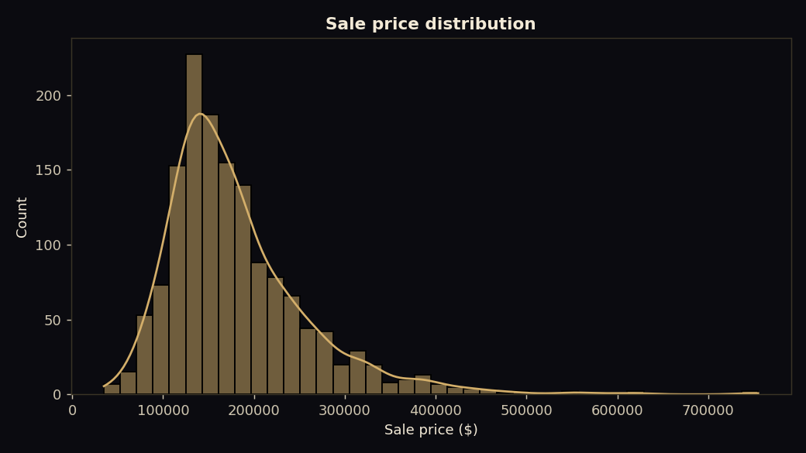
Figure 1: Distribution of sale prices

3.2 Location Comparison
Location matters strongly. The highest median prices are in NridgHt ($315,000), NoRidge ($301,500), StoneBr ($278,000); the lowest are in BrDale ($106,000), IDOTRR ($103,000), MeadowV ($88,000). The most expensive neighborhood, NridgHt, has a median price about 3.6 times that of the cheapest, MeadowV.
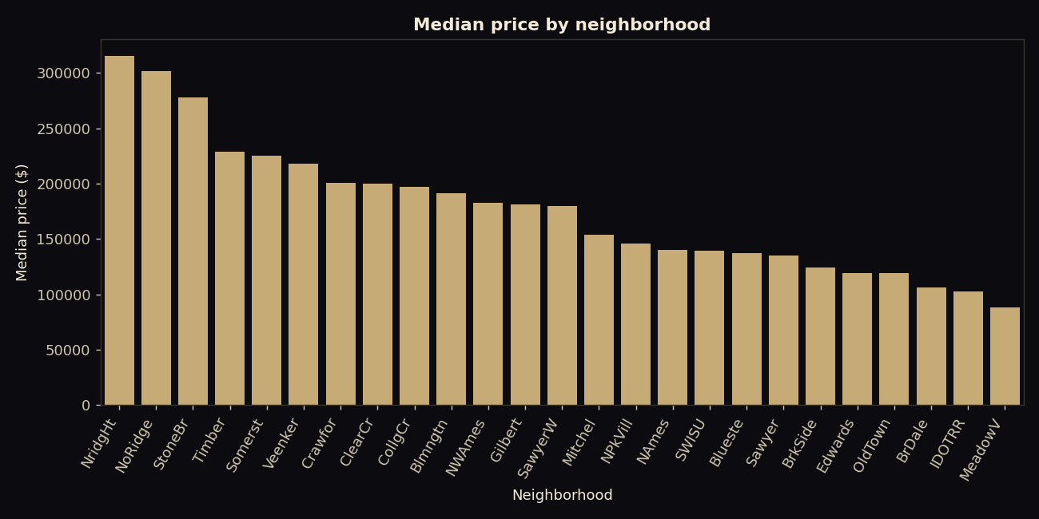
Figure 2: Median sale price by neighborhood

3.3 Size and Quality
Living area and quality are the strongest numeric drivers of price. The correlation between living area and price is 0.735, and between overall quality and price 0.796. Median price rises steeply with quality: $86,250 at quality 3, $133,000 at 5, $200,141 at 7, $345,000 at 9 and $445,365 at 10.
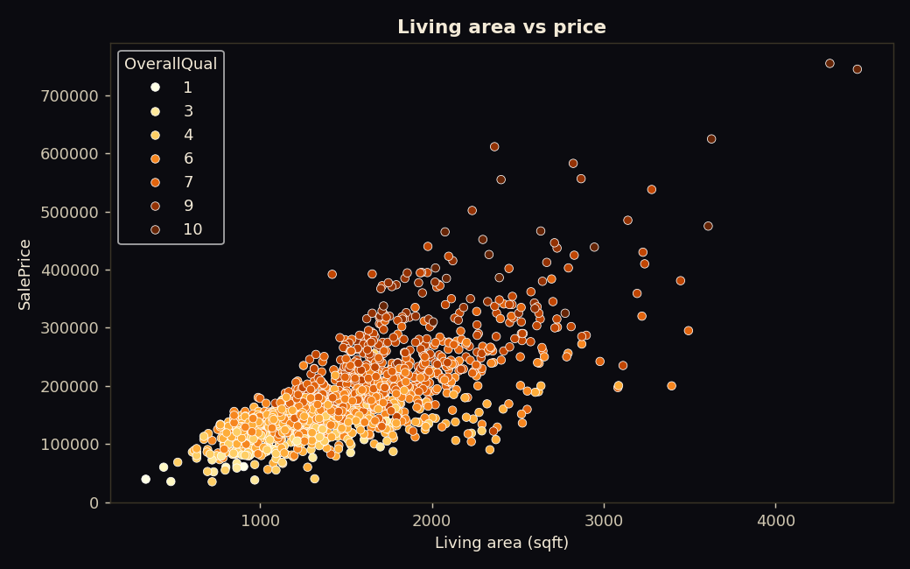
Figure 3: Living area versus sale price, colored by overall quality
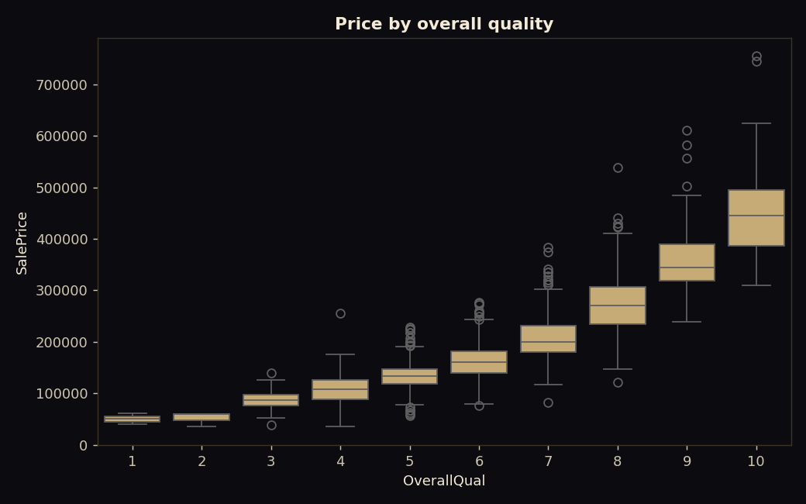
Figure 4: Sale price by overall quality

3.4 Age, Trend and Correlations
Newer homes tend to sell for more, although the effect is partly explained by quality and size. A correlation heatmap of the eleven features most related to price confirms that quality, area, garage capacity, basement size and year built move together with price.
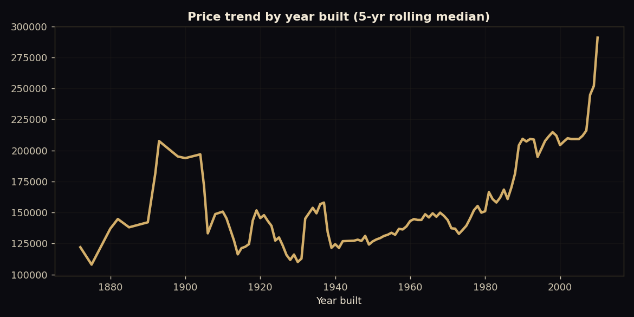
Figure 5: Median price by year built (five-year rolling average)
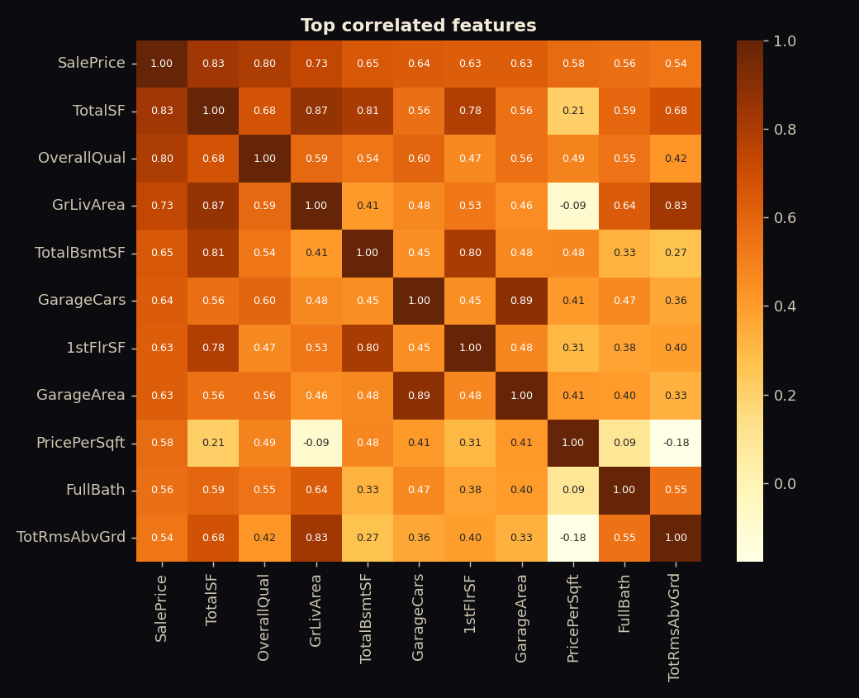
Figure 6: Features most correlated with sale price
Key insights. (1) Overall quality is the single strongest signal. (2) Living area and garage capacity add steady value. (3) Neighborhood adds a large premium or discount on top of physical features. (4) Prices are skewed, so medians describe a typical home better than means.

4. Machine Learning Methodology

4.1 Problem Formulation
Price prediction is a supervised regression problem. The target is log(1 + SalePrice); predictions are converted back to dollars with the inverse transform. Working in log space stabilizes the variance, reduces the influence of very expensive homes and makes errors proportional to price.

4.2 Pipeline
A scikit-learn Pipeline combines preprocessing and the model so that exactly the same steps run during training and in the web application. The neighborhood is converted to a number with a target encoder (its smoothed average log price, computed with internal cross-fitting to avoid leakage), and the eight numeric features pass through unchanged. The fitted pipeline is saved as a single joblib file of about 2 MB.
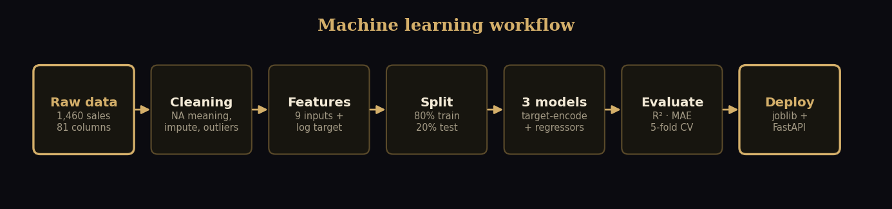
Figure 7: Machine-learning workflow

4.3 Models Compared
Table 4: Models and settings
Model | Settings | Why it is included
Linear Regression | Defaults | Simple, interpretable baseline
Decision Tree | max_depth 9, min_samples_leaf 5 | Non-linear model that is easy to explain
Random Forest | 150 trees, max_depth 16, min_samples_leaf 2 | Ensemble that captures interactions and reduces variance

4.4 Evaluation Protocol
The data is split 80/20 with a fixed random seed (1,166 training and 292 test homes). Models are compared on the held-out test set using R², mean absolute error (MAE) and root mean squared error (RMSE) in dollars, together with five-fold cross-validated R² on the training data. In the accompanying notebook, a grid search over tree count, depth and leaf size selects the Random Forest settings (best cross-validated R² 0.8455; test R² 0.884, MAE $17,811).

4.5 A Defect Found Through Testing
The first version encoded the neighborhood with one-hot columns. Accuracy looked fine, but automated tests exposed a serious problem: for the same house, most neighborhoods returned an identical estimate of $203,204, so changing the neighborhood in the web form did nothing. The trees almost never split on the sparse one-hot columns, so the location signal was ignored.
Replacing one-hot encoding with target encoding fixed the problem. For the same home, estimates now range from $165,473 to $210,800 across neighborhoods (21 distinct values), the neighborhood contributes about 10% of the model's importance, and test performance improved slightly. This episode illustrates why a model should be tested as a product and not only scored with a metric.

5. Results and Evaluation

5.1 Model Comparison
Table 5: Test-set performance of the three models
Model | R² | MAE | RMSE | 5-fold CV R²
Linear Regression | 0.876 | $18,829 | $26,144 | 0.859
Decision Tree | 0.840 | $20,913 | $29,761 | 0.769
Random Forest (deployed) | 0.885 | $17,782 | $25,251 | 0.847

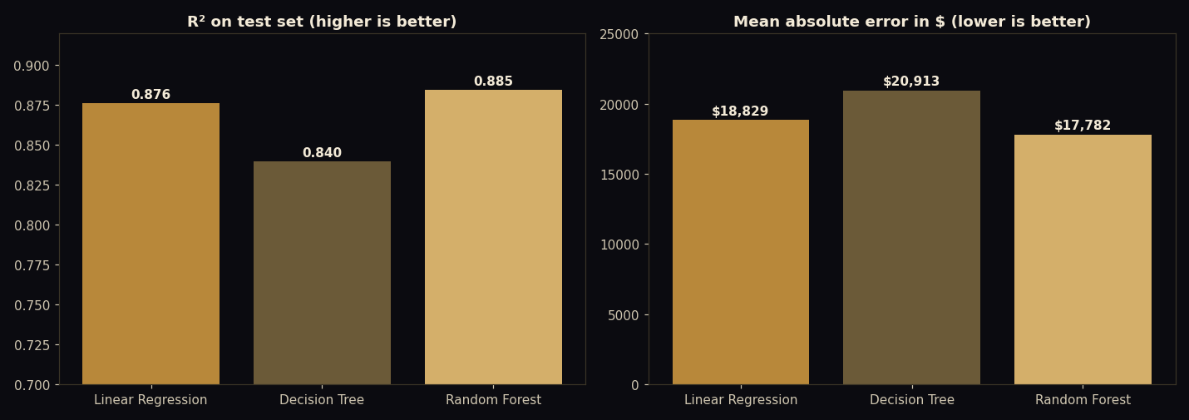
Figure 8: R² and mean absolute error for the three models
The Random Forest achieves the best test R² (0.885) and the lowest errors. Linear Regression is close behind and even has a slightly higher cross-validated R² (0.859 against 0.847), so the difference between the two is small. The Random Forest was selected because of its lower average error on unseen data and because it captures non-linear effects such as the steep premium for high build quality. The Decision Tree is clearly weaker, as expected for a single tree.

5.2 How Close Are the Predictions?
Table 6: Share of test predictions within a given error
Error band | Share of test homes
Within 10% of the real price | 63%
Within 15% | 77%
Within 20% | 87%
Median absolute percentage error | 6.6%

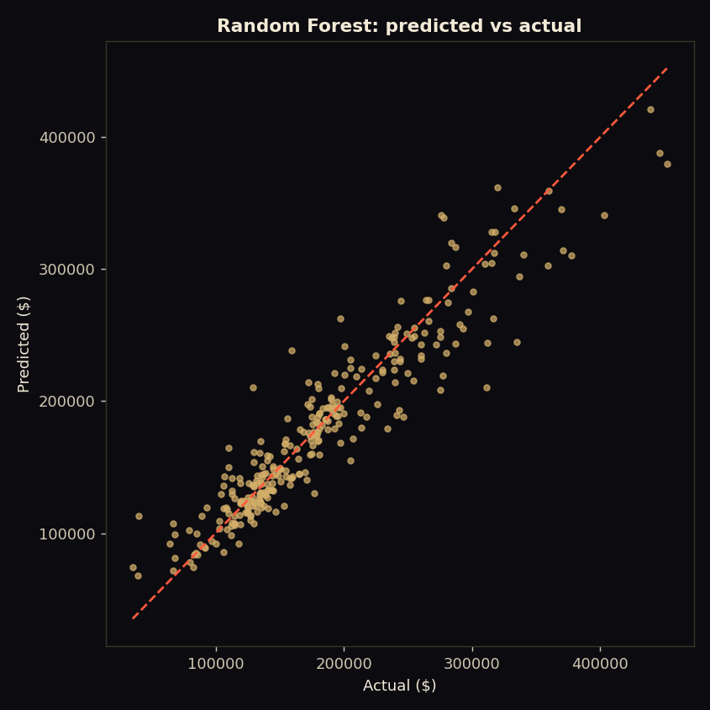
Figure 9: Predicted versus actual sale price on the test set
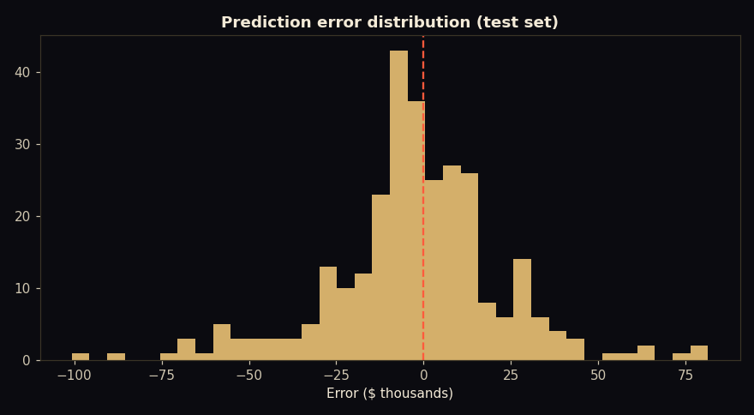
Figure 10: Distribution of prediction errors
Errors are centered on zero with no strong bias. The model is less accurate for the most expensive homes, which are rare in the data.

5.3 Feature Importance
Overall quality dominates (about 54% of total importance), followed by living area (15%), neighborhood (10%), basement size (8.5%), garage capacity (4.8%), year built (3.6%) and lot area (3.0%). Bedrooms and bathrooms contribute little once size and quality are known, which matches the exploratory analysis.
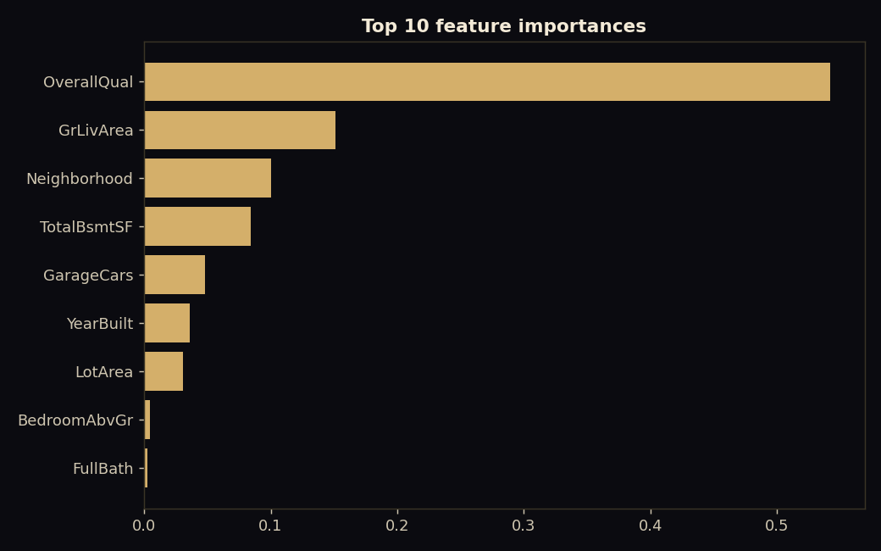
Figure 11: Top feature importances of the Random Forest

5.4 What-If Analysis
To make the model explainable, the application re-predicts the price after changing one feature. For a sample three-bedroom home in College Creek (estimate $198,017), one extra quality point adds about $17,616, 200 extra square feet add about $11,123 and one more garage space adds about $8,376. Because a forest is not a smooth function, such effects should be read as model estimates and not as exact renovation returns.

6. Recommendation System

6.1 Inputs and Filtering
The user provides a maximum budget, a minimum number of bedrooms, and optional neighborhoods and preferences (garage, newer build, high quality, large lot, spacious home, big basement). Homes outside the budget or bedroom requirement are removed first.

6.2 Scoring
Table 7: Components of the match score
Component | Weight | Meaning
Budget fit | 30% | Homes that use the budget well score higher than very cheap ones
Value | 30% | Sale price compared with the AI fair-value estimate; below the estimate scores higher
Build quality | 20% | Overall quality rating divided by 10
Preferences | 20% | Share of the chosen preferences the home satisfies (living area when none is chosen)

6.3 Explanations and Worked Example
For a budget of $250,000, at least three bedrooms, the neighborhoods College Creek, Somerset and Gilbert, and the preferences garage and newer build, 216 homes qualify. Every result carries plain-language reasons, which makes the ranking auditable. The top result is: a 3-bedroom home in CollgCr priced at $245,350 with a match score of 83. Its reasons are:
- Priced at $245,350, $4,650 under your $250,000 budget
- Listed 9% below the AI fair-value estimate of $268,289
- 3 bedrooms, meeting your 3+ requirement
- Located in CollgCr, your preferred area
- Matches your preference: has a 3-car garage
- Matches your preference: built in 2008 (newer construction)
Table 8: Top three recommendations for the example query
Rank | Neighborhood | Price | AI fair value | Beds | Sqft | Quality | Built | Score
1 | CollgCr | $245,350 | $268,289 | 3 | 1,694 | 8/10 | 2008 | 83
2 | CollgCr | $228,500 | $253,115 | 3 | 2,169 | 8/10 | 2002 | 81
3 | Somerst | $235,128 | $249,504 | 3 | 1,580 | 8/10 | 2007 | 80

Note. Listed prices are historical sale prices. The AI fair value is also computed for homes seen in training, so value gaps are somewhat optimistic; a production system would score only unseen listings.

7. Generative AI Assistant

7.1 Design
The assistant is a thin, testable layer around the Groq API (Llama 3.3 70B). Three modules cooperate: a prompts module that holds all prompt text, an LLM client that handles the API call and errors, and an assistant module that assembles messages for chat, document answers and property summaries.

7.2 Prompt Engineering
Table 9: Elements of the system prompt
Element | Purpose
Role | Defines PropMind as a professional real estate advisor and sets a concise, plain-English style
Injected market context | Real facts computed from the data (city median, highest and lowest neighborhoods, model accuracy) so answers stay grounded
Rules: no invented numbers | Figures may only come from the context or from what the user provides; otherwise the assistant says it does not know and points to the right tool
Rules: professional limits | States that it is not a lawyer, tax or financial adviser and recommends a licensed professional for major decisions
Rules: balanced advice | Mentions a key risk or trade-off, never guarantees appreciation or returns, never asks for personal identification or bank details
Rules: scope and length | Stays on real estate topics and keeps answers under about 180 words unless more detail is requested
Conversation memory | The last eight turns are sent with each request so follow-up questions work
Low temperature | 0.3 for consistent, factual answers (0.1 for document answers)

7.3 Property Summaries
A separate data-only prompt asks the model for a three to four sentence summary of one property: neighborhood, size, quality, asking price against the AI fair value, one strength and one point to verify. The prompt forbids inventing features, so the summary can be trusted to reflect the data.

7.4 Reliability: Offline Mode
If no API key is configured or the call fails, the assistant does not break. Chat falls back to neighborhood facts computed from the data, document questions return the best matching passage, and property summaries use a template. The interface labels these answers as offline, so users always know what produced them.

Figure 12: The AI advisor page (shown here in offline mode)

8. RAG Knowledge Assistant

8.1 Knowledge Base
The knowledge base contains four documents written for this project in the style of professional guides. Users can add their own PDF, TXT or Markdown files, which are indexed immediately.
Table 10: Documents in the knowledge base
Document | Content | Words | Passages
Ames Area Information | Neighborhood profiles generated from the dataset statistics | 2,391 | 32
Investment Tips | Cap rate, cash-on-cash, worked example, risks, taxes | 979 | 12
Registry & Legal Process | Iowa purchase process: offer, title, disclosures, deeds, taxes, recording | 1,080 | 12
Property Buying Guide | Budgeting, mortgages, offers, inspection, closing, mistakes | 1,134 | 13

8.2 Pipeline
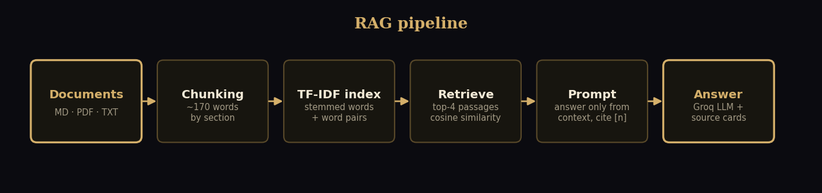
Figure 13: RAG pipeline from document to cited answer
Each document is split by section into passages of about 170 words with a short overlap. Passages are indexed with TF-IDF over lightly stemmed words and word pairs, and section titles are counted twice so that a question about "inspection" finds the section titled "Inspection and Appraisal". At question time, cosine similarity returns the top four passages.

8.3 Grounded Generation
The prompt gives the model only the numbered passages and instructs it to answer using only them, to cite passages inline as [1], [2], and to reply "I could not find this in the uploaded documents" when the passages do not contain the answer. The interface shows the answer together with the source cards (document, section, relevance score and text), so every claim can be checked.

8.4 Retrieval Evaluation
A set of 15 questions with known source documents was used to measure whether the correct document is retrieved first. The first version (plain TF-IDF) ranked the correct document first for 14 of 15 questions (93%). The one failure was "What should I check during a home inspection?", which returned a legal-process section instead of the buying guide's inspection section. Adding light stemming and title weighting fixed it:
Table 11: Retrieval accuracy on 15 evaluation questions
Retriever | Correct document ranked first | Correct document in top three
Plain TF-IDF (baseline) | 14 of 15 (93%) | 15 of 15 (100%)
Stemmed TF-IDF with title weighting (deployed) | 15 of 15 (100%) | 15 of 15 (100%)

Caveat. The evaluation set is small and was also used to guide the fix, so the 100% figure should be read as evidence that the system works on typical questions and not as a guarantee on all questions. Semantic retrieval with embeddings is listed as future work.


Figure 14: The document assistant answering with cited sources

9. System Design and Implementation

9.1 Architecture
The browser calls a small JSON API served by FastAPI, which also renders the seven pages with Jinja2 templates. The business logic lives in plain Python service modules that do not depend on the web framework, which keeps them easy to test and to reuse in the notebook.
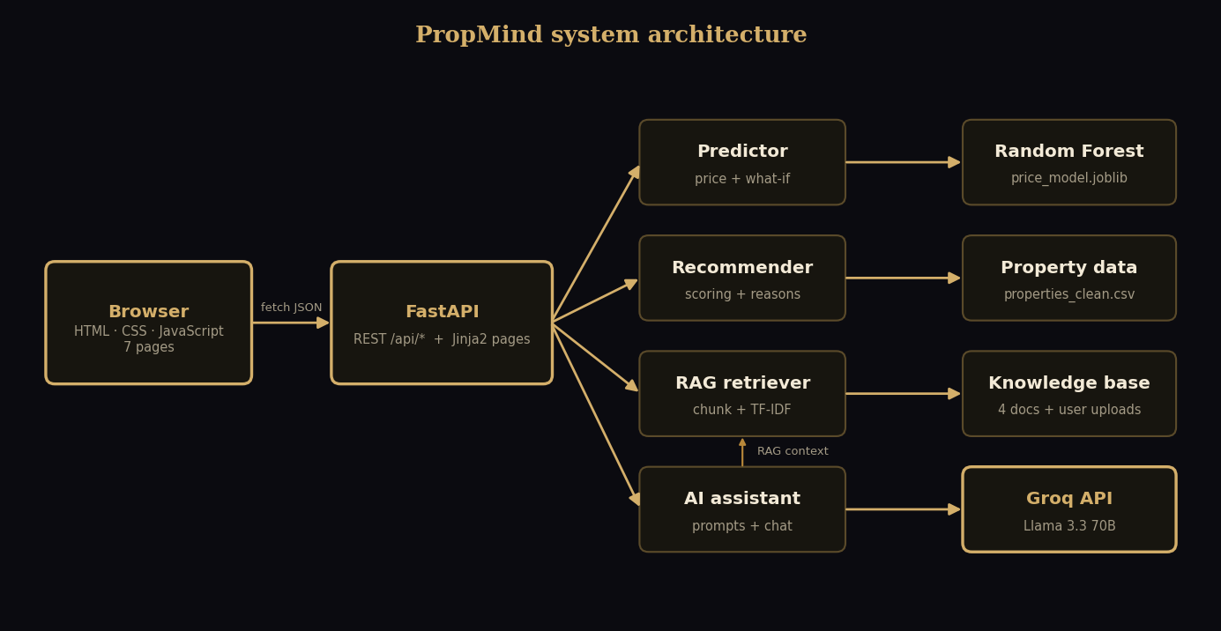
Figure 15: PropMind system architecture

9.2 Backend Modules
Table 12: Backend modules
Module | Responsibility
predictor.py | Loads the model; returns the estimate, 80% range, confidence and what-if effects
recommender.py | Filters and scores homes; builds the reasons
rag.py | Chunks documents, builds the index, retrieves passages, accepts uploads
assistant.py, llm.py, prompts.py | Prompt assembly, Groq client, offline fallbacks
main.py | Routes, input validation with Pydantic, CORS, PDF report generation

9.3 API Endpoints
Table 13: REST API
Method | Endpoint | Purpose
GET | /api/health, /api/meta | Status; neighborhoods, preferences and model metrics
POST | /api/predict | Price estimate with range and what-if
POST | /api/recommend | Ranked homes with reasons
GET | /api/properties | Property details by id
POST | /api/summary | AI summary of one property
POST | /api/chat | General AI advisor
POST | /api/rag/ask | Answer from documents with sources
GET, POST | /api/rag/docs, /api/rag/upload | List and upload documents
GET | /api/insights | Neighborhood statistics
POST | /api/report | Download a PDF valuation report

9.4 Web Interface
The interface uses a dark-luxury design system in black and gold with a serif display typeface, glass-style cards and subtle motion. It is written in plain HTML, CSS and JavaScript with no framework, which keeps the pages fast and easy to host. All seven pages are responsive and work on phones.

Figure 16: Home page with a live model estimate and neighborhood price map

Figure 17: Price prediction page with range, what-if analysis and PDF report

Figure 18: Recommendation page with explained matches and compare tray
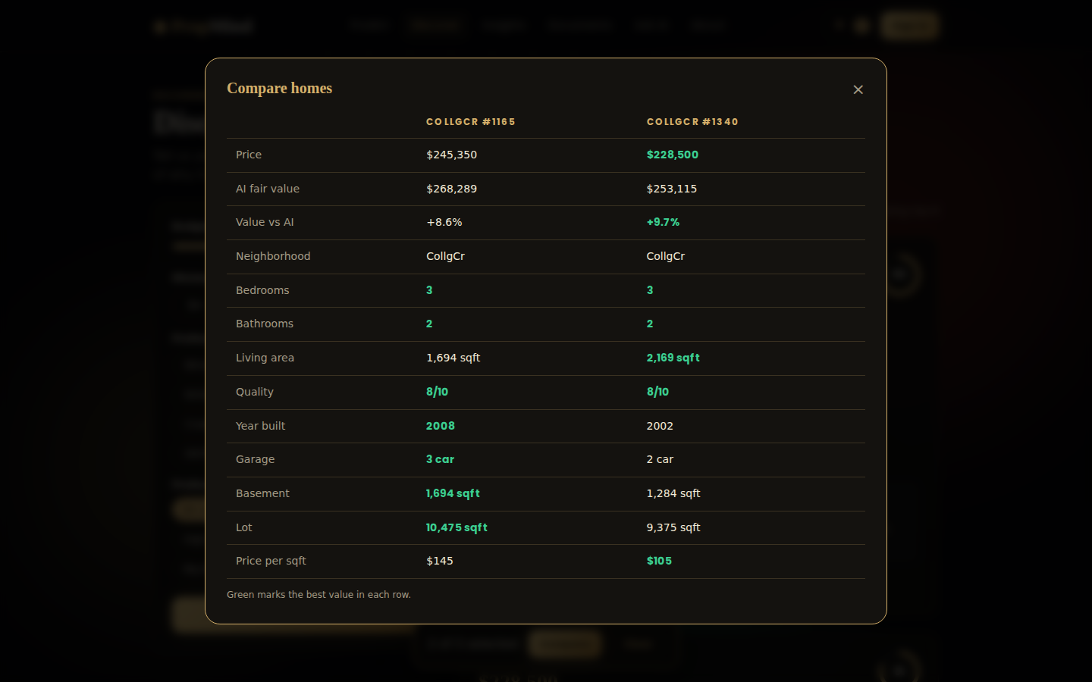
Figure 19: Side-by-side comparison of recommended homes
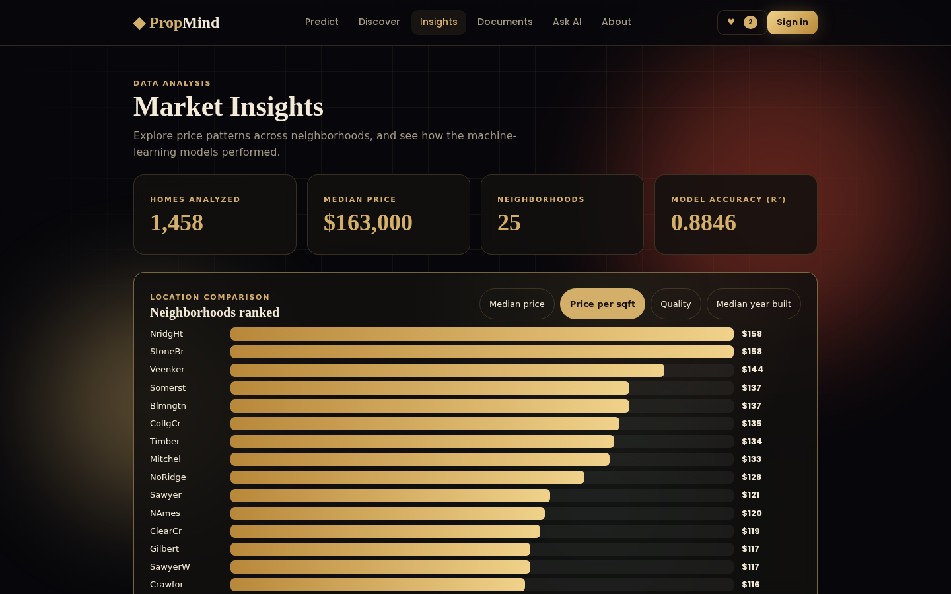
Figure 20: Market insights with interactive neighborhood ranking

9.5 Additional Features
Table 14: Features beyond the minimum requirements
Feature | Description
Login | Demo accounts stored in the browser with a hashed password; separate shortlist and history per user
Saved homes | Heart button on every result and a shortlist view
Compare | Up to three homes side by side with the best value highlighted
AI summary | One-click written summary of any property
PDF report | Downloadable valuation report
Valuation and chat history | Stored locally for the signed-in user
Offline fallback | The product keeps working without an API key
Static build | A script exports the site for Firebase Hosting

10. Testing and Quality Assurance

10.1 Automated Tests
Ten automated tests cover the core logic without needing a web server. They run with a single command and all pass.
Table 15: Automated tests
Test | What it checks
Prediction shape and range | Estimate is plausible and the range brackets it
Quality raises price | Quality 9 predicts more than quality 5 for the same home
Premium neighborhood costs more | Guards against the encoding defect described in Section 4.5
Recommender filters | Results respect budget, bedrooms and neighborhood and carry reasons
Recommender no-match | Impossible filters return a clear message
Property lookup | Details are returned by id
RAG retrieves the right document | Transfer tax, FHA down payment and cap rate questions find the right guide
RAG stemming | The inspection question finds the buying guide
RAG upload is searchable | A newly added document is found immediately
Assistant offline fallbacks | Chat, document answers and summaries work without a key

10.2 Browser Tests
The interface was also exercised in a real Chromium browser through Playwright, driving the application's route handlers. The tests covered the home page statistics and price map, the predictor (changing inputs, saving a valuation, downloading the PDF report), the recommendation filters, favourites, compare and AI summary, the insights charts, document questions with citations, the chat, registration and sign-in, and the mobile layout (no horizontal overflow). Console errors and failed requests were recorded during the run.

10.3 Defects Found and Fixed
Table 16: Issues discovered during testing
Issue | Fix
Neighborhood had almost no effect on predicted price | Replaced one-hot encoding with target encoding
RAG returned the wrong section for the inspection question | Added light stemming and title weighting
Insights bars for price per sqft and quality looked almost equal | Scaled bars from a lower baseline for those metrics
Offline document answers showed raw markdown and a repeated notice | Cleaned passages at indexing and removed the duplicate note
Training needed plotting libraries that hosting does not | Split requirements into runtime and development files

11. Deployment and Operations
The project is designed to run on free tiers without a billing card. The repository is hosted on GitHub. The backend and the website are deployed together on Vercel as a Python serverless function (configured by vercel.json, index.py and .vercelignore), with the Groq key stored as an environment variable. The same website can also be exported as static files with ml/build_static.py and published on Firebase Hosting, where the pages call the Vercel API. Google Cloud Run was not used because it requires billing to be enabled.
Table 17: Deployment components
Component | Host | Notes
Source code | GitHub | Includes data, notebook, tests and documentation
Backend and website | Vercel | Stateless function; built-in documents always available
Static frontend | Firebase Hosting | Built with ml/build_static.py pointing at the Vercel URL
LLM | Groq API | Key kept in the GROQ_API_KEY environment variable

Because serverless functions are stateless, documents uploaded through the web page may disappear between requests. The four built-in documents are part of the deployment and always remain. For permanent user documents, a database or object storage would be added (see Section 12).

12. Limitations and Future Work

12.1 Limitations
- Data scope: one city and 2006-2010, so estimates are educational and not appraisals.
- Inputs: nine features keep the form simple but ignore details such as renovation state or exact location.
- Retrieval: TF-IDF matches words and not meaning, so paraphrased questions can miss.
- Recommender value gap: uses fair values computed on homes the model has seen.
- Accounts: demo login lives only in the visitor's browser.
- Documents: legal and investment content is general and Iowa-oriented, not advice.

12.2 Future Work
- Embedding-based retrieval with a vector database for semantic search.
- Real authentication and storage with Firebase Authentication and Firestore.
- Gradient boosting models, prediction intervals from quantile regression and a larger, more recent dataset.
- Map view with listing photos and an image-based condition score.
- Multilingual interface, including Urdu.

13. Conclusion
PropMind shows how data analysis, machine learning, generative AI and retrieval can be combined into one coherent product. The final Random Forest model explains about 88% of price variance on unseen homes with an average error of $17,782, and 77% of predictions fall within 15% of the real price. The recommender explains every match, the assistant is constrained by a careful prompt and an offline fallback, and the RAG assistant answers from real documents with citations, ranking the right document first on all 15 evaluation questions.
Just as important, testing the system as a product, and not only scoring the model, uncovered and fixed real defects such as the ignored neighborhood feature and a retrieval miss. The result is a deployable application with source code, tests, documentation and a clear path for improvement.

14. References
- De Cock, D. (2011). Ames, Iowa: Alternative to the Boston Housing Data as an End of Semester Regression Project. Journal of Statistics Education, 19(3).
- Kaggle. House Prices: Advanced Regression Techniques (competition and dataset). kaggle.com/c/house-prices-advanced-regression-techniques
- Pedregosa, F. et al. (2011). Scikit-learn: Machine Learning in Python. Journal of Machine Learning Research, 12, 2825-2830.
- Breiman, L. (2001). Random Forests. Machine Learning, 45(1), 5-32.
- Salton, G. and Buckley, C. (1988). Term-weighting approaches in automatic text retrieval. Information Processing and Management, 24(5), 513-523.
- Lewis, P. et al. (2020). Retrieval-Augmented Generation for Knowledge-Intensive NLP Tasks. Advances in Neural Information Processing Systems, 33.
- FastAPI documentation. fastapi.tiangolo.com
- Groq API documentation. console.groq.com/docs

Appendix A: Setup and Run Guide
Requires Python 3.10 or newer.
python -m venv .venv
.venv\Scripts\activate
pip install -r requirements-dev.txt
python ml/train.py
copy .env.example .env
uvicorn app.main:app --reload

Open http://127.0.0.1:8000 for the website and http://127.0.0.1:8000/docs for the interactive API documentation. Add GROQ_API_KEY to the .env file to enable full AI answers; without it the assistant runs in offline mode. Run the tests with python tests/test_core.py.

Appendix B: Example API Call
Request to POST /api/predict:
{"GrLivArea": 1710, "BedroomAbvGr": 3, "FullBath": 2, "OverallQual": 7,
"YearBuilt": 2003, "GarageCars": 2, "TotalBsmtSF": 856, "LotArea": 8450,
"Neighborhood": "CollgCr"}

Response (abridged):
{"price": 198017, "low": 162713, "high": 240981,
"price_per_sqft": 116, "vs_neighborhood_pct": 0.4,
"confidence": 80, "model": "Random Forest", "r2": 0.8846,
"what_if": [{"change": "+1 overall quality", "effect": 17616}, ...]}

