PROJECT REPORT
Waypoint
A visual LangGraph retrieval-augmented question-answering system
Prepared by
Anushay Ayat
SMIT, AI and Data Science
Technologies: Python, FastAPI, LangGraph, LangChain, Groq, Sentence Transformers, HTML, CSS, JavaScript

Contents
Abstract
1 Introduction
2 Background
3 System design
4 Implementation
5 Features and results
6 Testing
7 Limitations and future work
8 Conclusion
References
Appendix A API reference
Appendix B Configuration

Abstract
Large language models are fluent but can state things that are not true, especially about documents they have never seen. Retrieval-augmented generation (RAG) reduces this problem by retrieving relevant passages first and asking the model to answer only from them. This report describes Waypoint, a RAG application built with LangGraph that makes the workflow visible: each question travels along a transit-map version of the graph while its shared state fills in live.
The system has a FastAPI backend that streams node-by-node events and a plain HTML, CSS, and JavaScript frontend. It adds a conditional route that sends weak matches to a fallback node, citations that link answers to their sources, PDF upload, five visual themes, and an automated test suite.
Keywords: retrieval-augmented generation, LangGraph, FastAPI, embeddings, streaming, conditional routing

1 Introduction

1.1 Motivation
A question-answering system that cannot show how it reached an answer is hard to trust and hard to teach. LangGraph models an application as a graph of nodes that share state, which makes the flow of work explicit. The motivation for Waypoint was to turn that explicit structure into something a person can see and inspect while it runs.

1.2 Objectives
- Answer questions using only text supplied by the user, and say so when the text does not contain the answer.
- Implement the workflow as a LangGraph graph with shared state, nodes, and edges, including a conditional edge.
- Expose the workflow through an API that streams each step, and build an interface that animates those steps.
- Keep the stack simple enough to run locally with one command.

1.3 Scope
The project covers the full path from document ingestion to a cited answer. It does not include user accounts, conversation memory, or a persistent database; these are listed as future work in Chapter 7.

2 Background

2.1 Retrieval-augmented generation
RAG combines a retriever and a generator. The retriever finds passages relevant to a question; the generator, a language model, receives those passages as context and writes the answer. The approach was introduced by Lewis et al. (2020) and is widely used to ground model output in a specific body of text.

2.2 Embeddings and similarity search
An embedding model maps text to a vector so that texts with similar meaning lie close together. Waypoint embeds each passage once, embeds the question at query time, and ranks passages by cosine similarity. The default model is all-MiniLM-L6-v2 from the Sentence Transformers family (Reimers and Gurevych, 2019), which runs on a CPU.

2.3 LangChain, LangGraph, and LangSmith
LangChain provides integrations for models, prompts, retrievers, and tools. LangGraph is a framework for building workflows as graphs, with explicit state, nodes, edges, branches, and optional checkpoints. LangSmith offers tracing and evaluation of runs. In Waypoint, LangGraph defines and runs the workflow, LangChain integrations connect the Groq model and the embeddings, and LangSmith tracing can be enabled through environment variables without code changes.

2.4 Groq
Groq provides hosted inference for open models through an API. Waypoint uses the openai/gpt-oss-120b model by default with the temperature set to zero for consistent answers; the model name is configurable.

3 System design

3.1 Architecture
The browser talks to a FastAPI application over a JSON API. FastAPI runs the compiled LangGraph, which reads from a document library and calls the language model. The same FastAPI application also serves the frontend files, so a single process provides the whole system.
Component | Technology | Responsibility
Frontend | HTML, CSS, JavaScript | Ask questions, animate the graph, show state, answer, and sources
API | FastAPI, Uvicorn | Routes, validation, streaming, static files
Workflow | LangGraph | retrieve, route, generate or fallback
Library | InMemoryVectorStore, MiniLM | Store passages and rank them by similarity
Model | Groq, gpt-oss-120b | Write the answer from retrieved context

3.2 The LangGraph workflow
The graph shares one state object with five fields: question, k (how many passages to retrieve), sources, context, and answer. Three nodes read and update it.
- retrieve: searches the library for the k most similar passages and writes sources and a numbered context.
- generate: sends the context and question to the model with a prompt that restricts the answer to that context and asks for citations such as [1] and [2].
- fallback: used when nothing in the library is close enough; it writes a short message and makes no model call.
After retrieve, a conditional edge compares the best similarity score with a threshold (MIN_SCORE, default 0.15). A score at or above the threshold routes to generate; a lower score routes to fallback. Both branches then lead to the end of the graph.

3.3 Streaming protocol
The streaming endpoint runs the graph and sends newline-delimited JSON events so the interface can follow along.
Event | Meaning
start | The run has begun; carries the question
node_start | A node has started; carries its name
node_end | A node finished; carries the state update and its duration
done | The run finished; carries the answer, sources, route taken, and total time
error | Something failed mid-run, such as a rejected API key

4 Implementation

4.1 Backend
The backend is organised into small modules: graph.py defines the state, nodes, and edges; library.py manages the vector store and passage registry; engine.py wires configuration, embeddings, model, and graph together; main.py defines the routes; and config.py reads environment variables. The Groq key can come from the server environment or from a request header supplied by the user, and it is passed to the generate node through the per-run configuration rather than stored.

4.2 Document library
Text is split on blank lines and packed into passages of at most 800 characters; overlong paragraphs are split at sentence ends. The library holds up to 60 passages and accepts uploads of up to 5 MB. PDFs are read with pypdf; scanned PDFs without selectable text are rejected with a clear message. The vector store is held in memory, so the library resets when the server restarts.

4.3 Frontend
The frontend uses no build step. The workflow is drawn as an SVG transit map: stations for the nodes, a train that moves to each station, per-node timings, and a dashed branch for the route not taken. A state panel shows each field as it is written, and the answer appears on a ticket with clickable citations that scroll to and highlight the matching source. Further features include a journey log saved in the browser, a passage-count slider, slow motion, optional sound, Listen, Markdown export, library search, and five themes.

4.4 Demo mode
Demo mode replaces the embedding model with hashed bag-of-words vectors and the language model with a small extractive answerer. It needs no key or download and uses the same graph, API, and streaming code as real mode, which allows the test suite to run offline.

5 Features and results
Figure 1 shows a completed run. The train has reached the end station, each node displays its timing, the state fields have been filled in, and the answer carries a citation linking to its source passage. Figure 2 shows the five themes that can be selected from the header.
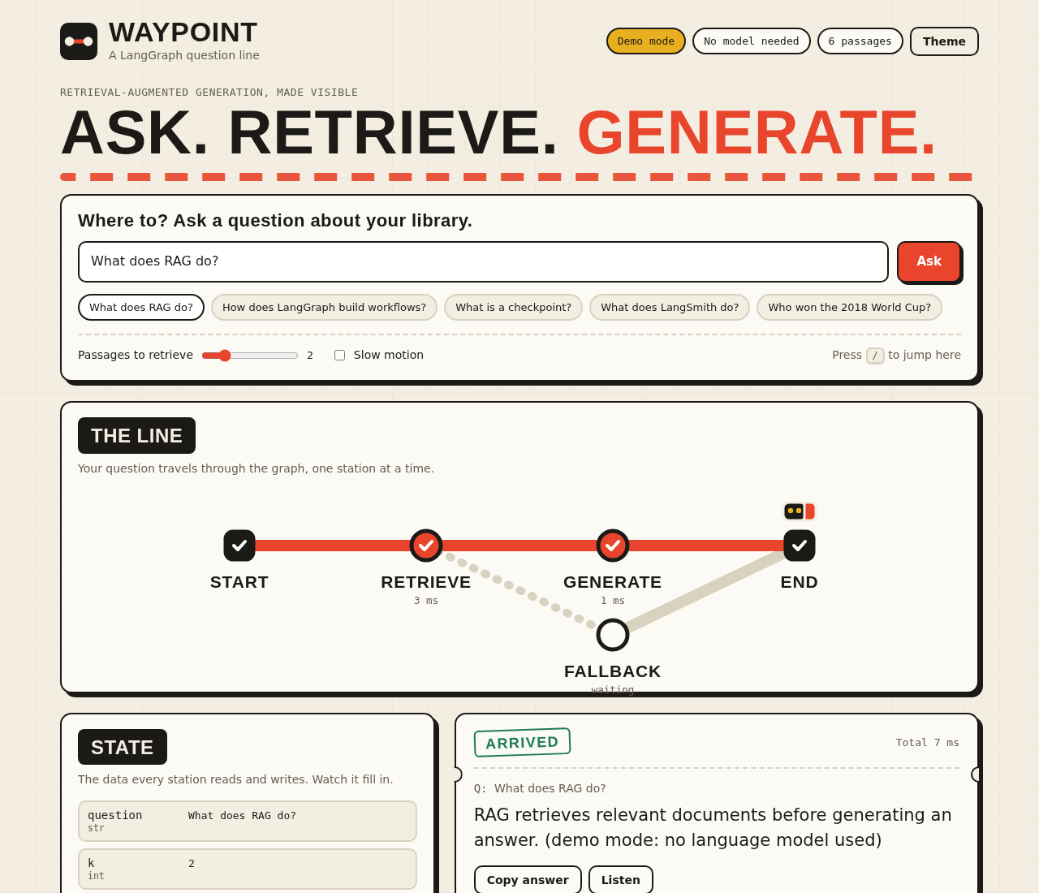
Figure 1. The answer view: the line, the state panel, the answer ticket, and the sources.
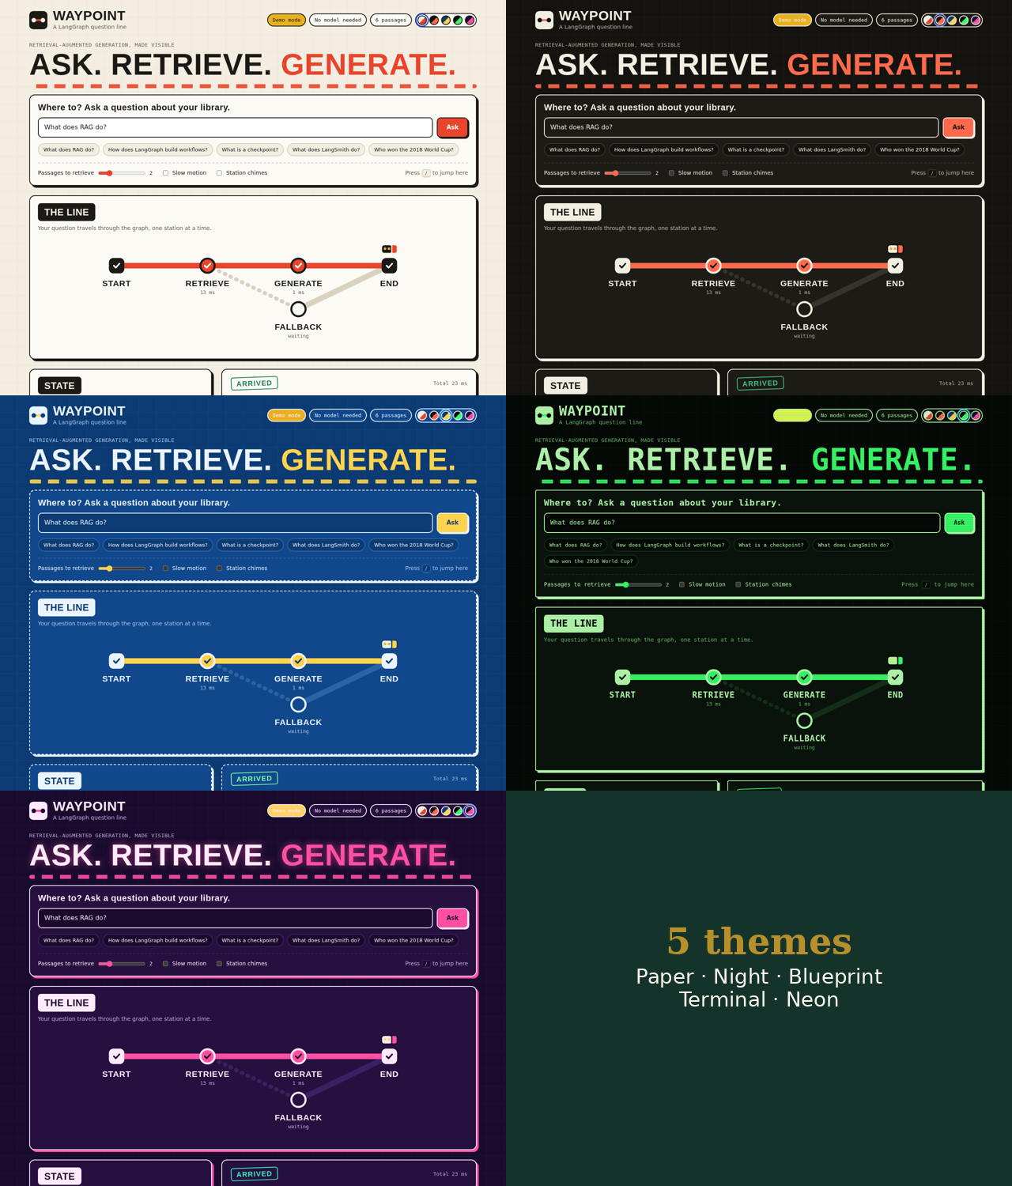
Figure 2. The five themes: Paper, Night, Blueprint, Terminal, and Neon.
- Conditional routing: questions the library cannot answer are rerouted to the fallback node, and the map shows the route taken.
- Citations: answers refer to their sources, and clicking a citation highlights the source.
- Library tools: paste text or upload PDF, TXT, and MD files, then search and remove passages.
- Journey log: past questions, answers, and feedback are kept and can be exported.
- Accessibility: keyboard focus styles, screen-reader labels, reduced-motion support, and a responsive layout for phones.

5.2 Application walkthrough
The figures below follow one session from the first question to the journey log, so a reader can understand the application from the screenshots alone.

5.2.1 Asking a question
The home view contains the question box, five example questions (one deliberately unrelated to the library), and options for how many passages to retrieve, slow motion, and station chimes.
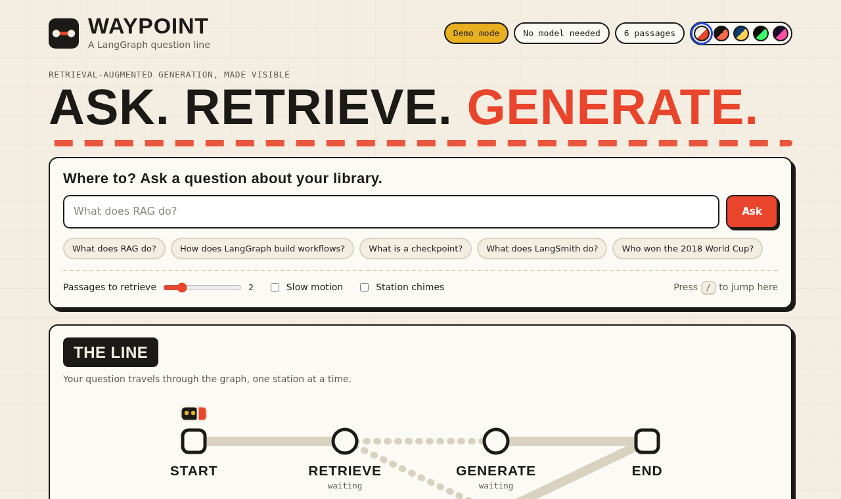
Figure 3. The home view with the question box, example questions, and options.

5.2.2 Watching the line
As the workflow runs, the train moves from station to station. Finished stations show a tick and their duration, and the next station pulses while it works. The dotted line marks the branch that has not been taken.
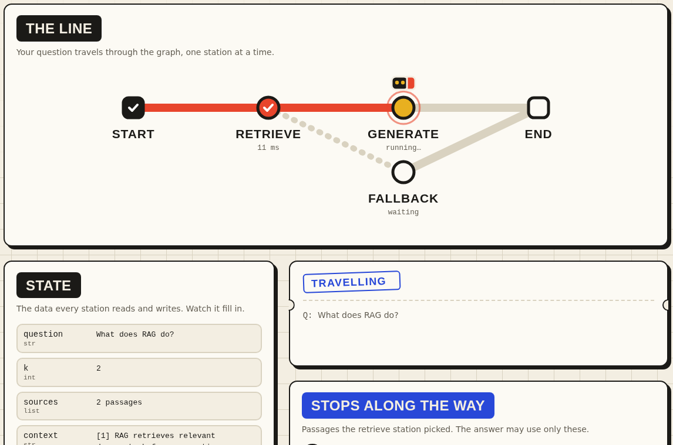
Figure 4. A run in progress: retrieve is done and the train is at generate.

5.2.3 The answer and the state
When the run ends, the answer appears on a ticket with its total time. The state panel shows what each node wrote, and the sources panel lists every retrieved passage with its label and match score.
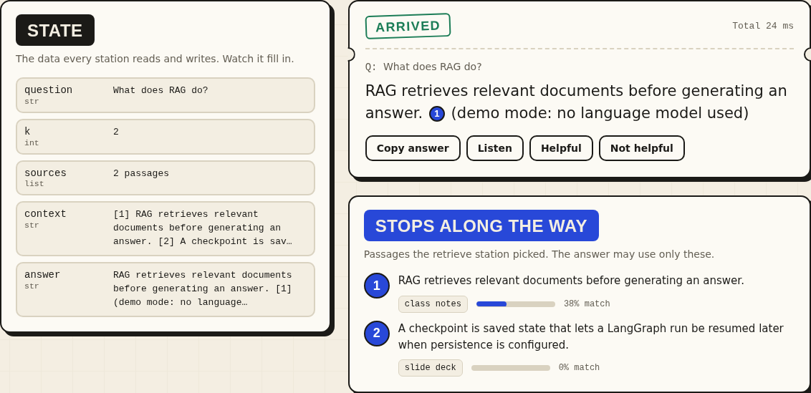
Figure 5. The state panel, the answer ticket, and the retrieved sources.

5.2.4 Citations
The model cites passages as [1], [2], and so on. Each citation is a button; pressing it scrolls to the matching source and highlights it, so a reader can check where a statement came from.
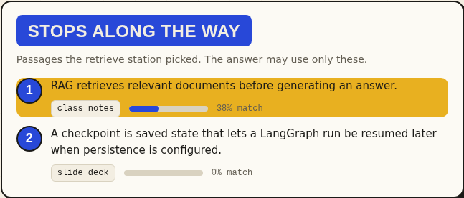
Figure 6. Clicking a citation highlights its source.

5.2.5 The fallback route
A question the library cannot answer scores below the threshold, so the conditional edge sends it to the fallback node. The map shows the route taken, no model is called, and the stamp reads Rerouted.
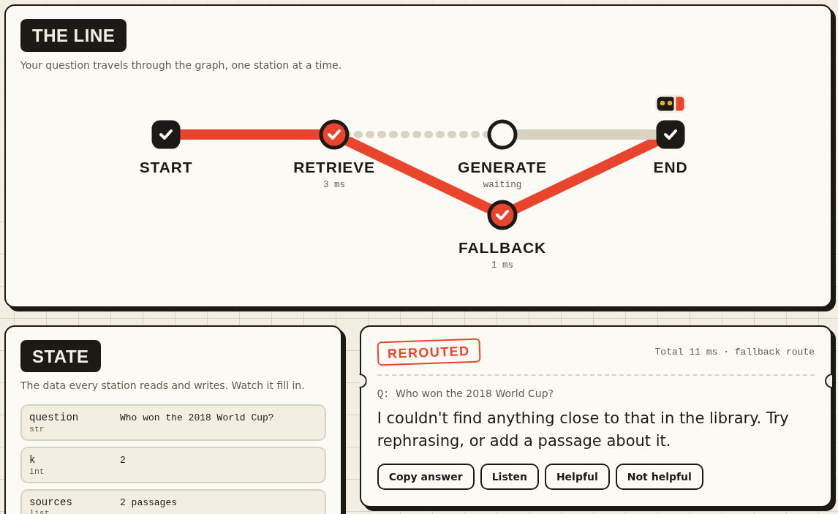
Figure 7. An unrelated question is rerouted to the fallback node.

5.2.6 Library
Passages can be pasted, loaded from a file, or uploaded as a PDF. After a question, the passages that were retrieved are badged with their rank, which links the library view to the answer.
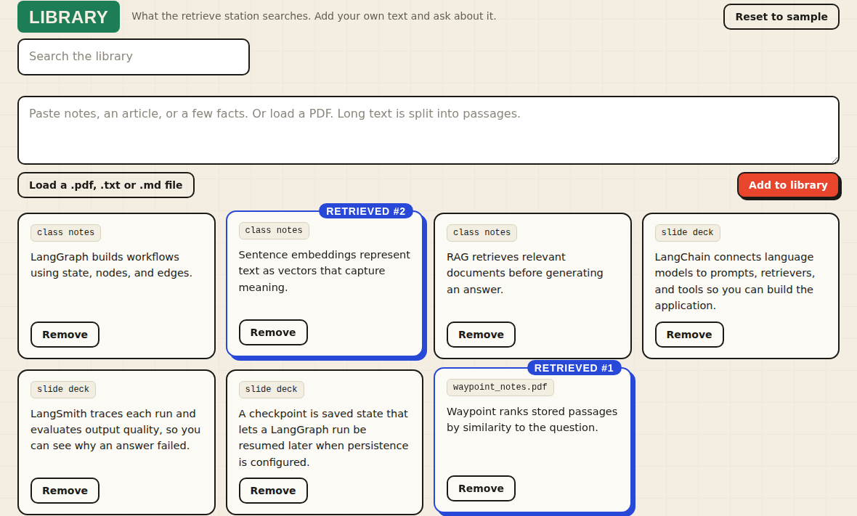
Figure 8. The library after a PDF upload; retrieved passages are badged.

5.2.7 Journey log
Every question is saved in the browser with its answer, timing, and optional feedback. Entries can be reopened, and the whole log can be exported as Markdown.
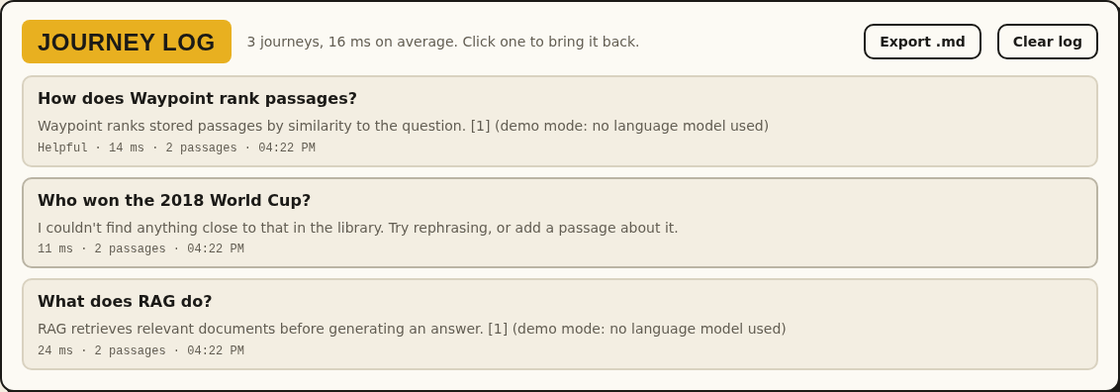
Figure 9. The journey log with feedback and export.

5.2.8 On a phone
On narrow screens the layout becomes a single column and the map is drawn vertically, with all features still available.
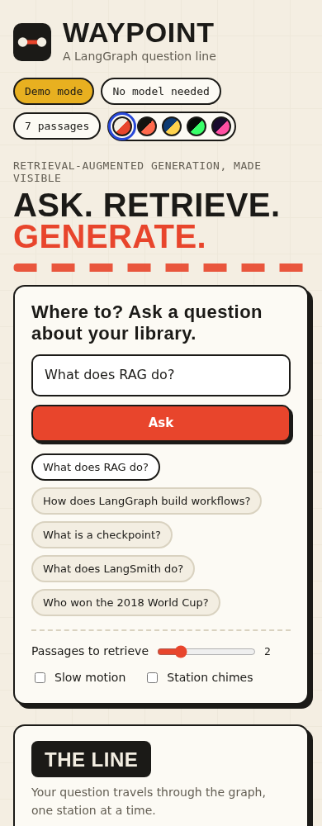
Figure 10. The phone layout, with the map drawn vertically.

6 Testing
The backend has 16 automated tests written with pytest and run by GitHub Actions on every push. They use demo mode, so they need no API key or network access.
Area | What is verified
Graph structure | The graph has the expected nodes and the conditional branch after retrieve
Retrieval | The most relevant passage is ranked first
Grounded answers | Answers come from context; unrelated questions take the fallback route
Library | Add, list, remove, reset, chunking limits, and new passages becoming searchable
Streaming | Events arrive in the expected order for both routes
API behaviour | Input validation, missing-key errors, header keys, and PDF or text upload

The interface was also exercised in a headless browser, covering asking questions, both routes, the journey log, themes, and uploads.

7 Limitations and future work
- The library is held in memory and resets on restart; a persistent vector store such as Chroma or FAISS would fix this.
- There is no conversation memory, so each question is answered independently; a LangGraph checkpointer could add it.
- Answers appear when complete rather than token by token.
- Scanned PDFs are not supported; OCR would be needed.
- The automated tests use demo mode. The real Groq model and MiniLM embeddings should be checked by running the application with a key, and the MIN_SCORE threshold may need tuning for the chosen embedding model.

8 Conclusion
Waypoint shows that a LangGraph workflow can be both a working RAG system and a clear teaching tool. Explicit state, nodes, and a conditional edge made the behaviour easy to test and to visualise, and streaming each node let the interface present the workflow as it runs. The project provides a base for further work on memory, persistence, and richer evaluation.

References
Lewis, P. et al. (2020). Retrieval-Augmented Generation for Knowledge-Intensive NLP Tasks. Advances in Neural Information Processing Systems 33.
Reimers, N. and Gurevych, I. (2019). Sentence-BERT: Sentence Embeddings using Siamese BERT-Networks. Proceedings of EMNLP-IJCNLP 2019.
LangGraph documentation: https://docs.langchain.com/oss/python/langgraph/overview
LangChain documentation: https://docs.langchain.com/oss/python/langchain/overview
LangSmith documentation: https://docs.langchain.com/langsmith/observability
FastAPI documentation: https://fastapi.tiangolo.com/
Groq documentation: https://console.groq.com/docs
Sentence Transformers documentation: https://www.sbert.net/

Appendix A API reference
Method | Path | Purpose
GET | /api/health | Mode, model names, and passage count
GET | /api/graph | Nodes and edges of the compiled graph
GET | /api/documents | List passages
POST | /api/documents | Add text, split into passages
POST | /api/documents/upload | Upload a PDF, TXT, or MD file (up to 5 MB)
DELETE | /api/documents/{id} | Remove one passage
POST | /api/documents/reset | Restore the sample library
POST | /api/ask | Ask and receive one JSON response
POST | /api/ask/stream | Ask and stream node-by-node events

Appendix B Configuration
Variable | Default | Purpose
GROQ_API_KEY | empty | Server-side key; users can supply their own in the app
GROQ_MODEL | openai/gpt-oss-120b | Groq chat model
EMBEDDING_MODEL | all-MiniLM-L6-v2 | Local embedding model
TOP_K | 2 | Passages retrieved per question (1 to 10)
MIN_SCORE | 0.15 | Best-match score below which the fallback route is used
EMBEDDING_BACKEND | huggingface | Set to keyword for lightweight search without PyTorch
DEMO_MODE | false | Run without a key or model download
CORS_ORIGINS | * | Origins allowed to call the API

