# Kaggle

Breweries

<https://www.kaggle.com/brkurzawa/us-breweries#breweries_us.csv>

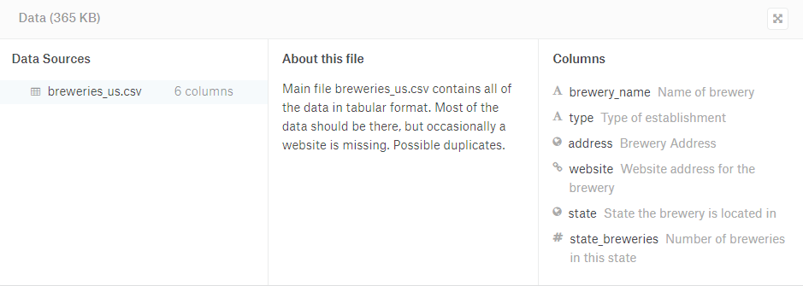

# United States Census Bureau

<https://www.census.gov/newsroom/press-kits/2018/pop-estimates-national-state.html>