Command:

tests/test_batch_sampler_load_batch.py
[my_path]/derivatives//noArtefact/hdf5/ismrm2015_noArtefact_test.hdf5
[my_path]/derivatives//noArtefact/dwi_ml_ready/ismrm2015_noArtefact/anat/t1_tractoflow.nii.gz
[my_path]/derivatives//noArtefact/hdf5/tests/

Output:

Saving path = /home/local/USHERBROOKE/rene2201/Documents/phantoms_or_simulated/ismrm2015/derivatives//noArtefact/hdf5/tests/

========= NON-LAZY =========

Initializing dataset...

INFO:root:Reading hdf file: [my_path]/derivatives//noArtefact/hdf5/ismrm2015_noArtefact_test.hdf5
INFO:root:Database version: 1
100%|█████████████████████████████████████████████████████████████████| 1/1 [00:00<00:00, 1.42it/s]

=======================Test with batch size 10000 + resample + reverse
Initializing sampler...
DEBUG:root:********* Entering batch sampler iteration!
Choosing out of 1242883 possible streamlines
DEBUG:root: Sampled subjects for this batch: dict_keys([0])
DEBUG:root: Iteration for cycle # 1/inf.
DEBUG:root: Available streamlines for this subject: 1242883
DEBUG:root: Chunk_size was 256 but after verifying heaviness, keeping only 74 streamlines.
DEBUG:root: Batch is big enough. Stopping loop.
DEBUG:root: Finished loop on subjects. Now yielding.
(If this was called through a dataloader, it should start using load_batch and even training
on this batch while we prepare a batch for the next cycle, if any).

DEBUG:root: Loading a batch of streamlines!
DEBUG:root: Processing data preparation for streamlines [(0, array([ 832895, 700497, 782791, 971576, 105216, 820529, 478586,
869412, 953436, 463542, 1109894, 472124, 524456, 682615,
721291, 839854, 222236, 1229566, 665443, 76792, 151237,
946249, 1073195, 232096, 309927, 589890, 955556, 1018573,
933645, 1022917, 939390, 155845, 851110, 60719, 964402,
645715, 144664, 599711, 908949, 74571, 1182537, 438021,
891852, 400056, 1165205, 183696, 514143, 11225, 714446,
1171278, 1041875, 1125653, 232540, 377569, 203254, 1030959,
829458, 368162, 1043771, 98081, 813457, 954670, 697000,
305518, 67596, 885261, 234656, 16278, 1133180, 1081277,
1148238, 961777, 646395, 573425]))]:

DEBUG:root: => Subj: 0
DEBUG:root: Resampling (if True)
DEBUG:root:Initial stateful tractogram contained data_per_point. This information will not be carried in the finaltractogram.
DEBUG:root: Adding noise (if True)
DEBUG:root: Splitting (if True)
DEBUG:root: Reversing (if True)
DEBUG:root: Project-specific data augmentation, if any...
DEBUG:root: Not loading the input data because user prefers to do it later on GPU.
Nb loaded processed batch streamlines: 74. Streamline 1: [ 61.05574 115.04886 106.33066]
Saving subj 0's tractogram test_batch1_355305

=======================Test with batch size 10000 + resample + do cpu computations + axis neighborhood
Initializing sampler...
DEBUG:root:********* Entering batch sampler iteration!
Choosing out of 1242883 possible streamlines
DEBUG:root: Sampled subjects for this batch: dict_keys([0])
DEBUG:root: Iteration for cycle # 1/inf.
DEBUG:root: Available streamlines for this subject: 1242883
DEBUG:root: Chunk_size was 256 but after verifying heaviness, keeping only 74 streamlines.
DEBUG:root: Batch is big enough. Stopping loop.
DEBUG:root: Finished loop on subjects. Now yielding.
(If this was called through a dataloader, it should start using load_batch and even training
on this batch while we prepare a batch for the next cycle, if any).

TEST 1: Debug mode. Saving input coordinates as mask.

DEBUG:root: Loading a batch of streamlines!
DEBUG:root: Processing data preparation for streamlines [(0, array([ 832895, 700497, 782791, 971576, 105216, 820529, 478586,
869412, 953436, 463542, 1109894, 472124, 524456, 682615,
721291, 839854, 222236, 1229566, 665443, 76792, 151237,
946249, 1073195, 232096, 309927, 589890, 955556, 1018573,
933645, 1022917, 939390, 155845, 851110, 60719, 964402,
645715, 144664, 599711, 908949, 74571, 1182537, 438021,
891852, 400056, 1165205, 183696, 514143, 11225, 714446,
1171278, 1041875, 1125653, 232540, 377569, 203254, 1030959,
829458, 368162, 1043771, 98081, 813457, 954670, 697000,
305518, 67596, 885261, 234656, 16278, 1133180, 1081277,
1148238, 961777, 646395, 573425]))]:
DEBUG:root: => Subj: 0
DEBUG:root: Resampling (if True)
DEBUG:root:Initial stateful tractogram contained data_per_point. This information will not be carried in the finaltractogram.
DEBUG:root: Adding noise (if True)
DEBUG:root: Splitting (if True)
DEBUG:root: Reversing (if True)
DEBUG:root: Project-specific data augmentation, if any...
DEBUG:root: Computing and normalizing directions (if True)
DEBUG:root: Loading a batch of inputs!
DEBUG:root:Adding 12 neighboors to each point.
DEBUG:root:DEBUGGING MODE. Returning batch_streamlines and mask together with inputs.
DEBUG:root: Computing previous dirs!
Nb loaded processed batch streamlines: 74. Streamline 1: [ 61.05574 115.04886 106.33066]
Saving subj 0's tractogram test_batch1_355322
DEBUG:root:Save [my_path]/derivatives//noArtefact/hdf5/tests//test_batch1_355322.trk with 74 streamlines in 0.003 seconds.
Saving subj 0's underlying coords mask: test_batch1_underlying_mask_355322

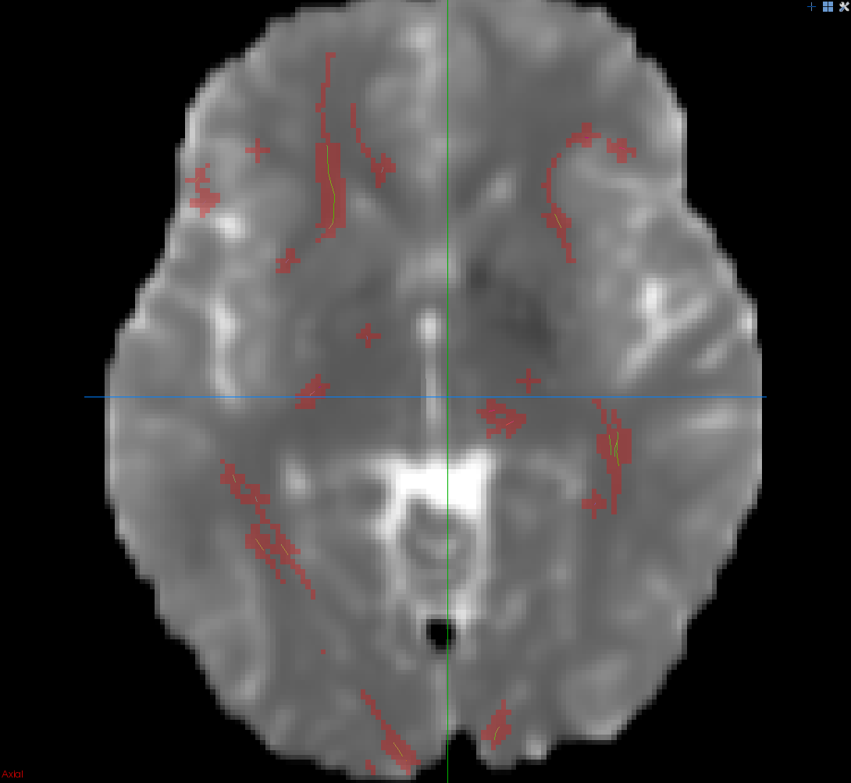

TEST 2: Loading batch normally and checking result.
DEBUG:root: Loading a batch of streamlines!
DEBUG:root: Processing data preparation for streamlines [(0, array([ 832895, 700497, 782791, 971576, 105216, 820529, 478586,
869412, 953436, 463542, 1109894, 472124, 524456, 682615,
721291, 839854, 222236, 1229566, 665443, 76792, 151237,
946249, 1073195, 232096, 309927, 589890, 955556, 1018573,
933645, 1022917, 939390, 155845, 851110, 60719, 964402,
645715, 144664, 599711, 908949, 74571, 1182537, 438021,
891852, 400056, 1165205, 183696, 514143, 11225, 714446,
1171278, 1041875, 1125653, 232540, 377569, 203254, 1030959,
829458, 368162, 1043771, 98081, 813457, 954670, 697000,
305518, 67596, 885261, 234656, 16278, 1133180, 1081277,
1148238, 961777, 646395, 573425]))]:
DEBUG:root: => Subj: 0
DEBUG:root: Resampling (if True)
DEBUG:root:Initial stateful tractogram contained data_per_point. This information will not be carried in the finaltractogram.
DEBUG:root: Adding noise (if True)
DEBUG:root: Splitting (if True)
DEBUG:root: Reversing (if True)
DEBUG:root: Project-specific data augmentation, if any...
DEBUG:root: Computing and normalizing directions (if True)
DEBUG:root: Loading a batch of inputs!
DEBUG:root:Adding 12 neighboors to each point.
DEBUG:root: Computing previous dirs!
Nb of inputs: 74. Ex of inputs shape: torch.Size([113, 468]),
Nb of directions: 74. Ex of direction shape: torch.Size([113, 3])
Previous_dirs: 74. Ex of shape (should be x6): torch.Size([113, 6])

=======================Test with batch size 10000 + resample + do cpu computations + grid neighborhood
Initializing sampler...
DEBUG:root:********* Entering batch sampler iteration!
Choosing out of 1242883 possible streamlines
DEBUG:root: Sampled subjects for this batch: dict_keys([0])
DEBUG:root: Iteration for cycle # 1/inf.
DEBUG:root: Available streamlines for this subject: 1242883
DEBUG:root: Chunk_size was 256 but after verifying heaviness, keeping only 91 streamlines.
DEBUG:root: Batch is big enough. Stopping loop.
DEBUG:root: Finished loop on subjects. Now yielding.
(If this was called through a dataloader, it should start using load_batch and even training
on this batch while we prepare a batch for the next cycle, if any).

TEST 1: Debug mode. Saving input coordinates as mask.
DEBUG:root: Loading a batch of streamlines!
DEBUG:root: Processing data preparation for streamlines [(0, array([ 819495, 1180925, 972827, 329693, 1172340, 38539, 742881,
1148380, 500006, 6327, 479213, 847152, 1195844, 691232,
94994, 519211, 762849, 735169, 191029, 108268, 657738,
708035, 662786, 925111, 666037, 303022, 728749, 314764,
890557, 1205350, 203945, 1101378, 212541, 474355, 739952,
378528, 565364, 147994, 974802, 891955, 610995, 1081880,
1070447, 1075657, 139398, 948610, 1052295, 660777, 630417,
382274, 671038, 125429, 500113, 242783, 356241, 8062,
1172456, 1141348, 785495, 682802, 1107952, 139904, 1192413,
1087525, 471164, 67837, 1119268, 837107, 544744, 293501,
319191, 871013, 1128570, 824381, 738932, 788685, 498720,
991375, 1106528, 986629, 739842, 62586, 67656, 483281,
405399, 316032, 732072, 197697, 562209, 152583, 470850]))]:
DEBUG:root: => Subj: 0
DEBUG:root: Resampling (if True)
DEBUG:root:Initial stateful tractogram contained data_per_point. This information will not be carried in the finaltractogram.
DEBUG:root: Adding noise (if True)
DEBUG:root: Splitting (if True)
DEBUG:root: Reversing (if True)
DEBUG:root: Project-specific data augmentation, if any...
DEBUG:root: Computing and normalizing directions (if True)
DEBUG:root: Loading a batch of inputs!
DEBUG:root:Adding 124 neighboors to each point.
DEBUG:root:DEBUGGING MODE. Returning batch_streamlines and mask together with inputs.
DEBUG:root: Computing previous dirs!
Nb loaded processed batch streamlines: 91. Streamline 1: [78.71976 40.380367 63.898148]
Saving subj 0's tractogram test_batch1_355586
DEBUG:root:Save [my_path]/derivatives//noArtefact/hdf5/tests//test_batch1_355586.trk with 91 streamlines in 0.003 seconds.
Saving subj 0's underlying coords mask: test_batch1_underlying_mask_355586

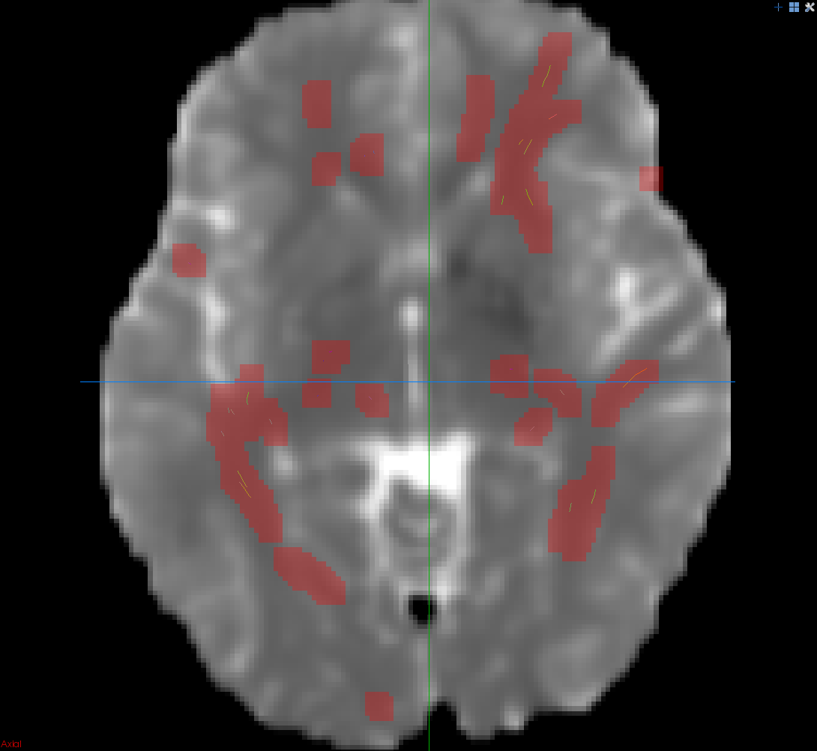

TEST 2: Loading batch normally and checking result.
DEBUG:root: Loading a batch of streamlines!
DEBUG:root: Processing data preparation for streamlines [(0, array([ 819495, 1180925, 972827, 329693, 1172340, 38539, 742881,
1148380, 500006, 6327, 479213, 847152, 1195844, 691232,
94994, 519211, 762849, 735169, 191029, 108268, 657738,
708035, 662786, 925111, 666037, 303022, 728749, 314764,
890557, 1205350, 203945, 1101378, 212541, 474355, 739952,
378528, 565364, 147994, 974802, 891955, 610995, 1081880,
1070447, 1075657, 139398, 948610, 1052295, 660777, 630417,
382274, 671038, 125429, 500113, 242783, 356241, 8062,
1172456, 1141348, 785495, 682802, 1107952, 139904, 1192413,
1087525, 471164, 67837, 1119268, 837107, 544744, 293501,
319191, 871013, 1128570, 824381, 738932, 788685, 498720,
991375, 1106528, 986629, 739842, 62586, 67656, 483281,
405399, 316032, 732072, 197697, 562209, 152583, 470850]))]:
DEBUG:root: => Subj: 0
DEBUG:root: Resampling (if True)
DEBUG:root:Initial stateful tractogram contained data_per_point. This information will not be carried in the finaltractogram.
DEBUG:root: Adding noise (if True)
DEBUG:root: Splitting (if True)
DEBUG:root: Reversing (if True)
DEBUG:root: Project-specific data augmentation, if any...
DEBUG:root: Computing and normalizing directions (if True)
DEBUG:root: Loading a batch of inputs!
DEBUG:root:Adding 124 neighboors to each point.
DEBUG:root: Computing previous dirs!
Nb of inputs: 91. Ex of inputs shape: torch.Size([66, 4500]),
Nb of directions: 91. Ex of direction shape: torch.Size([66, 3])
Previous_dirs: 91. Ex of shape (should be x6): torch.Size([66, 6])

========= LAZY =========

Initializing dataset...

INFO:root:Database version: 1
100%|████████████████████████████████████████████████████████████████| 1/1 [00:00<00:00, 309.47it/s]

=======================Test with batch size 10000 + resample
Initializing sampler...
DEBUG:root:********* Entering batch sampler iteration!
Choosing out of 1242883 possible streamlines
DEBUG:root: Sampled subjects for this batch: dict_keys([0])
DEBUG:root: Iteration for cycle # 1/inf.
DEBUG:root: Available streamlines for this subject: 1242883
DEBUG:root: Chunk_size was 256 but after verifying heaviness, keeping only 76 streamlines.
DEBUG:root: Batch is big enough. Stopping loop.
DEBUG:root: Finished loop on subjects. Now yielding.
(If this was called through a dataloader, it should start using load_batch and even training
on this batch while we prepare a batch for the next cycle, if any).

DEBUG:root: Loading a batch of streamlines!
DEBUG:root: Processing data preparation for streamlines [(0, array([ 830695, 1192946, 764447, 1055055, 915156, 208377, 710322,
1195621, 480059, 1193731, 664011, 425274, 62839, 14909,
313903, 857122, 721864, 958734, 881476, 229947, 843727,
1035276, 613282, 182104, 1121835, 725337, 803299, 562471,
685286, 506796, 34219, 751637, 322792, 254004, 161390,
34868, 215822, 551957, 488588, 600375, 1000194, 583901,
640257, 129164, 442073, 99471, 163301, 986708, 982499,
1109815, 433068, 147294, 389549, 265738, 498803, 1009570,
794457, 924147, 735228, 1185990, 811825, 258467, 429560,
497281, 902290, 454501, 54753, 1230526, 313286, 1242364,
1023464, 429152, 1102405, 985332, 14517, 72434]))]:
DEBUG:root: => Subj: 0
DEBUG:root: Resampling (if True)
DEBUG:root:Initial stateful tractogram contained data_per_point. This information will not be carried in the finaltractogram.
DEBUG:root: Adding noise (if True)
DEBUG:root: Splitting (if True)
DEBUG:root: Reversing (if True)
DEBUG:root: Project-specific data augmentation, if any...
DEBUG:root: Not loading the input data because user prefers to do it later on GPU.
Nb loaded processed batch streamlines: 76. Streamline 1: [109.565506 107.973724 60.789062]
Saving subj 0's tractogram test_batch1_361930

=======================Test with batch size 10000 + resample + computations
Initializing sampler...
DEBUG:root:********* Entering batch sampler iteration!
Choosing out of 1242883 possible streamlines
DEBUG:root: Sampled subjects for this batch: dict_keys([0])
DEBUG:root: Iteration for cycle # 1/inf.
DEBUG:root: Available streamlines for this subject: 1242883
DEBUG:root: Chunk_size was 256 but after verifying heaviness, keeping only 76 streamlines.
DEBUG:root: Batch is big enough. Stopping loop.
DEBUG:root: Finished loop on subjects. Now yielding.
(If this was called through a dataloader, it should start using load_batch and even training
on this batch while we prepare a batch for the next cycle, if any).

TEST 1: Debug mode. Saving input coordinates as mask.
DEBUG:root: Loading a batch of streamlines!
DEBUG:root: Processing data preparation for streamlines [(0, array([ 830695, 1192946, 764447, 1055055, 915156, 208377, 710322,
1195621, 480059, 1193731, 664011, 425274, 62839, 14909,
313903, 857122, 721864, 958734, 881476, 229947, 843727,
1035276, 613282, 182104, 1121835, 725337, 803299, 562471,
685286, 506796, 34219, 751637, 322792, 254004, 161390,
34868, 215822, 551957, 488588, 600375, 1000194, 583901,
640257, 129164, 442073, 99471, 163301, 986708, 982499,
1109815, 433068, 147294, 389549, 265738, 498803, 1009570,
794457, 924147, 735228, 1185990, 811825, 258467, 429560,
497281, 902290, 454501, 54753, 1230526, 313286, 1242364,
1023464, 429152, 1102405, 985332, 14517, 72434]))]:
DEBUG:root: => Subj: 0
DEBUG:root: Resampling (if True)
DEBUG:root:Initial stateful tractogram contained data_per_point. This information will not be carried in the finaltractogram.
DEBUG:root: Adding noise (if True)
DEBUG:root: Splitting (if True)
DEBUG:root: Reversing (if True)
DEBUG:root: Project-specific data augmentation, if any...
DEBUG:root: Computing and normalizing directions (if True)
DEBUG:root: Loading a batch of inputs!
DEBUG:root:DEBUGGING MODE. Returning batch_streamlines and mask together with inputs.
DEBUG:root: Computing previous dirs!
Nb loaded processed batch streamlines: 76. Streamline 1: [109.565506 107.973724 60.789062]
Saving subj 0's tractogram test_batch1_361946

TEST 2: Loading batch normally and checking result.
DEBUG:root: Loading a batch of streamlines!
DEBUG:root: Processing data preparation for streamlines [(0, array([ 830695, 1192946, 764447, 1055055, 915156, 208377, 710322,
1195621, 480059, 1193731, 664011, 425274, 62839, 14909,
313903, 857122, 721864, 958734, 881476, 229947, 843727,
1035276, 613282, 182104, 1121835, 725337, 803299, 562471,
685286, 506796, 34219, 751637, 322792, 254004, 161390,
34868, 215822, 551957, 488588, 600375, 1000194, 583901,
640257, 129164, 442073, 99471, 163301, 986708, 982499,
1109815, 433068, 147294, 389549, 265738, 498803, 1009570,
794457, 924147, 735228, 1185990, 811825, 258467, 429560,
497281, 902290, 454501, 54753, 1230526, 313286, 1242364,
1023464, 429152, 1102405, 985332, 14517, 72434]))]:
DEBUG:root: => Subj: 0
DEBUG:root: Resampling (if True)
DEBUG:root:Initial stateful tractogram contained data_per_point. This information will not be carried in the finaltractogram.
DEBUG:root: Adding noise (if True)
DEBUG:root: Splitting (if True)
DEBUG:root: Reversing (if True)
DEBUG:root: Project-specific data augmentation, if any...
DEBUG:root: Computing and normalizing directions (if True)
DEBUG:root: Loading a batch of inputs!
DEBUG:root: Computing previous dirs!
Nb of inputs: 76. Ex of inputs shape: torch.Size([52, 36]),
Nb of directions: 76. Ex of direction shape: torch.Size([52, 3])
Previous_dirs: 76. Ex of shape (should be x6): torch.Size([52, 6])

