SEP #101 : File browser

Version: 1.0
Author: Calixte Denizet
Review:
Commented:
State: Draft
Scilab-Version: 5.4.0
Created: 2011-07-11

Abstract
The aim of this SEP is to describe the future graphical file browser in Scilab connected with the current working directory (CWD).

Rationale
The File Browser will a dockable graphic element. It will propose to :
- change the CWD ;
- browse the contents of the CWD ;
- execute actions on files.

Possible actions will be :
- double-click on a directory will set it to the CWD ;
- double-click on a Scilab file with extension :
  - .sce or .sci : will open it in SciNotes ;
  - .xcos : will open it in Xcos ;
  - .scg or .bin : will load it in Scilab ;
  - .* as binary file : will load it as a uint8 matrix with a name given by the user.
- right-click will open a popup menu with actions :
  - Execute ;
  - Open in SciNotes ;
  - Load as a uint8 matrix in a Scilab variable with a name given by the user ;
  - Open the default associated application (such as Evince or Acrobat for .pdf files) ;
  - Rename ;
  - Delete ;
  - Copy.
The CWD contents will be refreshed with a given frequence (configurable in the future Preference System).

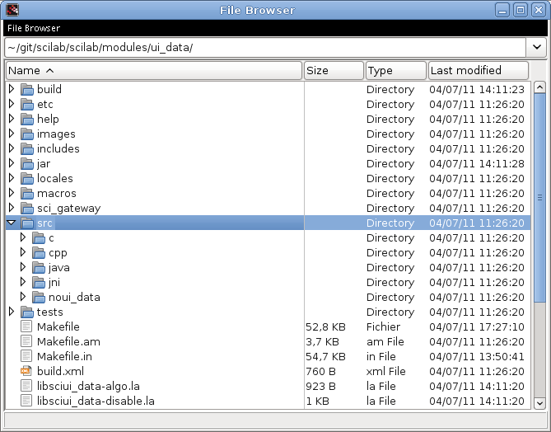

Example Usage

Changelog
  - – 2011-07-11 – Calixte DENIZET <calixte.denizet@scilab.org>
First draft

Copyright
This document has been placed under the licence CeCILL-B.

