SEP #132: implicitplot and implicitplot3d

Version: 1.0
Author: Pierre-Aimé Agnel
Review:
Commented:
State: Prototype
Scilab-Version: 5.5.0
Created: Aug 29th 2014

Abstract
Functions to draw an implicit function in 2d or 3d.
2D implicit functions are of the form F(x, y) = 0. 3D implicit functions, F(x, y, z) = 0.

Rationale
Scilab lacks an interface for implicit function plotting. There is an interface for polar plots, parametric plots and explicit functions plot, but for implicit plots one has to evaluate the function then use contour to select the points where zero-crossing occur.
This SEP proposes to create a simple interface for implicit plots in 2D and 3D.
For implicitplot3d, no contour3d function exists in scilab. This SEP also suggests to add the function created by Anthony Roberts as defined here, on the condition he agrees to let us use his function.

Calling Sequences
implicitplot(fun, [x_range, [y_range, [options]]])
implicitplot(f_eval, x_range, y_range, [options])

INPUT
fun: a scilab function or a string defining a function F(x,y).
x_range: a vector of real values. Sampling values on x.
y_range: a vector of real values. Sampling values on y.
f_eval: a matrix of real values of size [length(x_range), length(y_range)]. The evaluation of F(x,y) over the ranges defined.
options: plot options available for the plot function.

Default values can be selected for x_range, y_range and z_range (300 points in [-2*%pi, 2*%pi] for instance

implicitplot3d(fun, [x_range, [y_range, [z_range, [options]]]])
implicitplot(f_eval, x_range, y_range, z_range, [options])

z_range: a vector of real values. Sampling values on z.
f_eval: a 3D hypermatrix of real values of size [length(x_range), length(y_range), length(z_range)]. The evaluation of F(x,y) over the ranges defined.

Examples
implicitplot("x^2 + y^2 – 1");
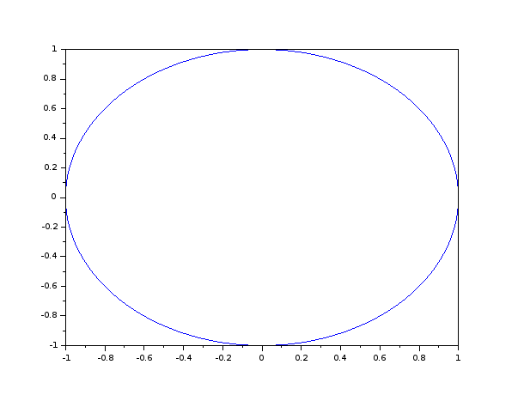

function result = fun(x, y)
result = 3 * x^2 * exp(x) - x * y^2 + exp(y) / (y^2 + 1) -1
endfunction

x_range = -1:0.01:1;
y_range = -10:0.01:10;

implicitplot(fun, x_range, y_range, "r--");
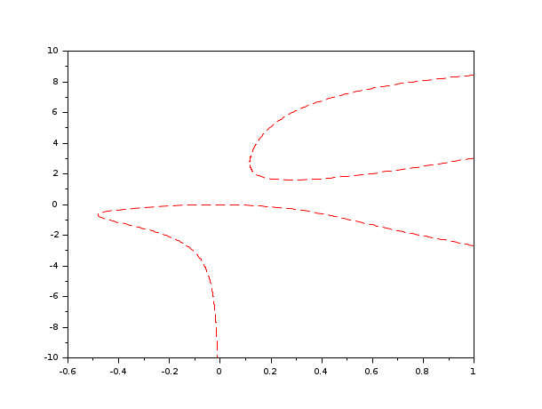

Changelog
1.0 – Pierre-Aimé Agnel - Initial version

Copyright
This document has been placed under the license CeCILL-B

