SEP # 56: Modification of nyquist function profile

Title: Modification of nyquist function profile
Version:1.0
Author: Serge Steer, INRIA
Review:
Commented:
State:DRAFT
Scilab-Version:Scilab 5.3.x
Vote:No
Created: April 18th, 2011

Abstract
The aim of this SEP is to motivate the addition of an optional input argument to the nyquist function.

Rationale

The Nyquist locus is usually drawn for positive and negative frequency ranges that gives a curve symmetrical with respect to the real axis. In the previous nyquist function versions, only the locus associated to positive frequency was drawn. Recently the locus has been symmetrize to fit with the traditional representation. This change made some user unsatifactory (bug reports 9205 and 9322).

To satisfy all users, it is proposed to add a final optional argument to the nyquist function. To be able to distinguist it from the previous it is proposed to set it as a boolean (the TRUE value request for a symmetrical locus). Not to change the 5.3.1 behavior, it is proposed to set the default value as TRUE.

The possible calling sequences become:

nyquist( sl,[fmin,fmax] [,step] [,comments] [,symmetry])

nyquist( sl, frq [,comments] [,symmetry])

nyquist(frq,db,phi [,comments] [,symmetry])

nyquist(frq, repf [,comments] [,symmetry])

Example Usage
h=syslin('c',22801+4406.18*s+382.37*s^2+21.02*s^3+s^4,...
22952.25+4117.77*s+490.63*s^2+33.06*s^3+s^4

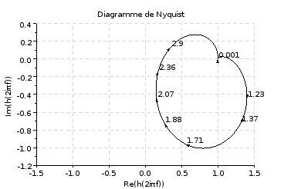
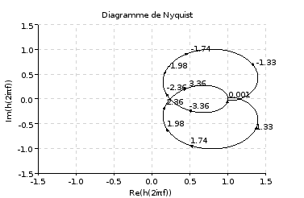
nyquist(h) nyquist(h,%f)

Changelog
1.0 – Initial Version

Copyright
This document has been placed under the license CeCILL-B.

