SEP # 56: functions comet and comet3d

Title: functions comet and comet3d
Version:1.0
Author: Serge Steer, INRIA
Review:
Commented:
State:DRAFT
Scilab-Version:Scilab 5.3.x
Vote:No
Created:April 19th, 2011

Abstract
This sep proposes to define two graphic functions that animates comet graph of 2d or 3d curve in the spirit of Matlab comet and comet3 functions

Rationale

Comet graph is an animated graph of the curve which visualize the evolution of a curve

y(t) versus x(t) for while t increases, The animation is composed of three parts
- the « head » similar to the comet solid part
- The « body « similar to the trolling gas of the comet
- The tail similar to the past trajectory of the comet

This type of graph is useful for understanding the evolution. It can be in particular be used to visualize ode results.

Beyond the functionality of the Matlab functions these ones can animate multiple curves, they can also animate curve given by a scilab function.

Example Usage
function y=traj(x),y=1.5*sin(x^2),endfunction
clf();comet(linspace(0,5,500),traj)
t = linspace(0,10*%pi,500);
clf();comet(t.*sin(t),t.*cos(t))

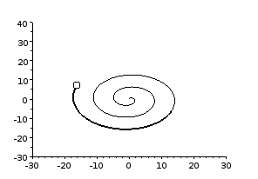
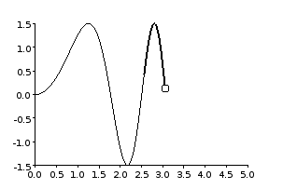

Changelog
1.0 – Initial Version

Copyright
This document has been placed under the license CeCILL-B.

