SEP # : 29

Title: datatips
Version: 0
Author: Serge Steer
Review:
Commented:
State:
Scilab-Version: 5.2
Vote:
Created: August 15, 2009

Abstract
Datatips are small text boxes that display data values at data cursor locations in graphic windows.

Rationale
Datatips are very convenient to inspect curve or surface value(s). They can also be used to hilite some particular point of a curve or surface.
A datatip consist of a small black square appears at the selected point of the curve together with a small text area containing the coordinates of the selected point. The text area is automatically located near the black square to keep it inside the axes rectangle (top-left, top-right, bottom-left or bottom right)

Specifications
- Creating a datatip
Datatips can be created either by program either interactively when the user enables this mode (calling a function or selecting a menu).
Setting a datatip by program can simply be done calling a function with the desired curve coordinates as arguments. In the following we concentrates on the interactive mode.
In the interactive mode, a datatip is created when the user clicks on a point of a curve or a surface. The datatip is drawn either on the nearest mesh point of the curve/surface or on a point interpolated from the 2 (4) nearest curve (surface) points. This depends on a mode that can be changed using the contextual menu.
An option can be discussed: either a click on a point of a curve adds a new datatip or deletes the previous one, if any, and creates a new one at the new location. In the latter case a contextual menu can be used to add a new datatip. I prefer the first solution.
- Moving a datatip
A datatip can be moved along a curve or a surface, pressing the left mouse button on the small black square and then dragging the mouse up to the desired point, the datatip follows the curve from mesh point to mesh point or using interpolated positions depending on the selected mode. The displayed coordinates are refreshed during the movement.
- Removing a datatip
A datatip can be removed using a contextual menu that opens by a right click on the « black square ». This contextual menu may also propose to remove all the datatips of the current curve/surface
A left click far away all curves deletes all the datatips on all curves/surfaces
- Customizing datatips
The legend format displayed in the text box can be customized. The customization menu is available through the contextual menu. This menu opens a Scilab function editor. The function takes as input the handle of the associated curve and the nearest selected point (interpolated point) and returns the string vector that has to be displayed. The customization may be different for each curve.

Implementation
As a consequence of the specifications a datatips data structure should be added to the polyline and surface entities (however in a first version the user_data field can be used for this purpose.
The datatips data structure must have at least the following fields:
- tip_positioning mode (nearest or interpolated)
- new_tip_mode : erase previous tips or append a new tip
- update_function: function used to generate de text associated with the tips
- tips_array: a vector of handle on each tips data_structure
The parametric curves (or surfaces) poses a question: Suppose one has a curve y=Y(t) vs x=X(t) and wants the datatips display the 2 values t,x,y corresponding to the selected point. For that, it is mandatory that the t discretization is stored in the graphic data structure. For example the black or nyquist function should store the frequency discretization.
Many options can be implemented to store the parameter(s) discretization:
- for curve it is possible to store t as the third column of the polyline data field (z 3D component),
- for polylines and surfaces it is possible to create a new field in the entity data structure, to store the discretization of the parameter(s) (one array t for polyline, 2 arrays u and v for surfaces,
- it is also possible to store these data in the datatips data structure itself (it is the solution I have implemented in my prototype.
For simplicity of use, the interactive mode should be implemented using a special callback associated with the axes or the figure. In a first stage, the figure event handler can be used.
A menu should be added to activate/deactivate the interactive mode.

Finally it should be pleasant that the datatips of a given curve/surface may take into account the deletion , the visibility property change of the associated entity or to the modification of its data. To be able to implement callbacks that reacts to this events should be added to the entity properties. Note that it should be convenient to add these callbacks fields to all the entity types.

Example Usage
A simple case with one curve and mutiple datatips. Note that the tips text has been customized using the function:
function str=ans(curve, index)
pt = string(round(100*curve.data(index, :)/100);
str = msprintf('x: %s\nsinc(x): %s', pt(1), pt(2))
endfunction

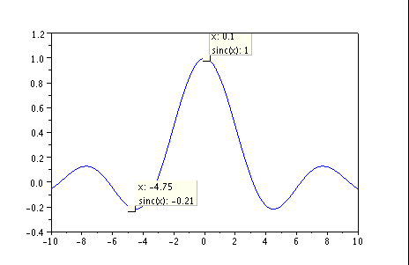
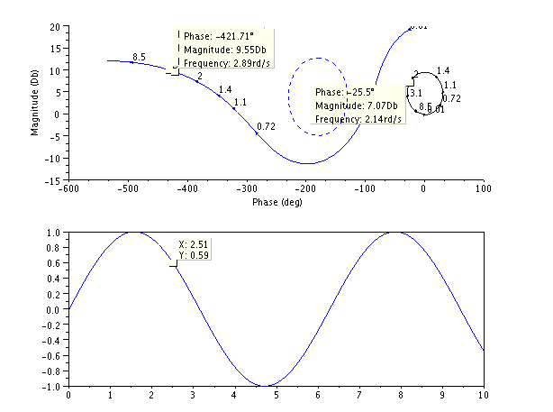
A second example with 2 subplots and a black graph of a 2 outputs system

Changelog
1.0 –

Copyright
Serge Steer INRIA

