SEP #120: New function unwrap()

Version: 1.0
Author: Samuel Gougeon
Review:
Commented:
State: Prototype
Scilab-Version: 5.5.0
Created: Oct. 5th 2013

Abstract
This SEP describes features proposed through a new function unwrap(). unwrap() mainly aims to somewhat invert actions such as the modulo() one, or to extend the inverse of periodic functions such as atan().

Rationale
When an unknown original curve Y(x) or a surface Z(x,y) is wrapped by a function such as Yw = modulo(Y, m) or Yw = atan(tan(Y)), or is folded by functions such as Yf = acos(cos(Y)) etc, presently Scilab does not propose any function enabling to recover Y from Yw or Yf. unwrap() will implement such features.

Calling Sequences
unwrap() // runs a demo
[U, breakPoints] = unwrap(Y)
[U, breakPoints] = unwrap(Y, z_jump)
[U, cuspPoints] = unwrap(Y, "unfold")
U = unwrap(Z)
U = unwrap(Z, z_jump)
U = unwrap(Z, z_jump, dir)

Arguments
Y
Vector of real numbers: the profile to unwrap or unfold. Implicit abscissae X are assumed to be equispaced
Z
Matrix of real numbers: the surface to unwrap. Implicit abscissae (X,Y) are assumed to be cartesian and equispaced (constant steps may be different along X versus along Y).
z_jump
Scalar real positive number used in unwrapping mode: the jump's height applied at breakpoints, performing the unwrapping. Only its absolute value is considered. The jump actually applied has the sign of the slope on both sides of each breakpoint. The default value is z_jump = 2*%pi. The special value z_jump = 0 applies jumps equal to the average slope around each breakpoint, restoring a continuous slope over the whole profile or surface.
dir
"c" | "r" | "" (default): direction along which unwrapping is performed. "c" unwraps along columns, "r" unwraps along rows, "" unwraps in both directions.
"unfold"
Provide this switch to unfold the given curve if it is folded, instead of unwrapping it
U
Unwrapped profile or surface, or unfolded profile. U has the same sizes as Y or Z.
breakPoints, cuspPoints
Vector of indices of points in Y where wrapping or folding has been detected and processed.

Description
Unwrapping
unwrap(..) will be useful to process profiles or even surfaces wrapped for instance by a periodic and monotonic function such as Y = modulo(X,w) or Y = atan(tan(X)). It aims to somewhat invert these functions, recovering the input X over it full range instead of the limited w or [-%pi/2, %pi/2] one.
A breakpoint of a wrapped profile is detected as a point where slopes on both neighbouring sides of the point are almost equal but much smaller (in absolute value) from and opposite to the slope at the considered point: At the point, there is a jump breaking and opposed to the neighbouring slope.
This detection strategy avoids considering any particular level as a wrapping one. It allows to process wrapped profiles to which a constant (or even a trend) has been added afterwards.
Unwrapping consists in reducing every detected jump and somewhat restoring a continuous slope (initially assumed to be so). At each point, it is performs by applying a Y-shift on a whole side of the profile, with respect to the other. The Y-shift may be the same for all breakpoints, as provided by the user. If the user specifies a null Y-shift, unwrap(..) applies a jump equal to the average neighbouring slope, depending on each breakpoint.
An unwrapped profile is always defined but for a constant.

Unless dir is used, unwrap(..) applied to a surface unwraps its first column. Each point of this one is then taken as reference level for unwrapping each line starting with it.
Unfolding
If the "unfold" keyword is used and a profile -- not a surface -- is provided, the profile is assumed to be folded instead of being wrapped.
At a folding point -- or "cusp point" --, the profile is continuous, but its slope is broken: The slope has almost the same absolute value on both sides of the point, but is somewhat opposed from one side to the other.
Folding may occur for instance when a non-monotonic periodic function and its inverse are applied to a profile X, like with Y = acos(cos(X)). Recovering X from Y is quite more difficult than if it was wrapped. Indeed, some ambiguous situations may exist, like when the profile is tangentially folded on one of its quasi-horizontal sections (if any).
When a cusp point is detected, a) one side of the profile starting from it is opposed (upside down), and b) the continuity of the profile and of its slope are preserved and retrieved at the considered point (this may need adding a small jump by the local slope)
The slope on the left edge of the input profile is used as starting reference. The unfolded profile may be upside down with respect to the original true one. In addition, as for unwrapping, it is defined but for a constant.
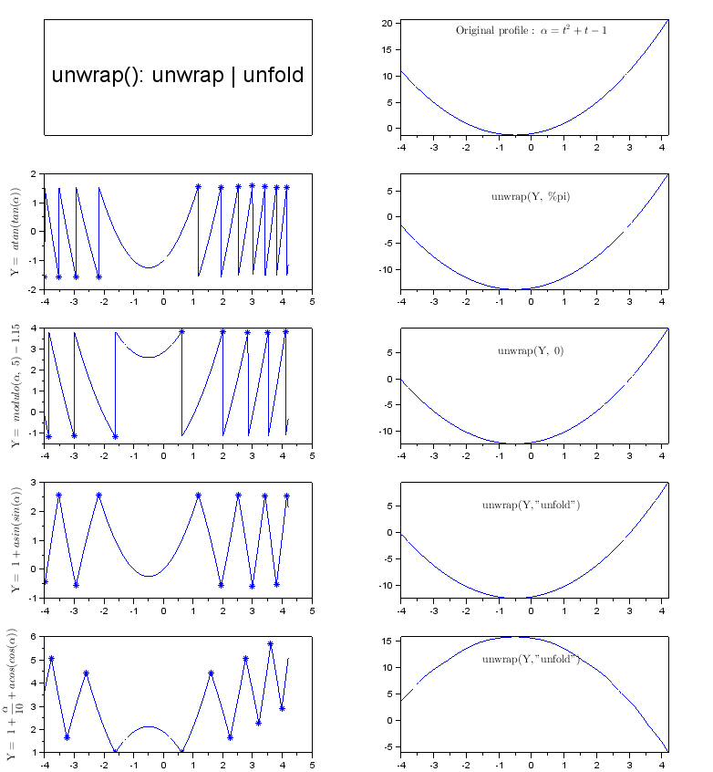
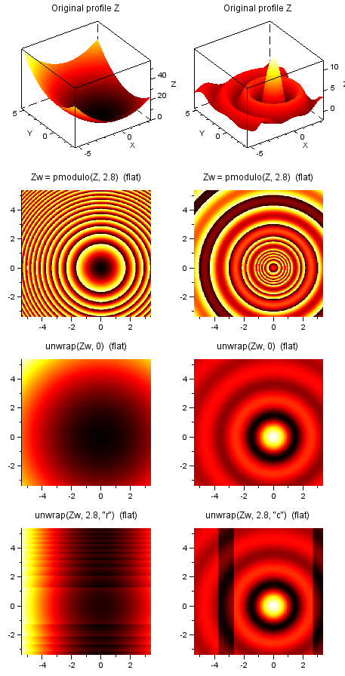

Examples
Unwrapping or unfolding 1D profiles:
// Example #1 (1D wrapped)
t = linspace(-4,4.2,800);
Y = t.^2 + t -1;
Yw = atan(tan(Y)); // raw wrapped recovered Y [pi]
Yunw = unwrap(Yw, %pi);

// Example #2 (1D wrapped)
c = (rand(1,1)-0.5)*4;
Yw = pmodulo(Y, 5) + c; // unwrap() is unsensitive to a constant and even to a trend
[Yunw, K] = unwrap(Yw, 0);

// Example #3 (1D folded)
Yf = 1 + asin(sin(Y)); // raw folded recovered Y [2.pi], + constant Y shift
Yunf = unwrap(Yf, "unfold");

// Example #4 (1D folded)
Yf = 1 + Y/10 + acos(cos(Y)); // raw recovered Y [2.pi], + linear trend
[Yunf, K] = unwrap(Yf, "unfold");

Unwrapping 2D surfaces:
nx = 300;
ny = 400;
rmax = 8.8;
x = linspace(-rmax/2, rmax/2, nx)-1;
y = linspace(-rmax/2, rmax/2, ny)+1;
[X, Y] = meshgrid(x,y);

// Example #5 : 2D wrapped
Z = X.^2 + Y.^2; // paraboloïd
m = 2.8;
Zw = pmodulo(Z, m); // wraps it
Zunw = unwrap(Zw, 0); // unwraps it in both directions, with free jumps
ZunwR = unwrap(Zw, 0, "r"); // unwraps it along rows
ZunwC = unwrap(Zw, 0, "c"); // unwraps it along columns

// Example #6 : 2D wrapped
Z = sqrt(0.3+sinc(sqrt(Z)*3))*17-7; // defines the surface
m = 2.8; // wrapping step (jump's amplitude)
Zw = pmodulo(Z, m); // wraps it
Zunw = unwrap(Zw, m); // unwraps it in both directions, with given jump
ZunwR = unwrap(Zw, m, "r"); // unwraps it along rows
ZunwC = unwrap(Zw, m, "c"); // unwraps it along columns

Changelog
1.0 – Samuel Gougeon - Initial version

Copyright
This document has been placed under the license CeCILL-B

