

Project no. 035143

Project acronym: hArtes

Project Title: Holistic Approach to Reconfigurable real Time Embedded Systems

Instrument: Integrated Project

Thematic Priority: 2.5.3 – Embedded Systems

“Sci2C User’s Guide”

Last update: 31st January 2010

Start date of project: 01 September 2006 Duration: 42 months

Project co-funded by the European Commission within the Sixth Framework Programme (2002-2006)
Dissemination Level : PU
PU | Public
PP | Restricted to other programme participants (including the Commission Services)
RE | Restricted to a group specified by the consortium (including the Commission Services)
CO | Confidential, only for members of the consortium (including the Commission Services)
The following list of authors reflects the major contribution to the writing of the document.

ORGANIZATION | AUTHORS
POLIBA | Raffaele Nutricato
POLIBA | Maria Teresa Chiaradia
POLIBA | Alberto Morea
Scilab | Bruno Jofret

© 2010 hArtes Consortium, All Rights Reserved. For the hArtes Consortium, see the www.hartes.org web-site.

The list of author does not imply any claim of ownership on the Intellectual Properties described in this document.
The authors and the publishers make no expressed or implied warranty of any kind and assume no responsibilities for errors or omissions. No liability is assumed for incidental or consequential damages in connection with or arising out of the use of the information contained in this document.

EXCEPT AS OTHERWISE EXPRESSLY PROVIDED, THE HARTES INFORMATION IS PROVIDED BY HARTES TO MEMBERS "AS IS" WITHOUT WARRANTY OF ANY KIND, EXPRESS, IMPLIED OR STATUTORY, INCLUDING BUT NOT LIMITED TO ANY IMPLIED WARRANTIES OF MERCHANTABILITY, FITNESS FOR A PARTICULAR PURPOSE AND NONINFRINGEMENT OF THIRD PARTY RIGHTS.
HARTES SHALL NOT BE LIABLE FOR ANY DIRECT, INDIRECT, INCIDENTAL, SPECIAL OR CONSEQUENTIAL DAMAGES OF ANY KIND OR NATURE WHATSOEVER (INCLUDING, WITHOUT LIMITATION, ANY DAMAGES ARISING FROM LOSS OF USE OR LOST BUSINESS, REVENUE, PROFITS, DATA OR GOODWILL) ARISING IN CONNECTION WITH ANY INFRINGEMENT CLAIMS BY THIRD PARTIES OR THE SPECIFICATION, WHETHER IN AN ACTION IN CONTRACT, TORT, STRICT LIABILITY, NEGLIGENCE, OR ANY OTHER THEORY, EVEN IF ADVISED OF THE POSSIBILITY OF SUCH DAMAGES.

The technology disclosed herein may be protected by one or more patents, copyrights, trademarks and/or trade secrets owned by or licensed to hArtes Partners. The partners reserve all rights with respect to such technology and related materials. Any use of the protected technology and related material beyond the terms of the License without the prior written consent of hArtes is prohibited.

This document contains material that is confidential to hArtes and its members and licensors. Until publication, the user should assume that all materials contained and/or referenced in this document are confidential and proprietary unless otherwise indicated or apparent from the nature of such materials (for example, references to publicly available forms or documents). Disclosure or use of this document or any material contained herein, other than as expressly permitted, is prohibited without the prior written consent of hArtes or such other party that may grant permission to use its proprietary material. The trademarks, logos, and service marks displayed in this document are the registered and unregistered trademarks of hArtes, its members and its licensors.

The copyright and trademarks owned by hArtes, whether registered or unregistered, may not be used in connection with any product or service that is not owned, approved or distributed by hArtes, and may not be used in any manner that is likely to cause customer confusion or that disparages hArtes. Nothing contained in this document should be construed as granting by implication, any license or right to use any copyright without the express written consent of hArtes, its licensors or a third party owner of any such trademark.
Table of Content
Table of Content i
1 Introduction 1
2 Implementation Details 2
2.1 Introduction 2
2.2 Sci2C Block Diagram 2
2.3 Current Development Status 4
2.4 Contributions from external SW designers 5
3 Supported Features 6
3.1 Introduction 6
3.2 Supported Data Types and Precisions 6
3.3 Supported Data Sizes 6
3.4 Supported Constructs 6
3.5 Operators and Functions Supported: Sci2C Library 6
3.6 Reserved Keywords 7
4 How to annotate the code 8
4.1 Introduction 8
4.2 Data Annotations 8
4.3 Function Annotation: General Considerations. 9
4.4 Function Annotation: User2C Functions. 10
4.5 Function Annotation: Sci2C Functions. 11
4.6 Function Annotation: NIN annotation tag 12
4.7 Function Annotation: NOUT annotation tag 12
4.8 Function Annotation: TP annotation tag 12
4.9 Function Annotation: SZ annotation tag 13
5 How to use customized Sci2C libraries 17
5.1 Introduction 17
5.2 Functions call naming rule 17
5.3 Interface description 17
6 How to install, configure and run Sci2C 19
6.1 Installation of Scilab 19
6.2 Installation of Sci2C 19
6.3 Configuration of Sci2C 19
6.4 How to Run Sci2C 20
7 Sci2C Library 21
7.1 Introduction 21
7.2 Internal complex representation 21
7.3 Single and Double precision management 21
7.4 Link to BLAS / LAPACK 21
7.5 Rules: Naming and Type consistency 22
7.5.1 Type consistency 22
7.5.2 Naming Rules 22
8 Tutorials 24
8.1 Introduction 24
8.2 Simple Tutorials 24
References 25
Glossary 26

Introduction
Sci2C is a tool capable to translate Scilab code into C code.
It is a standalone toolbox of Scilab and it has been primarily developed to become the interface between the Scilab scientific software package and the hArtes design flow.
The output C code is in a plain style and does not include any part of the Scilab interpreter thus making it small, efficient and easy to interface to the hArtes tool chain.
In other words, the generated C code is standalone and minimal in the sense that Scilab interpreter is no longer needed and only the minimal number of C files which are necessary to execute the application are generated. It follows that the generated code can be embedded in processors or used as entries for other software.
Sci2C is implemented in Scilab language, so it naturally becomes a Scilab toolbox available in the Scilab installation program and consequently it can be directly used in the Scilab Development Environment.
The implementation of Sci2C is mainly based on the introduction of data and function annotations into Scilab code which is seen as comment by the Scilab interpreter, but that are used by Sci2C to translate the Scilab code into an efficient and plain C code. Moreover the use of annotations allows the user to specify not only the size of data but also their precision, in that way it is possible to get a further optimization of the C code produced thanks to the possibility to use ad-hoc precision for each data to be processed.
Two major limitations can be identified in Sci2C: the first limitation of the tool is that the annotations must be manually added by the user, although it is the only manual intervention required by the tool; the second limitation is that the size of data is fixed and consequently no dynamic array extension is allowed.
Other minor limitations have been introduced in order to simplify the development of the tool without impacting on the usefulness of it for embedded systems.

Implementation Details
.

Introduction
This section is a useful source of information for those who want to provide their contribution to the development of Sci2C tool.
Standard Sci2C users can skip this section.

Sci2C Block Diagram
For the sake of clarity before introducing details about the status of Sci2C, a quick overview of Sci2C block diagram is presented here. As shown in the following figure the main blocks of Sci2C are:
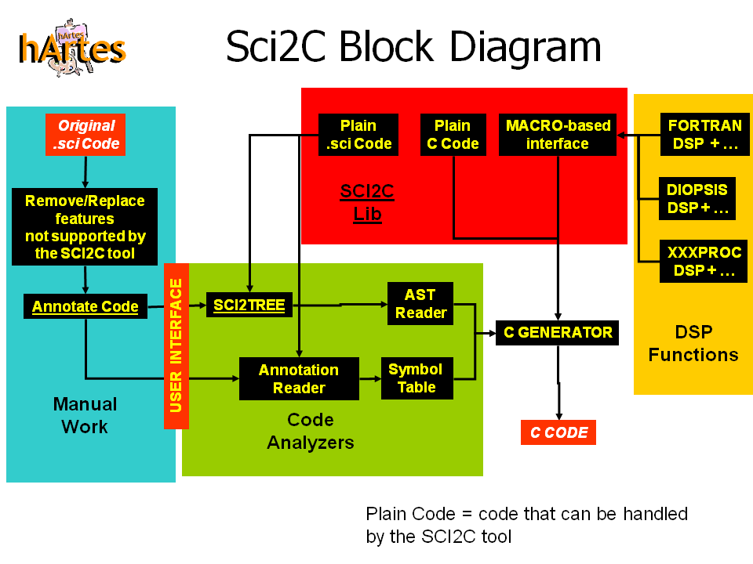
Figure 1: main blocks composing Sci2C tools.

- Manual work and User interface: in these blocks there are enclosed all the activities where the user intervention is required. In the other blocks all the processes are carried out automatically. Here the user has to configure Sci2C (“USER INTERFACE” block), and change the Scilab code to be translated (“Original.sci” block) in order to remove not supported features and annotate data and functions.
The Original.sci block represents the Scilab implementation of the application that must be ported to the target device. As typically happens in the application design flow, Scilab code is written to deeply test and debug algorithms, so in the original Scilab version it is possible to find many calls to plot-like and disp-like functions. These features, that are very useful to debug the code in Scilab, make no sense in a code for embedded processors, so they must be removed or ignored by Sci2C. Moreover due to the very large number of built-in functions available in Scilab, Atmel, PoliBa and INRIA have decided to reduce the number of functions available in Sci2C, and for that reason, it could happen that a particular function used in the Scilab code is not supported by Sci2C. In this particular case Sci2C will issue an error and the user will be asked to replace the missing function with alternative code or to provide his/her own C (or Scilab) implementation of the missing function (block “Remove/Replace features not supported by the Sci2C tool”).
The need to generate an optimised C version of the Scilab code in the sense that all the job related to the Scilab interpreter is suppressed, requires a careful annotation of the functions and data used by the software developer (block “Annotate Code”). Annotations are used to provide additional information concerning the functions (output size, type and precision returned by functions) and the data (size, type and precision of variables) used by the applications. Annotations are added by the user by using special form of comment lines so that the Scilab interpreter can ignore them and the Scilab code still continue to work.
- Code analyzers: at the end of the annotation step the Scilab code is ready to be analysed in order to extract two main sets of information: the Abstract Syntactic Tree (AST) and the Symbol Table (ST). The information collected during the generation of the AST and during the Annotation extraction is useful to generate the optimized C code for a given Scilab code line. More specifically for each Scilab function call the following information are retrieved by the code analysers:
• Function Name (from AST)
• Name of Input Arguments (from AST)
• Size, Type and Dimensions of Input Arguments (from Annotations)
• Number of Output Arguments (from AST)
• Size, Type and Dimensions of the Output Arguments (from Annotations)
All the information listed above is used by the C generator to generate the optimized combination of C function calls. Not knowing this set of information, it will force the C generator to perform non-optimised choices as clarified in the following example. Let’s consider the following Scilab line of code:
C = A+B;
The “+” operation can have different behaviours in Scilab, because it can be applied to the following input parameter combinations:
o A and B are both scalars (No need of for loop for its implementation).
o A is scalar and B is matrix and viceversa (A for loop over one of the two data is required).
o A and B are both matrices (A for loop over both data is required).
The corresponding C implementation cannot be optimized if we don’t know at compile time the size, type and dimensions of A and B, in fact, when this information is not known, we have to produce a single C function that must be able to manage, at run time, all the four combinations listed above. On the contrary, when the size, type and dimensions of A and B are known at compile time, we can generate four different C implementations of the “+” operation each of them optimized for the particular combination of the input arguments. This is exactly the approach we are using in Sci2C to generate optimized C code. The example here illustrated justifies the extreme importance of the annotations added in the Scilab code.
- Sci2C lib: this block represents the set of functions already available in Sci2C; this set has been named Sci2C library. Most of the functions in Sci2C library are written in C in order to get the maximum level of optimization, even though it is also possible to have functions directly written in Scilab. It is also possible to introduce additional libraries into the Sci2C library by using the MACRO-based interface.
- DSP Functions: with this block the user can provide his/her own optimised implementation of the Sci2C library functions by using a dedicated software interface. It is an important feature because typically embedded processors are already equipped with their own optimised libraries.
- C generator: this block is in charge of collecting all the information coming from the AST and the Symbol table and to generate the best combination of C functions selected among those available in the Sci2C library.

Contributions from external SW designers
Sci2C is an open source Software, developed in Scilab. If you want to contribute to this tool, please feel free to contact the Sci2C technical staff:
Raffaele Nutricato (Politecnico di Bari – Italy): raffaele.nutricato@gapsrl.eu
Bruno Jofret (Scilab – France): bruno.jofret@scilab.org

Supported Features

Introduction
In this section only the feature currently supported by Sci2C are described. Updates of this section will be carried out as soon as the new features will be added in Sci2C.

Supported Data Types and Precisions
The current implementation of Sci2C allows to work with DSP and math operations by using real or complex numbers in double or single precision. Data types for strings management are also available.
Integer, Boolean and Fixed-Float data types are not currently supported. For what concerns Integer and Boolean, they are coded as real-double or real-float data types.
At the moment, Sci2C supports the following data types and precisions:
- s: real, single precision. This data type can be used for math and DSP operations.
- d: real, double precision. This data type can be used for math and DSP operations. This is the default type and precision, so when the type and precision of a number is not explicitly specified, it is assumed that it is real-double.
- c: complex, single precision. This data type can be used for math and DSP operations.
- z: complex, double precision. This data type can be used for math and DSP operations.

Supported Data Sizes
Scalar (0D), Vectors (1D) and Matrices (2D) are all supported. Arrays having dimensions greater than 2 are not supported.

Supported Constructs
At the moment Sci2C supports:
- Scilab code composed of one or more source files containing function calls.
- “if/else”, “for” and “while” constructs.
- Polyrank functionality., This means that it is possible to call the same Scilab function with different dimensions of the input arguments.
- Recursive functions.

Operators and Functions Supported: Sci2C Library
The basic math and matrix operators are available. The full set of Sci2C Library functions are available in the INIT_FillSCI2LibCDirs.sci file. Below there is a short list (not complete) of the main functions and operators currently supported:
Basic Arithmetic Operators (for scalars and matrices)
- +
- -
- .*
- *
- ./
- /
Math functions (for scalars and matrices)
- sin
- cos
- sqrt
- abs
- mean
- sum
- exp
- log10
- log
Basic Matrix Operators
- ones
- zeros
- :
- [,]
- [;]
- ‘
- .^
Matrix Visualization
- disp

Reserved Keywords
All the SCILAB and C reserved keywords cannot be used as function or variable names in the Scilab code written by the user. In addition the following symbols are also reserved:
- float
- double
- floatcomplex
- doublecomplex
- int
- SCI2Cint

How to annotate the code

Introduction
Both data and functions declared into the Scilab source code must be annotated in order make the translator able to extract size, precision and type of data and of input and output function arguments. In this chapter the first section is dedicated to data annotation. Then there are three sections that give an overview concerning general rules of function annotations. Finally for each function annotation tag a dedicated section provides all the details and examples to easily and correctly annotate functions.

Data Annotations
Data annotations are used to define the size, type and precisions of variables and numbers used in the Scilab code.
By default Sci2C assumes the double precision, which is the default precision used by the Scilab language.
Actually the whole Scilab software only works with double precision. Pay attention that the computation done in Scilab and the C code generated with single precision can differ.
It is possible to force a default precision for each source file, by using a dedicated annotation that must be inserted after the function annotation section (Cf. Function Annotation: General Considerations.):
//SCI2C: DEFAULT_PRECISION= precision
This annotation specifies the default precision for all the data used in the function body. Allowed settings for precision are: FLOAT and DOUBLE, meaning that, if not otherwise specified, the precision of the data will be float single and float double, respectively.
For example, assuming that in a given function the following annotation has been added:
//SCI2C: DEFAULT_PRECISION= DOUBLE
then the following assignment:
y = 10;
will generate a C code with the y variable declared as a scalar, real, double. It is possible to force a particular data type and precision by using the following symbols and functions:
- float: forces a variable or a number or a matrix of numbers to be real-float.
- double: forces a variable or a number or a matrix of numbers to be real-double.
- %i: it is the imaginary variable and is used to generate a complex number.
- floatcomplex: forces a variable or a number or a matrix of numbers to be complex-float.
- doublecomplex: forces a variable or a number or a matrix of numbers to be complex-double.
- “” or ‘’: it is used to declare a string
- mopen: it is used to generate a file handler variable.

The following examples show how to use the data type and precision specifiers.

Example 1
Assuming that annotation “//SCI2C: DEFAULT_PRECISION” is not present => default precision is double.
y = -10.3; // declares y as scalar real-double.
y = zeros(10,3); // declares y as a 10-by-3 matrix of real-double zeros.
y = double(-10.3); // declares y as scalar real-double. In this case the double specifier is redundant.

Example 2
Assuming that annotation “//SCI2C: DEFAULT_PRECISION” is set to FLOAT
y = double(zeros(10,3)); // declares y as a 10-by-3 matrix of real-double zeros.
y = float(-10.3); // declares y as scalar real-float. In this case the float specifier is redundant.
y = (zeros(10,3)); // declares y as a 10-by-3 matrix of real-float zeros.

Example 3
Assuming that annotation “//SCI2C: DEFAULT_PRECISION” is set to FLOAT
x = double(3);
y = double(4);
z = x+y; // According to the behaviour of “+” operator and due to the fact that x and y are both in double precision, Sci2C will set z with double precision.

Function Annotation: General Considerations.
The annotation of every Scilab function is mandatory. Only the main function of the Scilab program you are translating doesn’t need any annotation. The main function can not return any output argument and can not accept any input argument. It is important to specify for each output argument of the Scilab function, its size and type in order to have the possibility to allocate the correct memory space at translation time. When the size of the returned output can be estimated only at run time, as happens for find-like functions that return an output whose size is related to the condition tested by the function, the user must be able to specify at least the maximum size that can be returned by the function. If it is not possible then the function should dynamically allocate memory and so can not be translated by Sci2C.
Function annotation must specify:
- the number of input arguments of the function
- the number of output arguments of the function
- the type and precision of every output argument
- the size of every output argument
- the default precision for the data declared in the function body
Scilab functions can be called with a variable number of input and output arguments.
In this case the arguments are not defined in the function prototype, but retrieved at run-time in the function body using the argn function.
This situation occurs in the Sci2C Lib, when we have the C code available for a given Scilab standard function.
In this case we have many C functions implementing all possible input/output argument combinations. Note that even if we have a variable number of input/output arguments, we know exactly the combinations that are allowed for this function.
When a function is directly developed in Scilab, by the user, in order to be translated, we can not know the number of input/output arguments combination the user wants to allow, which is possibly infinite.
If we have a Scilab function capable to work with a variable number of input and output arguments thanks to the argn function, we have to split it up into a number of Scilab functions equal to the number of input/output argument combinations and we have to annotate each of these functions.
IMPORTANT NOTE: the best way to learn how to annotate functions is to see how Sci2C functions have been annotated. File ToolInitialization\INIT_FillSCI2LibCDirs.sci contains the annotation of all the Sci2C functions. Remember, it is the best reference guide every time you want to annotate your functions.

Function Annotation: User2C Functions.
For User2C functions we intend all the Scilab functions developed by the user that have to be translated into C and that don’t belong to the Sci2C Library.
As specified above, Sci2C doesn’t support argn function and for that reason Scilab functions written by the user (User2C functions) cannot work with a variable number of input and output arguments.
Each User2C function (except the main function) must start with the function annotation section having the following structure:
//SCI2C: NIN=
//SCI2C: NOUT=
//SCI2C: OUT(1).TP=
//SCI2C: OUT(1).SZ(1)=
//SCI2C: OUT(1).SZ(2)=
//SCI2C: OUT(2).TP=
//SCI2C: OUT(2).SZ(1)=
//SCI2C: OUT(2).SZ(2)=
...
//SCI2C: OUT(NOUT).TP=
//SCI2C: OUT(NOUT).SZ(1)=
//SCI2C: OUT(NOUT).SZ(2)=
//SCI2C: DEFAULT_PRECISION= DOUBLE
Although a minimum flexibility is available in the function annotation, we suggest observing anyway the following annotation rules:
- Each annotation line must start with “//SCI2C:” tag. This makes possible to hide annotations to Scilab interpreter and makes also possible to run the code without error generation.
- The first line of the Scilab file to be translated must start with the number of input arguments annotation “//SCI2C: NIN=”
- The number of output annotations must be equal to NOUT
- No blank lines should be inserted in the annotation section.
- The “=” symbol used in the assignment cannot be separated from the annotation specifier:
  - The following annotation is correct: //SCI2C: OUT(2).TP= ...
  - The following annotation is wrong: //SCI2C: OUT(2).TP = ...
- To be sure that the annotation of the user code has been correctly interpreted by Sci2C please check the .ann file generated by Sci2C when the .sci file is read. Supposing that we are translating file myfun.sci, the user should access the myfun.ann file generated by Sci2C in order to check that it contains the right annotations.

Function Annotation: Sci2C Functions.
Functions available into Sci2C (Sci2C functions) are already annotated. The annotations of these functions are generated during the initialization step of Sci2C. The annotations of Sci2C functions are much more complex than the User2C functions. This is because Sci2C functions can handle a variable number of input and output arguments. As example we show how find function (the most complex function in Sci2C) is annotated, note how many NIN/NOUT annotation sections are present:
NIN= 1
NOUT= 1
OUT(1).TP= IN(1).TP
OUT(1).SZ(1)= '1'
OUT(1).SZ(2)= FA_SZ_RTMAX(FA_MUL(IN(1).SZ(1),IN(1).SZ(2)))
NIN= 1
NOUT= 2
OUT(1).TP= IN(1).TP
OUT(1).SZ(1)= '1'
OUT(1).SZ(2)= FA_SZ_RTMAX(FA_MUL(IN(1).SZ(1),IN(1).SZ(2)))
OUT(2).TP= IN(1).TP
OUT(2).SZ(1)= '1'
OUT(2).SZ(2)= FA_SZ_RTMAX(FA_MUL(IN(1).SZ(1),IN(1).SZ(2)))
NIN= 2
NOUT= 1
OUT(1).TP= IN(1).TP
OUT(1).SZ(1)= '1'
OUT(1).SZ(2)= FA_SZ_RTMAX(FA_MUL(IN(1).SZ(1),IN(1).SZ(2)))
NIN= 2
NOUT= 2
OUT(1).TP= IN(1).TP
OUT(1).SZ(1)= '1'
OUT(1).SZ(2)= FA_SZ_RTMAX(FA_MUL(IN(1).SZ(1),IN(1).SZ(2)))
OUT(2).TP= IN(1).TP
OUT(2).SZ(1)= '1'
OUT(2).SZ(2)= FA_SZ_RTMAX(FA_MUL(IN(1).SZ(1),IN(1).SZ(2)))

Function Annotation: NIN annotation tag
NIN specifies the number of input arguments that the function can handle. This tag is useful for Sci2C functions that can handle different number of input arguments, whereas it is not useful for User2C functions because they must work with a fixed number of input arguments. NIN annotation tag makes use of the following syntax:
//SCI2C: NIN= number
where:
- //SCI2C: is the annotation identifier.
- number is a number specifying the number of input arguments.

Function Annotation: NOUT annotation tag
NOUT specifies the number of output arguments the function can handle. This tag is useful for Sci2C functions that can handle different number of output arguments, whereas it is not useful for User2C functions because they must work with a fixed number of output arguments.
//SCI2C: NOUT= number
where:
- //SCI2C: is the annotation identifier.
- number is a number specifying the number of output arguments.

Function Annotation: TP annotation tag
This tag specifies the type (and precision) of the returned output arguments. The annotation section must contain a number of TP annotation tags equal to the number of output arguments. TP annotation tag makes use of the following syntax:
//SCI2C: OUT(k).TP= type expression
where:
- //SCI2C: is the annotation identifier.
- k is a sequential number (from 1 to NOUT) indicating that we are annotating the type and precision of the k-th output argument.
- type expression is an expression that specifies the type and precision of the k-th output argument. Type expression can be a composition of the type annotation functions listed below. In the following list, for each type annotation function it is specified its number of input and output arguments, and the result returned:
  - FA_TP_S: NInArgs = 0, NOutArgs=1; when this function is invoked it means that the output argument is of “s” type (real, float single precision).
  - FA_TP_D: NInArgs = 0, NOutArgs=1; when this function is invoked it means that the output argument is of “d” type (real, float double precision)..
  - FA_TP_C: NInArgs = 0, NOutArgs=1; when this function is invoked it means that the output argument is of “c” type (complex, float single precision).
  - FA_TP_Z: NInArgs = 0, NOutArgs=1; when this function is invoked it means that the output argument is of “z” type (complex, float double precision).
  - FA_TP_I: NInArgs = 0, NOutArgs=1; when this function is invoked it means that the output argument is of “i” type (real, integer precision). In the first release the integer precision is not supported.
  - FA_TP_USER: NInArgs = 0 NOutArgs=1; when this function is invoked it means that the output argument must be specified by the user in the Scilab code. More specifically, the type and precision can be specified in the Scilab code by using the following data annotation functions: float, double, floatcomplex, doublecomplex (see section dedicated to data annotation for more details).
  - IN(m).TP: NInArgs = 0 NOutArgs=1; when this function is invoked it will return the type and precision of the m-th input argument.
  - FA_TP_MAX: NInArgs = 2 NOutArgs=1; returns the maximum between the two input types. The following rules are applied in the max computation:
    - complex > real
    - double > float
    - with the two rules listed above we have:
    - FA_TP_MAX (‘s’,’d’) = ‘d’;
    - FA_TP_MAX (‘s’,’c’) = ‘c’;
    - FA_TP_MAX (‘s’,’z’) = ‘z’;
    - FA_TP_MAX (‘d’,’c’) = ‘z’;
    - FA_TP_MAX (‘d’,’z’) = ‘z’;
    - FA_TP_MAX (‘c’,’z’) = ‘z’;

The following examples should clarify how to use the FA_TP annotation functions:
Example 1: function “zeros”.
It returns a matrix of zeros. The precision of the data generated by the zeros function must be specified by the user in the Scilab code by means of the float or double functions (ex. float(zeros(10,3)) or double(zeros(3,4))). In case the user doesn’t specify any precision for the zeros function, the default precision will be used (Annotation “//SCI2C: DEFAULT_PRECISION=”)
As a result the type annotation for the zeros function is:
OUT(1).TP= FA_TP_USER
Example 2: Operator “.*”.
This operator performs the element-wise multiplication of two matrices. The type of the result is equal to the type of the input arguments. When the input arguments have different types, in order to preserve the precision of both arguments, the output type will be equal to the max between the two types.
As a result the type annotation of the operator “.*” is:
OUT(1).TP= FA_TP_MAX(IN(1).TP,IN(2).TP)

Function Annotation: SZ annotation tag
This tag specifies the size of the returned output arguments. The annotation section must contain a number of SZ annotation tags equal to twice the number of output arguments, this is because for each output argument two SZ annotations are required, the first one specifying the number of rows and the second one specifying the number of columns of the output argument. SZ annotation tag makes use of the following syntax:
//SCI2C: OUT(k).SZ(1)= size expression
//SCI2C: OUT(k).SZ(2)= size expression
where:
- //SCI2C: is the annotation identifier.
- k is a sequential number (from 1 to NOUT) indicating that we are annotating the size of the k-th output argument.
- .SZ: is assumed to be a 2-element string array indicating the number of rows (.SZ(1)) and columns (.SZ(2)) of the k-th output argument. Number of rows and columns can be specified by using numbers or symbols. The following examples should clarify the concept:
Example1:
.SZ = ['a','b'];
In this example the size comes from the value of the two symbols a and b.
Example 2:
.SZ = ['1','1']
In this example the size comes from immediate values specified as strings. More specifically the element is a scalar.
Example 3:
.SZ = ['3','s4']
In this example the number of rows is 3 and the number of columns is given by the value of symbol s4.
- size expression is an expression that specifies the size of the k-th output argument. Size expression can be a composition of the size annotation functions listed below. For each size annotation function it is specified its number of input and output arguments, and the result returned:
  - FA_SZ_1: NInArgs = 1, NOutArgs=1; this function extracts the first element of a two-element string array. It is useful to extract the number of rows from the size of an input argument as shows the following example:
//SCI2C: OUT(k).SZ(2)= FA_SZ_1(IN(m).SZ)
In this annotation we are indicating that the number of columns (.SZ(2)) of the k-th output argument is equal to the number of rows of the m-th input argument. An equivalent annotation is the following one:
//SCI2C: OUT(k).SZ(2)= IN(m).SZ(1)
  - FA_SZ_2: NInArgs = 1, NOutArgs=1; this function extracts the second element of a two-element string array. It is useful to extract the number of columns from the size of an input argument as shows the following example:
//SCI2C: OUT(k).SZ(1)= FA_SZ_2(IN(m).SZ)
In this annotation we are indicating that the number of rows (.SZ(1)) of the k-th output argument is equal to the number of columns of the m-th input argument. An equivalent annotation is the following one:
//SCI2C: OUT(k).SZ(1)= IN(m).SZ(2)
  - FA_SZ_OPDOTSTAR: NInArgs = 2, NOutArgs=1; this function accepts two input .SZ string arrays and returns a .SZ string array which specifies the size of the output argument returned by the .* operator. This is a useful function to annotate functions that work with two input arguments and return a single output argument whose size is a function of the sizes of the input arguments according to the rules used for the .* operator. For example for “./”, “.*” “.^” operators the following size annotations can be adopted:
//SCI2C: OUT(1).SZ(1)= FA_SZ_1(FA_SZ_OPDOTSTAR(IN(1).SZ,IN(2).SZ))
//SCI2C: OUT(1).SZ(2)= FA_SZ_2(FA_SZ_OPDOTSTAR(IN(1).SZ,IN(2).SZ))
  - FA_SZ_OPHAT: NInArgs = 2, NOutArgs=1; this function is an alias for FA_SZ_OPDOTSTAR. This is because “^” and “.*” operators have the same behaviour for what concerns the size of the output argument.
  - FA_SZ_OPMINUS: NInArgs = 2, NOutArgs=1; this function is an alias for FA_SZ_OPDOTSTAR. This is because “-” and “.*” operators have the same behaviour for what concerns the size of the output argument.
  - FA_SZ_OPPLUSA: NInArgs = 2, NOutArgs=1; this function is an alias for FA_SZ_OPDOTSTAR. This is because “+” and “.*” operators have the same behaviour for what concerns the size of the output argument.
  - FA_SZ_OPSTAR: NInArgs = 2, NOutArgs=1; this function accepts two input .SZ string arrays and returns a .SZ string array which specifies the size of the output argument returned by the * operator. This is a useful function to annotate functions that work with two input arguments and return a single output argument whose size is a function of the sizes of the input arguments according to the rules used for the * operator. See the following example:
//SCI2C: OUT(1).SZ(1)= FA_SZ_1(FA_SZ_OPSTAR(IN(1).SZ,IN(2).SZ))
//SCI2C: OUT(1).SZ(2)= FA_SZ_2(FA_SZ_OPSTAR(IN(1).SZ,IN(2).SZ))
- FA_ADD: NInArgs = 2, NOutArgs=1; this function accepts two input strings returns a string which contains the sum of the two input strings according to the following rules:
FA_ADD('3','43') = '46'
FA_ADD('symbol1','43') = 'symbol1+43'
FA_ADD('symbol1','symbol2') = 'symbol1+symbol2'
As shown in the examples above FA_ADD performs a sum of the two input strings when both strings contain numbers, otherwise the output string will be a composition of the two input strings with the “+” symbol. This function is used to annotate functions that generate outputs whose size is given by adding the sizes of the input arguments.
Let's consider, as example, the OpRc operator which implements the row concatenation (“[,]”). Row concatenation is shown in the following example:
A = [1 2 3; 3 4 5];
B = [4 5; 1 1];
C = [A,B]
According to the code above C is equal to [1 2 3 4 5; 3 4 5 1 1]
In terms of size, the number of rows of C is equal to the number of rows of A (or B) and the number of columns of C is equal to the number of columns of A plus the number of columns of B. It follows that the right annotation for the OpRc operator is:
//SCI2C: NIN= 2
//SCI2C: NOUT= 1
//SCI2C: OUT(1).TP= FA_TP_MAX(IN(1).TP,IN(2).TP)
//SCI2C: OUT(1).SZ(1)= IN(1).SZ(1)
//SCI2C: OUT(1).SZ(2)= FA_ADD(IN(1).SZ(2),IN(2).SZ(2))
  - FA_SUB: NInArgs = 2, NOutArgs=1; this function has the same behaviour of FA_ADD, but it performs a subtraction between the two input arguments.
  - FA_MUL: NInArgs = 2, NOutArgs=1; this function has the same behaviour of FA_ADD, but it performs a multiplication between the two input arguments.
  - FA_DIV: NInArgs = 2, NOutArgs=1; this function has the same behaviour of FA_ADD, but it performs a division between the two input arguments.
  - FA_MAX: NInArgs = 2, NOutArgs=1; this function has the same behaviour of FA_ADD, but computes the maximum between the two arguments. When the two input arguments don't specify a number, the output argument will be equal to the first input argument.
See the following examples:
FA_MAX('3','55') = '55'
FA_MAX('3','a') = '3'
FA_MAX('cccc','a') = 'cccc'
FA_MAX('cccc','88888888888888') = 'cccc'
  - FA_INT: NInArgs = 1, NOutArgs=1; this function truncates to int the input argument only if the input argument is a string specifying a number. See the following examples:
FA_INT('3.444') = '3'
FA_INT('-3.444') = '-3'
FA_INT('ciao') = 'ciao'

How to use customized Sci2C libraries

Introduction
The Scilab2C Translator is provided with a Scilab2C Library you can link the code with.
This library (described here: Sci2C Library) can also be replaced by a user library through the provided set of interfaces.

Functions call naming rule
Each time Scilab2C found a function call to translate, it automatically generates an explicit function name containing information about input and output types and dimensions.
Generally speaking the naming rule applied to this function can be described as this:
<inputs_type_&_dimensions><funtction_name><outputs_type_&_dimensions>
Example: Cosine of a given scalar (Input and output have the same dimensions and types).
Precision | Real / Complex | Generated function name
Single | Real | s0coss0
Double | Real | d0cosd0
Single | Complex | c0cosc0
Double | Complex | z0cosz0
Example : Length of a Matrix/Array (Input and output have different dimensions).
Precision | Real / Complex | Generated function name
Single | Real | s2lengths0
Double | Real | d2lengthd0
Single | Complex | c2lengthc0
Double | Complex | z2lengthz0

The type and dimension description is generated following those rules:
- Type rule:
  - ‘s’ : Real number, Single precision.
  - ‘d’ : Real number, Double precision.
  - ‘c’ : Complex number, Single precision.
  - ‘z’ : Complex number, Double precision.
- Size rule:
  - ‘0’: Scalar (0D)
  - ‘1’: Vectors (1D)
  - ‘2’: Matrices (2D)

Interface description
For each Scilab internal library function already translated, we provide an interface to link the automatically generated name to a C implementation. By default, the C implementation chosen is the Scilab2C Library one.
You can change this mapping by editing the interface file.
Example: Cosine interface
#ifndef __INT_COS_H__
#define __INT_COS_H__

#define s0coss0(in) scoss(in)

#define d0cosd0(in) dcoss(in)

#define c0cosc0(in) ccoss(in)

#define z0cosz0(in) zcoss(in)

#define s2coss2(in,size,out) scosa(in, size[0]*size[1], out)

#define d2cosd2(in,size,out) dcosa(in, size[0]*size[1], out)

#define c2cosc2(in,size,out) ccosa(in, size[0]*size[1], out)

#define z2cosz2(in,size,out) zcosa(in, size[0]*size[1], out)

#endif /* !__INT_COS_H__ */

How to install, configure and run Sci2C

Installation of Scilab
Sci2C is a Scilab toolbox. In order to be able to use it, you have to install the 5.2.0 (or newer) Scilab version available at www.scilab.org.
The proper functionality of Sci2C with other versions of Scilab is not guaranteed.

Installation of Sci2C
Sci2C is available from the SVN of hArtes web site: www.hartes.org.
After Scilab has been successfully installed, you have to install Scilab2C (by using the atomsInstall(“scilab2C”) command) which comes as a toolbox available in through Atoms (AuTomatic mOdules Management for Scilab) and can be directly and freely installed/used in the Scilab Development Environment.
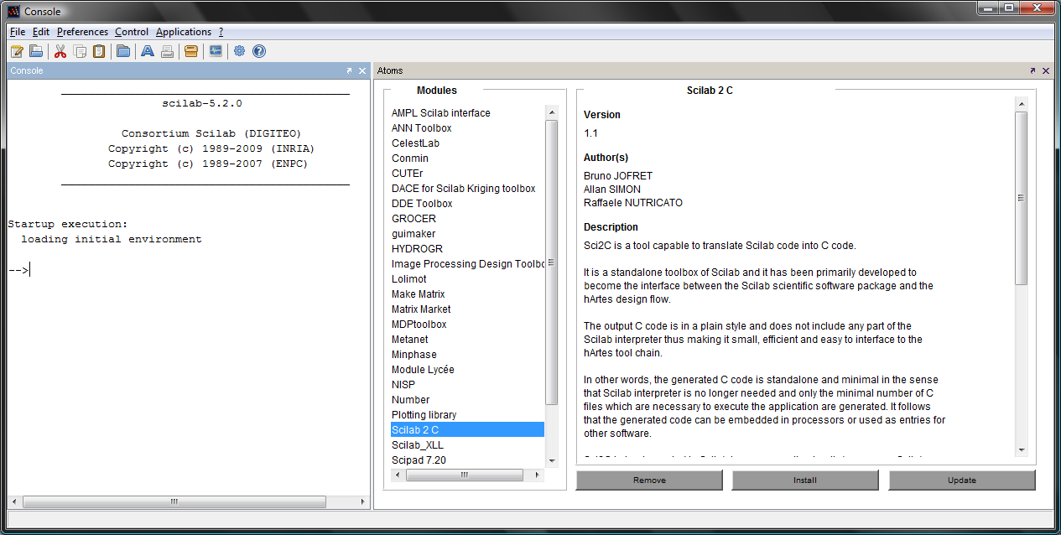
Screenshot of the Scilab2C tool integrated in the Scilab environment

How to Run Sci2C
The Scilab to C translation requires (to the Scilab user) only the following actions:
Step1: annotate the Scilab functions in order to specify the size and type of the output arguments;
Step2: (optional) specify the precision to be used for the data;
Step3: launch a GUI to generate the corresponding C-Code (see the following figure).

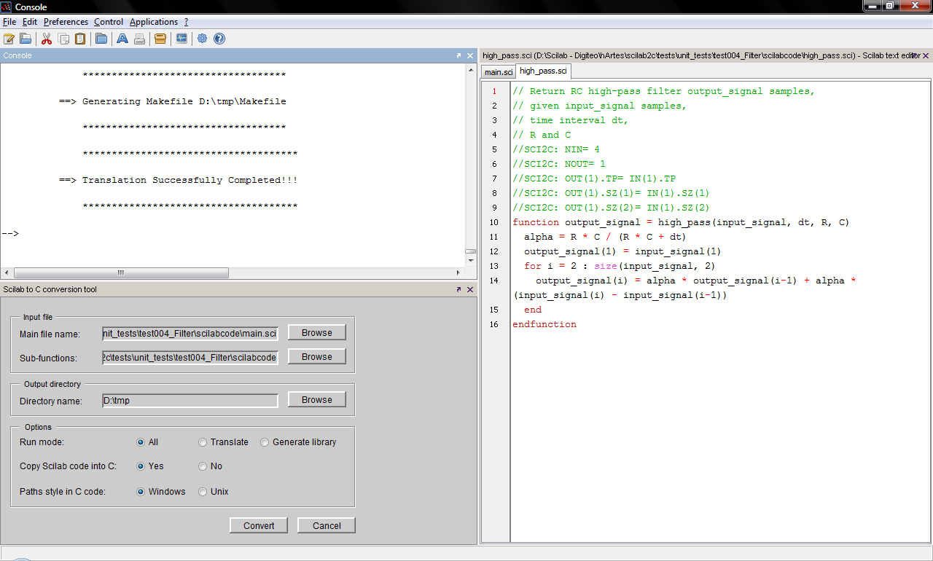
Screenshot of a Scilab2C conversion performed in the Scilab environment

Step 4: Compile and Execute C code by using the makefile created in the Output Directory
Step 5: Compare the results with the Scilab execution by launching again Sci2C (see the following figure).
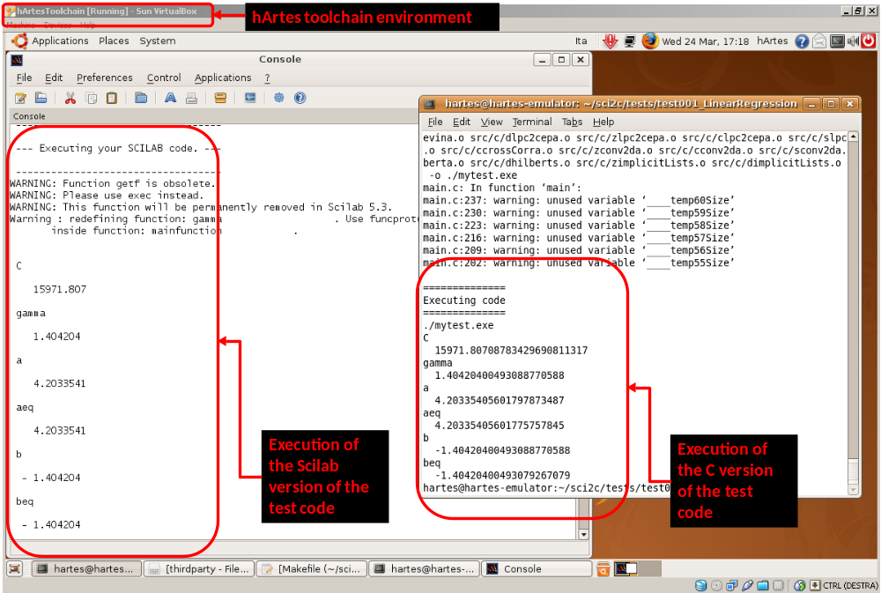
Screenshot of the comparison between the C and the Scilab versions of the test number 1. Note the perfect match between the numbers generated by the two versions.

Sci2C Library

Introduction
We provide with the Scilab2C code generator a library that aims to emulate Scilab behaviour. This is not an optimized library for embedded systems, but only a C snapshot of Scilab internal library. Knowing that Scilab only works in double precision and is linked to BLAS/LAPACK Library we tried to provide different implementations of algorithm to fit, as much as possible, user constraints.
Remember the given Sci2C Library can be replaced by a user Library (for instance the one provided by a dedicated chip) thanks to the interfacing system. The Scilab2C Library just guarantees you will have the same result compiling and executing the C code (translated in double precision) and running the translated script within Scilab.

Internal complex representation
Scilab has its own internal representation, based on double precision, for managing complex data type, and generally speaking to manage all data types.
In order to avoid embedding the entire Scilab types management in the Scilab2C Library, we choose to represent complex data type with C99 implementation and/or with a simple structure representation.
/*
** \function DoubleComplex
** \brief construct a Double Complex .
*/
doubleComplex DoubleComplex(double real, double imag) {
doubleComplex z;
#ifndef STDC99
z.real = real;
z.imag = imag;
#else
z = real + I * imag;
#endif
return z;
}

The user can switch between these two implementations specifying STDC99 flag when compiling Scilab2C Library.
Algorithms provided by the Scilab2C Library both work with or without STDC99 flag.

Single and Double precision management
As said before, Scilab only works with double precision.
This means we had to adapt the Silab2C Library with translated algorithm from double to single precision.
Moreover, if you choose to generate single precision C code, you may have some differences between the results obtained with C compilation/execution and the Scilab script.
There is, for now, no implementation of single precision representation inside Scilab.

Link to BLAS / LAPACK
Most of Scilab algorithms are based on BLAS / LAPACK implementation.
The Scilab2C Library is then provided with the same link to those Fortran Libraries. But we tried, as much as possible, to provide the user an alternative algorithm that will allow him to get rid of those dependencies.
Remember this link is only to guarantee the generated –double precision– code will have the same results as Scilab script.
Two alternative solutions exist:
- Use the Scilab2C Library alternative algorithm that can be enabled at compilation time using WITHOUT_BLAS tag.
{
#ifndef WITHOUT_BLAS
/*
** USES BLAS DGEMM FUNCTION.
*/
double One = 1;
double Zero = 0;

/* Cr <- 1*Ar*Br + 0*Cr */
dgemm_("N","N", &columns2, &columns2, &columns1, &One,
in1 , &lines1, in2, &lines2, &Zero, out, &columns2);
#else
/*
** DO NOT USE ANY BLAS FUNCTION.
*/
int i = 0;
/* ... */
}
- Use your own algorithm implementation through the given interfaces.

Rules: Naming and Type consistency

Type consistency
We consider the Scilab2C Library functions as non-transtyping one. This means for a given input type, there is only a single possible output type (which may be different for the input one).
Let’s explain it through two examples.
- The sqrt –square root– function (we only look at the double precision case):
Let’s consider we have a real input. In that particular case we can have two possible outputs:
  - Real Double: if the input is greater than zero.
  - Complex Double: if the input is lesser than zero.
- The abs –absolute value– function (we only look at the double precision case):
This function returns a real number for a given complex number.
This function also returns a real number for a given real number.
To conclude, we assume all the functions are non-transtyping functions. To roll back to this rule in every case, we treat real numbers as complex numbers with null imaginary part.
In that case the sqrt function become respect the rule we just describe:
If we have a real input, we consider it as a complex one. The sqrt function called is then the one with a complex value input and a complex value as output.

Naming Rules
Known the type consistency rule, we established a naming rule for the Scilab2C functions:
<input_type><function_name><array_or_scalar>
input_type can be :
- ‘s’ : Real number, Single precision.
- ‘d’ : Real number, Double precision.
- ‘c’ : Complex number, Single precision.
- ‘z’ : Complex number, Double precision.
array_or_scalar can be:
- ‘s’ : scalar.
- ‘a’ : array.
The ‘array’ functions only do the same treatment ‘scalar’ functions do, on each element of the array. They are called “element-wise” functions.
For what concerns functions that have a special behaviour when executed over matrixes, we specified other functions to manage those behaviour.
Example:
- cos –cosine– function:
‘dcosa’: The element-wise cosine on double precision real numbers
‘dcosma’: The matrix cosine on double precision real numbers (which in this case behaves like ‘dcosa’)
- mul –multiplication– function:
‘dmula’: The element-wise multiplication (C = A .* B ⬄ c_{ij} = a_{ij}*b_{ij})
‘dmulma’: The matrix multiplication (C = A * B ⬄ c_{ij} = ∑ (a_{ik} * b_{kj})

Tutorials

Introduction
In this section you can find the description of several demos available along with the installation package of Sci2C. At the moment only very simple tutorials are described here.

Simple Tutorials
In this section you find a list and a description of very simple demos that you should be able to run without any problem. This is only a partial list of Demos already available in directory Scilab2C\SCI2CTests
- test000_TrigonIdentity: simple code composed of only one function, that shows how to declare matrices and how to call Sci2C library functions. This code is an application of the trigonometric identity cos^2(x)+sin^2(x)=1
- test001_LinearRegression: simple code composed of only one function, that shows how to declare matrices and how to call Sci2C library functions. It is an interesting application because it solves a real problem. More specifically it is an application of the linear regression technique used to fit the volume and pressure measurements of a real gas.
- test004_LinearCombination: it is the first demo with more than one source files. It performs linear combinations between two variables that can be both arrays and scalars. This demo shows the polyrank behaviour of Scilab and how it is managed by Sci2C. You will discover how a simple Scilab function is converted into several C functions.
- test005_LinearCombinationNoTempVars: It is the same demo available in test004_LinearCombination, but with a different approach in calling the functions. In particular in order to remove realloc usage in the C code, temporary variables have been created in the main function.
- test100_recursivefunctions: computes the factorial by using both iterative and recursive algorithms.

In order to run these Demos you can simply enter the demo directory and type the exec launchConversion.sci command from the Scilab environment.

Known bugs

Operator :
Operator : when used alone is not correctly managed by the AST generator.
Example:

/*SCI2C: ##################################################################

SCI2C: disp(a(2,:));

SCI2C: ##################################################################*/
!--error 4
Undefined variable: IN

To avoid such problem convert
disp(a(2,:))
into
disp(a(2,1:N)) where N is the number of columns of a.

Glossary
Sci2C | Scilab to C translator
Sci2C Lib | A library that can be linked to the C generated code and that emulates Scilab behaviour.

